IEEE P802.11
Wireless LANs
Resolution for CIDs assigned to Graham for D5.0
Date: 2016-02-02
Author(s):
Name | Affiliation | Address | Phone | email
Graham SMITH | SRT Wireless | Davie, FL, USA. | 916 799 9563 | gsmith@srtrl.com
Abstract
This submission proposes resolution for CID 7275, 7272, 7278, 7280, 7292, 7360, 7361, 7373, 7382, 7397.
Green indicates material agreed to in the group,
yellow material to be discussed, red material rejected by the group and
cyan material not to be overlooked.

The “Final” view should be selected in Word.

Original draft was sent to Mark R and this document contains changes and edits resulting from his comments.

Identifiers | Comment | Proposed change
CID 7275  Mark Rison  10.24.2  1387.12 | "When a block ack agreement is set up between STAs, one of which is a non-HT STA, the Block Ack Policy and Buffer Size fields in the ADDBA Request frame are advisory and may be changed by the recipient. The Buffer Size field in the ADDBA Request frame is advisory and may be changed by the recipient for a block ack set up between HT STAs. The Block Ack Timeout Value field in the ADDBA Request frame is advisory and may be changed by the recipient for a block ack set up between HT STAs." Also 9.4.1.14 says "In an ADDBA Request frame, the Buffer Size subfield is intended to provide guidance for the frame receiver to decide its reordering buffer size and is advisory only." This is rather confusing and the non-HT case is underspecified. Arguably also the case with two non-HT STAs | Delete "and is advisory only" in 9.4.1.14. In 10.24.2 say: "When a block ack agreement is set up between HT STAs, the Buffer Size and Block Ack Timeout fields in the ADDBA Request frame are advisory. When a block ack agreement is set up between a non-HT STA and another STA, the Block Ack Policy and Buffer Size fields in the ADDBA Request frame are advisory." Note that the second sentence applies to DMG; I don't know whether this is intentional

Discussion:

10.24.2 Setup and modification of the block ack parameters
“………………..When a block ack agreement is set up between STAs, one of which is a non-HT STA, the Block Ack Policy and Buffer Size fields in the ADDBA Request frame are advisory and may be changed by the recipient. The Buffer Size field in the ADDBA Request frame is advisory and may be changed by the recipient for a block ack set up between HT STAs. The Block Ack Timeout Value field in the ADDBA Request frame is advisory and may be changed by the recipient for a block ack set up between HT STAs.”

9.4.1.14 P670.18
“In an ADDBA Request frame, the Buffer Size subfield is intended to provide guidance for the frame receiver to decide its reordering buffer size and is advisory only.”

In the Block Ack we have “Block Ack Policy” Buffer Size fields and Block Ack Timeout Value
The text indicates
 | Block Ack Policy | Buffer Size | BA Timeout
HT STAs |  | Advisory | Advisory
HT and non-HT STAs | Advisory | Advisory
Non-HT STAs | Advisory | Advisory

“When a block ack agreement is set up between STAs, one of which is a non-HT STA”. If one is not an HT STA, then does that mean the other must be an HT STA? I think it does. Mark feels that it just means that one of them is a non-HT STA; the other can be anything.
Hence, the new text should make that clear (as the commentor did observe). I do accept the commenter’s text.

In 9.4.1.14 it does add the “and is advisory only” for the Buffer Size, which indicates that this field is always advisory. Does the phrase “intended to provide guidance” say the same thing? I think the former is clearer.

Non-HT STAs also applies to DMG STAs. As to whether that is intentional, I shudder to think. As the commenter did not actual make this part of the comment, or provide an opinion, or an instruction, I decided not to investigate.

RESOLUTION:
REVISED
At P1387.12
Replace
When a block ack agreement is set up between STAs, one of which is a non-HT STA, the Block Ack Policy and Buffer Size fields in the ADDBA Request frame are advisory and may be changed by the recipient. The Buffer Size field in the ADDBA Request frame is advisory and may be changed by the recipient for a block ack set up between HT STAs. The Block Ack Timeout Value field in the ADDBA Request frame is advisory and may be changed by the recipient for a block ack set up between HT STAs.

With
(This is identical to commenter’s proposal)
"When a block ack agreement is set up between HT STAs, the Buffer Size and Block Ack Timeout fields in the ADDBA Request frame are advisory. When a block ack agreement is set up between a non-HT STA and another STA, the Block Ack Policy and Buffer Size fields in the ADDBA Request frame are advisory.”

At P670.17
Edit as follows:
“In an ADDBA Request frame, the Buffer Size subfield provides guidance for the frame receiver to decide its reordering buffer size. If the Buffer Size subfield is equal to 0, it implies that the originator of the block ack has no information to specify its value.”

Identifiers | Comment | Proposed change
CID 7272  Mark Rison | There are references to "PS STA"s, but the term is undefined. Does it mean a STA which can do PS or one which is currently in PS mode? | Define the expression as refererring to a STA that is in PS mode

Discussion:
P40.8
“power save (PS) mode”
P58.14
“PS power save (mode): A power management mode in which a non-mesh station (STA) alternates between awake and doze state”
P60.47
“STA station”

So is it clear that PS STA is a STA in PS mode?

The first instance in text of “PS STA” is P.1294.20, and that paragraph begins with (P1294.9)
“A STA in PS mode, in an infrastructure BSS, initiates a frame exchange sequence by transmitting a PS-Poll…”

So, either reject or add PS STA to 3 “Definitions, acronyns, abbreviations”

I opt to add definition.

RESOLUTION
REVISE
At P40.40, insert
“power save (PS) station (STA): A station that is in power save mode.”

Identifiers | Comment | Proposed change
CID 7278  Mark Rison  144.01 | In Clause 6, when an OperationalRateSet is passed down in MLME-JOIN/START.request, it can't include rates not in dot11SupportedDataRatesRxTable | Add this caveat to the "Valid range" cell (where it currently says 1-127). Make a similar statement about HT-MCS and VHT-MCSes

Discussion:
6.3.4.2. P159.51 MLME-JOIN.request

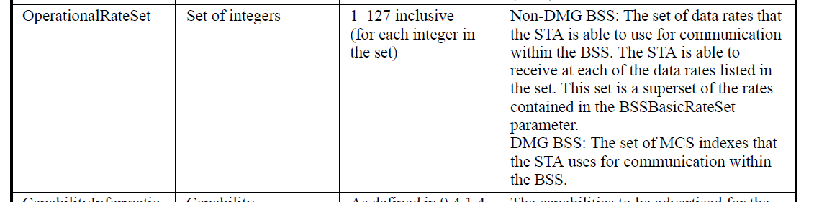

6.3.11.2 MLME-START.request
6.3.3.3 MLME-SCAN.confirm
“BSSBasicRate Set is defined in 6.3.11.2”

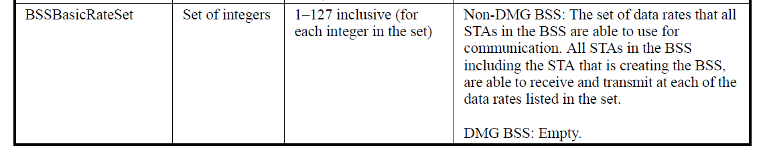

OperationalRateSet is defined at P37.35 and refers to the Supported Rates and BSS Membership Selectors element.

730.38
9.4.2.3 Supported Rates and BSS Membership Selectors element
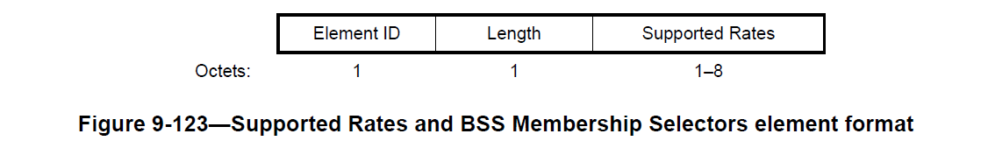
730.58
“…each Supported Rate contained in the BSSBasicRateSet parameter is encoded as an octet with the MSB (bit 7) set to 1, and bits 6 to 0 are set to the data rate,…”…“Rates not contained in the BSSBasicRateSet parameter are encoded with the MSB set to 0, and bits 6 to 0 are set to the appropriate value from the valid range column of the DATARATE row of the table in 6.5.5.2…”
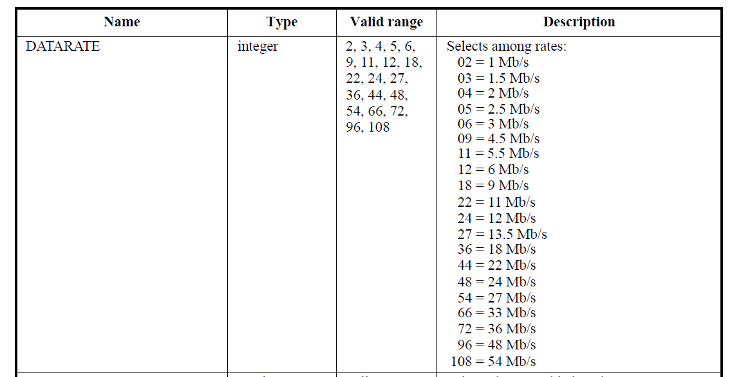

P740.14
9.4.2.13 Extended Supported Rates and BSS Membership Selectors element
“BSSBasicRate Set is defined in 6.3.11.2”

Maybe this should be added to 9.4.2.3 where it first appears

Commenter refers to dot11SupportedDataRatesRXTable
P2412.23 HT PHY MIB attributes
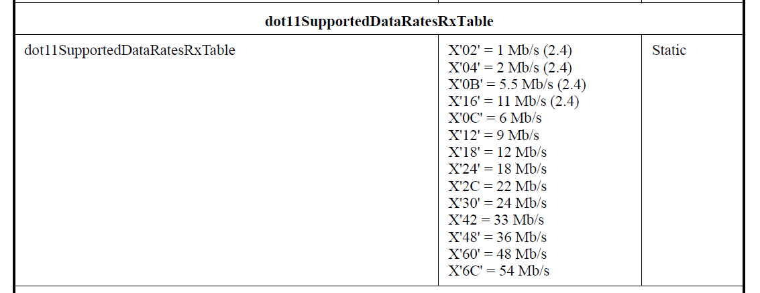

Now let’s recap what I know about the rates indications:
- Supported rates is up to 8 rates, usually
  - 2 to 4 if 11b 1, 2, 5.5, 11
  - 4 to 8 if 11b/g
  - 0 to 8 if 11a/n
These are always only from the 11a/b/g selection as per the dot11SupportedDataRatesRx Table, i.e. never 11n rates. This is as per the “Description” in 6.5.5.2.

Aside: I think 22Mb/s and 33Mb/s should now be removed?? But not sure about 1.5, 2.5, 3 etc. are these from the reduced BW? Another investigation?
22 and 33 are at following places in the “Valid range” and the “Description” columns
P537.16 and 20
P2317.31 and 33, 47 and 50
P2412.17 and 19, 34 and 36
Opinions??

An AP adds a (B) bit to indicate “basic rate” (from the BSSBasicRateSet). I don’t know why a STA should indicate Basic Rates unless it is as a confirmation?
BSSBasicRateSet is clear, it is the basic rates

So the commenter is pointing out that the OperationalRateSet and the BSSBasicRateSet can only be from the 11b/g list. This is clear for the “9.4.2.3 Supported Rates and BSS Membership Selectors element” and 9.4.2.13 Extended Supported Rates and BSS Membership Selectors element” which refer to the Table 6.5.5.2.

So what about OperationalRateSet? This is a “superset of BSSBasicRateSet”.
“Superset” means that all the rates in the BSSBasicRateSet are in the OperationalRateSet and it also contains rates not in the BSSBasicRateSet.

SO after all that, it does seem that the the limits of the rates are defined and restricted to those in Table 6.5.5.2. The description in the cited tables does set the limit and whether it is necessary to spell this out in the “Valid range” column to me does not seem necessary, hence the recommended resolution is “Reject”

MARK - That’s not the problem (well, except that 6.5.5.2 allows for e.g. 33 Mbps). The problem is that the operational rate set cannot include 108 (54 Mbps), say, if this is not in dot11SupportedDataRatesRxTable, even though it is in T6.5.5.2

BUT all the rates are in dot11SupportedDataRatesRXTable. Mark says that if the AP, for some reason, does not include 54 Mb/s in its dot11SupportedDataRatesRXTable then it cannot include 54Mb/s in its OperationalRateSet. I suppose the question is whether these are independent entities or whether they are, in fact, linked?

Now as to the HT-MCS. In the MLME-START.request the HT capabilities element is included.
9.4.2.56 HT Capabilities element includes the “Supported MCS Set” 16 octets. This has a bitmask to set the supported MCSi index values MCS 0 to 76. I am unclear as to what this has to do with the basic rates???
MARK
“The HT Caps shows the operational HT-MCS set. The HT Op shows the basic HT-MCS set. The MIB variables defining a device’s HT-MCS capabilities are dot11SupportedMCSTxTable and dot11SupportedMCSRxTable; for VHT-MCS capabilities they are dot11VHTTxVHTMCSMap and dot11VHTRxVHTMCSMap”

OK, I know that the Basic HT-MCS Set is part of the HT Operation element. (I also know that in the vast majority of APs, if not all, I have looked at, this field is all zeros.)
“HT Operation” is in
MLME-SCAN.confirm (Probe Response and Beacons), AND
MLME- START.request
“Valid Range: as defined in 9.4.2.57 (HT Operation Element)”
“A bitmap size 128 bits”

So what is the problem? I still don’t get it. Dot11SupportedMCSTxTable etc. do not actually have any datarates in them, they just refer to the bitmap. P3255.5.

RESOLUTION:
OPTION A
REJECT
The set of data rates in the OperationalRateSet and the BSSBasicRateSet are limited to the rates as per Table 6.5.5.2 which is a superset of the dot11SupportedDataRatesRXTable. This is stated in the text for “9.4.2.3 Supported Rates and BSS Membership Selectors element” and “9.4.2.13 Extended Supported Rates and BSS Membership Selectors element” where the supported rates are provided. Hence, further clarification is not necessary. Furthemore the data rates and MCS entries that are advertised over the air are what is important and the STA clearly has a set list to choose from. If it makes an internal mistake in not using the same lists for the internal MIBs, shame on it.

OPTION B
REVISE
At P159.33 and P202.5
Add the following to the “Valid Range” entry of “OperationalRateSet”:
“Only data rates in dot11SupportedDataRatesRxTable may be present”

At P202.44 and P153.17
Add the following to the “Valid Range” entry of “HT Operation”
“Only MCSs present in dot11SupportedMCSTxTable and dot11SupportedMCSRxTable may be present in Basic HT-MCS Set”

At P156.52
Add the following to the “Valid Range” entry of “VHT Capabilities”
“Only MCSs present in dot11VHTTxVHTMCSMap and dot11VHTRxVHTMCSMap may be present in the RX VHT-MCS Map subfield of the Supported VHT-MCS and NSS Set”

Identifiers | Comment | Proposed change
CID 7280  Mark Rison  6.3.11.2.2  201.52 | The BSSBasicRateSet can't include rates not in both dot11SupportedDataRatesRxTable and dot11SupportedDataRatesTxTable | Add this caveat to the "Valid range" cell (where it currently says 1-127). Make a similar statement about HT-MCS and VHT-MCSes

Discussion:
Please see discussion for CID 7278 above.
MARK
Same rebuttal as above

RESOLUTION:
OPTION A
REJECT
The set of data rates in the OperationalRateSet and the BSSBasicRateSet are limited to the rates as per Table 6.5.5.2 which is a superset of the dot11SupportedDataRatesRXTable. This is stated in the text for “9.4.2.3 Supported Rates and BSS Membership Selectors element” and “9.4.2.13 Extended Supported Rates and BSS Membership Selectors element” where the supported rates are provided. Hence, further clarification is not necessary.

OPTION B
P201.54
Add the following to the “Valid Range” entry of “BSSBasicRateSet”:
“Only data rates present in dot11SupportedDataRatesRxTable and dot11SupportedDataRatesTxTable may be present”

Identifiers | Comment | Proposed change
CID 7292  Mark Rison  6.5.4.2  534.28 | "The delay, in microseconds, from a point in time specified by the PHY to the issuance of the PHY-RXSTART.indication primitive." -- none of the PHYs do so | Change to "The delay, in microseconds, from the start of the PPDU at the receiver's antenna to the issuance of the PHY-RXSTART.indication primitive."

Discussion:

A search for “from a point in time” indeed shows that this is the only place in the Standard this expression is used.

RESOLUTION:
ACCEPT

Identifiers | Comment | Proposed change
CID 7360  Mark Rison  G.2  3402.42 | "Except where modified by the pifs attribute, frames are separated by a SIFS" -- so no frame exchange sequences involving RIFS are allowable? | Append "or RIFS"

Discussion:

“G.2 Basic sequences
The allowable frame exchange sequence is defined by the rule frame-exchange-sequence. Except where modified by the pifs attribute, frames are separated by a SIFS.”

10.3.2.3.2 RIFS
The use of RIFS is obsolete, and support for such use might be subject to removal in a future revision of the standard. A VHT STA shall not transmit frames separated by a RIFS.
RIFS is a means of reducing overhead and thereby increasing network efficiency.
RIFS may be used in place of SIFS to separate multiple transmissions from a single transmitter,

The commenter is right in that when RIFS was introduced it should have been added at the cited place.
Now that RIFS is obsolete, one can strongly argue that the cited text is actually correct and adding RIFS would make it incorrect as RIFS should not be used, because it is obsolete.

If, however, RIFS is still allowed for DMG, then we have a bigger problem.
Table 29-31 DMG PHY characteristics does list “aRIFSTime 1us”, but then so does Table 19-25 HT PHY characteristics (2us).

Reached out to Carlos to confirm,.
CARLOS
From a 802.11 spec perspective, it is not true that RIFS is obsolete for DMG. Please see 10.3.2.3.2 RIFS. Since we have an ongoing 11ay project, it would be better to defer to 11ay the discussion of making RIFS obsolete for DMG.

Note: from an implementation perspective, I doubt any DMG implementation is using RIFS. With that said, my response above is from a spec perspective.

As 10.3.2.3.2. starts with “The use of RIFS is obsolete, and support for such use might be subject to removal in a future revision of the standard.”
I cannot see how that is ambiguous or how it allows DMG STAs to use it.

Hence until it is decided that the opening to 10.3.2.3.2 should be changed to “The use of RIFS is NOT obsolete, and may be used by DMG STAs.” OR “The use of RIFS is limited to DMG STAs” - I think I stick with my resolution proposals otherwise it makes no sense, IMHO.

MARK,
So I think the statement should be:
“The use of RIFS in the 2.4 GHz and 5 GHz bands is obsolete, and support for such use might be subject to removal in a future revision of the standard.”

This is a bigger question. When and how was it decided to make RIFS obsolete amd how did this line up with DMG? It was there in 802.11 – 2012. I think this was added in D3.0? Was it agreed at the time with DMG advocates present for the vote? I note that is ‘obsolete’ not ‘deprecated’ so this is quite advanced. I can’t see that RIFS is required for DMG. VHT definitely does not use it.
ADRIAN
This was a misteak by TGac. They saw that .11n RIFS wasn’t implemented, so rather than extending it for .11ac,they marked it as deprecated.
What they failed to understand is that .11ad supports RIFS, although it was too soon when TGac were doing their
stuff to know if any particular part of .11ad would be implemented. They also failed to understand that .11ac camein publication *after* .11ad, so it was TGac’s responsibility to properly account for .11ad.
IMHO the statement could and should be modified to be “The use of RIFS by a non-DMG STA is obsolete”, unlessthe DMG guys indicate that .11ad manufacturers are not going to implement it.

RESOLUTION:

REVISED
P1270.34
Edit as follows:
“The use of RIFS by a non-DMG STA is obsolete, and support for such use might be subject to removal in a future revision of the standard.”

AND
P3402.42
Add “and RIFS” at end of sentence to read as follows:
“Except where modified by the pifs attribute, frames are separated by a SIFS or RIFS.”

Identifiers | Comment | Proposed change
CID 7361  Mark Rison  10.3.2.3.2  1270.33 | "The use of RIFS is obsolete" -- even for DMG? | After "RIFS" add "in the 5 GHz band"

Discussion:
Depends on whether RIFS was made obsolete (first appears in D3.0) with votes that included DMG participants.

RESOLUTION:
REVISED
P1270.34
Edit as follows:
“The use of RIFS for non-DMG STAs is obsolete, and support for such use might be subject to removal in a future revision of the standard.”

Identifiers | Comment | Proposed change
CID 7373  Mark Rison  11.2.3.5  1602.13 | "BUs may be sent to STAs in active mode at any valid time." -- and what's a "valid time"? | Delete the sentence

Discussion:

“If power management is in use within an IBSS, a STA shall buffer individually addressed BUs for STAs that are known to be in PS mode. BUs may be sent to STAs in active mode at any valid time.”

Indeed what is a “valid time”? There is a complete set of rules for when and how to send BUs to the PS STA. I agree with comment, this is a sentence that adds nothing and may be misunderstood.

RESOLUTION:
ACCEPT

Identifiers | Comment | Proposed change
CID 7382  Mark Rison  10.22.2.7  1357.28 | "NOTE---The bandwidth of a PS-Poll frame does not constrain the bandwidth of an immediate data response to that PSPoll frame." -- is this normative? Where? It seems to be in conflict with "If there is no RTS/CTS exchange in non-HT duplicate format in a TXOP and there is at least one non-HT duplicate frame exchange in a TXOP, the TXOP holder shall set the CH_BANDWIDTH parameter in TXVECTOR of a PPDU sent after the first non-HT duplicate frame to be the same or narrower than the CH_BANDWIDTH parameter in TXVECTOR of the initial frame in the first non-HT duplicate frame exchange in the same TXOP." above | Either delete the NOTE or make it normative and address the apparent contradiction noted in the comment

Discussion:
The cited text is in 10.2.2.7. Multiple frame transmission in an EDCA TXOP.

We are talking about VHT here and the PS-Poll certainly can include bandwidth information.

The NOTE says “The bandwidth of a PS-Poll frame does not constrain the bandwidth of an immediate data response to that PSPoll frame.”

First let’s see if it contradicts the other cited text, namely:
“If there is no RTS/CTS exchange in non-HT duplicate format in a TXOP and there is at least one non-HT duplicate frame exchange in a TXOP the TXOP holder shall set the CH_BANDWIDTH parameter in TXVECTOR of a PPDU sent after the first non-HT duplicate frame to be the same or narrower than the CH_BANDWIDTH parameter in TXVECTOR of the initial frame in the first non-HT duplicate frame exchange in the same TXOP.”

Condition is NO RTS/CTS, and at least one non-HT duplicate frame. As the NOTE refers to an “immediate data response” it cannot be a duplicate. So far so good.
Then IF we have a duplicate, then the next PPDU is bandwidth restrictive. Hence, I think that the NOTE does NOT contradict the sentence above it. As I read it, the initial triggered data response to the PS-Poll is unrestricted, but if a duplicate occurs (later) then the restriction kicks in.
MARK
OK, I *think* you’re right (though I’m having trouble thinking this through clearly!)

So, is the NOTE normative or just information? I think it works as a NOTE. If it were text then it would need to have a lot more descriptive text to it.
MARK
The question is: is it already the case that the rules don’t place any restriction on the bandwidth in this case (immediate data response to PS-Poll frame)? This would require careful analysis of 10.7 Multirate support, I think

RESOLUTION:
REJECT
The cited NOTE does not contradict the cited text. The NOTE refers to the immediate data response which cannot be a duplicate, whereas the cited text refers to duplicate frame.

Identifiers | Comment | Proposed change
CID 7397  Mark Rison  10.29.2.7  1433.11 | "NOTE 6--Multi-TID BlockAck and Multi-TID BlockAckReq frames transmitted during PSMP use the Normal Acknowledgment setting of the BA Ack Policy or BAR Ack Policy subfield." is bogus as the subfield is reserved in those cases (since they are not (HT-)Delayed, which are the only type where the subfield is not reserved) | Delete this NOTE

Discussion:

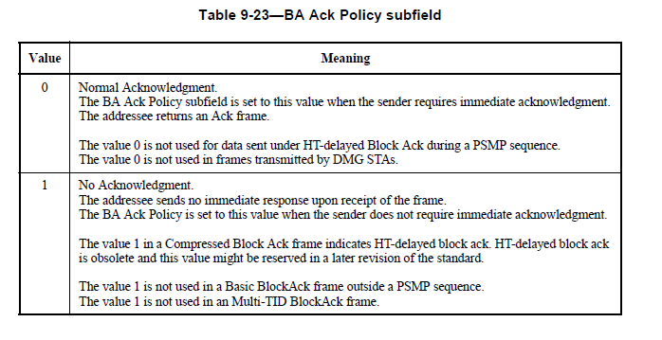
Reading 9.3.1.9.1 and Table 9-23 we read
“Normal Acknowledgement: “The value 0 is not used for HT-delayed Block Ack during a PSMP sequence.
No Acknowledgment: “The value 1 is not used in a Basic BlockAck frame outside a PSMP sequence”

BUT NOTE 6 says
NOTE 6--Multi-TID BlockAck and Multi-TID BlockAckReq frames transmitted during PSMP use the Normal Acknowledgment setting of the BA Ack Policy or BAR Ack Policy subfield."

So clearly this note is not 100% true and is “bogus”.
MARK
The key contradiction is with the stuff above the tables, namely “For BlockAckReq frames sent under Delayed and HT-delayed agreements, […] For BlockAckReq
frames sent under other types of agreement, the BAR Ack Policy subfield is reserved.” and “For BlockAck frames sent under Delayed and HT-delayed agreements, […]. For BlockAck frames sent under other types of agreement, the BA Ack Policy subfield is reserved.”

Having said that, I note a possible additional contradiction with DMG, since 0 is stated in the tables to be not used with DMG STAs, but if the field is reserved it’s set to 0. Something for Carlos et al.

RESOLUTION:
ACCEPT

