IEEE P802.11
Wireless LANs
TGaj China Interim WG Minutes - January 2016 - Harbin
Date: 2016-01-27
Author(s):
Name | Affiliation | Address | Phone | email
Jon Rosdahl | Qualcomm Technologies Inc. | 10871 N 5750 W  Highland, UT 84003 | +1-801-492-4023 | jrosdahl @ ieee . org
Abstract
WG Minutes for the January 2016 TGaj China Interim in Harbin, China.
The meeting was held at the Heilongjiang Trade Union Business Hotel,

- 802.11 WG – 802.11aj China Interim, Harbin, China – 27 January 2016 – AM1 – 09:00
  - Called to order by the 2nd Vice-Chair, Dorothy STANLEY (HPE) at 9:18am
  - Introduction of WG officers in attendance
    - Dorothy STANLEY – HPE – 802.11 2nd Vice Chair
    - Jon ROSDAHL – Qualcomm – 802.11 1st Vice Chair
  - Review of Agenda
    - 11-16/0200/r0 with changes agreed in session to become r1.
    - Change to move closing plenary to Wednesday PM3 (17:00-18:00)
    - MOTION #H1: Approve Agenda
      - Moved to Approve
      - Moved Haiming Wang 2nd: Jiamin Chen
      - 6-0-0 – Motion Passes
  - New Attendees: 3 -- 11 participants for 802.11aj China Interim January 2016
  - Review Patent Policy –
    - 5 slides reviewed. – see 11-16/201r0
    - No issues noted.
    - Review rules slides.
      - Review summary of recent changes to the rules
  - Review Reflector process
    - Slides:
  - Meeting Registration
    - Harbin Meeting registration fee – 1800 RMB
    - Pay during the morning break
  - Meeting attendance:
    - See slide 24 – 11-16/201r1
    - Use IMAT.IEEE.ORG for link
    - Meeting passcode: 888888
  - Review local logististics
    - Locations of facilities reviewed
  - 802 EC and IEEE-SA Board
    - No items
  - Items from EC Workshop related to 802.11
    - Jon reviewed 802 EC Workshop activities.
    - See slides 27-29 11-16/201r1
  - Review WG structures and PAR expiration dates
    - TGaj – Dec 2016
    - Expect to request extension during the July Plenary
  - Review TG officers – slide 34-35 – 11-15/201r1
  - Review Revision History – slide 36-37
  - Ballot status – slide 38 – 11-15/201r1
  - Treasurer report 11-15/1525
  - 802.11aj TG status report – slide 13 11-15/1526r1
  - Recess at 10:00
- 802.11 WG Closing Plenary – TGaj China Interim – January 27th 17:00
  - Meeting called to order by Dorothy STANLEY (HPE) 1st Vice Chair at 5:08pm
  - Introduce Officers
  - Review Agenda for closing plenary
    - No objection to agenda in 11-16/200r1
  - Review Patent Policy
    - No issues noted
  - Reminder for getting minutes, objectives and snapshots turned in on time.
  - Administrative Reminders – slide 45
  - Letters of Assurance – slide 46
  - Drafts for sale online reviewed
    - Added line for 802.11aj in the report, but no request to put for sale this time.
  - Report on 802.11 drafts sent to ISO/IEC JTC1/SC6
  - March 2016 tutorials
    - No requests have been received at this time
  - Future Venue
    - For 2017, TGaj will be winding down, so will collocate with the Wireless Interims – No separate China Interim
    - Review WG future venue webpage
  - Closing Report for TGaj 11-16/211r0 – Haiming WANG
    - Review list of 5 submissions presented
    - A motion was passed on initial comment resolutions
    - Motion to approve swapping the location of the China Interims for May and Sept 2016.
    - Review next meeting for TGaj – March 2016 – Macau – 802 Plenary
    - Conference Call Times
      - Feb18, 2016 9pm (ET) – Beijing Time: Feb 19, 2016, 10 am (China)
  - Motions:
    - Motion #H2: Teleconference Motion
      - Motion to approve a TGaj Teleconference:
Feb18, 2016 9pm (ET) – Beijing Time: Feb 19, 2016, 10 am (China)
      - Moved: Jiamin CHEN 2nd: Haiming WANG
      - Results: 6-0-0 motion Passes
    - Motion #H3: Venue Change
      - Motion to approve the following venues for the China Interim Sessions:
May 25-26, 2016 Chongqing, China
September 28-29, 2016 Beijing
      - Moved: Jiamin CHEN 2nd: Haiming WANG
      - Results: 6-0-0 motion Passes
  - Wireless Chairs Meeting announcement
    - Meeting at 4:pm local time
  - Next Meeting – March 2016 Macau –
    - Registration is open, Deadline is Jan 29 for regular registration
  - Thanks to all that came, especially the Vice-chairs was expressed by the TG officers.
  - Adjourn 5:41pm

2016 802.11aj China Interim Participant List:

Last Name | First Name | Affiliation | Attendance Credit | Current Involvement Level
Chen | Jiamin | HUAWEI | 100% | Voting Member
He | Shiwen | Southeast University, China | 100% | Voting Member
Huang | Wenyuan | Toshiba Electronics China | 100% | Observer
Huiyi | Jizhi | Shenzhen iTest Technology Co.,Ltd. | 100% | Observer
Li | Dejian | Huawei Technologies; HiSilicon | 100% | Voting Member
Ma | Yuanye | CESI Group | 100% | Observer
Rosdahl | Jon | Qualcomm Technologies Inc. | 100% | Voting Member
Stanley | Dorothy | Hewlett Packard Enterprise | 100% | Voting Member
Tian | Kaibo | ZTE Corporation | 100% | Aspirant Member
Wang | Haiming | Southeast University, China | 100% | Voting Member
Zhuo | Lan | CESI Group | 100% | Voting Member

Photo of January 2016 China Interim – Harbin China - Participants:

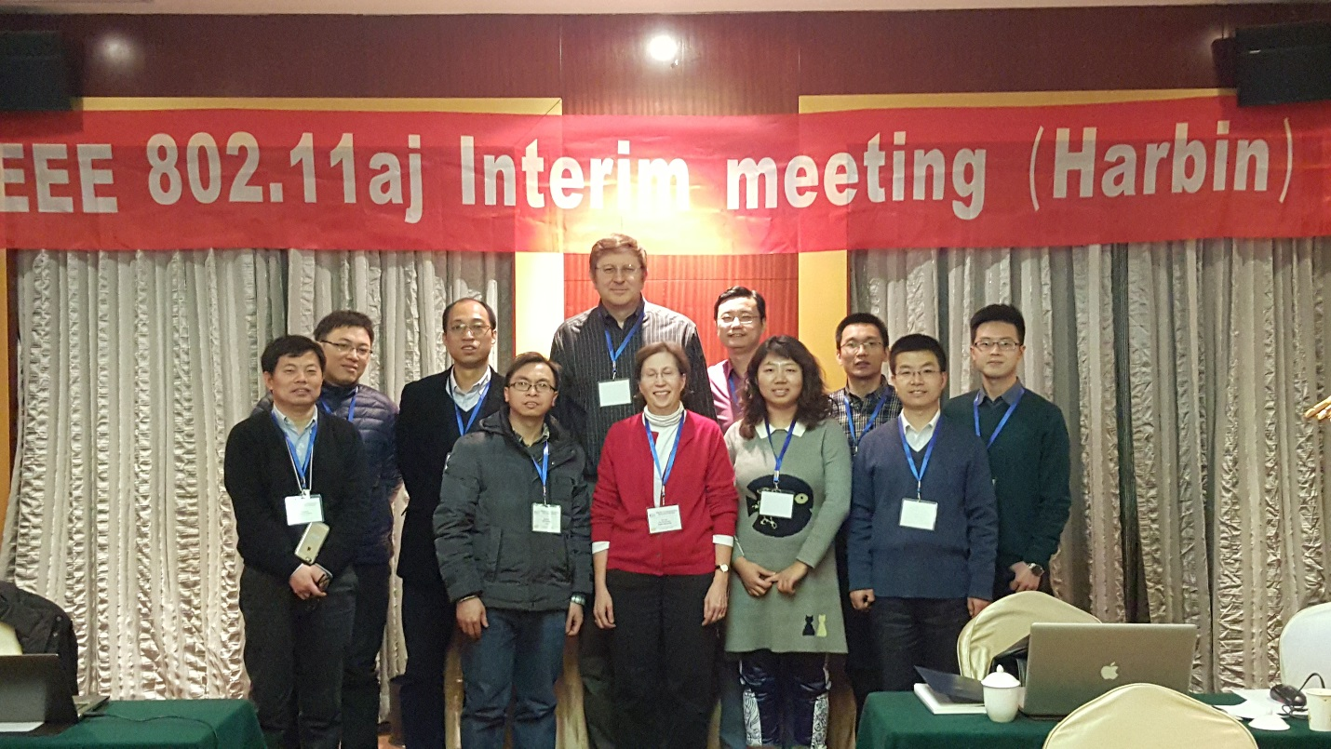

References:

WG Session Reports
WG Agenda | https://mentor.ieee.org/802.11/dcn/11-16-0200
Opening report | https://mentor.ieee.org/802.11/dcn/11-16-0201
Snapshots | https://mentor.ieee.org/802.11/dcn/11-15-1526
1st vice chair | https://mentor.ieee.org/802.11/dcn/11-15-1524
Treasurer | https://mentor.ieee.org/802.11/dcn/11-15-1525

