IEEE P802.11
Wireless LANs
11ah SB0 resolution to comments on frame control field
Date: 2016-01-20
Author(s):
Name | Affiliation | Address | Phone | email
Zander Lei | Institute for Infocomm Research (I2R) | 1 Fusionopolis Way  #21-01 Connexis  Singapore 138632 | +65 6408 2436 | leizd@i2r.a-star.edu.sg
Yongho Seok | NEWRACOM

Abstract
This submission proposes resolutions to the following comments for TGah 1st Sponsor Ballot (TGah Draft 5.0).
- CIDs: 8059, 8256 (2 CIDs)

Interpretation of a Motion to Adopt

A motion to approve this submission means that the editing instructions and any changed or added material are actioned in the TGah Draft. This introduction is not part of the adopted material.

Editing inst ructions formatted like this are intended to be copied into the TGah Draft (i.e. they are instructions to the 802.11 editor on how to merge the text with the baseline documents).

TGah Editor: Editing instructions preceded by “TGah Editor” are instructions to the TGah editor to modify existing material in the TGah draft. As a result of adopting the changes, the TGah editor will execute the instructions rather than copy them to the TGah Draft.

Clause 8.2.4.1.1 (2 CIDs)

CID | Pg. Ln | Comment | Proposed Change | Resolution
8059 | 76. 16 | "The caption on this figure now reads like an excerpt of most of ""War and Peace"". Likewise the caption at line 36 gives ""the rise and fall of the Roman empire"" a good run for its money.  This makes them hard to read, and increases the likelihood that the reader picks the wrong figure." | Define a term for this condition, introduce that term in this subclase, and consider adding to the 802.11-specific definitions and caption Figure 8-2 "... in <new term> frames".  Alternatively you might want to use something like "Basic variant Frame Control field", and build a table of conditions that establishes the type of variant (see Block Ack for an example).  Likewise for the other variants of the control field. | Revised.  Agree in principle.  TGah Editor to make the changes under the heading of CID8059 in 11-16/0070r0
8256 | 76. 16 | Caption is excessively wordy and repeats what is stated in the text. | Leave the caption as it appears in the base standard (delete changes to caption) | Revised.  Agree in principle.  TGah Editor to make the changes under the heading of CID8059 in 11-16/0070r0

[CIDs 8059, 8256]
Instruction to TGah editor: Please replace the subclause 8.2.4.1.1 (General) of TGah D5.0 as follows:

8.2.4.1.1 General
Modify the subclause 8.2.4.1.1 as follows
The first three subfields of the Frame Control field are Protocol Version, Type, and Subtype. The remaining subfields of the Frame Control field depend on the setting of the Type and Subtype subfields, together with the condition that whether the Frame Control field is carried by an S1G PPDU or a non-S1G PPDU, determines which of six possible Frame Control field variants is represented, as indicated in Table 8-0a Frame Control field variants.
Table 8-0a Frame Control field variant

Type  subfield value | Subtype  subfield value | Frame Contro field is carried in an S1G PPDU or  a non-S1G PPDU | Frame Control field variant
not 1 | any value | non-S1G | Basic
1 | not 6 | non-S1G | Basic
0 or 2 | any value | S1G | Basic
1 | 6 | either non-S1G or S1G | Extended Control
1 | not 3, not 6, or not 10 | S1G | S1G Basic Control
1 | 3 | S1G | S1G TACK
1 | 10 | S1G | S1G PS-Poll
3 | 1 | S1G | S1G Beacon

8.2.4.1.1.1 Basic Frame Control field variant
When the value of the Type subfield is not equal to 1 or the value of the Subtype subfield is not equal to 6, the remaining subfields within the Frame Control field are: To DS, From DS, More Fragments, Retry, Power Management, More Data, Protected Frame, and Order. In this case, the The format of the Frame Control field for the Basic variant is illustrated Figure 8-2 (Frame Control field for Basic variant when Type is not equal to 1 or Subtype is not equal to 6).

 | B0 B1 | B2 B3 | B4 B7 | B8 | B9 | B10 | B11 | B12 | B13 | B14 | B15
 | Protocol  Version | Type | Subtype | To DS | From DS | More  Fragments | Retry | Power  Management | More Data | Protected Frame | Order
Bits: | 2 | 2 | 4 | 1 | 1 | 1 | 1 | 1 | 1 | 1 | 1
Figure 8-2—Frame Control field for Basic variant when Type is not equal to 1 or Subtype is not equal to 6

8.2.4.1.1.2 Extended Control variant
When the value of the Type subfield is equal to 1 and the value of the Subtype subfield is equal to 6, the remaining subfields within the Frame Control field are the following: Control Frame Extension, Power Management, More Data, Protected Frame, and Order. In this case, the The format of the Frame Control field for the Extended Control variant is illustrated in Figure 8-3 (Frame Control field for Extended Control variant when Type is equal to 1 and Subtype is equal to 6).

 | B0 B1 | B2 B3 | B4 B7 | B8 B11 | B12 | B13 | B14 | B15
 | Protocol Version | Type | Subtype | Control Frame  Extension | Power  Management | More Data | Protected Frame | Order
Bits: | 2 | 2 | 4 | 4 | 1 | 1 | 1 | 1
Figure 8-3—Frame Control field for Extended Control variant when Type is not equal to 1 or Subtype is not equal to 6

8.2.4.1.1.3 S1G Basic Control variant
The format of the Frame Control field for the S1G Basic Control variant is illustrated in Figure 8-3a (Frame Control field for S1G Basic Control variant).

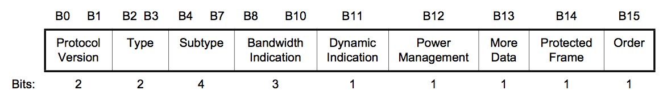
Figure 8-3a—Frame Control field for S1G Basic Control variant

8.2.4.1.1.4 S1G TACK variant
The format of the Frame Control field for the S1G TACK variant is illustrated in Figure 8-3b (Frame Control field for S1G TACK variant).

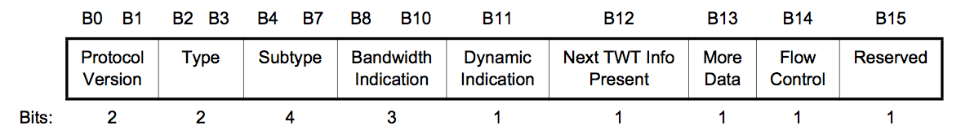
Figure 8-3b—Frame Control field for S1G TACK variant

8.2.4.1.1.5 S1G PS-Poll variant
The format of Frame Control field for the S1G PS-Poll variant is illustrated in Figure 8-3c (Frame Control field for S1G PS-Poll variant).

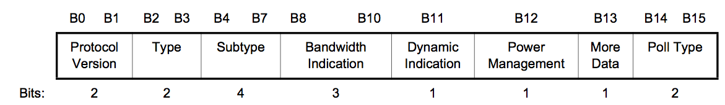
Figure 8-3c—Frame Control field for S1G PS-Poll variant

8.2.4.1.1.6 S1G Beacon variant
The format of the Frame Control field for the S1G Beacon variant is illustrated in Figure 8-3d (Frame Control field for S1G Beacon variant).
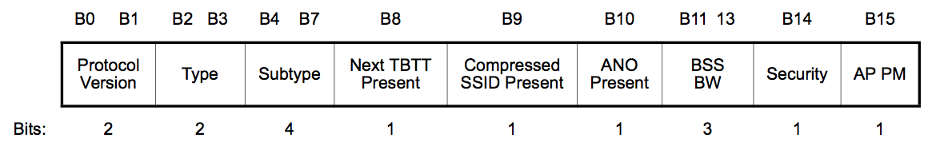
Figure 8-3d—Frame Control field for S1G Beacon variant

