IEEE P802.11  
Wireless LANs

|  |  |  |  |  |
| --- | --- | --- | --- | --- |
| SB0 Comment Resolutions for Misc. Clause 24 CIDs | | | | |
| Date: 2015-11-04 | | | | |
| Author(s): | | | | |
| Name | Affiliation | Address | Phone | email |
| Sabita Nahata | Qualcomm Inc. | 1060 Rincon Circle, San Jose, CA-95131 |  | snahata@qti.qualcomm.com |
| Raja Banerjea | Qualcomm Inc. |  |  | rajab@qti.qualcomm.com |
| Hong Wan | Qualcomm Inc. |  |  | hwan@qti.qualcomm.com |
| Eugene Baik | Qualcomm Inc. |  |  | eugeneb@qca.qualcomm.com |
| Alfred Asterjadhi | Qualcomm Inc. |  |  | aasterja@qti.qualcomm.com |

Abstract

This submission provides Sponsor Ballot CID resolutions contained in multiple sections of Clause 24 TGah Draft 5.0.

CIDs: 8212, 8213, 8214, 8215, 8216, 8217, 8218

|  |  |  |  |  |  |  |
| --- | --- | --- | --- | --- | --- | --- |
| **CID** | **Commenter** | **P.L** | **Clause** | **Comment** | **Proposed Change** | **Resolution** |
| 8212 | Naveen Kakani | 437.16 | 24.3.8.2.1.4 | Clarify in the BW field description to what happens when duplicate modes are considered. Basically, what should be the value of BW field in case of duplicate mode. | Table 24.11, Ln 16 change “  Set to 0 for 2 MHz, 1 for 4 MHz, 2 for 8 MHz, 3 for 16 MHz”  to  “If FORMAT is S1G in TXVECTOR, set to:  0 when CH_BANDWIDTH is CBW2  1 when CH_BANDWIDTH is CBW4  2 when CH_BANDWIDTH is CBW8  3 when CH_BANDWIDTH is CBW16  If FORMAT is S1G_DUP_2M in TXVECTOR, set to 0.” | Accepted |

**Discussion: None.**

|  |  |  |  |  |  |  |
| --- | --- | --- | --- | --- | --- | --- |
| **CID** | **Commenter** | **P.L** | **Clause** | **Comment** | **Proposed Change** | **Resolution** |
| 8213  8214 | Naveen Kakani | 413.46, 415.55 | 24.3.4.3.2, 24.3.4.4.2 | Step ‘a’ should be texted separately for non-duplicate and duplicate mode as given in the resolution table below in the relevant section | Separate the text for non-duplicate and duplcate mode. | Revised.  Instruction to Editor: please use the proposed changes in the “Proposed Changes Table” on Page 4 of doc. IEEE-802.11-15-1491r0 |

**Discussion:**

**24.3.4.3 Construction of the Preamble part in an S1G_SHORT PPDU**

Section 24.3.4.3.2 describes construction of Preamble in S1G SHORT PPDU. Step ‘b, sequence generation in LTF construction depends on CH_BANDWIDTH parameter defined in step ‘a’. Again, if we look at Table 24-2 (shown below) CH_BANDWIDTH is CBW4 when an S1G PPDU of 4 MHz or S1G_DUP_2M is transmitted and similar is the case with 8 and 16 MHz transmission with and without duplicate mode.

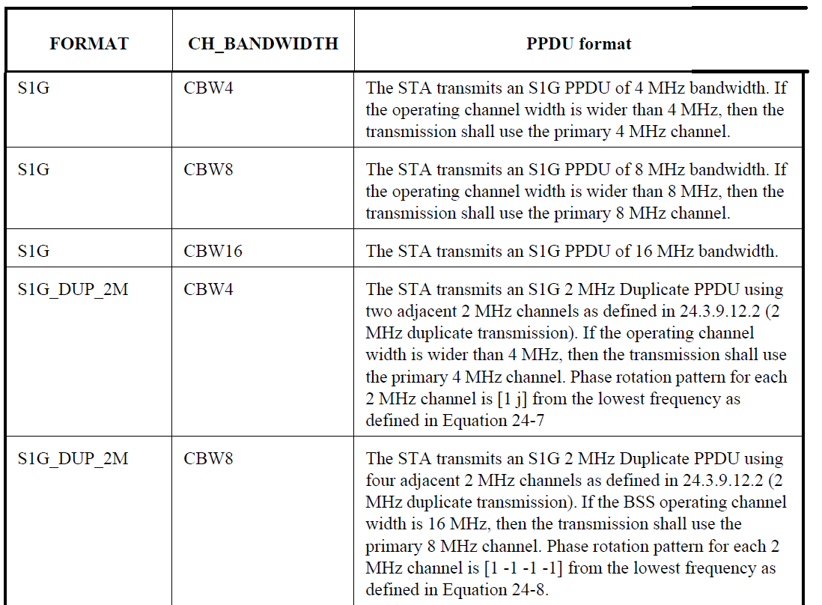

The LTF1 sequence used for S1G_DUP_2M with CBW4 should be different from the LTF1 sequence used for S1G with CBW4. Detailed explanations are as follows.

The DATA field signal is defined in 24.3.9.12.2.2 Equation (24-60):



For each 2MHz sub-band, data and pilot symbols are loaded on subcarrier $-28≤k≤28$. For CBW4, the loaded subcarriers are:

$$\left\{\begin{matrix} -60≤k≤-4 \\ 4≤k≤60\end{matrix}\right.$$

However, the LTF defined for HT/VHT 40MHz is:



This LTF sequence is not aligned with the subcarrier indexing of the DATA field in S1G_DUP_2M. If we use this LTF sequence for S1G_DUP_2M, we can’t perform LTF channel estimation on subcarrier -60, -59, 59, and 60 while these 4 subcarriers are loaded with data symbols.

**Proposed change table:**

|  |  |  |
| --- | --- | --- |
|  | **Current draft** | **Proposed change** |
| CID 8213  Section 24.3.4.3.2 Construction of LTF1 (a)  P.L: 413.46 | Sequence generation: Generate the LTF1 field sequence in the frequency-domain over the bandwidth indicated by CH_BANDWIDTH as described in 24.3.8.2.1.3 (LTF definition). | **Add a bullet point before a) Sequence Generation**  **a) Determine FORMAT from TXVECTOR**  **b) Sequence generation: If FORMAT is S1G, generate the LTF1 field sequence in the frequency-domain over the bandwidth indicated by CH_BANDWIDTH as described in 24.3.8.2.1.3 (LTF definition). If format is S1G_DUP_2M, generate the LTF1 field sequence in the frequency-domain over a 2MHz** **bandwidth.** |
| CID 8214  Section 24.3.4.4.2 Construction of 1MHz LTF1  P.L: 415.55 | Sequence generation: generate the 1MHz LTF1 field sequence in the frequency-domain over the bandwidth indicated by CH_BANDWIDTH as described in 24.3.8.3.3 (LTF definition). | **Add a bullet point before a) Sequence Generation**  **a) Determine FORMAT from TXVECTOR**  **b) Sequence generation: If FORMAT is S1G, generate the LTF1 field sequence in the frequency-domain over the bandwidth indicated by CH_BANDWIDTH as described in 24.3.8.3.3 (LTF definition). If format is S1G_DUP_1M, generate the LTF1 field sequence in the frequency-domain over a 1MHz** **bandwidth.** |

|  |  |  |  |  |  |  |  |
| --- | --- | --- | --- | --- | --- | --- | --- |
| **CID** | **Commenter** | **P.L** | **Clause** | **Comment** | **Proposed Change** | **Resolution** | |
| 8215 | Naveen Kakani | 474.4 | 24.3.9.12.2 | Gamma values are not explicitly defined to generate data field of 2 MHz duplicated transmission. Equation (24-6)-(24-20) defines it for only non-duplicate mode. | Define Gamma values | Revised.  Instruction to Editor: please apply the proposed changes described on Page 4-5 of doc. IEEE-802.11-15-1491r0 |

**Discussion:**

**1 MHz and 2 MHz duplicate transmission:** **Section 24.3.9.12:**

This section gives the mathematical equation for the data field for both 1 MHz and 2 MHz duplicate transmission. For 1 MHz duplicate transmission the phase rotation or gamma values are clearly defined in equation 24-10 – 24-13. For 2 MHz transmission on the other hand, the gamma values are defined only for non-duplicated transmission (equation 24-6 -24-9). Are they applicable for 2 MHz duplicated transmission also?

**Proposed change**

**Insert following equations in the current draft. Insertions should be at P.L: 432.36**

**For a 4MHz PPDU transmission of S1G or S1G_DUP_2M packets**



**For an 8 MHz PPDU transmission of S1G or S1G_DUP_2M packets**



**For a 16 MHz PPDU transmission of S1G or S1G_DUP_2M packets**



|  |  |  |  |  |  |  |
| --- | --- | --- | --- | --- | --- | --- |
| **CID** | **Commenter** | **P.L** | **Clause** | **Comment** | **Proposed Change** | **Resolution** |
| 8216 | Naveen Kakani | 440.52 | 24.3.8.2.1.5 | Maximum degree of the polynomial should be 3.  The order of cofficients in the equation should be reversed. As per the diagram, it is not correct. | Ln 52:  Change crc(D) = $C_{0}D^{4}+C_{1}D^{2}+C_{2}D^{1}+C_{3}D^{0}$ **To $$C_{3}D^{3}+C_{2}D^{2}+C_{1}D^{1}+C_{0}D^{0}$$** | Accepted. |

**Discussion:**

**24.3.8.2.1.5 CRC calculation for S1G SIG-A fields:**

The CRC polynomial is given as,

cid:image002.png@01D05D96.25360840

Looking at the diagram in figure (24-10), page 441, it seems the maximum degree should be 3 and the order of cofficients should be reversed.

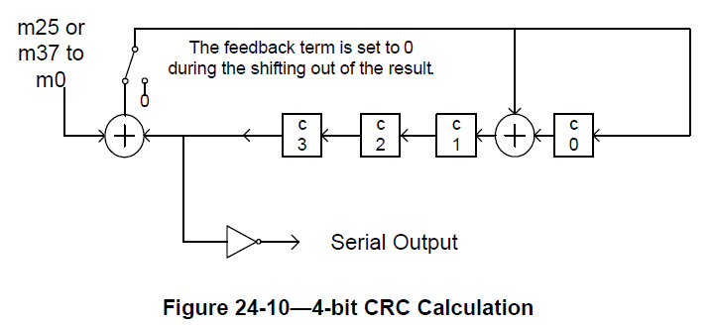

D4

D3

D2

D1

D0

Figure 24-10 above is consistent with the generating polynomial:



Accordingly, the CRC should be written as C3D3 + C2D2 + C1D1 + C0D0.

|  |  |  |  |  |  |  |
| --- | --- | --- | --- | --- | --- | --- |
| **CID** | **Commenter** | **P.L** | **Clause** | **Comment** | **Proposed Change** | **Resolution** |
| 8217  8218 | Naveen Kakani | 416.30, 464.44 | 24.3.4.4.3, 24.3.9.8 | BCC interleaver should be encoded as per legacy interleaver (section 18.3.5.7) or VHT interleaver (section 22.3.10.8)?  Section 24.3.4.4.3 and section 24.3.8.3.4 (points to clause 24.3.9 which defines BCC interleaver in section 24.3.9.8) should specify identical interleaver encoding. | Change “c)BCC interleaver: Interleave as described in 18.3.5.7 (Data interleaving).”  To  **“c)BCC interleaver: Interleave as described in 24.3.9.8 (BCC interleaver).** | Revised**.**  Instruction to Editor: please apply the proposed changes highlighted on Page 6 of doc. IEEE-802.11-15-1491r0 |

**Discussion:**

We realize that for Nss = 1, legacy interleaver is a special case of VHT interleaver with N_ROW = 3 and N_COL = 16 (described in 18.3.5.7 and 22.3.10.8). However, Table 24-20 specifies N_ROW and N_COL specifically for 1 MHz interleaver encoding which is not equal to the one specified for VHT, hence the section 24.3.4.4.3 Construction of 1 MHz SIG should reference this section (24.3.9.8) containing Table 24-20 instead of 18.3.5.7.

**24.3.4.4.3 Construction of 1 MHz SIG**

a) Obtain the STBC, NUM_STS, GI_TYPE, FEC_CODING, MCS, SMOOTHING, LENGTH, AGGREGATION, RESPONSE_INDICATION, NDP_INDICATION and DOPPLER from the TXVECTOR. Add the reserved bits, append the calculated 4 bit CRC, then append the *N*tail tail bits **as shown in 24.3.8.3.4 (SIG definition).** This operation gives as a result 36 uncoded bits.

c) BCC interleaver: Interleave as described in **~~18.3.5.7~~** ~~(Data interleaving)~~**24.3.9.8 (BCC interleaver)**.

**24.3.8.3.4 SIG definition**

The SIG field of S1G_1M is composed of six OFDM symbols, SIG-1 ~ SIG-6, each containing 6 data bits, as shown in Table 24-18 (Fields in the SIG field of S1G_1M PPDU). SIG-1 is transmitted first and SIG-6 is the last. The SIG field symbols shall be BCC encoded at rate, R = 1/2, and repeated two times for the encoded bits within each OFDM symbol, interleaved, mapped to a BPSK constellation, and have pilots inserted, following the steps for MCS10 transmission flow described in **Clause 24.3.9 (Data field).**

**24.3.9 Data field**

**24.3.9.8 BCC Interleaver**

The BCC interleaver for S1G 2 MHz, 4 MHz, 8 MHz and 16 MHz PPDUs are the same as those defined for 20 MHz, 40 MHz, 80 MHz, and 160 MHz PPDUs respectively as specified in **22.3.10.8** (BCC interleaver).

**For S1G_1M PPDU, the interleaver parameters are defined by Table 24-20 (Number of rows and columns in the interleaver for 1 MHz).**

