IEEE P802.11
Wireless LANs
IEEE 802.11 TGax, MU Ad hoc
November 2015 Dallas TGax MU Ad hoc Meeting Minutes
Date: 2015-11-10
Author(s):
Name | Affiliation | Address | Phone | email
Kiseon  Ryu | LG |  |  | kiseon.ryu@lge.com
Sigurd Schelstraete | Quantenna Communications |  |  | sigurd@quantenna.com
Kaushik Josiam | Samsung |  |  | k.josiam@samsung.com
Abstract
The meeting minutes from the MU Ad Hoc group meeting of TGax in the IEEE 802.11 Dallas session, November 9th – 12th, 2015.
IEEE 802.11 Task Group ax, MU Ad hoc
November 2015 Bangkok Meeting
November 9th – 12th, 2015

MU Adhoc Session #1
Tuesday, November 10th, 2015, PM1 TGax Session (1:30 – 3:30PM)

- The meeting called to order by Kaushik Josiam (Samsung), the co-chair of the TGax MU Ad hoc
  - At 2:25 pm, 116 people are present.

- Announcement
  - Agenda Doc.11-15/xxx on the server. Rev. 0 is the working document.
  - Meeting Protocol: The Chair asked to state name and affiliation when speaking for the first time.
  - Attendance reminder.
    - The attendance server: https://imat.ieee.org/

- The chair reviewed the mandatory 5 slides of P&P.
  - Instructions from the WG Chair. [reviewed, did not review]
  - Participants, Patents, and Duty to Inform. [reviewed, did not review]
  - Patent Related Links. [reviewed, did not review]
  - Call for potentially essential patents.
    - Chair asked if anyone is aware of potentially essential patents
[Asked. Did not ask]
    - Potentially essential patents
[None reported. Reported as follows]
  - Other Guidelines for IEEE WG Meetings.

- The Chair identified 12 presentations assigned by the TGax chair to be treated in MU Ad hoc
  - No new presentations, other than those listed in the agenda, were requested.

- The Chair asked for approval of the agenda
  - No objection raised

- Presentation of contributions
  - 1280 Traffic priority for random Multi User Uplink OFDMA
    - Strawpoll #1 (pre-motion): The spec shall define a procedure for the data selection upon random trigger frame reception, respectful of AC priorities:
Y/N/A: 5/2/many
SP fails

    - Strawpoll #2 (pre-motion):
The spec shall define a Collision Risk Factor (CRF) reflecting the probability of transmission error to be taken into account in the CWO computation according to the formula: CWO = CWOmin x 2^{CRF}
The CRF can be provided by the AP (optional Randomization Parameter [4]) or computed locally by each STA based on its previous MU UL transmission status.
Randomization Parameter received from AP is priority compared to locally computed CRF value.

Y/N/A: 5/7/many
SP fails

    - Strawpoll #3 (pre-motion):
A STA shall compute the CWOmin and CWOmax values upon TF-R reception. The CWOmin value shall be adapted according to the number of RU (NbRu) defined by the received TF-R, and the CWOmax shall be adapted (AC_Priority_Factor[] is TBD) according to the current highest priority (CurrentAC) of the data contained in AC queues.
The resulting formulas for the CWOmin and CWOmax shall be:
CWOmin=NbRu
CWOmax=fct (AC_Priority_Factor[Current AC] )

Y/N/A: 2/5/many
SP fails

    - Strawpoll #4 (pre-motion):
The STA shall compute the OBO from CWO + an offset based on data AC according to the formula :
OBO=rand[0,CWO]+AC_Offset[Current_AC](TBD)

Y/N/A: 3/5/many
SP fails

  - 1301 NAV Rule for UL MU Response
    - Strawpoll #1 (pre-motion): Do you agree to add the following underlining part to the TGax SFD:
4.3 UL MU operation
A STA that is polled from a Trigger frame for UL MU transmission considers the NAV in determining whether to respond unless one of the following conditions is met
- The NAV was set by a frame originating from the AP sending the trigger frame
- The response contains ACK/BA and the duration of the UL MU transmission is below a TBD threshold
- The NAV was set by a frame originating from intra-BSS STAs
- Other condition TBD

Y/N/A: 35/0/28
SP passes

  - 1328 Scheduling information for UL OFDMA Acknowledgement
    - Strawpoll #1 (pre-motion):
Scheduling information for UL OFDMA Acknowledgement from STA may be contained within the “HE variant of the HT Control Field”

Y/N/A: 19/0/26
SP passes

    - Strawpoll #2 (pre-motion):
HE variant of HT control field that contains scheduling information for UL MU Acknowledgement from STAs shall also include
  - number of LTF symbols, N_{LTF},
  - and PHY padding and packet extension signaling, PE
for UL MU transmission. The signaling format of the scheduling information for UL MU Acknowledgement is defined as

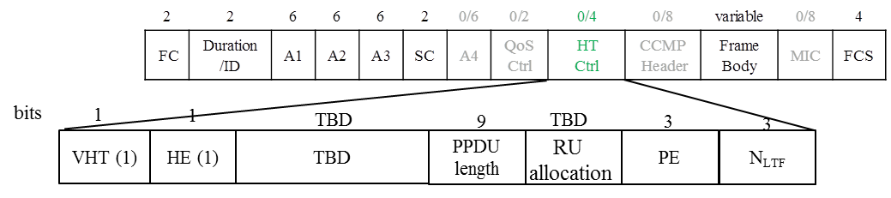

Y/N/A: 9/23/25
SP fails

  - 1314 I/Q Imbalance Impact to TGax OFDMA Uplink Reception
SPs deferred to TGax session

- The Chair announced the end of the MU ad hoc session at 3:30 pm.

MU Adhoc Session #2

