IEEE P802.11
Wireless LANs
Clarification to IPI densities text
Date: 2015-11-10
Author(s):
Name | Company | Address | Phone | email
Mark Hamilton | Ruckus Wireless | 350 W. Java Dr  Sunnyvale, CA | +1.303.818.8472 | mark.hamilton@ruckuswireless.com
Dick Roy | SRA |  | +1.650.861.3351 | dickroy@alum.mit.edu
Abstract
This submission contains proposed changes to clarify text on how IPI densities are measured and computed.

References herein are to REVmc Draft 4.3.

R0 – initial version

Discussion:

The context of this proposed change is, from 10.11.9.4 Noise Histogram report:
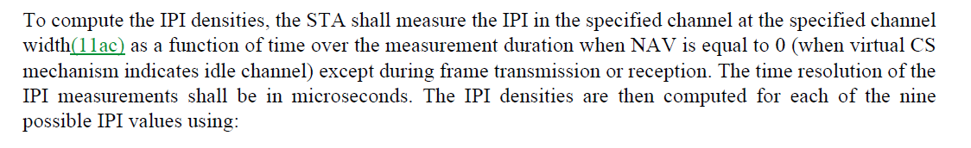

This text is confusing due to:
- Use of the structure “"... measure ... over ... when ... except" has too many dependent clauses to be clearly understood.
- Measurements are made "over" channel bandwidths, not "at" channel bandwidths
- "resolution" is not the same as "unit of measure", and what is meant is the latter
- The current text could be interpreted as a prescription to make a measurement yielding some value, then do some computation. A simple bank of power comparators and counters could be used to implement an IPI density measurement without having to actually "measure IPI".
- Lack of any reference back to Table 8-108 means this text is too far from that Table, which is critical to understanding the density ‘buckets’ concept intended.

Proposed change:

Replace the two sentences:

“To compute the IPI densities, the STA shall measure the IPI in the specified channel at the specified channel width(11ac) as a function of time over the measurement duration when NAV is equal to 0 (when virtual CS mechanism indicates idle channel) except during frame transmission or reception. The time resolution of the IPI measurements shall be in microseconds.”

with

“To compute the IPI densities, a STA shall measure the amount of time, in microseconds, during which the IPI is in each IPI range specified in Table 8-108. These IPI measurements shall be taken over the entire associated channel bandwidth, and during the entire measurement duration except for those time intervals during which the NAV is not equal to 0 (when virtual CS mechanism indicates channel busy), or during which frame transmission or reception is occurring.”

