IEEE P802.11
Wireless LANs
IEEE 802.11 TGax
November 2015 Dallas Meeting Minutes
Date: 2015-11-27
Author(s):
Name | Affiliation | Address | Phone | email
Yasuhiko Inoue | NTT | 1-1 Hikari-no-oka, Yokosuka, Kanagawa 239-0847 Japan | +81 46 859 5097 | inoue.yasuhiko@lab.ntt.co.jp
Abstract
Minutes of the TGax full meetings from the IEEE 802.11 Dallas session, November 9th – 13th, 2015.

Minutes from the TGax ad hoc sessions are contained in the following documents.

- PHY ad hoc:
  - https://mentor.ieee.org/802.11/dcn/15/11-15-1442-00-00ax-nov-2015-phy-ad-hoc-meeting-minutes.docx
- MAC ad hoc:
  - https://mentor.ieee.org/802.11/dcn/15/11-15-1414-00-00ax-nov-2015-mac-ad-hoc-meeting-minutes.docx
- Multiuser ad hoc:
  - https://mentor.ieee.org/802.11/dcn/15/11-15-1423-01-00ax-tgax-mu-ad-hoc-meeting-minutes-november-2015.docx
- Spatial Reuse ad hoc:
  - https://mentor.ieee.org/802.11/dcn/15/11-15-1421-01-00ax-nov-2015-spatial-reuse-ad-hoc-meeting-minutes.docx
IEEE 802.11 Task Group ax
November 2015 Dallas Meeting
Hyatt Regency Dallas, Dallas, TX
November 9th – 13th, 2015

--- TGax Officers ---
Chair Osama: Aboul-Magd (Huawei Technologies)
Vice Chair: Simone Merlin (Qualcomm)
Vice Chair: Ron Porat (Broadcom)
Secretary: Yasuhiko Inoue (NTT)
Technical Editor: Robert Stacy (Intel)

Monday, November 9th, 2015, AM1 TGax Ad Hoc Session (8:00-10:00)

- The meeting called to order by Osama Aboul-Magd (Huawei Technologies), the chair of the TGax, @8:02

- Announcement
  - This is an ad hoc session of TGax. No decision can be made.
  - Agenda Doc.11-15/1232r0 on the server.
  - Meeting Protocol: Please announce your affiliation when you first address the group during a meeting slot.
  - Attendance reminder.
    - The attendance server: https://imat.ieee.org/

- The chair reviewed the mandatory 5 slides of P&P.
  - Instructions for the WG Chair.
  - Participants, Patents, and Duty to Inform.
  - Patent Related Links.
  - Call for potentially essential patents.
    - Chair asked if anyone is aware of potentially essential patents.
    - No potentially essential patents reported.
  - Other Guidelines for IEEE WG Meetings.

- Agenda items for this ad hoc session
  - Call meeting to order
  - Patent policy, etc.
  - Ad Hoc meeting (No motions)
  - Call for submissions
  - Set and approve agenda for the ad hoc meeting
  - Presentations
    - 11-15/1100 – affecting Simulation Scenario document.
    - 11-15/1176 – affecting Evaluation Methodology document
    - Presentations assigned to the TG (Those related to Simulations)
    - Other presentations

- Call for submissions – slides 15 to 19 of 15/1232r1 contains current submission lists 69 submissions in total.
  - Submissions (PHY) – 27 submissions
    - 11-15-1059, “SIG-B Encoding Structure Part II,” Ron Porat (Broadcom)
    - 11-15-1289, “Non-Uniform Constellations for 1024-QAM,” Thomas Handte (Sony)
    - 11-15-1303, “LTF Sequence Designs,” Sungho Moon (Newracom)
    - 11-15-1304, “Supported Resource Allocations in SIG-B,” Sungho Moon (Newracom)
    - 11-15-1305, “STBC and Padding Discussions” Hongyuan Zhang (Marvell)
    - 11-15-1309, “Extended Range Support for 11ax,” Sameer Vermani (Qualcomm)
    - 11-15-1310, “11ax LDPC Tone Mapper for 160MHz,” Bin Tian (Qualcomm)
    - 11-15-1311, “11ax Spectral Mask,” Bin Tian (Qualcomm)
    - 11-15-1315, “HE-SIG-B Mapping and Compression,” Kaushik Josiam (Samsung)
    - 11-15-1320, “Maximum Tone Grouping Size for 802.11ax Feedback,” Kome Oteri (InterDigital)
    - 11-15-1321, “Reducing Explicit MIMO Compressed Beamforming Feedback Overhead for 802.11a,” Kome Oteri (InterDigital)
    - 11-15-1322, “Channel Estimation Enhancement and Transmission Efficiency Improvement Using Beam-Change Indication and 1x HE-LTF,” Jianhan Liu (MediaTek)
    - 11-15-1323, “HE-STF Sequence,” Ensung Park (LG Electronics)
    - 11-15-1324, “MCS for HE-SIG-B,” Dongguk Lim (LG Electronics)
    - 11-15-1327, “Diversity Mode in OFDMA,” Yujin Noh (Newracom)
    - 11-15-1329, “Link Adaptation for HE WLAN,” Yujin Noh (Newracom)
    - 11-15-1331, “PHY Padding Capability Signaling,” Daewon Lee (Newracom)
    - 11-15-1332, “Implicit Sounding for HE WLAN,” Daewon Lee (Newracom)
    - 11-15-1334, “HE-LTF Sequence Design,” Le Liu (Huawei)
    - 11-15-1335, “HE-SIG-B Contents,” Le Liu (Huawei)
    - 11-15-1347, “Strategies to reduce MIMO feedback overhead,” Filippo Tosato (Toshiba)
    - 11-15-1349, “Sounding for Uplink Transmission,” Sungho Moon (Newracom)
    - 11-15-1350, “Spatial Configuration And Signaling for MU-MIMO,” Yakun Sun (Marvell)
    - 11-15-1353, “Preamble Formats,” Ron Porat (Broadcom)
    - 11-15-1354, “SIGA fields and Bitwidths,” Ron Porat (Broadcom)
    - 11-15-1357, “Extra tones in the preamble,” Xiaogang Chen (Intel)
    - 11-15-1372, “L-LENGTH Equation Updates,” Hongyuan Zhang (Marvell)

  - Submissions (MAC) – 14 submissions
    - 11-15-1265, “RTSCTS for UL DL OFDMA Control,” Cheeha Kim (POSTECH)
    - 11-15-1278, “HE MU Acknowledgment Procedure,” Yongho Seok (Newracom)
    - 11-15-1300, “DL MU transmission sequence,” Yong Hoon Kwon (Newracom)
    - 11-15-1318, “Fragmentation for MU frames-Follow up,” Alfred Asterjadhi (Qualcomm)
    - 11-15-1319, “Scheduled Trigger frames-Follow up,” Alfred Asterjadhi (Qualcomm)
    - 11-15-1330, “A method of transmitting Multi-STA Block frame,” Jeongki Kim (LG Electronics)
    - 11-15-1341, “Reception Status of Frames Transmitted in Random Access RUs,” Tomoko Adachi (Toshiba)
    - 11-15-1344, “Trigger Frame Format,” Simone Merlin (Qualcomm)
    - 11-15-1345, “Trigger type specific information,” Kiseon Ryu (LG Electronics)
    - 11-15-1346, “Ack Policy for UL MU Ack transmission,” Kiseon Ryu (LG Electronics)
    - 11-15-1351, “Rate MCS Selection Rules for M-BA and DL OFDMA BA,” Liwen Chu (Marvell)
    - 11-15-1352, “broadcast STAID in HE SIG B,” Liwen Chu (Marvell)
    - 11-15-1355, “Considerations for TDLS transmission in 11ax,” Yingpei Lin (Huawei)
    - 11-15-1359, “System Performance Evaluation of 802.11ae,” Yu Wang (Ericsson)

  - Submissions (MU) – 12 submissions
    - 11-15-1280, “Traffic priority for random Multi User Uplink OFDMA,” Stephane Baron (Canon)
    - 11-15-1301, “NAV Rule for UL MU Response,” Yingpei Lin (Huawei)
    - 11-15-1312, “MU BAR Frame Format,” Reza Hedayat (Newracom)
    - 11-15-1314, “I/Q Imbalance Impact to TGax OFDMA Uplink Reception,” Rui Yang (InterDigital)
    - 11-15-1325, “MU-RTS/CTS Follow Up,” Po-Kai Huang (Intel)
    - 11-15-1326, “NAV Consideration for UL MU Response Follow Up,” Po-Kai Huang (Intel)
    - 11-15-1328, “Scheduling information for UL OFDMA Acknowledgement,”Yujin Noh (Newracom)
    - 11-15-1340, “NDP Announcement for HE Sequence,” Narendar Madhavan (Toshiba)
    - 11-15-1364, “Signaling Trigger Information for STAs in 11ax,” Chittabrata Ghosh (Intel)
    - 11-15-1369, “Random access based buffer status report,” Woojin Ahn (Yunsei Univ.)
    - 11-15-1370, “UL OFDMA Random Access Control,” Jinsoo Ahn (Yonsei Univ.)
    - 11-15-1374, “Consideration for protecting cascading MU DL/UL transmission with MU RTS/CTS,” Jing Ma (NICT)

  - Submissions (SR) – 8 submissions
    - 11-15-1259, “Use of TG ax Scenarios for Spatial Reuse,” Graham Smith (SR Tecnologies)
    - 11-15-1284, “Simulation results for spatial reuse in 11ax,” Jinmin Kim (LG Electronics)
    - 11-15-1313, “Considerations for Spatial Reuse,” Reza Hedayat (Newracom)
    - 11-15-1316, “DSC calibration results with NS-3,” M. Shahwaiz Afaqui (T.U. Catalonia)
    - 11-15-1336, “BSS Color Field Size Measurements,” Chuck Lukaszewski (Aruba-HP)
    - 11-15-1337, “Secondary Channel CCA of HE STA,” John Son (Willus Institute)
    - 11-15-1338, “Improving Spatial Reuse During OBSS UL MU Procedure,” Geonjung Ko (Willus Institute)
    - 11-15-1348, “Multiple NAVs for Spatial Reuse,” Sigurd Schelstraete (Quantenna)
    - 11-15-1427, “Drivers of the dynamic CCA adaptation,” Eduard Garcia-Villegas (UPC)

  - Submissions (TG) – 8 (+2) submissions
    - (Huawei)
    - 11-15-1288, “An issue of wider bandwidth operation at real denser environment,” Katsuo Yunoki (KDDI R&D Labs)
    - 11-15-1302, “System Level Simulator Evaluation with/without Capture Effect,” Vida Ferdowsi (Newracom)
    - 11-15-1360, “Implications of wrap-around for TGax Scenario 3 and Scenario 4 – follow-up,” Marcin Filo (Univ. of Surrey)
    - 11-15-1361, “Energy consumption with Scheduled PSP,” Dmitry Akhmetov (Intel)
    - 11-15-1362, “On TGax Scenario 4 channel model – follow-up,” Marcin Filo (Univ. of Surrey)
    - 11-15-1363, “Regulatory Landscape for Narrowband Transmissions in 11ax,” Ilan Sutskover (Intel)
    - 11-15-1373, “Updated Box5 Calibration Results,” Narendar Madhavan (Toshiba)
    - 11-15-1375, “11ax Support for IoT - Requirements and Technological Implications,” Shimo Shilo (Huawei Technologies)
(Late Submissions - not presented)
    - 11-15-1386, “Hybrid Multiple Access in 802.11ax,” Yanyan Guo (BUPT)
    - 11-15-1389, “TA Address Field in Trigger Frame,” Kaiying Lv (ZTE)

- Agenda items for the week
  - Approve TG and Teleconferences minutes since September 2015 meeting.
  - Continue to advance task group documents.
    - Simulation Scenarios and Evaluation Methodology
    - Channel Model
    - Function Requirements
    - Specification Framework
  - Ad Hoc group meetings
  - Technical Presentations and related straw polls and/or motions
  - Schedule Teleconference times.

- General Flow of the meeting
  - Slides 13 and 14 of the 15/0735r1 contain general flow of the meeting.

 | Monday | Tuesday |  |  | Wednesday |  | Thursday
AM1 | TGax  (ad hoc) |  |  |  | TGax |  | TGax
AM2 |  | TGax  (PHY) |  | TGax  (MAC)
PM1 | TGax | TGax  (MU) |  | TGax  (SR) | TGax  (PHY) | TGax  (SR) | TGax
PM2 |  |  |  |  | TGax  (PHY) | TGax  (MU)
PM3 |  | TGax  (PHY) | TGax  (MAC)

- Presentations
  - Chittabrata Ghosh (Intel) presented “Discussion on Deep and Shallow Sleep States,” based on the submission 11-15-1100-02.
    - Summary
      - The Simulations Scenario document [1] described the common power model parameters in Deep Sleep, Shallow Sleep, Listen, Receive, and Transmit states.
      - This submission proposes:
        - specific values for current consumption in Deep Sleep state, and
        - to modify the current definition of Deep Sleep and Shallow Sleep states
    - Discussions – No discussion.
      - Chitto highlighted the changes.

    - Straw Polls
      - Straw Poll #1: Do you agree to define the current consumption value in Deep Sleep state in the Simulation Scenarios document as proposed in Slide 5?
        - Discussion – no discussion.
        - Result: No objection.

      - Straw Poll #2: Do you agree to include the modified definition for Shallow and Deep Sleep state in the Simulation Scenarios document as discussed in Slide 6?
        - Discussion:
          - SSD editor asked how to modify the SSD.
        - Result: No objection.

      - Straw Poll #3: Do you agree to modify the transition time from Deep Sleep to Listen state in the Simulation Scenarios document as proposed in Slide 8?
        - Discussion:
        - Result: No objection.

  - Kome Oteri (InterDigital) presented “Link level Simulation Assumption Updates to Evaluation Methodology,” based on the submission 11-15-1176-00.
    - Summary
      - Proposed updates to the evaluation methodology document that clarify link level simulation assumptions for TGax.
      - The assumptions are updated from the TGac functional requirements and evaluation methodology document.
    - Discussions – No discussion.

    - Straw Poll: Do you agree to modify the Evaluation Methodology document IEEE 802.11-15/571r9 as provided in IEEE 802.11-15/01176r0?
      - Result: No objection.

  - Katsuo Yunoki (KDDI R&D Labs.) presented “An issue of wider bandwidth operation
at real denser environment,” based on the submission 11-15-1288-00.
    - Summary
      - Real experiences on our public WLAN service at denser environment presented.
      - Importance of bandwidth adjustment at such environment is explained from a standpoint of public WLAN operator.
      - Proposal: an AP shall have a mechanism to explicitly adjust its operating bandwidth during the operation based on interference situation at denser environment.
    - Discussion
      - Q: For the channel selection, what kind of information will be needed? Not sure.
      - C: Discussed about this during the 802.11aa. Two separate 20 MHz channels will be better than a shared 40 MHz channel.
      - C: There are many channel selection algorithm developed by vendors. What else do we have to define?

    - Straw Poll: Do you agree to add the following text into 11ax SFD?
An AP shall have a mechanism to explicitly adjust its operating bandwidth during the operation based on interference situation at denser environment.

Note: Existing specifications in the current 802.11 standards may be used for control of associated STAs. Determination for operating bandwidth adjustment will be on an implementation.
      - Discussion:
        - We already have this mechanism. What do you want to see in the spec? Would like to make it mandatory.
        - What exactly is the mechanism that shall be mandated?
      - Result: Y/N/A = 13/4/many
        - The straw poll gains more than 75% of support. However, it is up to the presenter to conduct a motion.

  - Narendar Madhavan (Toshiba) presented “Updated Box 5 Calibration Results,” based on the submission 11-15-1373-01.
    - Summary
      - Presented the updated results:
        - 2 BSS and 3 BSS results with defined traffic flow;
        - Comparison plots with some discussion;
      - It is hard to clarify whether the throughput ratio among BSSs is correct or not.
        - More analysis and offline discussions are required by companies to complete Box 5 calibration.
    - Discussion
      - We have been discussing about calibrating the simulation results for long time. Any ideas for further discussions?

  - Dmitry Akhmetov (Intel) presented “Energy Consumption with Scheduled PSP,” based on the submission 11-15-1361-00.
    - Summary
      - Simulation results on energy consumption for Scheduled PSP in comparison with regular PSP presented
      - Performance benefit of Scheduled PSP by reducing 50-60% time in Listen mode and around 15% in Receive mode.
      - Designated/centralized wake up time allow to save more energy.
    - Discussion
      - C: The idea of scheduled power save is good. But there are many unknown conditions.
      - C: Why not the AP to schedule PS-Poll?

- TGax ad hoc meeting adjourned @ 9:58 AM.

Monday, November 9th, 2015, PM1 TGax Session (13:30-15:30)
- The meeting called to order by Osama Aboul-Magd (Huawei Technologies), the chair of the TGax, @13:30

- Announcement
  - Agenda Doc.11-15/1232r1 on the server. Rev. 2 is the working document.
  - Meeting Protocol: Please announce your affiliation when you first address the group during a meeting slot.
  - Attendance reminder.
    - The attendance server: https://imat.ieee.org/

- Agenda for Monday, July 13th, PM1 (13:30 – 15:30).
  - Proposed agenda for this session
    - Call meeting to order
    - Patent policy, etc.
    - Call for submissions – done
    - Set Ad Hoc Groups schedule and approve agenda
    - Summary from May 2015 meeting
    - SFD review - Editor
    - TG motions
      - Approve TG meeting and Telecon minutes since May meeting.
      - Approve the latest SFD revision
    - Timeline
    - Ad Hoc group Rules
    - Presentations
    - Recess
  - Chair asked if there is any objection to approve this agenda No objection.
    - The agenda was approved.

- The chair reviewed the mandatory 5 slides of P&P.
  - Instructions for the WG Chair.
  - Participants, Patents, and Duty to Inform.
  - Patent Related Links.
  - Call for potentially essential patents.
    - Chair asked if anyone is aware of potentially essential patents.
    - No potentially essential patents reported.
  - Other Guidelines for IEEE WG Meetings.

- Scheduling for the Ad Hoc Group meetings
  - Result from the discussion in AM1;.

 | Monday | Tuesday |  | Wednesday |  | Thursday
AM1 | TGax  (ad hoc) |  |  | TGax |  | TGax
AM2 |  | TGax  (PHY) | TGax  (MAC)
PM1 | TGax | TGax  (SR) | TGax  (MU) | TGax  (PHY) | TGax  (SR) | TGax
PM2 |  |  |  | TGax  (PHY) | TGax  (MU)
PM3 |  | TGax  (PHY) | TGax  (MAC)

  - Chair asked if there is any objection for this schedule TGax Schedule approved.

- Summary from September 2015 Meeting
  - Passed a number of motions affecting the TG Specification Framework. Motions passed related to PHY, MAC, SR, and MU.
  - Latest revision (not yet approved) of the Specification Framework is available at;
    - https://mentor.ieee.org/802.11/dcn/15/11-15-0132-09-00ax-spec-framework.docx
  - Discussed changes to the Simulation Scenarios and Evaluation Methodology documents.
  - No time to motion the changes.
  - Latest revisions available on mentor:
    - https://mentor.ieee.org/802.11/dcn/14/11-14-0571-10-00ax-evaluation-methodology.docx
    - https://mentor.ieee.org/802.11/dcn/14/11-14-0980-14-00ax-simulation-scenarios.docx
  - Other TG documents
    - https://mentor.ieee.org/802.11/dcn/14/11-14-0882-04-00ax-tgax-channel-model-document.docx
    - https://mentor.ieee.org/802.11/dcn/14/11-14-1009-02-00ax-proposed-802-11ax-functional-requirements.doc

- SFD Review
  - Chair showed the latest version of the Specification Framework document.
    - There was no further discussion since the editor is not available.

- Approval of TG Minutes (September 2015 Meeting and Teleconference Minutes)

  - Motion: Approve TGax minutes of meetings and teleconferences from September 2015 interim meeting to today:
    - https://mentor.ieee.org/802.11/dcn/15/11-15-1093-00-00ax-tgax-september-2015-bangkok-meeting-minutes.docx
    - https://mentor.ieee.org/802.11/dcn/15/11-15-1206-00-00ax-sept-2015-spatial-reuse-ad-hoc-meeting-minutes.docx
    - https://mentor.ieee.org/802.11/dcn/15/11-15-1205-00-00ax-sept-2015-phy-ad-hoc-meeting-minutes.docx
    - https://mentor.ieee.org/802.11/dcn/15/11-15-1130-02-00ax-sept-2015-mac-ad-hoc-meeting-minutes.docx
    - https://mentor.ieee.org/802.11/dcn/15/11-15-1160-00-00ax-tgax-mu-ad-hoc-meeting-minutes-september-2015.docx

  - Move: Brian Hart, Second: Guido R. Hiertz
  - Result: Minutes approved with no objection.

  - Motion: Move to accept document 11-15/0132r9 as the current revision of the TG Specification Framework document.

    - Moved by Yasu Inoue, Second by Po-kai Huang
    - Discussion: No discussion.
    - Result: Motion accepted with no objection.

- Timeline discussion

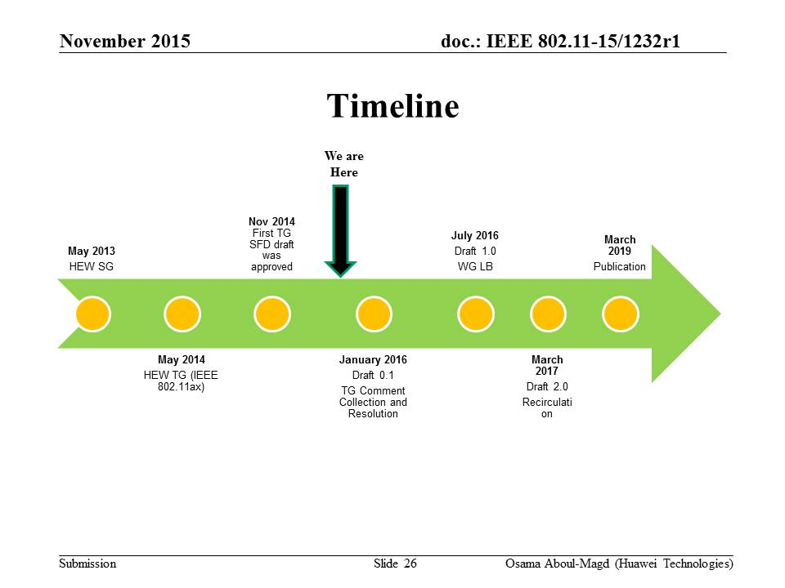

  - Discussion
    - A member suggested review of TG timeline every after meeting.

- Review Ad Hoc Group Rules
  - A straw poll needs to achieve at least 75% at the ad-hoc level to be converted to a motion at the TG level.
  - In the case a consensus cannot be reached within an Ad Hoc group (a stalemate that prohibits further progress), the subject is moved to the Task group, if an Ad Hoc straw poll vote to move the subject to the Task Group achieves > 50% approval.
  - A straw poll affecting the Spec Framework has to start with,
    - Do you agree to add to the TG Specification Frame work document?
      - x.y.z. <feature description>
  - For further details, please see 11-15-0075r0
  - Minutes of the Ad Hoc group meetings will be available on mentor.

- Presentations
  - Vida (Newracom) presented “System Level Simulator Evaluation with/without Capture Effect,” based on the submission 11-15-1302-02.
    - Summary

      - System Level Simulator Evaluation with/without Capture Effect.
      - Results from capture effect and non-capture effect shall be compared
    - Discussion

      - Q: A member asked for the value of capture window size? Calibration document already contains consideration for the capture effect.

  - Marcin Filo (Univ. of Surrey) presented “Implications of wrap-around for TGax Scenario 3 and Scenario 4 – follow-up,” based on the submission 11-15-1360-00.
    - Summary

      - Wrap-around is necessary for proper evaluation of SCE#3 and SCE#4 (assuming we simulate just a small fraction of the actual deployment instead of the whole network)
      - The accuracy of wrap-around technique depends to the size (i.e. number of rings) of the BSS layout
      - Number of rings is scenario specific and may change depending on simulation settings (e.g. 11ax only deployment vs mixed deployment)
      - Number of rings for SCE#3 and SCE#4 BSS layouts need to be sufficient to provide reliable results (if used with wrap-around)
      - AP/STA power settings for SCE#3 may need to be reconsidered to reduce simulation complexity (if used with wrap-around)
      - SCE#4 LOS probability function may need to be updated to reduce simulation complexity (if used with wrap-around)
    - Discussion

    - Straw Poll: Should the table on Slide 13 be added to 11-14-980-14-00ax (Section 3 and Section 4)?
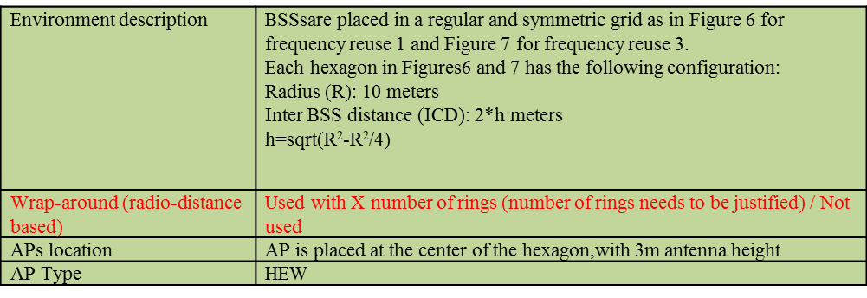

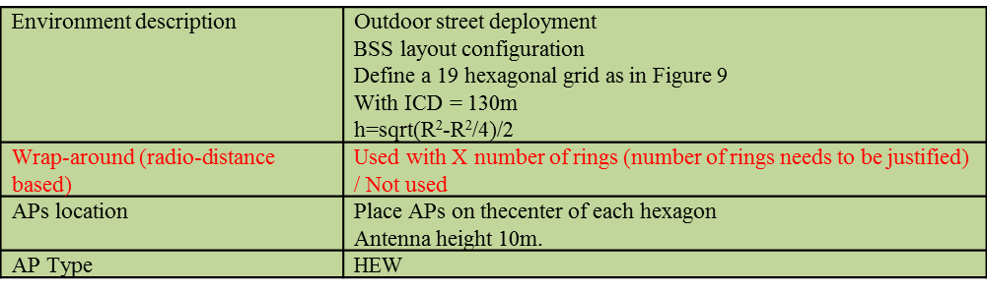
      - Discussion
      - Result: Y/N/A = 5/1/many, straw poll gains > 75% approval.

  - Marcin Filo (Univ. of Surrey) presented “On TGax Scenario 4 channel model – follow-up,” based on the submission 11-15-1362-00.
    - Summary

      - Two issues with existing SCE#4 channel model were highlighted and recommendations were provided.
      - Proposed to improve existing SCE#4 channel model was presented and appropriate recommendations were provided

    - Straw Polls

      - Straw Poll #1: Should the minimum 2D distance requirement of 10m for STA-AP links be removed from the description of SCE#4 in 11-14-980-14-00ax (Section 4), as proposed below?

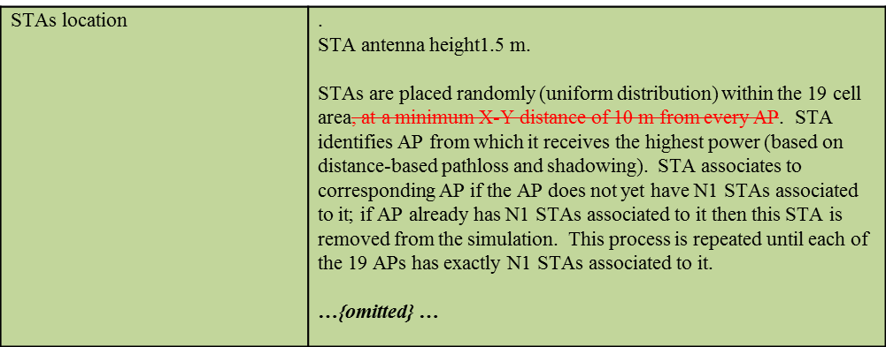

        - Discussion
          - What was the motivation to put the requirement of min. 10m for the distance between AP and STA? Path loss model may not appropriate for such distance.
        - Result: Straw Poll accepted with no objection.

      - Straw Poll #2: Should the SCE#4 LOS path-loss formula in 11-14-980-14-00ax (Section 4) be modified, to remove the discontinuity issue, as shown below?

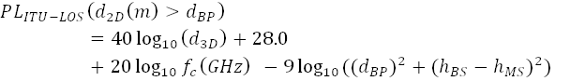

        - Discussion
          - How much difference can we expect?
          - Preferred to keep the original
        - Result: Y/N/A = 5/9/many

      - Straw Poll #3: Should the statement related to LOS occurrence correlation on Slide 18 be added to 11-14-980-14-00ax (Section 4)?
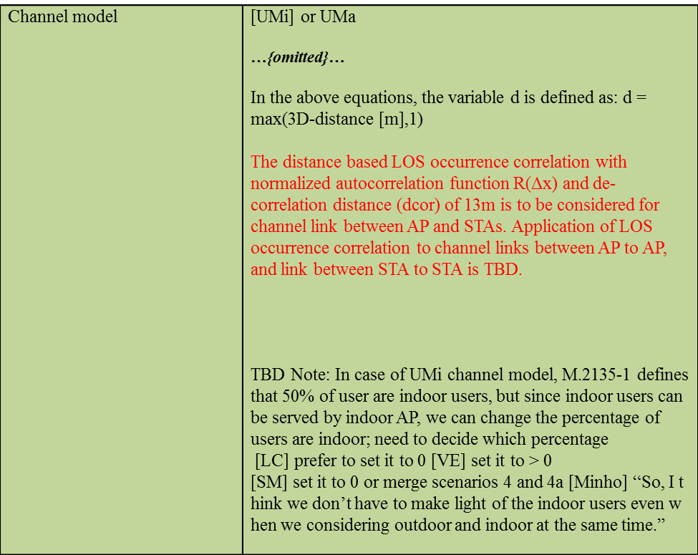

        - Discussion
          - Q: What will be the benefit of this? This helps to adjust the performance of CSMA/CA protocol which was over-estimated or under-estimated in the original condition.
          - C: We need more time to consider this correlation function.
        - Result: The straw poll deferred for further discussions.

  - Shimi Shilo (Huawei) presented “11ax Support for IoT – Requirements and Technological Implication,” based on the submission 11-15-1375-01.
    - Summary
      - Essential requirements for efficient support of IoT in 11ax and their technological implications suggested.
      - Discussed the respective technological implications.
      - Considered dividing the accommodation of IoT into several phases, such that the original 11ax timeline is relatively unchanged
    - Discussions
      - Concurrent operation of IoT and typical 11ax STAs assumed? Basically yes.
      - 2.4GHz and 5GHz frequency bands are assumed for this IoT use case. That’s current assumption of presenter. Low rate long range transmission could degrade

- Recess@15:23. Tuesday AM2 and PM1 will be the ad hoc sessions.
TGax full session will be Wednesday AM1.

Tuesday, November 10th, 2015, AM2 TGax Ad Hoc Sessions (10:30-12:30)
- TGax PHY ad hoc session@Landmark C
Agenda for the PHY ad hoc is contained in 11-15-1385.

- TGax MAC ad hoc session@Landmark B
Agenda for the MAC ad hoc is contained in 11-15-1382.

Tuesday, Novemebr 10th, 2015, PM1 TGax Ad Hoc Sessions (13:30-15:30)
- TGax Multiuser ad hoc session@Landmark C
Agenda for the MU ad hoc session is contained in 11-15-1418

- TGax Spatial Reuse ad hoc session @ Land,ark B
Agenda for the SR ad hoc session is contained in 11-15-1403

Tuesday, November 10th, 2015, PM3 TGax Ad Hoc Sessions (19:30-21:30)
- TGax PHY ad hoc session@Landmark C
Agenda for the PHY ad hoc is contained in 11-15-1385

- TGax MAC ad hoc session@Landmark B
Agenda for the MAC ad hoc is contained in 11-15-1382.

Wednesday, November 11th, 2015, AM1 TGax Session (08:00-10:00)
- The meeting called to order by Osama Aboul-Magd (Huawei Technologies) at 8:00 AM.

- Announcement/Reminder
  - Agenda Doc.11-15/1232r2 on the server. R3 is the working document.
  - Meeting Protocol: Please announce your affiliation when you first address the group during a meeting slot.
  - Reminder.
    - IEEE 802 and 802.11 P&P.
    - Attendance - URL of attendance server: https://imat.ieee.org/

- Agenda for this session
  - Proposed agenda for Wednesday AM1
    - Call Meeting to order
    - IEEE 802 and 802.11 IPR Policy and procedure.
    - Progress Review
    - Presentations
      - 11-15-1363, “Regulatory Landscape for Narrowband Transmissions in 11ax,” Ilan Sutskover (Intel)
      - 11-15-1320 Maximum Tone Grouping Size for 802.11ax Feedback
      - 11-15-1321 Reducing Explicit MIMO Compressed Beamforming Feedback Overhead for 802.11a
      - 11-15-1332 Implicit Sounding for HE WLAN
      - 11-15-1095, “OFDMA Performance,” (LG Electronics)
      - 11-15-1347 Strategies to reduce MIMO feedback overhead
      - 11-15-1349 Sounding for Uplink Transmission
    - Recess
  - Chair asked if there is any objection to proceed with this agenda No objection.
  - The agenda for Wednesday AM1 was approved.

- Progress Review
  - Ad Hocs
    - MAC Ad Hoc
      - All presentations but one completed.
    - PHY Ad Hoc
      - 11 presentations heard.
      - Still have 11 presentations.
    - SR Ad Hoc
      - 4 presentations finished. 4 still remaining. Will finish in the next ad hoc.
    - MU Ad Hoc
      - 4 presentations finished. 8 still remaining.
  - Additional slot
    - Chair will request one slot on Thursday (AM2?) if available.

- Presentations
  - Ilan Sutskover (Intel) presented, “Regulatory Landscape for Narrowband Transmissions in 11ax,” based on the submission 11-15-1363-00.
    - Summary
      - The narrow-band transmissions allowed by 802.11ax were shown to have currently the following issues:
        - Minimum BW requirement of 5MHz exists in ETSI at the 5GHz band
        - Some countries allow transmissions only within explicitly stated bandwidth (20/40/80/160)
      - Mask is measured by ETSI, defined relatively to OBW
      - Narrow band transmission lacks identification terminology for world-wide testing (incl. regulatory)
    - Discussions
      - C: A clarification is requested about the definition of Duty Cycle.
      - C: A member commented that is very good summary in the early stage of standardization and recommends members of TGax to talk to regulator based on this submission.

  - Kome Oteri (InterDigital) presented “Maximum Tone Grouping Size for 802.11ax Feedback,” based on the submission 11-15-1320-01.
    - Summary
      - The maximum tone grouping parameter {Ng} for 802.11ax investigated.
        - The maximum tone grouping parameter {Ng} to 16 results in a large savings in feedback overhead.
        - The minimal PER performance differences are seen with Ng = 16 compared with Ng = 4 for channel B/D scenario in SU-MIMO-OFDMA.
        - The minimal PER performance differences are seen with Ng = 8 compared with Ng = 4 for channel B/D scenario in SU-MIMO-OFDMA
      - Ng = 2, 4, 8, or 16 should be allowed.
    - Discussion
      - C: A member commented that we agreed to disallow Ng = 1, but others will be okay. He also discussed about feedback delay.
      - C: Tone allocation for Ng = 16 discussed.

    - Straw Poll: Do you agree with the following?
      - 802.11ax spec shall support Ng = 2, 4, 8 or 16 for sounding feedback.
        - NOTE—The tone grouping factor, Ng is defined with respect to data tones of the HE PPDU.

      - Discussion
        - Friendly amendment proposed to divide the straw poll into two SPs.

    - SP#1: Do you agree with the following?
      - 802.11ax spec shall support Ng = 2, 4, 8 for sounding feedback.
      - NOTE—The tone grouping factor, Ng is defined with respect to data tones of the HE PPDU.
      - Result: Y/N/A = 49/0/many

    - SP#2: Do you agree with the following?
      - 802.11ax spec shall support Ng = 16 for sounding feedback.
      - NOTE—The tone grouping factor, Ng is defined with respect to data tones of the HE PPDU.
      - Result: Y/N/A = 18/4/many

  - Kome Oteri (InterDigital) presented “Reducing Explicit MIMO Compressed Beamforming Feedback Overhead for 802.11ax,” based on the submission 11-15-1321-01.
    - Summary
      - Discussed to reduce the explicit MIMO compressed beamforming Feedback Overhead for 802.11ax
        - They include six schemes that are simple extensions of 802.11ac feedback schemes.
        - They include two new (to 802.11) MIMO compressed beamforming feedback schemes.
      - The performance of these methods should be studied and a combination of them adopted in 802.11ax

    - Discussion
      - C: The concept is okay. The slide talks about the size of CSI feedback. Need analysis on the impact to the total frame sequences.
      - Q (slide 12):the categorization is too much arbitrary. Not clear if we can vote on straw poll.
      - C: The specification frame work allows this as agreed in Bangkok meeting.

    - Straw Poll
      - Straw Poll #1: Do you agree to add the following to section 4.6 of the SFD?
        - The amendment may consider methods that extend the compressed beamforming feedback ideas in 802.11ac.

        - Result: Y/N/A = 34/11/many

      - Straw Poll #2: Do you agree to add the following to section 4.6 of the SFD?
        - The amendment may consider new ideas that are different from the compressed beamforming feedback ideas in 802.11ac

      - Result: Y/N/A = 16/24/many

  - HanGyu Chi (LG Electronics) presented “OFDMA performance in 11ax,” based on the submission 11-15-1095-03.
    - Summary
      - Evaluated OFDMA performance using PHY/MAC integrated simulator in previous meeting
      - Present updates considering the trigger based UL OFDMA.
    - Discussion
      - The impact on the legacy STAs discussed.
      - The performance of OFDMA in a dense OBSS environment discussed. Basically, it is the next step of this work.
      - The impact of interval of trigger frames on the various aspects of performances discussed.
      - Discussed traffic conditions.

  - Mouhammud Bocus (Toshiba) presented “Strategies to reduce MIMO feedback overhead,” based on the submission 11-15-1347-00
    - Summary
      - MIMO Feedback overhead can be reduced by adopting different compression strategies.
      - Showed how the representation of multiple eigenmodes can be modified to achieve a higher level of compression
      - Performance evaluation shows that the beamforming gain loss is minimal especially for MU-MIMO, whilst the overhead saving is substantial (typically between ~20% and 50%)

    - Discussion
      - Q: Some members discussed about optimization of quantization on slide 10 discussed.
      - C (slide 13): Discussed about the overhead reduction.
      - C (slide 13): A member pointed out that 4x3 feedback may not be applicable to MU-MIMO. For the MU-MIMO case, only 4x2 case will be beneficial.
      - Q (slide 21): Discussed impact on the performance since the proposed scheme does not distinguish the first and the second eigen-modes.

- AoB
  - We only have 5 minutes rest. Any items to discuss? – None.
  - Chair asked any objection to recess – No objection. The chair will send meeting room assignment for the ad hoc sessions.

- Recess @ 9:56 AM. PM1 and PM2 today is TGax ad hoc sessions. The next TGax full session is Thursday AM1.

Wednesday, November 11th, 2015, PM1 TGax Ad Hoc Session (13:30-15:30)
- PHY ad hoc @ Landmark C meeting room.
  - Agenda: 11-15-1385

- Spatial Reuse (SR) ad hoc @ Landmark B meeting room.
  - Agenda: 11-15-1403

Wednesday, November 11th, 2015, PM2 TGax Ad Hoc Session (16:00-18:00)
- PHY ad hoc @ Landmark C meeting room.
  - Agenda: 11-15-1385

- Multiuser (MU) ad hoc @ Landmark B meeting room.
  - Agenda: 11-15-1418

Thursday, November 12th, 2015, AM1 TGax Session (8:00-10:00)

- Meeting called to order by Osama Aboul-Magd (Huawei Technologies), chair of TGax, @ 8:03.
  - The agenda document 11-15/1232r3 is on the server.
    - Rev 5 is the working document.
      - Rev 4 is the working document..

- Administrative Items
  - Chair reminded the IEEE 802 and IEEE 802.11 Policy and Procedures.
  - Chair asked people to state name and affiliation when addressing for the first time.
  - Chair also reminded people to do attendance.

- Agenda setting
  - Proposed agenda for today
    - Call Meeting to order
    - IEEE 802 and 802.11 IPR Policy and procedure.
    - Presentations
      - 1MAC presentation
      - 2 MU presentations (11-15-1369, 11-15-1370)
      - Updated straw Poll – Katsuo Yunoki
    - Simulation Scenarios related submissions and motion
    - Evaluation Methodology related submissions and motion
    - TG Motions – hard start at 10:30 am
    - Timeline
    - Goals for January 2016
    - Teleconference Schedule
    - Adjourn
  - Chair asked if there is any objection to proceed with this agenda. No objection.
    - The agenda for Thursday was approved.

- Presentations
  - Guido R. Hiertz (Ericsson) presented “System Performance Evaluation of 802.11ae,” based on the submission 15/1359r0.
    - Summary:
      - Quality of Service (QMF) for Management frames provides a simple mechanism to prioritize management traffic through different Access Categories which works very well without any arrangements.
      - In dense deployments QMF helps substantially reducing traffic sent through highest priority Access Category.
    - Discussions
      - Q: A member asked which aspect of 802.11ax design will be affected by assuming 802.11ae as a baseline? The answer is nothing.
      - Q: Another member asked what will be appropriate position for the 802.11ax for the 802.11ae. Should it be mandatory or optional? Currently it is optional. But it is nice to have.

  - Woojin Ahn (Yonsei Univ.) presented “Random Access Based Buffer Status Report,” based on the submission 15/1369r0.
    - Summary:
      - BSR scheme in 11ax might cause unfairness problem in terms of opportunity for UL transmission.
      - Random Access BSR can be considered as an additional option for relieving mentioned problem.
    - Discussions
      - Q: A member asked for simulation or analytical results of how much unfairness was improved. No result right now..

    - Straw Poll: Do you agree to add to the TG Specification Frame work document?
      - 4.x.y AP may transmit Trigger Frame to elicit buffer status report using random access

      - Rssult: Y/N/A = 33/0/some, the straw poll will be converted to a motion.

  - Jinsoo Ahn (Yonsei Univ.) presented “UL OFDMA Random Access Control,” based on the submission 15/1370r0.
    - Summary:
      - Access Categories need to be considered in the OBO mechanism.
      - Trigger frame could advertise the index of contention level instead of specific contention parameter.
    - Discussions
      - A member asked that in which part of the random access control the access categories should be considered. Data transmission phase.
      - Another member asked about the backoff procedure depicted in the slide 6.

    - Straw Polls

      - Straw Poll #1: Do you agree to add to the TG Specification Frame work document?
        - 4.5. A STA transmitting data using UL OFDMA random access shall follow OBO QoS parameters (TBD) for its access category.
        - Result: Y/N/A = 8/4/many.

      - Straw Poll #2: Do you agree to add to the TG Specification Frame work document?
        - 4.5. The spec shall define a contention index field in the random access trigger frame to indicate contention level. Depending on the contention index value, TBD parameters (e.g., CWO_{min}, P_{Tx} , etc) are used for random access procedure.

        - Discussion:
          - C: We have not discussed about this within the context of trigger frame.
        - Result: Y/N/A = 5/7/many.

  - Katsuo Yunoki (KDDI R&D Labs) presented a straw poll based on the updated submission 15/1288r1.

    - Straw Poll: Do you agree to add the following text into 11ax SFD?
      - An HE AP shall narrow its operating bandwidth after detecting severe performance degradation due to existence of interferences on the secondary 20MHz, 40MHz or 80MHz channel during the operation.

      - Discussion:
        - Some members mentioned that this asks mandatory behaviour which is unusual for a standard and not sure if it is appropriate to put this into the specification framework document.
      - Result: Y/N/A = 2/5/many.

  - Rui Yang (InterDigital Communications) presented “I/Q Imbalance Impact to TGax OFDMA Uplink Reception,” based on the submission 15/1314r1.
    - Summary:
      - To mitigate the image interference due to I/Q impairments, accurate power control in uplink may be necessary.
      - To understand other potential impacts, it may be beneficial to include I/Q imbalance settings in evaluation methodology document.
    - Discussions

    - Straw Polls
      - Straw Poll #1: Do you agree to include the following I/Q imbalance information in the Evaluation Methodology document?
        - I/Q imbalance parameters at Tx:
          - Phase Imbalance($I_{p})$: TBD (Degree), Amplitude Imbalance($I_{a})$: TBD (dB)
        - I/Q imbalance parameters at Rx:
          - Phase Imbalance($I_{p})$: TBD (Degree), Amplitude Imbalance($I_{a})$: TBD (dB)

        - Discussion
          - A member it is not clear how we use it if we implement this into our evaluation methodology. This could make system level simulations more complicated.
        - Result: Y/N/A = 12/23/many

      - Straw Poll #2: Do you agree to use the following I/Q imbalance model in the Evaluation Methodology document?
$$y_{a}=y_{a,r}+jy_{a,i}= \left[{10}^{0.5\frac{I_{a}}{20}}*x_{r}\right]+j\left[{10}^{-0.5\frac{I_{a}}{20}}*x_{i}\right]$$

$$y_{a\&p}= e^{-j0.5π\frac{I_{p}}{180}}{*y_{a,r}}+e^{j\left(\frac{π}{2}+0.5π\frac{I_{p}}{180}\right)}{y_{a,i}}$$

where $x=x_{r}+jx_{i}$ is the input.

        - Based on the result of the previous straw poll, this straw poll was not voted on.

- Evaluation Methodology related submissions and motion
  - Ron Porat (Broadcom) presented the changes of the evaluation methodology document.

  - Motion (Evaluation Methodology Document)
    - Move to accept document 11-14/0571r11 as the current revision of the TG Evaluation Methodology document.
      - Moved by Ron Porat, Second: Kome Oteri
      - Discussion: No discussion.
      - Result: Motion accepted with no objection.

- Announcement
  - Meeting room for AM2 session is Landmark B (the next room).
  - Meeting room for PM1 session is here (Landmark C)

- AoB
  - Chair asked if there is any other business during this session None.

- Recess @ 9:30 until AM2 (10:30 AM) today.

Thursday, Novemebr 12th, 2015, AM2 TGax Session (10:30-12:30)
- Meeting called to order by Osama Aboul-Magd (Huawei Technologies), chair of TGax, @ 10:30.
  - The agenda document 11-15/1232r3 is on the server.
    - Rev 4 is the working document.

- Administrative Items
  - Chair reminded the IEEE 802 and IEEE 802.11 Policy and Procedures.
  - Chair asked people to state name and affiliation when addressing for the first time.
  - Chair also reminded people to do attendance.

- Discussion on the agenda
  - Proposed agenda for this session:
    - Call Meeting to order
    - IEEE 802 and 802.11 IPR Policy and procedure.
    - Presentations
      - 1 MAC presentation
      - 2 MU presentations
      - Updated straw Poll – Katsuo Yunoki
    - Simulation Scenarios related submissions and motion
    - Evaluation Methodology related submissions and motion
    - TG Motions – hard start at 10:30 am
    - Timeline
    - Goals for January 2016
    - Telecon Schedule
    - Adjourn

- TG Motions
  - PHY Motions

    - PHY Motion #66: Move to add the following to the spec framework
“L-STF power is boosted by 3 dB in the extended range preamble”

      - Moved by Sameer Vermani, Seconded by Simone Merlin
      - Discussion: No discussion
      - Result: Motion Accepted with no objection.

    - PHY Motion #67: Move to add the following to the spec framework
“L-LTF power is boosted by 3 dB in the extended range preamble”

      - Moved by Sameer Vermani, Seconded by Simone Merlin
      - Discussion: No discussion
      - Result: Motion Accepted with no objection.

    - PHY Motion #68: Move to add the following to the specification framework document
There are only three pre-HE-STF preamble formats defined as:
  - SU format (mandatory) / Trigger based UL
  - MU format (mandatory)
  - Extended range SU format

      - Moved by Sameer Vermani, Seconded by Simone Merlin
      - Discussion: No discussion
      - Result: Motion Accepted with no objection.

    - PHY Motion #69: Move to add to the specification framework document:
- support the signaling of the three preamble formats as shown on slide 15 of 11-15/1353r1?

      - Moved by Ron Porat, Seconded by Sameer Vermani
      - Discussion: No discussion
      - Result: Motion Accepted with no objection.

    - PHY Motion #70: Move to add to the specification framework document:
The following are the only mandatory combinations of LTF size and CP size
- 2x LTF+ 0.8uS
- 2x LTF+ 1.6uS
- 4x LTF+ 3.2uS
with HE-LTF and payload using the same CP size.
and that LTF size and CP size are jointly signaled using 3 bits.

      - Moved by Ron Porat, Seconded by Simone Merlin
      - Discussion: No discussion
      - Result: Motion Accepted with no objection.

    - PHY Motion #71: Move to add to the specification framework document:
SIGB only has one CP size equal to 0.8uS.

      - Moved by Ron Porat, Seconded by Simone Merlin
      - Discussion: No discussion
      - Result: Motion Accepted with no objection.

    - PHY Motion #72: Move to add to the specification framework document:
Allocate 4 extra subcarriers, two at each edge of each 20MHz sub-channel, for L-SIG, RL-SIG, HE-SIG-A and HE-SIG-B fields in 11ax PPDUs.
    - The 4 subcarriers added to the L-SIG and RL-SIG fields are transmitted with known TBD BPSK constellations (+-1).
    - The number of data subcarriers in HE-SIG-A and HE-SIG-B fields are increased by 4 in each 20MHz sub-channel.
    - L-SIG, RL-SIG, HE-SIG-A and HE-SIG-B fields are always transmitted with the same total power as L-LTF field (in cases when L-LTF is not being boosted).

      - Moved by Xiaogang Chen, Seconded by Ron Porat
      - Discussion: No discussion
      - Result: Motion Accepted with no objection.

    - PHY Motion #73: Move to make the following changes in red, on the equations in Section 3.3.5 of TGax SFD
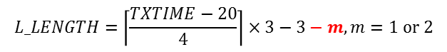

      - Moved by Hongyuan Zhang, Seconded by Ron Porat
      - Discussion: No discussion
      - Result: Motion Accepted with no objection.

    - PHY Motion #74: Move to add the following text to 11ax SFD
- 2x996RU employs a segment parser (as in 11ac) between two 996 tones (frequency segments) and the LDPC tone mapper in each 996 tone segment uses D_{TM}=20

      - Moved by Bin Tian, Seconded by Ron Porat
      - Discussion: No discussion
      - Result: Motion Accepted with no objection.

    - PHY Motion #75: Move to add the following text to 11ax SFD
- STBC is an optional feature in 11ax and it is ONLY defined for single spatial stream (Nss=1 and Nsts=2)
- In a MU PPDU all RUs are either STBC or not STBC.

      - Moved by Hongyuan Zhang, Seconded by Ron Porat
      - Discussion: No discussion
      - Result: Motion Accepted with no objection.

    - PHY Motion #76: Move to add the following to 11ax SFD
The spectral masks for 11ax non-OFDMA 20/40/80/160/80+80 MHz PPDU are defined as in slides 13-15 of doc 11-15/1311r0
  - The bandwidth of the applied spectrum mask for a (non-OFDMA) PPDU shall be determined by the bandwidth occupied by the pre HE-STF portion of the preamble in this PPDU, regardless of the BSS bandwidth
  - The spectral mask requirements do not apply to LO leakage

      - Moved by Bin Tian, Seconded by Ron Porat
      - Discussion: No discussion
      - Result: Motion Accepted with no objection.

    - PHY Motion #77: Move to include the following text to TGax SFD:
  - HE link adaptation shall define reference payload size for the reported MCS in MFB.
    - Reference payload size may be dependent on the frames involved in link adaptation or fixed in specification. Details are TBD.

      - Moved by Yujin Noh, Seconded by Ron Porat
      - Discussion: No discussion
      - Result: Motion Accepted with no objection.

    - PHY Motion #78: Move to include the following text to TGax SFD:
  - HE link adaptation field, which is part of HE variant of HT control field, consists of MFB and TBD subfields. The MFB subfield includes NSS and MCS subfield.

      - Moved by Yujin Noh, Seconded by Ron Porat
      - Discussion: No discussion
      - Result: Motion Accepted with no objection.

    - PHY Motion #79: Move to add the following HE-STF sequences for 0.8us and 1.6us periodicity to the 11ax SFD:
  - M = {-1 -1 -1 +1 +1 +1 -1 +1 +1 +1 -1 +1 +1 -1 +1}
  - 1x HE-STF sequences
    - 20MHz
      - HES_{-112,112}(-112:16:112) = M *(1+j)*sqrt(1/2)
      - HES_{-112,112}(0) = 0
    - 40MHz
      - HES_{-240,240}(-240:16:240) = {M, 0, -M} *(1+j)*sqrt(1/2)
    - 80MHz
      - HES_{-496,496}(-496:16:496) = {M, 1, -M, 0, -M, 1, -M} *(1+j)*sqrt(1/2)
  - 2x HE-STF sequences
    - 20MHz
      - HES_{-120,120}(-120:8:120) = {M, 0 , -M} *(1+j)*sqrt(1/2)
    - 40MHz
      - HES_{-248,248}(-248:8:248) = {M, -1, -M, 0, M, -1, M} *(1+j)*sqrt(1/2)
      - HES_{-248,248}(±248) = 0
    - 80MHz
      - HES_{-504,504} (-504:8:504) = {M, -1, M, -1, -M, -1, M, 0, -M, 1, M, 1, -M, 1, -M} *(1+j)*sqrt(1/2)
      - HES_{-504,504}(±504) = 0

      - Moved by HanGyu Cho, Seconded by Ron Porat
      - Discussion: No discussion
      - Result: Motion Accepted with no objection.

    - PHY Motion #80: Move to add to SFD
  - 4x/2x HE-LTF sequences for 80MHz in slides 13-15 of 11-15/1334r1
  - 4x/2x HE-LTF sequences for 40MHz in slides 20-21 of doc 11-15/1334r1
  - 4x/2x HE-LTF sequences for 20MHz in slide 26 of doc 11-15/1334r1

      - Moved by Le Liu, Seconded by Ron Porat
      - Discussion: No discussion
      - Result: Motion Accepted with no objection.

    - PHY Motion #81: Move to add to SFD
  - In all transmission modes, HE-STF and HE-LTF only populate RUs that are populated in the data field.

      - Moved by Le Liu, Seconded by Ron Porat
      - Discussion: No discussion
      - Result: Motion Accepted with no objection.

    - PHY Motion #82: Move to add to SFD
  - Gamma (tone rotation as defined in Clause 22.3.7.5 of 11ac amendment) is not applied on HE-STF and beyond.
    - TBD in case of a duplicated HE PPDU (if ever defined)

      - Moved by Le Liu, Seconded by Ron Porat
      - Discussion: No discussion
      - Result: Motion Accepted with no objection.

    - PHY Motion #83: Move to add 1-bit beam-change indication into HE-SIGA
  - Value “1” indicates that spatial mapping is changed
  - Value “0” indicates that spatial mapping is unchanged

      - Moved by Jianhan Liu, Seconded by Ron Porat
      - Discussion: No discussion
      - Result: Motion Accepted with no objection.

    - PHY Motion #84: Move to add to the specification framework document:
  - When beam-change indication is “0”, the pre-HE-STF portion preamble shall be spatially mapped in the same way as HE-LTF1 on each tone

      - Moved by Jianhan Liu, Seconded by Ron Porat
      - Discussion: No discussion
      - Result: Motion Accepted with no objection.

    - PHY Motion #85: Move to add 1x HE-LTF as an optional mode in 11ax for SU PPDU (TBD for MU-MIMO)
  - 1xLTF + 0.8us GI is one optional combination as indicated by the “GI and LTF size” sub-field in HE-SIG-A.

      - Moved by Jianhan Liu, Seconded by Ron Porat
      - Discussion: No discussion
      - Result: Motion Accepted with no objection.

    - PHY Motion #86: Move to add the following text to the 11ax SFD
  - The resource allocation signaling in the common control field and user specific subfields for an STA carried in the HE-SIG-B are transmitted in the same 20MHz sub-channel as the data for 20MHz and 40MHz PPDU.
  - For an 80MHz PPDU, the default mapping per 20MHz is as shown in the figure below.

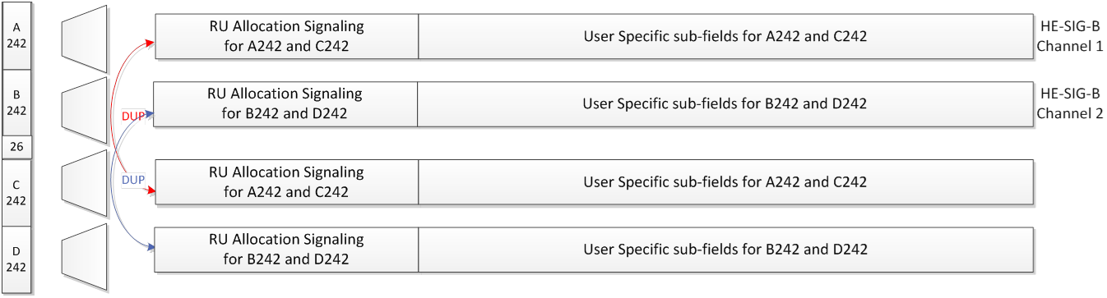

  - For a 160MHz PPDU , the default mapping per 20MHz is as shown in the figure below.

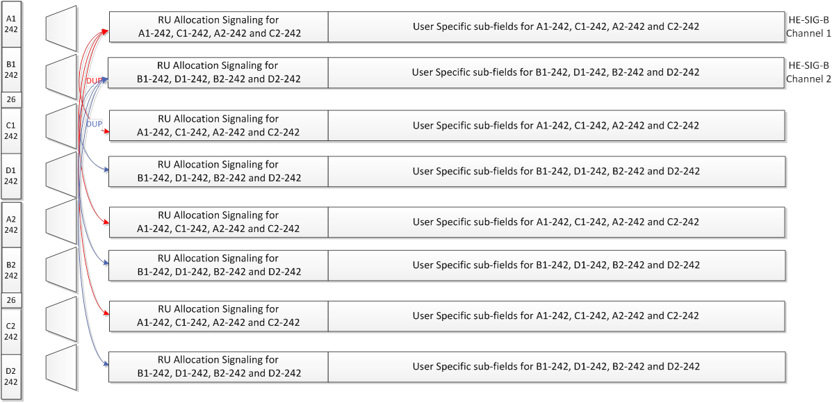

      - Moved by Kaushik Josiam, Seconded by Ron Porat
      - Discussion: No discussion
      - Result: Motion Accepted with no objection.

    - PHY Motion #87: Move to add the following text to the 11ax SFD:
  - A compression bit is carried in the HE-SIG-A MU format to differentiate full BW MU-MIMO from OFDMA MU PPDU.
  - In case of full BW MU-MIMO, the following conditions hold:
    - Only applicable for RU sizes 242,484,996,2*996
    - The RU information in HE-SIGB common is not signaled
    - For bandwidths > 20MHz, the user specific sub-fields are split equitably between the two HE-SIG-B Channels

      - Moved by Kaushik Josiam, Seconded by Ron Porat
      - Discussion: No discussion
      - Result: Motion Accepted with no objection.

    - PHY Motion #88: Move to add to the TGax Spec Framework
  - Signaling in the first encoded part (HE-SIG-A) has the following MCS values for HE-SIG-B
    - MCS0, MCS 1, MCS 2, MCS 3, MCS4, MCS5
    - Other MCS is TBD

  - Signaling for HE-SIG-B MCSs has 3 bits
    - If two MCS values for BW >= 40 MHz are to be signaled, additional TBD bits used.

      - Moved by Ron Porat, Seconded by Jianhan Liu
      - Discussion: No discussion
      - Result: Motion Accepted with no objection.

    - PHY Motion #89: Move to modify the text in IEEE 802.11ax SFD(r9) as follows
  - Change “The exact mapping of the 8 bit to the arrangement and the number of MU-MIMO allocations is TBD.” to “The mapping of the 8 bits to the arrangement and the number of MU-MIMO allocations is defined in the following lookup table.”

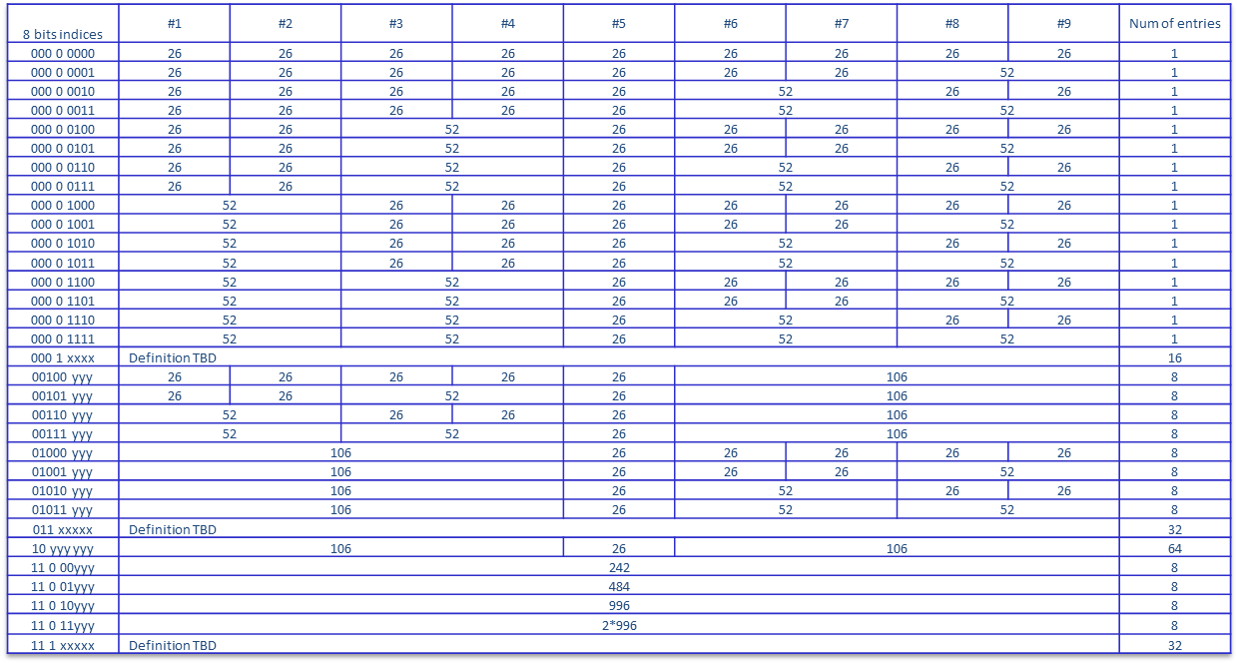
Note: ‘yyy’ = 000~111 indicates number of MU-MIMO STAs.
Definition for entries with ‘x’ bits are TBD.

      - Moved by Le Liu, Seconded by Ron Porat
      - Discussion: No discussion
      - Result: Motion Accepted with no objection.

    - PHY Motion #90: Move to add to the specification framework document
  - the STAID size in the user specific subfields of HE-SIGB is 11bits

      - Moved by Le Liu, Seconded by Ron Porat
      - Discussion: No discussion
      - Result: Motion Accepted with no objection.

    - PHY Motion #91: Move to add a DCM subfield (1-bit) to the user-specific subfields of HE-SIG-B in IEEE 802.11ax SFD(r9) (as shown in red)
  - For single-user allocations in a RU: NSTS (Number of Spatial Streams), TxBF (transmit beamforming ), MCS (Modulation and Coding Scheme), DCM (Dual Sub-Carrier Modulation) and Coding (Use of LDPC)
  - For each user in a multi-user allocation in a RU: Spatial Configuration Fields, MCS, DCM and Coding

      - Moved by Le Liu, Seconded by Ron Porat
      - Discussion: No discussion
      - Result: Motion Accepted with no objection.

    - PHY Motion #92: Move to add the following text in Section x.x.x in current SFD
  - The number of spatially multiplexed users in a DL or UL MU-MIMO transmission is up to 8 (in a given RU)

      - Moved by Yakun Sun, Seconded by Ron Porat
      - Discussion: No discussion
      - Result: Motion Accepted with no objection.

    - PHY Motion #93: Move to add the following text in Section x.x.x in current SFD
  - The Nsts value for each user in a MU-MIMO RU is less than or equal to 4

      - Moved by Yakun Sun, Seconded by Ron Porat
      - Discussion: No discussion
      - Result: Motion Accepted with no objection.

    - PHY Motion #94: Move to add the following text in Section x.x.x in current SFD
  - A MU-MIMO user block includes a “spatial config” field of 4 bits indicating the number of spatial streams for each multiplexed STA. The field is constructed by using the entries corresponding to the value of Nuser of this RU in the following table

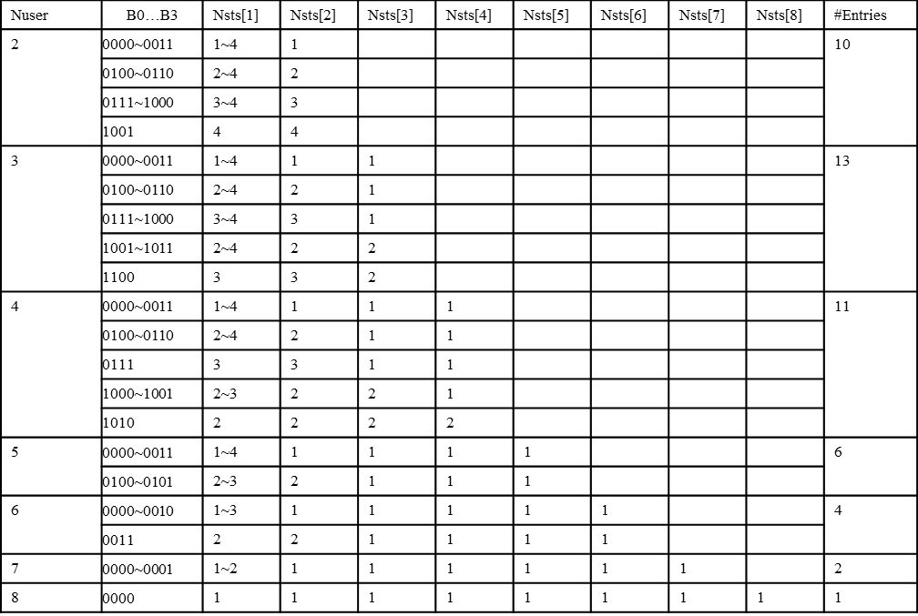

      - Moved by Yakun Sun, Seconded by Ron Porat
      - Discussion: No discussion
      - Result: Motion Accepted with no objection.

    - PHY Motion #95: Move to modify the text in Section 3.2.4 of the SFD as follows
  - Two users are grouped together and jointly encoded in each BCC block in the user specific section of HE-SIG-B
  - The CRC in the common block is TBD
  - The common block has a CRC separate from the CRC of the user specific blocks
  - The last user information is immediately followed by tail bits (regardless of whether the number of users is odd or even) and padding bits are only added after those tail bits

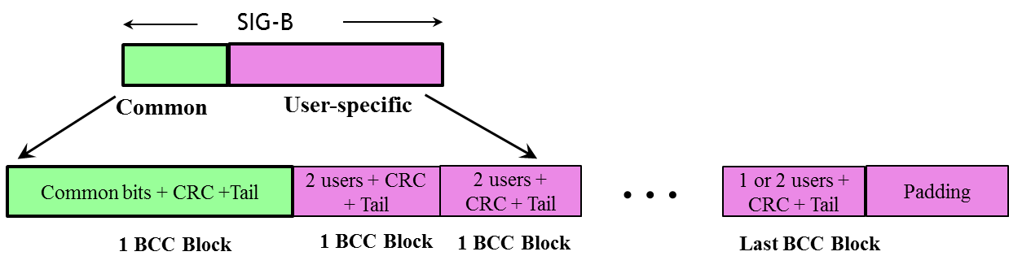

      - Moved by Ron Porat, Seconded by Kaushik Josiam
      - Discussion: No discussion
      - Result: Motion Accepted with no objection.

    - PHY Motion #96: Move to add to the TG Specification Framework document:
  - the HE-SIG-A field definitions for SU preamble format in [11-15/0132r9] (PHY Motions 43, 46, 48, 54) shall be replaced with the table in slide 11 of 11-15/1354r1.

      - Moved by Ron Porat, Seconded by Yasu Inoue
      - Discussion: No discussion
      - Result: Motion Accepted with no objection.

    - PHY Motion #97: Move to add to the TG Specification Framework document:
  - the HE-SIG-A field definition for the MU preamble format [11-15/0132r9] (PHY Motions 44, 46, 54) shall be replaced with the table in slide 12 of 11-15/1354r1.

      - Moved by Ron Porat, Seconded by Jianhan Liu
      - Discussion: No discussion
      - Result: Motion Accepted with no objection.

    - PHY Motion #98: Move to add to the TG Specification Frame work document: the HE-SIG-A field definition for trigger based UL preamble format in [11-15/0132r9] (PHY Motion 45) shall be replaced with the table in slide 13 of 11-15/1354r1.

      - Moved by Ron Porat, Seconded by Yasu Inoue
      - Discussion: No discussion
      - Result: Motion Accepted with no objection.

    - PHY Motion #99: Move to add to the specification frame work document:
  - 802.11ax spec shall support Ng = 2, 4, 8 for sounding feedback.
  - NOTE—The tone grouping factor, Ng is defined with respect to data tones of the HE PPDU.

      - Moved by Kome Oteri, Seconded by Daewon Lee
      - Discussion:
        - Relation between Ng and SU/MU transmissions discussed.
        - Some members suggested more discussion before vote on this motion.
      - Result: Y/N/A = 21/38/28, motion fails.

    - PHY Motion #100: Move to add to the spec framework, at the end of section 4.6
The amendment may consider methods that extend the compressed beamforming feedback ideas in 802.11ac

      - Moved by Kome Oteri, Seconded by Daewon Lee
      - Discussion:
        - Some members mentioned this does motion text is not good enough.
        - Amendment to the PHY motion #100 proposed.
      - Motion to amend the PHY Motion #100
        - Amend PHY motion #100 to:
That mechanism shall use the compressed beamforming feedback as defined in section 8.4.1.48 in 802.11ac as a baseline

          - Moved by Kome Oteri, Seconded by Ron Porat
          - Requires simple majority to amend the motion.
          - Result: Y/N/A = 44/24/21, motion to amend passes. Back to the main Motion

      - Amended PHY Motion #100: Move to add to the spec framework, at the end of section 4.6
That mechanism shall use the compressed beamforming feedback as defined in section 8.4.1.48 in 802.11ac as a baseline
      - Moved by Kome Oteri, Seconded by Ron Porat
      - Result: Y/N/A = 30/32/30, motion fails.

  - MAC Motions

    - MAC Motion #42: Move to add to the TGax SFD:
  - 4.2 DL MU operation
Ack Policy field set to 01 (Trigger based UL MU Ack) has the following normative behavior for an HE STA:
i) The addressed recipient that receives the trigger information, within a DL MU PPDU returns an immediate Ack/BlockAck response, either individually or as part of an A-MPDU after the PPDU carrying the frame, according to the trigger information carried in the same DL MU PPDU
ii) The addressed recipient that does receive no valid trigger information takes no action upon the receipt of the frame, except for recording the state (if necessary)

      - Moved by Yongho Seok, Seconded by Minho Cheong
      - Discussion: No discussion
      - Result: Motion accepted with no objection.

    - MAC Motion #43: Move to add to the spec framework document
  - Ack Policy field in a frame soliciting an immediate response is set to 00 (Normal Ack or Implicit Block Ack Request ) if the immediate response is carried in SU PPDU, or it is set to 01 (Trigger based UL MU Ack) if the immediate response is carried in MU PPDU.

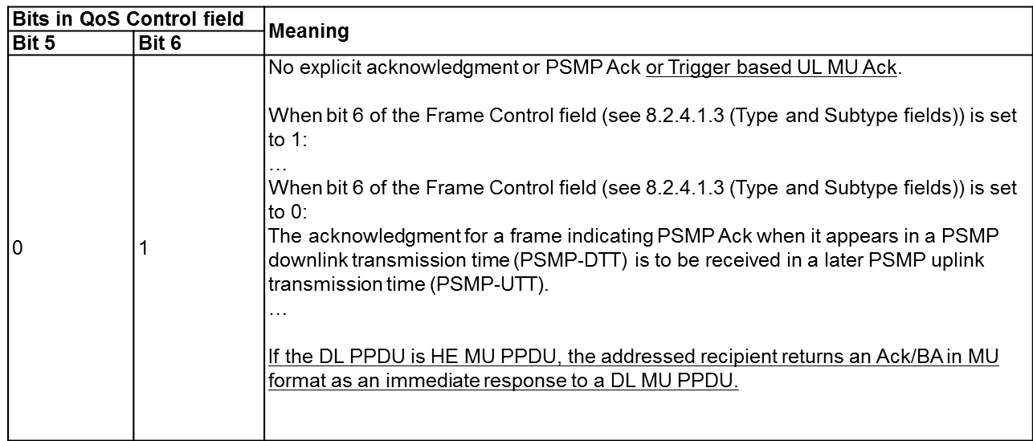

      - Moved by Kiseon Ryu, Seconded by Simone Merlin
      - Discussion: No discussion
      - Result: Motion accepted with no objection.

    - MAC Motion #44: Move to add to SFD
  - The spec shall allow DL OFDMA transmission of Multi-STA Block ACK frame in response to UL MU PPDUs.

      - Moved by Kiseon Ryu, Seconded by David Xun Yang
      - Discussion: No discussion
      - Result: Motion accepted with no objection.

    - MAC Motion #45: Move to add the following rate/MCS selection rules of DL acknowledgement for UL MU to the SFD
  - When an AP selects rate, MCS, NSS of M-BA or OFDMA BA that acknowledges the UL OFDMA, the AP may ignore the MCS, NSS of UL OFDMA PPDU that elicits the DL acknowledgement.
  - The AP shall transmit the M-BA using one of rate, MCS, NSS that all of the acknowledgement receivers support.

      - Moved by Liwen Chu, Seconded by Simone Merlin
      - Discussion: No discussion
      - Result: Motion accepted with no objection.

    - MAC Motion #46: Move to add to the TG Specification Framework:
  - 4.y.z When an AP initiates a DL MU transmission soliciting more than one immediate response frames, the DL MU transmission is successful if the AP receives the response frame correctly from at least one STA indicated by any trigger information in the DL MU transmission.

      - Moved by Young Hoon Kwon, Seconded by Minho Cheong
      - Discussion: No discussion
      - Result: Motion accepted with no objection.

    - MAC Motion #47: Move to add to the 11ax SFD:
  - The 11ax fragmentation negotiation shall allow the following fragmentation types (levels) to be indicated:
    - Level 0: No support for fragments
    - Level 1: Support for a fragment in a VHT single MPDU only
    - Level 2: Support for up to one fragment per MSDU in an A-MPDU
    - Level 3: Support for multiple fragments of an MSDU per A-MPDU

      - Moved by Simone Merlin, Seconded by David Xun Yang
      - Discussion: No discussion
      - Result: Motion accepted with no objection.

    - MAC Motion #48: Move to add to the 11ax SFD:
  - The TWT Flow Identifier field in the TWT IE included in the Beacon frame specifies the different types of flows allowed during the TWT SP

      - Moved by Simone Merlin, Seconded by George Cherian
      - Discussion: No discussion
      - Result: Motion accepted with no objection.

    - MAC Motion #49: Move to add to the SFD:
  - Multiple TWTs can be indicated in the TWT IE in the Beacon frame by allowing multiple TWT parameter sets in the same TWT IE

      - Moved by Simone Merlin, Seconded by George Cherian
      - Discussion: No discussion
      - Result: Motion accepted with no objection.

    - MAC Motion #50: Move to amend the existing text in the 11ax SFD as follows:
  - The spec shall indicate cascaded sequence of Trigger frames for random access by using a bit in the Trigger frame.

      - Moved by Simone Merlin, Seconded by George Cherian
      - Discussion: No discussion
      - Result: Motion accepted with no objection.

    - MAC Motion #51: Move to add to the SFD
The Trigger Frame includes the following subfields:
- Subfields of the Common Info field:
    - Length [12 bits]
      - Value of the L-SIG Length of the UL MU PPDU
      - A responding STA will copy this value in its L-SIG length field, hence the encoding shall be same as defined for the L-SIG Length of the UL MU PPDU
    - Info bits content of the SIG-A of the response UL MU PPDU [# of bits TBD]
    - May Exclude the bits that may be implicitly already known by all responding STAs, if any TBD
  - CP + HE LTF type [TBD # of bits]
  - Allowed response type / trigger type [# of bits TBD]
    - Types TBD

      - Moved by Simone Merlin, Seconded by Kiseon Ryu
      - Discussion: No discussion
      - Result: Motion accepted with no objection.

    - MAC Motion #52: Move to add to the SFD
The Trigger Frame includes the following subfields:
- Subfields of the Per-User Info field:
    - MCS [4 bits]
    - Coding type [# of bits TBD]
  - RU allocation information [# of bits TBD]
  - SS allocation [# of bits TBD]
  - DCM [1 bit]
  - User Identifier field [12 bits]
    - AID for STAs associated with AP; TBD for unassociated STAs

      - Moved by Simone Merlin, Seconded by Kiseon Ryu
      - Discussion: No discussion
      - Result: Motion accepted with no objection.

    - MAC Motion #53: Move to add to the SFD:
  - Trigger frame is a new subtype of the control type as indicated in the FC B4 to B7 with the subtype not equal to 6.

      - Moved by Simone Merlin, Seconded by Kiseon Ryu
      - Discussion: No discussion
      - Result: Motion accepted with no objection.

    - MAC Motion #54: Move to add to the spec framework document
  - The spec shall define optional type-specific Common Info and optional type-specific Per User Info of Trigger frame. The locations of type-specific Common Info and type-specific Per User Info are TBD.

      - Moved by Kiseon Ryu, Seconded by David Xun Yang
      - Discussion: No discussion
      - Result: Motion accepted with no objection.

- Recess @ 12:26 until PM1 today.

Thursday, November 12th 2015, PM1 Session (13:30 - 15:30)

- The meeting called to order by Osama Aboul-Magd (Huawei Technologies), the chair of TGax, @13:32.
  - Agenda 11-15/1232r4 is on the server. Rev 5 still is working document.

- Administrative Items
  - Chair reminded the IEEE 802 and IEEE 802.11 P&P.
  - Chair asked people to state name and affiliation when addressing for the first time in the session.
  - Attendance!

- Agenda for today’s session

  - Thursday PM1
    - Call Meeting to order
    - IEEE 802 and 802.11 IPR Policy and procedure.
    - Presentations
      - 1 MAC presentation
      - 2 MU presentations
      - Updated straw Poll – Katsuo Yunoki
    - Simulation Scenarios related submissions and motion
    - Evaluation Methodology related submissions and motion
    - TG Motions – hard start at 10:30 am
    - Timeline
    - Goals for January 2016
    - Telecon Schedule
    - Adjourn

- TG Motions (continued)
  - MAC Motions

    - MAC Motion #55: Move to add the following to the SFD
- A trigger frame that addresses STAs in multiple BSSs corresponding to a multiple BSS set shall use a common address TBD in the A2 field

      - Moved by Kaiying Lv, Seconded by Jianhan Liu
      - Discussion: No discussion
      - Result: Motion accepted with no objection.

    - MAC Motion #56: Move to add the following to the SFD
- The STAID field that identifies the RU allocation in HE SIG-B for broadcast traffic in DL OFDMA PPDU shall be defined as following:
  - 1, For single BSS AP, the STAID for Broadcast will be 0;
  - 2, For Multiple BSS AP, the STAID for Broadcast to a specific BSS will follow the group addressed AID assignment in the TIM according to the existing Multi-BSSID TIM operation;
  - 3, For Multiple BSS AP, the STAID for Broadcast to all BSSs of the AP will have a special STAID value reserved.

      - Moved by Liwen Chu, Seconded by George Cherian
      - Discussion: No discussion
      - Result: Motion accepted with no objection.

    - MAC Motion #57: Move to change the following words in SFD
- An UL/DL Flag field is present in the HE-SIG-A field of an HE SU PPDU. The UL/DL Flag field indicates whether the frame is UL or DL.
  - The value of this field for TDLS is TBD.
  - The value of this field for TDLS is configured as DL.
Note: The TDLS peer can identify the TDLS frame by To DS and From DS fields in the MAC header of the 11ax MPDU.

      - Moved by Yingpei Lin, Seconded by David Xun Yang
      - Discussion: No discussion
      - Result: Motion accepted with no objection.

  - MU Motions

    - MU Motion #28: Move to add the following underlined part to the TGax Specification Framework:
- 4.3 UL MU operation
A STA that is polled from a Trigger frame for UL MU transmission considers the NAV in determining whether to respond unless one of the following conditions is met
    - The NAV was set by a frame originating from the AP sending the trigger frame
    - The response contains ACK/BA and the duration of the UL MU transmission is below a TBD threshold
    - The NAV was set by a frame originating from intra-BSS STAs
    - Other condition TBD

      - Moved by Yingpei Lin, Seconded by David Xun Yang
      - Discussion: No discussion
      - Result: Motion accepted with no objection.

    - MU Motion #29: Move to add the following to the SFD:
  - Scheduling information for UL MU Acknowledgement from STA may be contained within the “HE variant of the HT Control Field”

      - Moved by Yujin Noh, Seconded by Minho Cheong
      - Discussion: No discussion
      - Result: Motion accepted with no objection.

    - MU Motion #30: Move to add to 11ax SFD:
  - 7.2.X: The MU BAR frame is a variant of Trigger frame whose Trigger Type subfield is MU BAR that carries additional BAR Control subfield (TBD) and an additional BAR Information subfield (TBD) in Common Info and/or each Per-User info.

      - Moved by Reza Hedayat, Seconded by Minho Cheong
      - Discussion: No discussion
      - Result: Motion accepted with no objection.

    - MU Motion #31: Move to add to the TG Specification Framework document:
  - x.y.z. MU-RTS/CTS frame exchange may be used for protection of MU transmissions during that TXOP.

      - Moved by Po-Kai Huang, Seconded by Chittabrata Ghosh
      - Discussion: No discussion
      - Result: Motion accepted with no objection.

    - MU Motion #32: Move to add to the TG Specification Framework document:
  - x.y.z. The MAC format of MU-RTS is a variant of trigger frame format.

      - Moved by Po-Kai Huang, Seconded by Chittabrata Ghosh
      - Discussion: No discussion
      - Result: Motion accepted with no objection.

    - MU Motion #33: Move to add to the TG Specification Framework document:
  - x.y.z. The CTS sent in response to a frame that solicits simultaneous CTS shall be transmitted on one or more 20 MHz channels.

      - Moved by Po-Kai Huang, Seconded by Chittabrata Ghosh
      - Discussion: No discussion
      - Result: Y/N/A = 48/8/21, motion passees.

    - MU Motion #34: Move to add to the TG Specification Framework document:
  - x.y.z. MU-RTS may request STAs to send non-HT CTS immediate response.

      - Moved by Po-Kai Huang, Seconded by Chittabrata Ghosh
      - Discussion: No discussion
      - Result: Motion accepted with no objection.

    - MU Motion #35: Move to add to the TG Specification Framework document:
  - x.y.z. MU-RTS will carry signaling for each STA to indicate the 20MHz channel(s) for transmitting CTS responses when CTS is sent in (duplicate) non-HT PPDU
    - When a STA sends CTS in response to MU-RTS, the CTS response shall be transmitted in the 20MHz channel(s) indicated in MU-RTS
      - provided other transmission conditions TBD are met (e.g. channel idleness)
    - The indicated 20 MHz channel(s) can be either Primary20, Primary40, Primary80 or 160/80+80 MHz. Other indications are TBD.
    - Exact Signaling TBD

      - Moved by Po-Kai Huang, Seconded by Chittabrata Ghosh
      - Discussion: No discussion
      - Result: Motion accepted with no objection.

    - MU Motion #36: Move to add to the TG Specification Framework document:
  - x.y.z. A STA maintains two NAVs
    - One is the NAV for Intra-BSS frame, and second one is the NAV for Inter-BSS frame or frame that cannot be determined to be Intra-BSS or Inter-BSS
    - Note that maintaining two NAVs does not imply maintaining two NAV timers
    - The detailed method of maintaining two NAVs (e.g., two NAV timers or one NAV timer with difference of two NAV values, etc.) is TBD
    - Mandatory or Optional TBD

      - Moved by Po-Kai Huang, Seconded by Chittabrata Ghosh
      - Discussion: No discussion
      - Result: Y/N/A = 53/11/27, motion passes.

    - MU Motion #37: Move to amend the following text in the SFD as follows:
4.6. Lines 47-49
  - The amendment shall define a new shall define a channel sounding sequence (Refer Fig. 14) initiated by an HE AP that includes a trigger information frame, a SIFS after NDP frame, in order to solicit UL MU mode of Compressed Beamforming Action frame from multiple HE STAs

      - Moved by Narendar Madhavan, Seconded by Minho Cheong
      - Discussion: No discussion
      - Result: Motion accepted with no objection.

    - MU Motion #38: Move to add the following text to the SFD:
Within an A-MPDU the trigger information for a STA, if present, shall be signaled either in Trigger frame(s) or in the MAC header of MPDU(s) contained in the A-MPDU but not both.

      - Moved by Chittabrata Ghosh, Seconded by Yaron Alpert
      - Discussion: No discussion
      - Result: Motion accepted with no objection.

    - MU Motion #39: Move to add to the TG Specification Framework document:
- 4.x.y The AP may send trigger frame to elicit buffer status report (BSR) using random access

      - Moved by Woojin Ahn, Seconded by John Son
      - Discussion: No discussion
      - Result: Motion accepted with no objection.

  - SR Motions

    - SR Motion #5: Move to add the following text in SFD:
- An HE STA should have a mechanism to remember and distinguish NAVs set by intra-BSS frame and OBSS frame. A CF-end frame that comes from intra-BSS should not reset NAV that was set by a frame from OBSS. To determine which BSS is the origin of a frame, the HE STA may use BSS color.

      - Moved by Sigurd Schelstraete, Seconded by Guido R. Hiertz
      - Discussion: No discussion.
      - Result: Motion accepted with no objection.

- Simulation Scenarios related submissions and motion
  - Simone explained the updates.
    - Power Save related timings and parameters
    - Wrap around model in scenario 3 and scenario 4.
  - Discussion
    - One more change requested – minimum distance requirement.
    - A member expressed objection to this.

  - Motion (Simulation Scenario Document)

    - Move to accept document 11-14-0980-16 as the current revision of the TG Simulation Scenario document.
      - Moved by Simone Merlin, Seconded by Bin Tian
      - Result: Motion accepted with no objection.

- Timeline discussion
  - A member suggested keeping current plan as it is if we do not see any delay from the original schedule.

- Goals for January 2016
  - Continue to advance the TG documents based on submissions.
    - Priority to the TG Specification Framework document.
  - TG timeline indicates draft D0.1 will be available in January 2016.
  - Technical presentations.

- Conference call scheduling
  - One conference call proposed
    - Thursday December 10th, 10:00 – 12:00 ET

- AoB
  - Chair asked if we have any other business to conduct – No response.

- Adjournment
  - TGax adjourned for the week @ 14:47.

