IEEE P802.11
Wireless LANs
Resolutions for CID 6470
Date: 2015-10
Author(s):
Name | Affiliation | Address | Phone | email
Graham SMITH | SRT Wireless | Davie, FL, USA. | 916 799 9563 | gsmith@srtrl.com
Abstract
This submission proposes resolution for CID 6470 on 11mc/D4.0.

Green indicates material agreed to in the group,
yellow material to be discussed, red material rejected by the group and
cyan material not to be overlooked.

Identifiers | Comment | Proposed change
CID 6470  Mark Rison  8.4.2.29  836.1 | It's not clear how to indicate A-MSDU/A-MPDU aggregation in TSPECs; this can have a significant effect on the medium time required for a particular traffic stream | Create a new IE to signal this information (sadly, the TSPEC IE is not extensible). Consider whether A-MSDU aggregation would be better handled by redefining the Nominal MSDU Size field to be the nominal A-MSDU size if A-MSDUs are used, and if so (a) whether giving information on A-MSDU aggregation could be useful and (b) how the Data Rates in the TSPEC should account for the A-MSDU overheads.

Discussion:

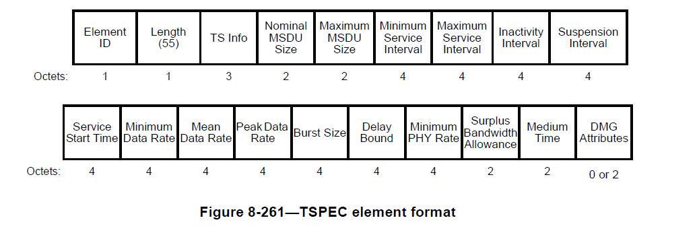

Nominal and Maximum MSDU sizes do now specify that the Nominal MSDU does include the A-MSDU where aggregation is used.

Annex N was re-written to include method(s) for limiting for A-MPDUs and A-MSDUs using the Maximum Service Interval.

“N.4.2.2 Use of Maximum Service Interval with Aggregation of Packets
Aggregation of MPDUs or MSDUs introduces delay to the packets, but the use of aggregated packets is to be encouraged because of the increased efficiency. In the case of scheduled traffic, the aggregation of packets is such that the number of MSDUs that are aggregated into a single packet (A-MSDU or A-MPDU) does not exceed the scheduling service interval.”

This clause provides examples of how to use the Maximum Service Interval in order to set the limits for aggregating A-MPDUs with A-MSDUs.

What is missing in Clause 8.4.2.29 is any reference to the information that is provided in Annex N.
Hence, to resolve this CID, it is proposed to add appropriate references to Annex N at the right places in

Proposed Resolution
REVISED
At 839.14 insert the following para:
“N.4.2.2 provides guidance on the use of the Maximum Service Interval to determine the limit of aggregation of nominal MSDUs.”

At 840.32 add the following sentence:
“N.4.3 provides guidance on how to determine the standard deviation of the TS and how to calculate the total traffic when there are multiple TSs.”

At 841.18 add the following sentence:
“N.4.1 provides guidance on how to calculate the value for Surplus Bandwidth Allowance.”

At 841.33 add the following sentence:
“Annex N provides guidance on the use of the TSPEC and the settings of values of the various fields.”

