IEEE P802.11
Wireless LANs
Resolutions for TPC comments on 11mc/D4.0
Date: 2015-09-08
Author(s):
Name | Affiliation | Address | Phone | email
Graham SMITH | SRT Wireless | Davie, FL, USA. | 916 799 9563 | gsmith@srtrl.com
Abstract
This submission proposes resolutions for TPC Comments on 11mc/D4.0.
Green indicates material agreed to in the group,
yellow material to be discussed, red material rejected by the group and
cyan material not to be overlooked.

The “Final” view should be selected in Word.

Identifiers | Comment | Proposed change
CID 5551  David Hunter  10.8.6  1639.28 | ""include a TPC Report element with the Link Margin field set to 0 and containing transmit power information in the Transmit Power field in any Beacon frame,": (1) confusing -- it appears that the TPC Report element part and the transmit power information parts are separate, so the TPC Report element isn't necessarily in the Beacon; (2) "in any Beacon": literally this says that a single Beacon is sufficient, but it appears that the authors expect the TPC Report element to be in _every_ Beacon. | Replace "include a TPC Report element with the Link Margin field set to 0 and containing transmit power information in the Transmit Power field in any Beacon frame,"  with:  "include a TPC Report element, with its Link Margin field set to 0 and its Transmit Power field holding the current transmit power information, in every one of the following frames that it transmits:  " -- Beacon  " -- DMG Beacon  " -- Announce  " -- Probe Response"

Discussion:
Full text:
“An AP, PCP, or IBSS STA shall autonomously include a TPC Report element with the Link Margin field set to 0 and containing transmit power information in the Transmit Power field in any Beacon frame, DMG Beacon frame, Announce frame, or Probe Response frame it transmits.”

First of, let’s look at the claim “authors expect the TPC Report element to be in every Beacon”

“autonomously” = Not controlled by others or by outside forces; independent:
So based upon the use of the word “autonomously” AND the phrase “any Beacon” I am not convinced that this means “every beacon”. I would have thought that in place of “any”, a word such as “all” or “all successive” would have been used if this were the case. My interpretation is that the AP, PCP or IBSS STA may indepently choose when to include the TPC Report element in the Beacon etc.

Now let’s look at the “confusing -- it appears that the TPC Report element part and the transmit power information parts are separate,”

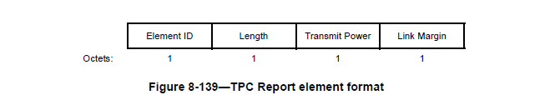
OK it is clear that the TPC Report element contains ONLY the Transmit Power field and the Link Margin field.

So in this case, the Link Margin is set to 0 and the Transmit Power field contains real power information. To me the text does say this but I suppose I need to see if it can be made any clearer.

Let’s try
Attempt #1 as per comment
“An AP, PCP, or IBSS STA shall autonomously include a TPC Report element with its Link Margin field set to 0 and its Transmit Power field holding the current transmit power information in any Beacon frame, DMG Beacon frame, Announce frame, or Probe Response frame it transmits.”

Do we use the term “field holding” ? I find zero instances of this.
“field containing” seems to be used.

Hence, use “containing” in place of “holding”

Proposed Resolution
REVISED

At P1639.28
Make changes as follows:
“An AP, PCP, or IBSS STA shall autonomously include a TPC Report element with its Link Margin field set to 0 and its Transmit Power field containing the current transmit power information in any Beacon frame, DMG Beacon frame, Announce frame, or Probe Response frame it transmits.”

Identifiers | Comment | Proposed change
CID 5550  David Hunter  10.8.6  1639.25 | "may use the Link Measurement procedure and the DMG Link Margin element to perform TPC.": Since this sentence refers to a different procedure and different element than was mentioned in the above specification, the standard needs to incorporate a specification of the DMG link measuremnt procedure using this element (similar to that specified above using the non-DMG TPC Request/Report frames and the TPC Report element). | Insert a new subclause specifying the DMG link measurement procedure and the use of the DMG Link Margin element to exchange TPC information.

Discussion:
Full text:
10.8.7 Adaption of the transmit power
“A STA may use a TPC Request frame to request another STA to respond with a TPC Report frame containing link margin and transmit power information. A STA receiving a TPC Request frame shall respond with a TPC Report frame containing the power used to transmit the response in the Transmit Power field and the estimated link margin in a Link Margin field. A DMG STA may also use the Link Measurement procedure and the DMG Link Margin element to perform TPC.

The DMG Link Margin element is covered in 8.4.2.141 (P1023.7).
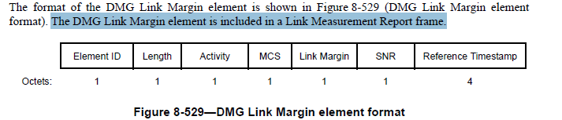

8.6.7.5 Link Measurement Report frame format
The Link Measurement Report frame is transmitted in response to a Link Measurement Request frame. In a
non-DMG BSS, a Link Measurement Report frame is an Action frame and in a DMG BSS, a Link
Measurement Report frame is an Action or an Action No Ack frame. The format of the Action field in the
Link Measurement Report frame is shown in Figure 8-631 (Link Measurement Report frame Action field
format).

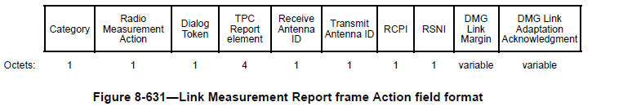

Note that the TPC Report element is part of the Link Measurement Report frame.

So now we have it, A DMG STA can use the Link Measurement Report frame which includes the DMG Link Margin and also the TPC Report element.

So back to the comment:
The clause in question covers “Adaption of Transmit Power”, so it is OK to cover both DMG and non-DMG STAs. I see nothing to stop a DMG STA using the TPC Request frame and the TPC Response frame. I also read that a DMG STA may also use the Link Measurement procedure. This all seems fine to me.
Proposed resolution:
REJECTED
The cited clause is transmit power adaption in general and covers DMG and non-DMG STAs. All STAs can use the TPC Request response frames and DMG STAs may also use the LinkMeasurement Report which includes the TPC Report element and the DMG Link Margin. Hence, although the sentence refers to an alternativer procedure to that preceeding it, it is still part of transmit power adaption.

CID 5545  David Hunter  10.8.5  1638.59 | "When dot11SpectrumManagementRequired is false and ot11RadioMeasurementActivated is true,": this doesn't say in what STAs these are false and/or true. If there is no requirement that these attributes shall have the same values in all STAs in a BSS, then, since the following subordinate clause is about issuing Beacons, Probe Responses, etc, we can assume that the STAs that have these attribute values are APs and PCPs. | Replace:  "When dot11SpectrumManagementRequired is false and dot11RadioMeasurementActivated is true," with:  "When the AP or PCP dot11SpectrumManagementRequired is false and dot11RadioMeasurement Activated is true,".

Discussion:
Full text is
“When dot11SpectrumManagementRequired is false and dot11RadioMeasurementActivated is true, a Power
Constraint element and a Transmit Power Envelope element may be included in Beacon, DMG Beacon,
Announce, and Probe Response frames.”

Yes, although obvious, that is obviously not good enough for the commenter (simple soul that he is). So grudgingly I do accept that it should be clear that it is referring to an AP or PCP.

Looking for’standard text’ I find different to the proposed text.

Proposed Resolution
REVISED
At P1638.59 Replace
“When dot11SpectrumManagementRequired is false and dot11RadioMeasurementActivated is true, a Power
Constraint element and a Transmit Power Envelope element may be included in Beacon, DMG Beacon,
Announce, and Probe Response frames.”

With
“An AP or PCP with dot11SpectrumManagementRequired false and dot11RadioMeasurementActivated true, may include a Power Constraint element and a Transmit Power Envelope element in Beacon, DMG Beacon, Announce, and Probe Response frames.”

Identifiers | Comment | Proposed change
CID 5541  David Hunter  10.8.5  1638.11 | "The Local Power Constraint field ... and each Local Maximum Transmit Power For X MHz field ... shall be set to a value that allows": the term "a value" (on line 14) is ambiguous -- does this mean "shall both be set to the same value that allows" or "shall each be set to its respective value that allows" ? | Decide which version is correct and replace "shall be set to a value that allows" with either of:  ""shall both be set to the same value that allows"  or  "shall each be set to its respective value that allows".

Discussion:
Full text is
“The Local Power Constraint field of any transmitted Power Constraint element and each Local Maximum Transmit Power For X MHz field (where X = 20, 40, 80, or 160/80+80) in the Transmit Power Envelope element shall be set to a value that allows the mitigation requirements to be satisfied in the current channel.

So we have two fields,
First the Local Power Constraint field in the Power Constarint element:

8.4.2.13 Power Constraint element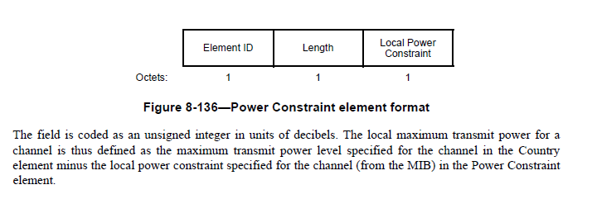

Aside, the text above just says “The field”, surprised this has not been commented on. Should read “The Local Power Constraint field…” (Note: added to resolution)

But, note the value, it is the value subtracted from the maximum transmit power specified to provide the local maximum local transmit power.

Let’s look at the Transmit Power Information field

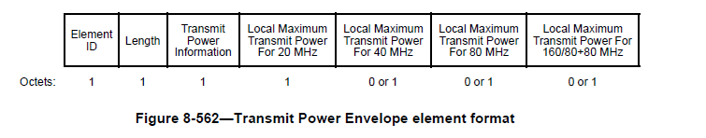
Local Maximum Transmit Power For X MHz fields (where X = 20, 40, 80, or 160/80+80) define the local
maximum transmit power limit of X MHz PPDUs. Each Local Maximum Transmit Power For X MHz field
is encoded as an 8-bit 2s complement signed integer in the range of –64 dBm to 63 dBm with a 0.5 dB step.
The value of 63.5 dBm indicates 63.5 dBm or higher (i.e., no local maximum transmit power constraint).

In frames transmitted by a TVHT STA the Local Maximum Transmit Power for 20 MHz field indicates the
Local Maximum Transmit Power for TVHT_W bandwidth; the Local Maximum Transmit Power for 40
MHz field indicates the Local Maximum Transmit Power for TVHT_2W or TVHT_W+W bandwidth; the
Local Maximum Transmit Power for 80 MHz field indicates the Local Maximum Transmit Power for
TVHT_4W or TVHT_2W+2W bandwidth; the Local Maximum Transmit Power for 160/80+80 MHz field
is not included in the Transmit Power Envelope element.

The Local Maximum Transmit Power For X MHz fields are set in 0.5dB steps, whereas the Local Power Constraint is set in 1 dB steps. The value indicates the Local Maximum Transmit Power.

Hence, it I clear that the two fields cited are mnot the same value, therefore the commenter is correct. It is also clear, however that the two are related. I will go with the second proposed change.

Proposed resolution:
REVISED

At P1638.11 make changes as shown:
“The Local Power Constraint field of any transmitted Power Constraint element and each Local Maximum Transmit Power For X MHz field (where X = 20, 40, 80, or 160/80+80) in the Transmit Power Envelope element shall each be set to its respective value that allows the mitigation requirements to be satisfied in the current channel.”

Also,
At P728.11
Replace “The field is coded …”
With
“The Local Power Constraint field is coded…”

Identifiers | Comment | Proposed change
CID 5538  David Hunter  10.8.4  1637.31 | Even the two minor editorial clarifications of the painfully long sentence help expose a technical confusion in that sentence. The beginning of the sentence refers to the "most recently received" Beacon or Probe Response. But line 31 references the element "sent first" in that Beacon or Probe Response. So how does a most recently received frame send an element _first_? The needed further rewrite of this sentence requires a technical decision. Does the text need to delete the "sent first" so that the referenced element is just that included in the most recently received Beacon or Probe Response? | Decide whether the correct appelation is "most recently received" or "sent first", and rewrite the text to reflect that decision.  Proposal: Delete "first" (so now "the B or PR frame" indicates the B or PR frame that began the sentence).  This same decision is needed about the following long paragraph (starting on line 36) about mesh STAs.

Discussion:
The 144 word sentence reads:
“If the Beacon or Probe Response frame most recently received from an AP by a STA that is extended spectrum management capable and that has dot11SpectrumManagementRequired or dot11RadioMeasurementActivated equal to true includes one or more Transmit Power Envelope elements, then the units of the Minimum Transmit Power Capability and Maximum Transmit Power Capability fields within the Power Capability element sent in the STA’s (Re)Association Request frame to the AP shall be interpreted according to the Local Maximum Transmit Power Unit Interpretation subfield in the Transmit Power Information field in the Transmit Power Envelope element (see 8.4.2.161 (Transmit Power Envelope element)) sent first in the Beacon or Probe Response frame; otherwise, the units of the Minimum Transmit Power Capability and Maximum Transmit Power Capability fields within the Power Capability element sent in the STA’s (Re)Association Request frame to the AP shall be interpreted as EIRP.”

Cutting through the fluff,
IF the latest received Beacon or Probe Response by a extended spectrum management STA includes a Transmit Power Envelope element, THEN in the Power Capability element sent in the STA Association Request, the units for max and min power capability are as per the Local Maximum Transmit Power Unit Interpretation subfield in the Transmit Power Information field in the Transmit Power Envelope element sent first in the Beacon or Probe Response frame; otherwise it is EIRP.

The “sent first” clearly is referring back to the original Beacon or Probe Request at the beginning of the sentence

Look at P1047.1 “8.4.2.161 Transmit Power Envelope element”
In particular
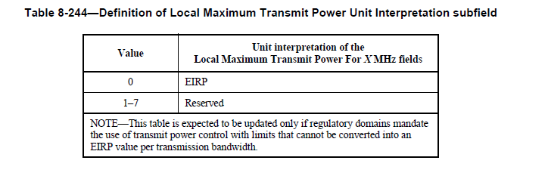

Spot the problem?? As far as I can see ONLY EIRP is defined! So what this complete sentence is doing is beyond me.

I suppose the sentence is laying the ground for the future whan possibly the table is updated?
I still don’t get it, SO would any sensible authority specify anything other than EIRP?

For those not familiar with EIRP it is the transmit power at the antenna connector. It assumes a perfect intrinsic antenna, which does not exist). The only alternative is to specify including the antenna gain, “Effective Radiated Power”, but this is directional so we get “Maximum Effective Radiated Power” or a specification for maximum antenna gain, in dBi or dBd - Very messy so better to specify EIRP and then, if necessary a maximum antenna gain.

So, to me the complete semtence is a waste of space, as there is no alternative at present to EIRP. If in future the ‘reserved’ values are converted, then possibly this sentence is needed.

So assuming we want to keep it we just need to clarify the “sent first in the Beacon or Probe Response frame”

As noted before, this is referring to the Beacon or Probe Response that started off the sentence, so how do we state that clearer? The commenter suggested deleting the ‘first’.

Options:
- “...sent in the Beacon or Probe Response frame
- “...sent in the most recently received Beacon or Probe Response frame
- Delete the sentence completely

Proposed resolution:
REVISED
At P1637.31 and at P1637.44

Make changes as follows:
“...sent in the most recently received Beacon or Probe Response frame”

Identifiers | Comment | Proposed change
CID 5534  David Hunter  10.8.3  1637.3 | "A mesh STA shall provide a candidate peer mesh STA with its minimum and maximum transmit power capability": such a generic term as "provide" leads to confusion. | Replace "provide a candidate peer mesh STA with its minimum and maximum" with "inform a candidate peer mesh STA of its minimum and maximum".

Discussion:

“A mesh STA shall provide a candidate peer mesh STA with its minimum and maximum transmit power capability for the current channel when becoming a member of an MBSS, using a Power Capability element in Mesh Peering Open frames.”

Hmm…whats’s confusing?
Let’s look at “shall provide”

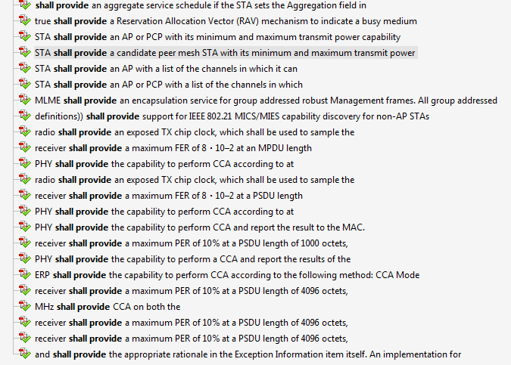

What’s a better term?
“shall inform” – to my mind no better, and maybe worse

Proposed resolution:
REJECT
The text is clear and unambiguous.

Identifiers | Comment | Proposed change
CID 5539  David Hunter  10.8.5  1637.51 | "for the current channel. The STA shall use the minimum of the following:": it is not clear here what about the two following options the word "minimum" applies to -- minimum with respect to what? The format of the following paragraphy "channel by selecting the minimum of the following:" tells the reader the context for minimum. So should use that wording here. | Replace "for the current channel. The STA shall use the minimum" with "for the current channel by selecting the minimum of the following:".

Discussion:

“A STA shall determine a regulatory maximum transmit power for the current channel. The STA shall use the minimum of the following:
— Any regulatory maximum transmit power received in a Country element from the AP in its BSS, PCP in its PBSS, another STA in its IBSS, or a neighbor peer mesh STA in its MBSS and
— Any regulatory maximum transmit power for the channel in the current regulatory domain known by the STA from other sources.

The repetition of “the STA” does seem to superfluous, so agree with comment.
Hence will now read:

“A STA shall determine a regulatory maximum transmit power for the current channel by selecting the minimum of the following:
— Any regulatory maximum transmit power received in a Country element from the AP in its BSS, PCP in its PBSS, another STA in its IBSS, or a neighbor peer mesh STA in its MBSS and
— Any regulatory maximum transmit power for the channel in the current regulatory domain known by the STA from other sources.

Proposed resolution:
ACCEPT

Identifiers | Comment | Proposed change
CID 5530  David Hunter  10.8.2  1636.39 | "an input into the algorithm used to determine the local transmit power constraint": there undoubtedly will be more than one such algorithm in the industry, so the need here is not _the_ algorithm, but _its_ algorithm, the algorithm of the AP or PCP. Then "the algorithm" on the next line refers to this AP or PCP algorithm. | Replace on line 39 and page 1637 line 10 "the algorithm used to determine" with "its algorithm used to determine".

Discussion:

“An AP or PCP may use the minimum and maximum transmit power capability of associated STAs as an input into the algorithm used to determine the local transmit power constraint for any BSS it maintains. The specification of the algorithm is beyond the scope of this standard.”

“…the algorithm” what alternatives may work?
- “…its algorithm”
- “…an algorithm”
- “…any algorithm”
- “…algorithms”
- Other?

I think I prefer #2

Proposed resolution:
REVISED
P1636.39 replace “the algorithm” with “an algorithm”

Identifiers | Comment | Proposed change
CID 5531  David Hunter  10.8.2  1636.51 | "where the interpretation of the Maximum Transmit Power Level field ... is the same as the Local Maximum Transmit Power Unit Interpretation subfield": presuming that "same as the" applies to the value in the Transmit Powe Unit Interpretation subfield (and not some evaluation of the subfield itself), then what does "interpretation" mean when it is applied to the Maximum Transmit Power Level field? Does it just mean the value that is that field in a special case? If that is the case, then why not use "value" instead of the unspecified term "interpretation"? The explanatory note below doesn't help, if only because it refers to both "interpretations" as beiing EIRP. Does this mean that both have the same value and that value is an ID for EIRP? | Replace "where" (on line 51) with "and" (so the reader doesn't worry about which of the three elements above is being referenced).  Replace "the interpretation of the" with "the value of the". Also replace "same as the Local" with "same as the value of the Local". On line 59 replace "interpretation" with "value".

Discussion:

“If a STA sends a Country element, a Power Constraint element, and a Transmit Power Envelope element, where the interpretation of the Maximum Transmit Power Level field in the Country element for a 20 MHz or 40 MHz Subband Triplet field is the same as the Local Maximum Transmit Power Unit Interpretation subfield, then at least one of local power constraints indicated by the Local Maximum Transmit Power For 20 MHz and Local Maximum Transmit Power For 40 MHz fields in the Transmit Power Envelope element shall be the same as the indicated local power constraint expressed by the combination of Country element and Power Constraint element.

NOTE—An example of when the interpretation of the Maximum Transmit Power Level field in the Country element for a 20 MHz or 40 MHz Subband Triplet field is the same as the Local Maximum Transmit Power Unit Interpretation subfield is when both are EIRP.”

The Note is clear that an example of “interpretation” is EIRP, but actually there is no other example.
As Noted before, the ONLY option in the Local Maximum Transmit Power Unit Interpretation subfield is EIRP.

OK so a STA decides to send three elements, Country, Power Constraint and Transmit Power Envelope.

Country element includes a Maximum Transmit Power Level, in dBm
Power Constraint element has the Maximum Transmit Power Capability (dBm +/- 5dB)
Transmit Power Envelope element has Local Maximum Transmit Power For 20 MHz dBm in 0.5dB steps,
AND the Local Maximum Transmit Power Unit Interpretation subfield (EIRP only)

So what does it mean by “interpretation”, the only option is EIRP, as that is the only choice in the Local Maximum Transmit Power Unit Interpretation subfield. Then it says that, if so, which it must be (as there is only one choice) then both the Local Max TX powers (20MHz and 40MHz) shall be the same as the “combination of Country element and Power Constraint element”.
What is a “combination”, they are both in dBm and refer to maximum power. Do we add them, take the minimum, maximum? Is there a case that they are different? YES
Country element is the max allowed, Max TX Power Capability is what it says, what the STA can do.
I can’t see why the TX Power capability should affect the allowed TX power (unless it is greater), but that is not the question here – the max allowed is the max allowed.

So what I amagine is what this sentence is trying to say is, if the STA sends the same information in different fields in different elements, then they should agree. Thus, the Country Element and the Power Constraint element therefore should agree on the local maximum allowed TX power. AND, in addition, the Local Max Power for the 20MHz and 40MHz in the Transmit Power Envelope elemnt should also be the same.

SO back to the comment:
“Interpretation” is actually the right word as it refers to the Local Maximum Transmit Power Unit Interpretation subfield. Having said that we could just say EIRP. Better to make it clear.
“combination’ is not right as the governing restraint is the Country element.
Assuming I have this right, how should the sentence read? ‘

Here is a stab at what I think it should say, or means to say:

Proposed resolution:
REVISED
At P 1636.50 make changes as follows:

“If a STA sends a Country element, a Power Constraint element, and a Transmit Power Envelope element, the Maximum Transmit Power Level field in the Country element for a 20 MHz or 40 MHz Subband Triplet field is the same unit interpretation as the Local Maximum Transmit Power Unit Interpretation subfield, then at least one of local power constraints indicated by the Local Maximum Transmit Power For 20 MHz and Local Maximum Transmit Power For 40 MHz fields in the Transmit Power Envelope element shall be the same as the local power constraint indicated in the Maximum Transmit Power Level field of the Country element.”

