IEEE P802.11
Wireless LANs
802.11 REVmc Initial Sponsor ballot - Proposed resolutions for some SB0 power saving comments
Date: 2015-12-07
Author(s):
Name | Company | Address | Phone | email
Emily Qi | Intel Corporation |  |  | Emily.h.qi@intel.com
Abstract

This document contains proposed resolutions for some of SB0 comments in the power saving group.

R0: Proposed resolutions for CIDs: 5212, 5214, 5216, 5218
R1: corrected the format.
R2: Added proposed resolutions for CIDs: 5217, 5219, 5220, 5221 (?), 5501, 5211, 6246, 6816, 6427 (?), 6462, 6468, 6473
R3: updated, reviewed and ready for motion with CIDs 5212, 5214, 5216, 5217, 5218, 5219, 5220 in the teleconference on 10/9/2015.
R4: Added proposed resolutions for CIDs: 6494, 6504, 6600, 6688, 6698(?), 6699(?), 6406, 6203
R5: updated, reviewed and ready for motion on 10/14/2015 with CIDs: 5501, 5211, 6246, 6816, 6462, 6468, 6473
R6: updated, review and ready for motion with CIDs: 6494, 6504, 6600, 6688. Assigned the following CIDs to Mark R for submission: 6698, 6699
R7: updated, review and ready for motion with CID 6406.
R8: updated CID 6203 and 6427

CID | Page | Clause | Resn Status | Comment | Proposed Change | Resolution | Owning Ad-hoc
5212 | 1552.34 | 10.2.2.5.1 |  | "The request may be sent for ACs for  which the ACM subfield is 0." This statement is not really needed, but the converse one is. | Replace with: "The request may be sent for ACs for which the ACM subfield is 0; the request shall not be sent for ACs for which the ACM subfield is 1." |  | MAC

Discussion

Context at 1552.34:
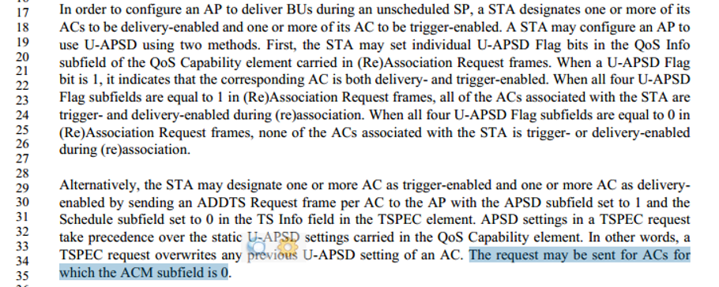

The cited sentence is nothing to do with the context. Agreed with the commenter that this statement is not really needed here.

However, the revised sentence suggested from the commenter is incorrect: “….. the request shall not be sent for ACs for which the ACM subfield is 1”.

How to send ADDTS request and relationship with ACM values are described in 8.4.2.28 EDCA Parameter Set element and 9.22.4 Admission Control at the HC. As an example, in 8.4.2.28 EDCA Parameter Set element

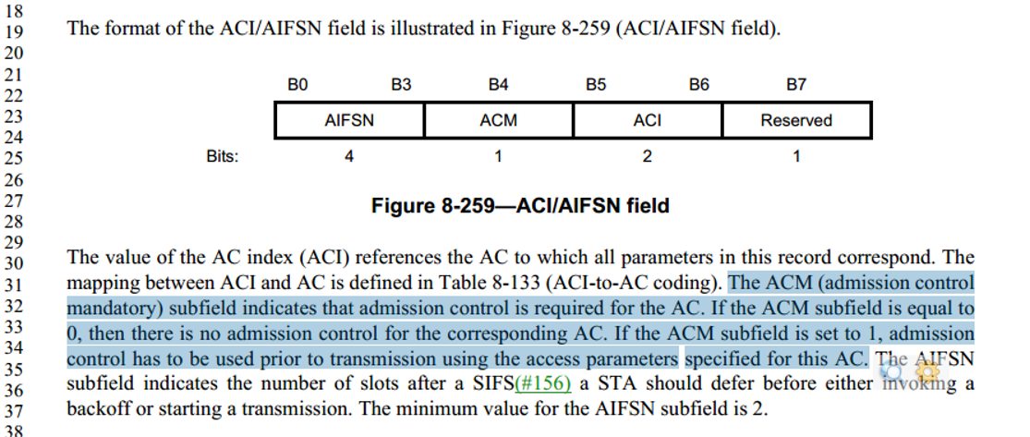

In 9.22.4.2.1 General
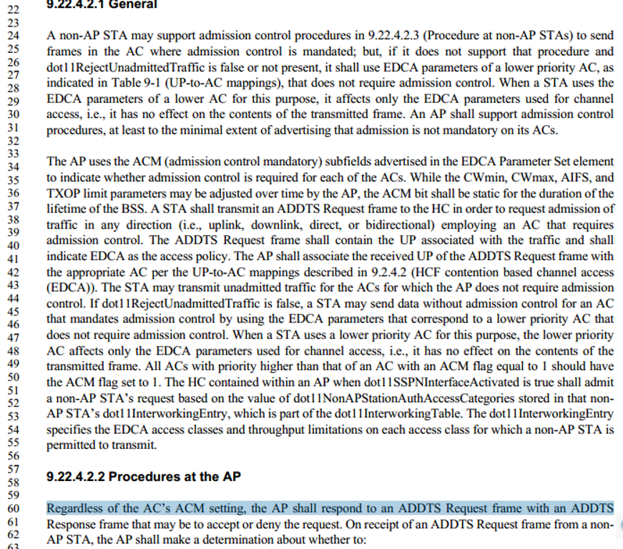

Proposed resolution:
Revised.
At 1552.34, change “The request may be sent for ACs for which the ACM subfield is 0”. to: “The ADDTS Request frame may be sent for ACs regardless of the ACs’ ACM settings.”.

CID | Page | Clause | Resn Status | Comment | Proposed Change | Resolution | Owning Ad-hoc
5214 | 1552.10 | 10.2.2.5.1 |  | This paragraph does not acknowledge that the times at which the AP transmits during an unscheduled SP may be additionally constrained by the U-APSD coexistence mechanism. | Add a statement to this para somewhere: "The times at which an AP may transmit during an unscheduled SP might be constrained by the U-APSD Coexistence mechanism (see 10.2.2.5.2)." |  | MAC

Discussion
Cited text:

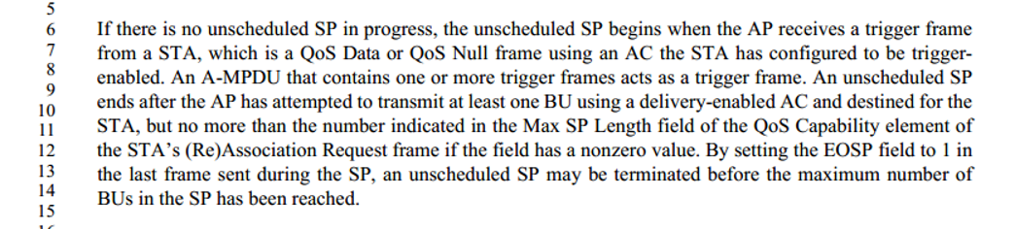

Agree with commenter that adding a statement might be helpful.

Proposed resolution:
Revised.
At the end of cited paragraph, add "The times at which an AP may transmit during an unscheduled SP might be constrained by the U-APSD coexistence mechanism (see 10.2.2.5.2)."

CID | Page | Clause | Comment | Proposed Change | Resolution | Owning Ad-hoc
5218 | 1560.62 | 10.2.2.10 | This subclause doesn't acknowledge the U-APSD coexistence mechanism, which has a whole raft of rules about receive operation. | Add a sentence, "For receive operation using the U-APSD coexistence mechanism, also see 10.2.2.5.2." |  | MAC

Discussion
Agree with commenter that adding a statement might be helpful.

However, I don’t think “also” is needed.

Cited clause:
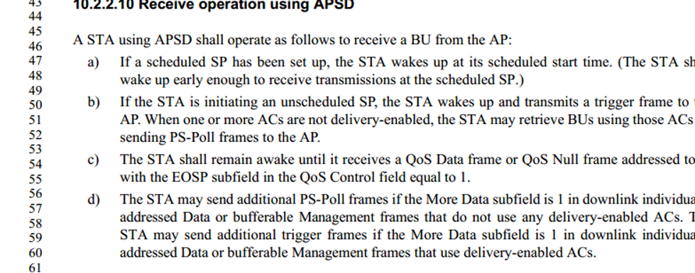

Proposed resolution:
Revised.
At the end of cited clause 10.2.2.10, add a paragraph/sentence: "For receive operation using the U-APSD coexistence mechanism, see additional procedures in 10.2.2.5.2.”

CID | Page | Clause | Resn Status | Comment | Proposed Change | Resolution | Owning Ad-hoc
5216 | 1557.53 | 10.2.2.6 |  | "The APmay base the aging function on the Listen Interval  specified by the STA in the (Re)Association Request frame or the WNM-Sleep Interval specified by  the non-AP STA in the WNM-Sleep Mode Request frame." -- this statement is a subset of the previous may, and is therefore strictly unnecessary. | Reword: "The AP might base..." |  | MAC

Discussion
Cited text:

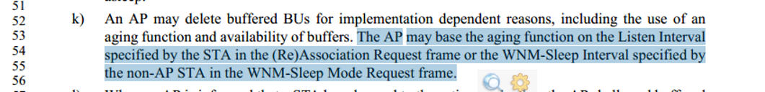

Agree with commenter.

Proposed resolution:
Rejected.
This sentence applies to the aging function. The previous sentence is much broader. This is not duplication.

CID | Page | Clause | Resn Status | Comment | Proposed Change | Resolution | Owning Ad-hoc
5217 | 1559.52 | 10.2.2.8 |  | Dual beacon is deprecated. This para should acknowledge this. | Add to this para "The use of the dual beacon (i.e., transmission of both non-STBC and STBC Beacon frames) mechanism is deprecated." |  | MAC
Discussion
Cited text:
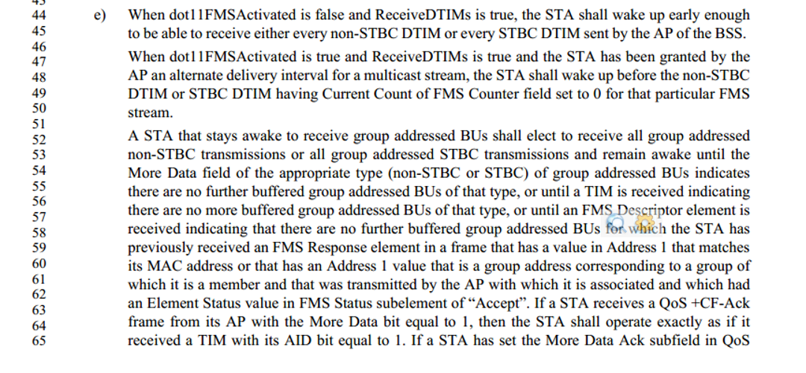
The dual beacon deprecation is acknowledged in 8.4.2.56 HT Operation element, see:

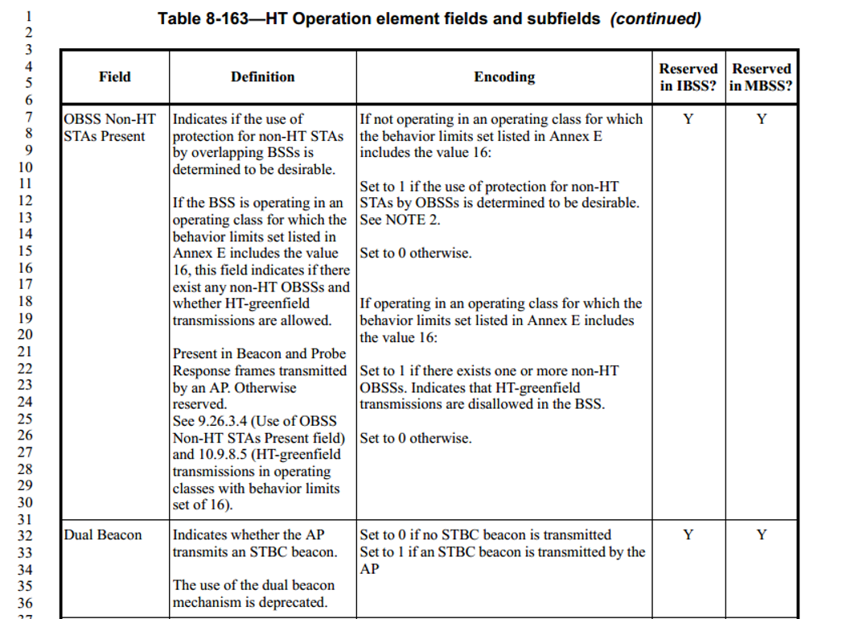

There is no need to acknowledge the deprecation in every location in the spec.

Proposed resolution:
Rejected. The deprecation is already acknowleged in 8.4.2.56 and 10.1.3.2.
CID | Page | Clause | Comment | Proposed Change | Owning Ad-hoc
5219 | 1548.00 | 10.2 | I congratulate the WG on inventing the following unique power-saving mechanisms:  1. IBSS  2. Infrastructure PS-Poll  3. U-APSD  4. U-APSD with coexistence mechanism  5. S-APSD  6. TDLS  7. Mesh  8. PCP  9. FMS power save  10. WNM Sleep mode  11. VHT TXOP power save  12. Spatial multiplexing power save  I encourage the WG to create additional power-saving mechanisms. | Add several new power-saving mechanisms.  For example, during one beacon interval, a STA might save power by transmitting only bits containing zero, and transmit the one bits in the next beacon interval.  Those cleverer than I can see this is a fruitful field of endeavor. Be creative ... you know you want to. | MAC

Discussion

Proposed resolution:
Rejected.
The comment fails to identify a specific issue to be addressed. It fails to identify changes in sufficient detail so that the specific wording of the changes that will satisfy the commenter can be determined.

CID | Page | Clause | Comment | Proposed Change | Owning Ad-hoc
5220 | 1580.18 | 10.2.6.1 | To be consistent with the DTI components, add "BHI" in the leftmost column covering the first three non-header rows.  Ditto at 1581.07 | As in the comment. | MAC

Discussion
Cited text:
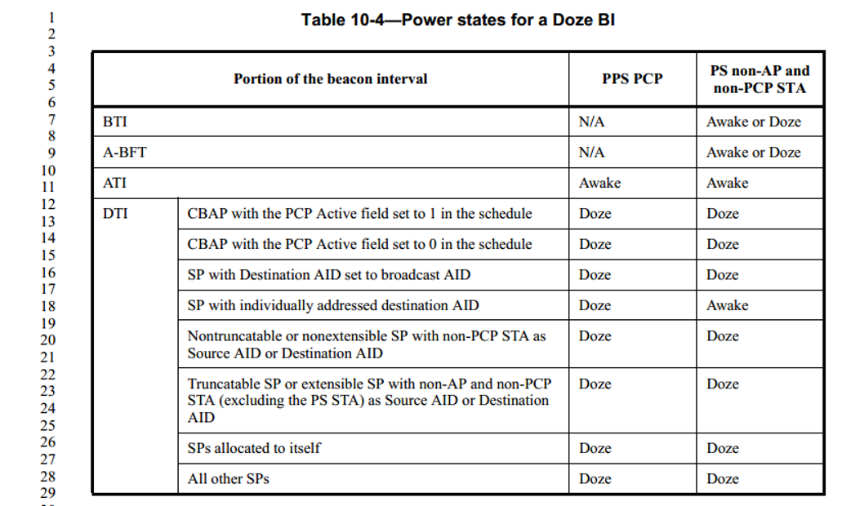

Agree with comenter. BHI comprises BTI, A-BFI, and ATI.

Proposed resolution:
Accepted.

CID | Page | Clause | Comment | Proposed Change | Owning Ad-hoc
5221 | 1582.13 | 10.2.6.2.2 | There is a layer of meaning in this state machine that is obscure.  The leftmost top bubble "expands" to the state machine below it. But the rightmost bubble expands to one of the two state machines below it with transitions that are not shown. | Redraw the state machine so that all states are shown and all transitions identified clearly.  Make matching changes at 1585.02. | MAC

Discussion
It is not clear how to redraw it. A submission is required for review.
Suggest assigning to the commenter.

Assigned to Solomon Trainin

Proposed resolution: TBD.

CID | Page | Clause | Comment | Proposed Change | Owning Ad-hoc
5501 | 1550.34 | 10.2.2.2 | "Wait until the ProbeDelay time has expired": but there is no such variable in the MLME. The only value of ProbeDelay available is that from the most recent invocation by the SME of one of the three primitives: MLME-SCAN.request, MLME-JOIN.request, or MLME-START.request. In the current context (after the MLME-POWERMGT.request primitive has run) the appropriate primitive appears to be either the MLME-JOIN.request or the MLME-START.request, so the text needs to specify either of those as the source of the value of the ProbeDelay parameter. | Replace "Waiit until the ProbeDelay time has expired" with "Wait until the time indicated by the ProbeDelay parameter (from the most recent SME invocation of either the MLME-JOIN.request or the MLME-START.request) has expired" | MAC

Discussion
I couldn’t find the quoted text at cited location 1550.34.
I guest the commenter may comment on “until a period of time equal to the ProbeDelay has transpired.”:

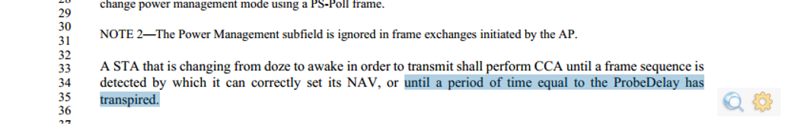

The commenter mentioned two primitives: MLME-JOIN and MLME-START. However, in the current context (after the MLME-POWERMGT.request primitive has run), I think the appropriate primitive appears to be the MLME-JOIN.request only, not MLME-Start.request. The MLME-Start.request is for “the MAC entity start a new BSS or become a member of an MBSS.”.

Therefore, only MLME-JOIN.request need to be cited.

Proposed resolution:
Revised.
At the cited location, change “until a period of time equal to the ProbeDelay has transpired " to “until a period of time indicated by the ProbeDelay parameter from the most recent MLME-JOIN.request primitive has transpired.”

CID | Page | Clause | Comment | Proposed Change | Owning Ad-hoc
5211 | 1550.17 | 10.2.2.2 | "a STA shall inform the AP through a successful frame exchange" -- in an unlicensed band "shall do something successfully" is not a valid requirement for compliance | Reword in terms of what the STA shall do "transmit" and how it responds to both successful and unsuccessful outcomes of the attempted transmission. | MAC

Discussion

Cited text:

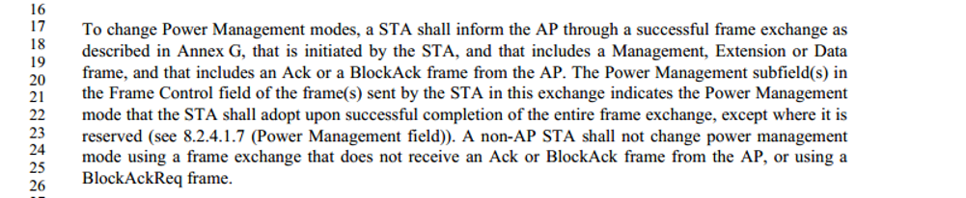

The first sentence can be improved or simplified.

Proposed resolution:
Revised.
Same comment resolution as CID 5499.
"To change power management modes a STA shall inform the AP by completing a successful frame exchange (as described in Annex G) that is initiated by the STA and that includes a Management frame, Extension frame or Data frame, and also an Ack or a BlockAck frame from the AP."

CID | Page | Clause | Comment | Proposed Change | Owning Ad-hoc
6246 | 1568.40 | 10.2.2.16.4 | It says "The AP will not deliver the requested streams at the delivery interval as specified by the non-AP STA in the FMS Request element" -- it will deliver them at a different delivery interval? Or not at all? | Clarify the subsequent AP behaviour | MAC

Discussion

Cited text:
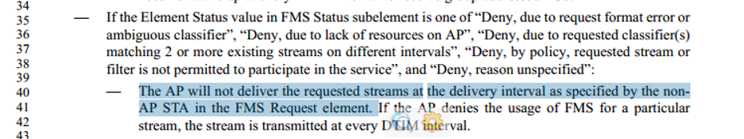

The subsequent AP behaviour is described in the second sentence: “If the AP denies the usage of FMS for a particular stream, the stream is transmitted at every DTIM interval.”.

Perhaps the second sentence can be improved.

Proposed resolution:
Revised.
Change “If the AP denies the usage of FMS for a particular stream, the stream is transmitted at every DTIM interval.” To “The AP delivers the requested streams at every DTIM interval.”

CID | Page | Clause | Comment | Proposed Change | Owning Ad-hoc
6816 | 1548.00 | 10.2 | "10.2.2 Power management in a non-DMG infrastructure network" contains vast amounts of detail. "10.2.6 Power management in a PBSS and DMG infrastructure BSS" is much thinner. Is it really the case that the latter is complete for DMG infrastructure BSSes (e.g. it doesn't include any APSD stuff)? | Add any missing stuff for PBSSes and DMG ABSSes | MAC

Discussion
The comment fails to identify a specific issue to be addressed.

Proposed resolution:
Rejected
The comment fails to identify a specific issue to be addressed. It fails to identify changes in sufficient detail so that the specific wording of the changes that will satisfy the commenter can be determined.

CID | Page | Clause | Comment | Proposed Change | Owning Ad-hoc
6427 | 1548.15 | 10.2.1 | Are FTM frames bufferable? This subclause suggests they are | Either state that a non-AP STA doing FTM needs to be in active mode during burst instances, or state that FTM frames are not bufferable | MAC

Discussion

Non-AP STA doing FTM needs to be in Active mode. This, though not explicitly stated, is implicit in the protocol specification.

Okay to add a sentence to clarify it.

Proposed resolution:
Revised

At the end of 10.24.6.1 (D4.0), add the following sentence:

“A STA that is in a FTM session shall be in active mode.”

CID | Page | Clause | Comment | Proposed Change | Owning Ad-hoc
6462 | 1556.43 | 10.2.2.6 | "For a STA using U-APSD, the AP transmits one BU destined for the STA from any AC that is not delivery-enabled in response to PS-Poll from the STA. When all ACs associated with the STA are delivery-enabled, AP transmits one BU from the highest priority AC that has a BU." -- in the first case it would be advisable if high-priority traffic were, like, prioritised | After the first sentence cited add "The AP should transmit the BU from the highest priority AC that is not delivery-enabled and that has a BU." | MAC

Discussion

Cited text:
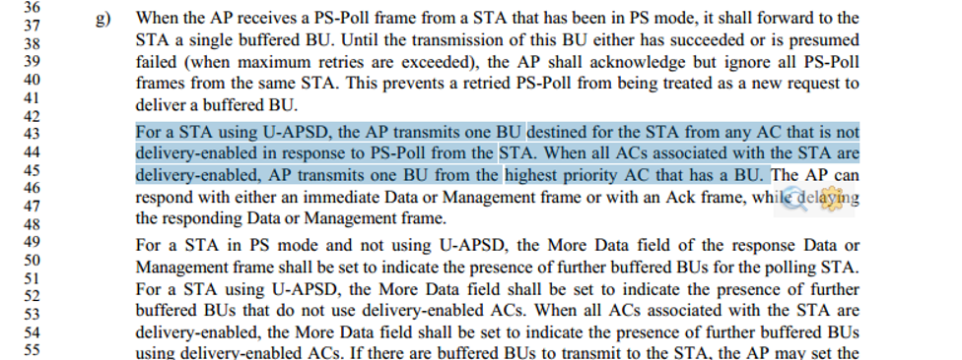

Proposed resolution:
Revised.
After the first sentence cited, add:
“The AP should transmit the BU from the highest priority AC that is not delivery-enabled and that has a buffered BU.”

CID | Page | Clause | Comment | Proposed Change | Owning Ad-hoc
6468 | 1549.15 | 10.2.2.1 | What does "A STA may use both WNM-sleep mode and PS mode simultaneously." mean? | Clarify, or demote to a NOTE | MAC

Discussion

Cited text:
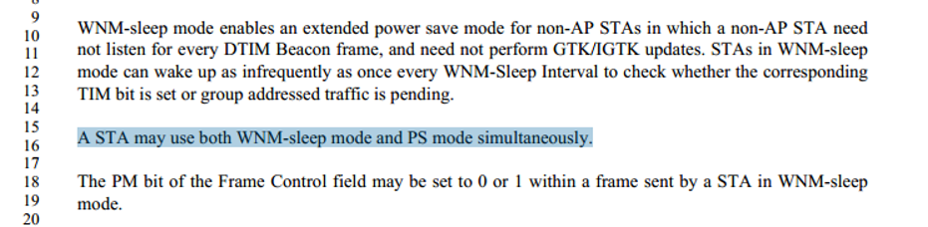

Don’t think we need additional clarification. Okay to change it to a note.

Proposed resolution:
Revised.

Change “A STA may use both WNM-sleep mode and PS mode simultaneously.” To “NOTE-- A STA can use both WNM-sleep mode and PS mode simultaneously.”

CID | Page | Clause | Comment | Proposed Change | Owning Ad-hoc
6473 | 1564.42 | 10.2.2.15.1 | When TDLS is used without QoS, TPU cannot be used. | Add a sentence to that effect in 10.2.2.15.1 | MAC

Discussion
If TDLS is used without QoS, the dot11TDLSPeerUAPSDBufferSTAActivated CANNOT be set to true.
I think the first sentence of the cited clause is sufficient.

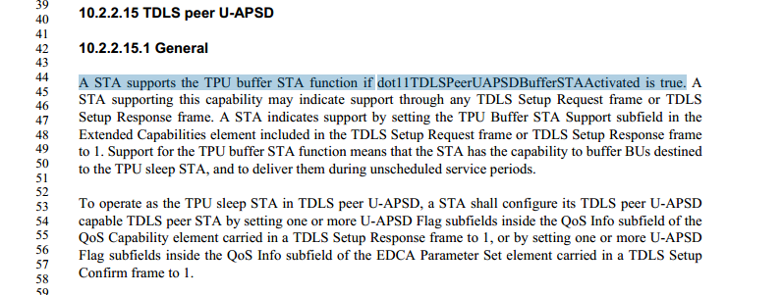

Proposed resolution:
Revised.
At 1564.42, after the first sentence, add:
“A non-QoS STA shall set dot11TDLSPeerUAPSDBufferSTAActivated to false.”

CID | Page | Clause | Comment | Proposed Change | Owning Ad-hoc
6494 | 1548.41 | 10.2.2 | 1557.51: "An AP may delete buffered BUs for implementation dependent reasons, including the use of an aging function [...] The AP may base the aging function on the Listen Interval". 1561.9: "Any AP aging function shall not cause the buffered BU to be discarded after any period that is shorter than the ListenInterval of the STA for which the BUs are buffered". Well, which is it? Is the AP required to honour the ListenInterval or not? | Change 10.2.2.6.k to have some kind of "subject to 10.2.2.12" | MAC

Discussion

The cited text at 1557.51 is in 10.2.2.6 AP Operation during the CP

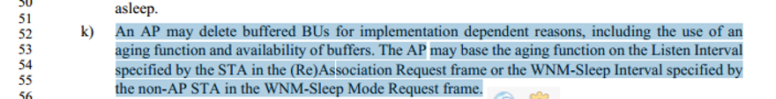

The cited text at 1561.9 is in 10.2.2.12 AP aging fnction

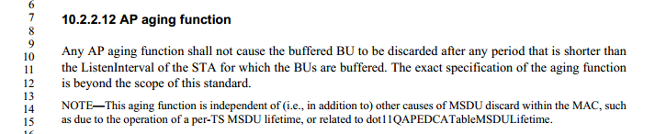

Agree with the comment’s suggestion. AP is required to honour the ListenInterval.

Proposed resolution:
Revised.
At 1557.52, change “…implementation dependent reasons, ” To “…implementation dependent reasons (subject to 10.2.2.12),”.

CID | Page | Clause | Comment | Proposed Change | Owning Ad-hoc
6504 | 1569.57 | 10.2.2.17 | What is the value of the "Overridden" status code in the TIM Broadcast Response element? | Add a NOTE to say this is treated exactly the same as Accept by the recipient, e.g. "NOTE---A Status field indicating Overridden can be treated exactly the same as one indicating Accept." | MAC

Discussion
Cited text at 1569.57: 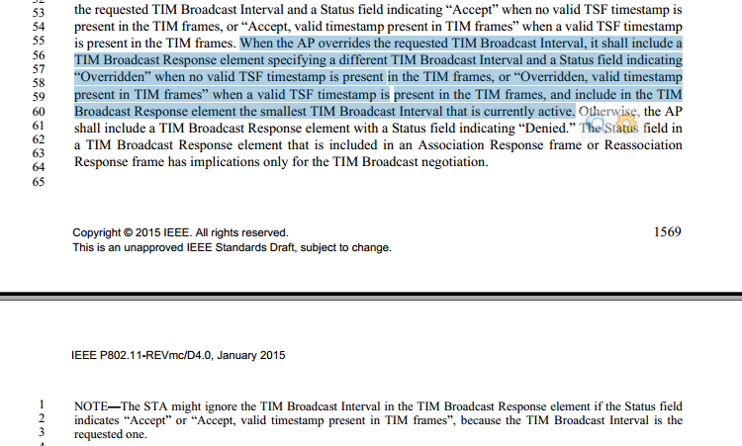

The the value of the “Overriden” is defined in Table 8-200:
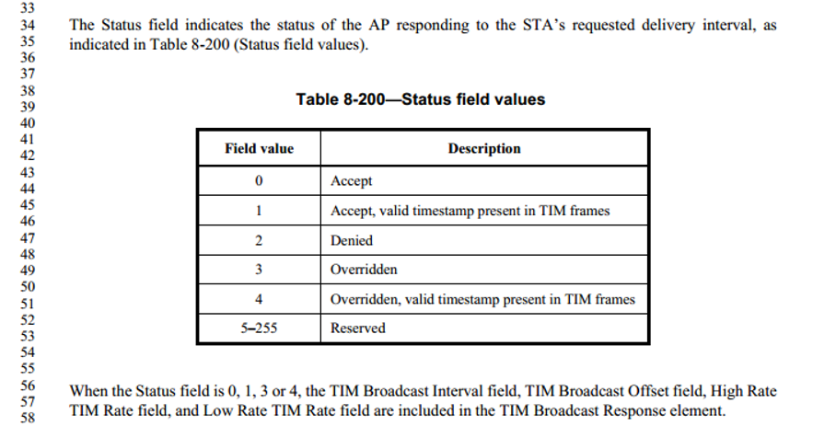

The behaviour of the STA receiving “Overridden” is different from the behaviour of receiving “Accept”.
According to 1570.1:
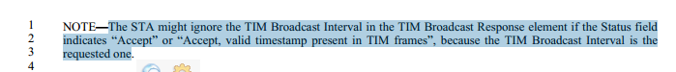
However, when the STA receives “Overridden”, it cannot ignore the TIM Broadcast Interval. The TIM Broadcast Interval specified in the TIM Broadcast Resposne element shall be used by the STA.

Proposed resolution:
Rejected.
The behaviour of the STA receiving “Overridden” might be different from the behaviour of the STA receiving “Accept”, see 1570.1

CID | Page | Clause | Comment | Proposed Change | Owning Ad-hoc
6600 | 1549.47 | 10.2 | "A STA that has transmitted a frame to an AP with which it is not associated and from which it expects a response shall remain in the awake state until such a response is received or until the procedure has timed out." -- equivalent statements need to be made for non-infrastructure cases | Add similar statements for IBSS, PBSS and perhaps also MBSS | MAC

Discussion

In IBSS, there is no “associated” concept. Therefore, similar statement won’t apply. The basic approach of power management in IBSS is described in 10.2.3. There is no need to add a similar sentence for IBSS.

For MBSS, s similar description is already covered in 13.14.8.3 Operation in deep sleep mode for nonpeer mesh STAs:
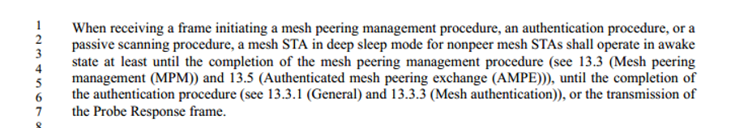

A PBSS is similar to an infrastructure BSS, a similar statement can be added.

Proposed resolution:
Revised.

At 1579.49 (for PBSS), add a new paragraph:
“A STA that has transmitted a frame to an AP or PCP with which it is not associated and from which it expects a response shall remain in the awake state until such a response is received or until the procedure has timed out.”

CID | Page | Clause | Comment | Proposed Change | Owning Ad-hoc
6688 | 1566.17 | 10.2.2.16 | Various FMS Element Statuses have the same behaviour (e.g. the "Terminate"s, the "Deny"s and some of the "Alternate preferred"s). Need a NOTE to say that the receiver may use the additional information in some vendor-specific way. | As it says in the comment | MAC

Discussion

Couldn’t identify a specific issue.

Proposed resolution:
Rejected.
The implementation can use the additional information in an implementation specific way without needing an additional note.

CID | Page | Clause | Comment | Proposed Change | Owning Ad-hoc
6698 | 1548.9 | 10.2 | Where are awake/doze state for IBSS, MBSS defined? | Add definitions, modelled on the infrastructure BSS ones | MAC

Discussion

Power management in IBSS is defined in 10.2.3 Power Management in an IBSS
Power management in MBSS is defined in 13.14 (Power Save in a mess BSS).
The procedures defined in 10.2.3 and 13.14 are sufficient. There is no need to modle on the infrastructure mode.

Proposed resolution: assigned to the commenter (Mark R), submission is required.
Rejected.
The comment fails to identify a specific issue to be addressed. It fails to identify changes in sufficient detail so that the specific wording of the changes that will satisfy the commenter can be determined.

CID | Page | Clause | Comment | Proposed Change | Owning Ad-hoc
6699 | 1548.9 | 10.2 | Where is active/PS mode for IBSS defined? | Add definitions, modelled on the infrastructure BSS ones | MAC

Discussion

Power management in IBSS is defined in 10.2.3 Power Management in an IBSS
The procedures defined in 10.2.3 is sufficient. There is no need to modle on the infrastructure mode.

Proposed resolution: a submission is required, and assigned to Mark R.
Rejected.
The procedures defined in 10.2.3 is sufficient. There is no need to modle on the infrastructure mode.

The comment fails to identify a specific issue to be addressed. It fails to identify changes in sufficient detail so that the specific wording of the changes that will satisfy the commenter can be determined.

CID | Page | Clause | Comment | Proposed Change | Owning Ad-hoc
6203 | 1568.4 | 10.2.2.16.3 | It says "To terminate the use of FMS for an FMS Stream identified by FMSID, the non-AP STA shall transmit an FMS Request frame with an FMS Request element and FMS subelement with the FMSID matching the FMS stream and the delivery interval set to 0.", but there is no FMSID in an FMS Request element, nor an FMS subelement. An FMS Request element contains an FMS Token for a stream set, but not the FMSID allocated by the AP to a stream | Resolution: add an FSMID to the FMS subelement in Figure 8-407---FMS subelement format | MAC

Discussion

There is no FMSID in an FMS Request element nor an FM subelement.

There are two possible solutions:
Option 1: add FMSID in the FMS subelement, if there is no any implemention existing today.
Option 2: remove FMSID in the cited sentence, if there is any implenention existing and clearly the FMSID is not needed.

My recommendation is option 2.
Rationale: The FMS subelement without FMSID should be sufficient to identify an FMS stream. The FMSID is just a value assigned by the AP. Each FMS subelement identifies an FMS stream…

see 1566.61 and 1567.16:
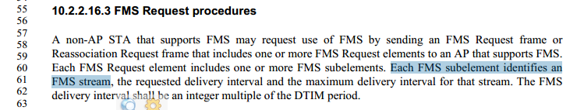

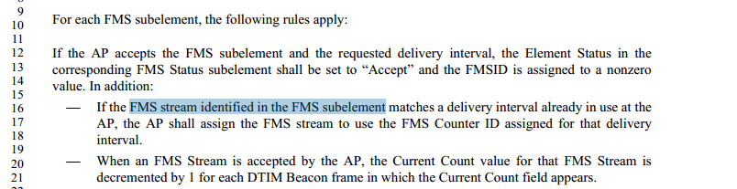

Proposed resolution:
Revised.
Option 1:
At 939.4 Figure 8-407, between the fields “Rate Identification” and “TCLAS Elements”, add the field “FMSID”, the length of this new field is 1 octet.

At 939.23, add a new paragraph:
“The FMSID field contains a unique identifier for this stream. If this is a new request, the FMSID field is reserved.. Otherwise, the FMSID is set to the value assigned by the AP in the FMS Response element.”

Option 2:
At 1568.4,

Change the text as follows:

To terminate the use of FMS for an FMS Stream identified by FMSID, the non-AP STA shall transmit an FMS Request frame with an FMS Request element and FMS subelement with the FMSID FMS subelement matching the FMS stream and the delivery interval set to 0.

CID | Page | Clause | Comment | Proposed Change | Owning Ad-hoc
6406 | 1578.15 | 10.2.5 | Does SMPS work for non-infrastructure BSSes (inc. IBSS, PBSS and MBSS)? | Add words to the effect that SMPS is only applicable to infrastructure BSSen | MAC

Discussion
SM power save is only applicable to infrastructure BSS.

Proposed resolution:
Revised
At 1578.22, change
“The SM power save feature allows a non-AP HT STA to operate with only one active receive chain for a significant portion of time.” To
“The SM power save feature allows a non-AP HT STA in an infrastructure BSS to operate with only one active receive chain for a significant portion of time.”

At 1578.59, Change
“A STA that has one or more DLS links shall not operate in SM power save mode.”
To
“A STA that has one or more DLS or TDLS links shall not operate in SM power save mode.”

