IEEE P802.11
Wireless LANs
802.11 REVmc Initial Sponsor ballot - Proposed resolutions for some SB0 power saving comments
Date: 2015-09-16
Author(s):
Name | Company | Address | Phone | email
Emily Qi | Intel Corporation |  |  | Emily.h.qi@intel.com
Abstract

This document contains proposed resolutions for some of SB0 comments in the power saving group.

R0: CIDs: 5212, 5214, 5216, 5218
R1: corrected the format.

CID | Page | Clause | Resn Status | Comment | Proposed Change | Resolution | Owning Ad-hoc
5212 | 1552.34 | 10.2.2.5.1 |  | "The request may be sent for ACs for  which the ACM subfield is 0." This statement is not really needed, but the converse one is. | Replace with: "The request may be sent for ACs for which the ACM subfield is 0; the request shall not be sent for ACs for which the ACM subfield is 1." |  | MAC

Discussion

Context at 1552.34:
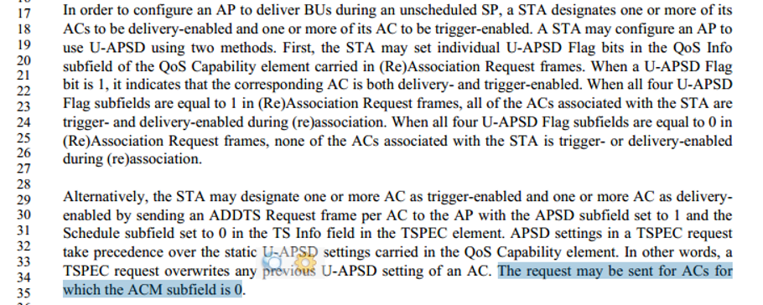

The cited sentence is nothing to do with the context.
Agree with the commenter that this sentence is not need.
However, the revised sentence suggested from proposed change is incorrect: “….. the request shall not be sent for ACs for which the ACM subfield is 1”.

How to send ADDTS request and relationship with ACM are described in 8.4.2.28 EDCA Parameter Set element and 9.22.4 Admission Control at the HC. As an example, in 8.4.2.28 EDCA Parameter Set element

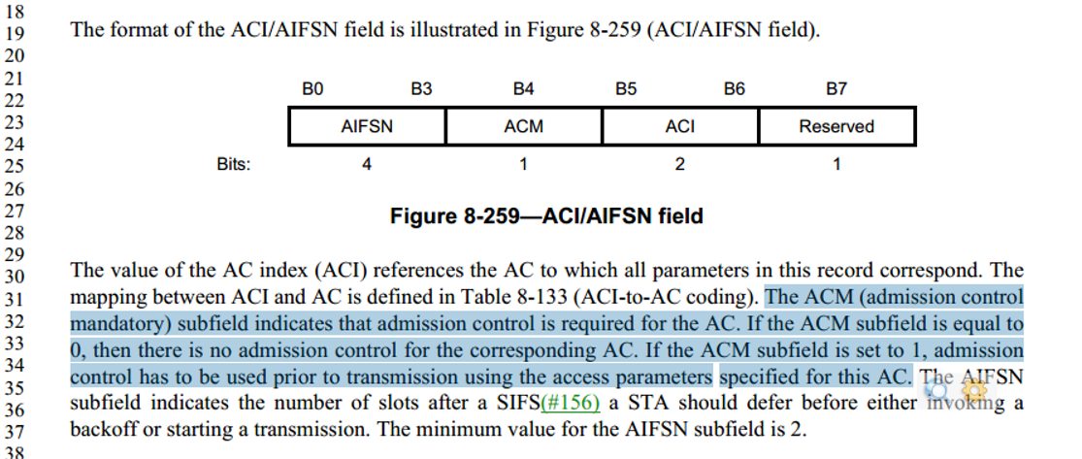

Proposed resolution:
Revised.
At 1552.34, remove the cited sentence “The request may be sent for ACs for which the ACM subfield is 0”.

CID | Page | Clause | Resn Status | Comment | Proposed Change | Resolution | Owning Ad-hoc
5214 | 1552.10 | 10.2.2.5.1 |  | This paragraph does not acknowledge that the times at which the AP transmits during an unscheduled SP may be additionally constrained by the U-APSD coexistence mechanism. | Add a statement to this para somewhere: "The times at which an AP may transmit during an unscheduled SP might be constrained by the U-APSD Coexistence mechanism (see 10.2.2.5.2)." |  | MAC

Discussion
Cited text:

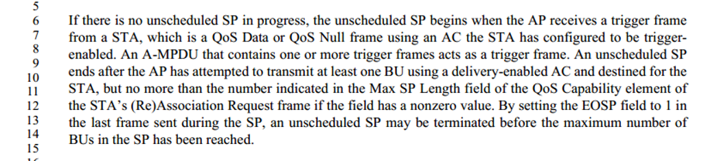

Agree with commenter that adding a statement might be helpful.

Proposed resolution:
Revised.
At the end of cited paragraph, add "The times at which an AP may transmit during an unscheduled SP might be constrained by the U-APSD coexistence capability (see 10.2.2.5.2)."

CID | Page | Clause | Comment | Proposed Change | Resolution | Owning Ad-hoc
5218 | 1560.62 | 10.2.2.10 | This subclause doesn't acknowledge the U-APSD coexistence mechanism, which has a whole raft of rules about receive operation. | Add a sentence, "For receive operation using the U-APSD coexistence mechanism, also see 10.2.2.5.2." |  | MAC

Discussion
Agree with commenter that adding a statement might be helpful.

Cited clause:
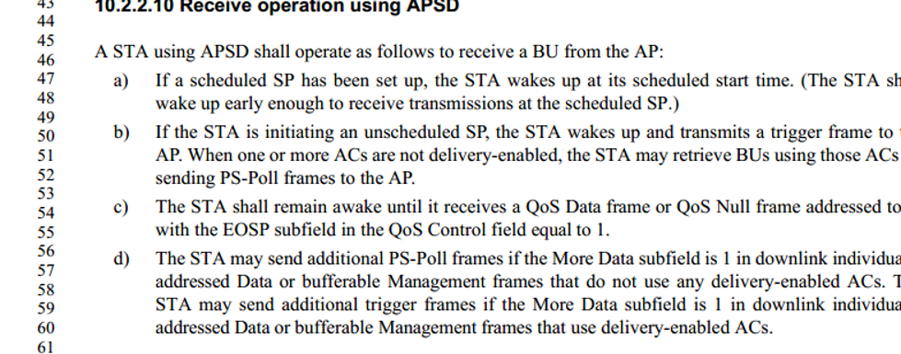

Proposed resolution:
Revised.
At the end of cited clause 10.2.2.10, add a paragraph/sentence: "For receive operation using the U-APSD coexistence capability, see 10.2.2.5.2.”

CID | Page | Clause | Resn Status | Comment | Proposed Change | Resolution | Owning Ad-hoc
5216 | 1557.53 | 10.2.2.6 |  | "The APmay base the aging function on the Listen Interval  specified by the STA in the (Re)Association Request frame or the WNM-Sleep Interval specified by  the non-AP STA in the WNM-Sleep Mode Request frame." -- this statement is a subset of the previous may, and is therefore strictly unnecessary. | Reword: "The AP might base..." |  | MAC

Discussion
Cited text:

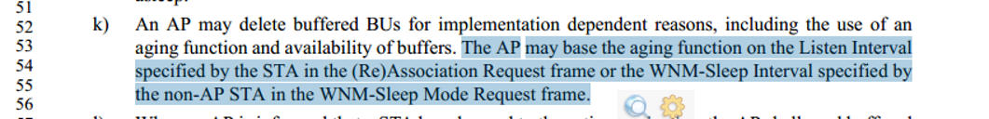

Proposed resolution:
Accept. At the cited location, replace “The AP may base …” with “The AP might base …”

