IEEE P802.11
Wireless LANs
REVmc SB1 Assorted CIDs
Date: November, 2015

Author:
Name | Affiliation | Address | Email
Menzo Wentink | Qualcomm | Straatweg 66, Breukelen, The Netherlands | mwentink@qti.qualcomm.com

Abstract

This document contains proposed resolutions for assorted REVmc comments received on sponsor ballot 1.

CIDs: 6199, 6186, 5966, 5967, 6181, 5965, 5968

History:
R0: initial revision
R1: updated after discussion in Bangkok and email from Mark Rison

CID | Identifiers | Comment | Proposed Change
6199 | 10.23.1  1711.6 | "A VHT STA with a TDLS link that is not an off-channel direct link shall use as its primary channel the channel indicated by the Primary Channel field in the HT Operation element." -- what if there isn't an HT Operation element (i.e. non-HT BSS or peer is not HT-capable)? | Clarify (perhaps say "shall use the primary channel of the BSS"?)

Discussion
The comment is correct in that the BSS does not have to be an HT BSS. The proposed resolution is generally acceptable.

Proposed resolution
Revised. On page 1711.6 change "A VHT STA with a TDLS link that is not an off-channel direct link shall use as its primary channel the channel indicated by the Primary Channel field in the HT Operation element." to "A VHT STA with a TDLS link that is not an off-channel direct link shall use as its primary channel the primary channel or the only channel of its BSS."

CID | Identifiers | Comment | Proposed Change
6186 | 10.23.6  1714.52 | It is not clear whether two HT non-VHT STAs may establish a 40 MHz direct link when the BSS is a 20 MHz-only BSS | Clarify (e.g. does "The channel width of a TDLS direct link with a primary channel equal to the base channel shall not exceed the channel width of the BSS to which the TDLS peer STAs are associated, except when the TDLS Wider Bandwidth subfield" apply in this case or only for VHT STAs?)

Discussion
The cited language indeed applies to the example of two HT non-VHT STAs, but the current text does not specifically need to be modified to make that clear (because the setting of the TDLS wider bandwidth subfield is not tied to HT or VHT specifically. However, the cited sentence should be modified to read "The channel width of a TDLS direct link on the base channel shall not exceed the channel width of the BSS to which the TDLS peer STAs are associated, except when the TDLS Wider Bandwidth subfield".

Proposed resolution
Revised. At 1710.64 (10.23.1), change

"The channel width of a TDLS direct link with a primary channel equal to the base channel shall not exceed the channel width of the BSS to which the TDLS peer STAs are associated, except when the TDLS Wider Bandwidth subfield"

to

"The channel width of a TDLS direct link on the base channel shall not exceed the channel width of the BSS to which the TDLS peer STAs are associated, except when the TDLS Wider Bandwidth subfield".

CID | Identifiers | Comment | Proposed Change
5966 | 9.22.2.3  1324.15 | EIFS can be avoided at devices that do not implement dynamic EIFS (yet) by requiring that a TXOP is always terminated with a transmission of an ACK at the lowest rate within the PHY. (Dynamic EIFS is defined in 9.3.7, P1042L13.) | Require that the TXOP holder terminates a TXOP with an ACK at the lowest rate within the PHY (i.e. at 6 Mbps for 11ac).

Discussion
Spurious EIFSs as addressed in the comment can be caused by any final control response frame transmitted at a rate higher than 6 Mbps (typically 12 or 24 Mbps), because the preamble of such PPDUs travels far beyond the MPDU, which causes an EIFS to occur in a potentially very large region. The response rate selection can not be controlled however, so an option is that the TXOP holder sends a short frame at 6 Mbps as the terminating frame in a TXOP. This final terminating transmission truncates an EIFS in a large region around the TXOP holder, strongly reducing the area where a a spurious EIFS may occur.

Based on offline discussion, it appears that there is a preference to use a CF-End as the terminating frame, because its definition already exists. A CF-End is longer than an ACK but probably still not causing much overhead. The proposed resolution therefore proposes to add an explanation about terminating any TXOP with a CF-End at 6 Mbps, and makes it a should requirement, while also allowing the use of an ACK or CTS.

Note that an alternative solution would be to deprecate EIFS altogether.

Proposed resolution
Revised. In 9.3.7 (DCF timing relations), at P1277 L5, add a new paragraph as follows:

"In the 5 GHz band, a final control response frame at a rate higher than 6 Mbps (typically 12 or 24 Mbps) can cause spurious EIFSs to occur in a wide region, because the preamble of such PPDUs travels much farther then the MPDU. For this reason, a TXOP in the 5 GHz band should be terminated by the TXOP holder with a transmission of a CF-End frame at 6 Mbps when the last response frame in the TXOP is transmitted at a rate higher than 6 Mbps. The CF-End frame may be replaced with an ACK or CTS frame when a NAV does not need to be truncated."

CID | Identifiers | Comment | Proposed Change
5967 | 8.4.2.157.3  1042.53 | In some cases it is desirable to be able to signal that the maximum supported NSS for 80+80 MHz or 160 MHz packet bandwidth is half the maximum supported NSS for 80 MHz packet bandwidth. However, the Supported VHT-MCS and NSS Set does not currently support this. | Add the option of signaling half-Max Nss support for 80+80 and 160 MHz packet bandwidth.

Discussion
This CID is addressed by document 11-15/654r14, for CID 5960.

Proposed resolution
Revised. Incorporate text changes in 11-15/654r14, for CID 5960.

CID | Identifiers | Comment | Proposed Change
6181 | 8.6.13.4  1157.36 | The HT Operation element is not included if the BSS supports HT. This prevents a 40 MHz TDLS link being set up in a 20 MHz HT BSS, and leads to ambiguities if the BSS also supports VHT | Delete ", and the BSS does not support HT" at the referenced location. Also delete "but the BSS is not" in "The HT Operation element shall be present in a TDLS Setup Confirm frame when both STAs are HT capable but the BSS is not." in 10.23.1

Discussion
The comment correctly observes that the omission of an HT operation element from the TDLS setup confirm frame was unnecessary, and it currently prevents setting up a 40 MHz HT TDLS link in a 20 MHz HT BSS. Therefore the comment should be accepted,

Proposed resolution
Accepted.

CID | Identifiers | Comment | Proposed Change
5965 | 8.4.2.28  835.09 | Techniques that rely on the freshness of sounding information, such as downlink MU MIMO, will benefit from TXOPs that are longer than 2 ms. Although the values in this table apply only to STAs and an AP can set its own TXOP limits, these values may still be used to set a default value for the AP also. Therefore, in order to allow for longer TXOPs, it should be allowed to exceed the TXOP limit in exchange for a larger CW. | Allow exceeding the TXOP limit in exchange for a larger CW.

Discussion
Trading a longer TXOP time for less TXOPs through the contention window is generally acceptable, but there should be an ultimate maximum TXOP limit to avoid issues with latency sensitive traffic.

As an example, when CWmin and CWmax of a node are multiplied by a factor 2, the effect on the success rate is as follows:

#active nodes | 5 | 10 | 20 | 40 | 60
success rate for 1x | 0.170 | 0.078 | 0.035 | 0.016 | 0.010
success rate for 2x | 0.089 | 0.041 | 0.018 | 0.007 | 0.005
TXOP ratio 2x:1x | 52% | 52% | 51% | 45% | 48%
success rate others 1x | 0.170 | 0.078 | 0.035 | 0.016 | 0.010
success rate others 2x | 0.192 | 0.082 | 0.036 | 0.016 | 0.010
TXOP ratio others | 113% | 106% | 103% | 102% | 101%

The effect of one node going from 1x to 2x CWmin/CWmax in a network with 10 active nodes is illustrated in the figure below.

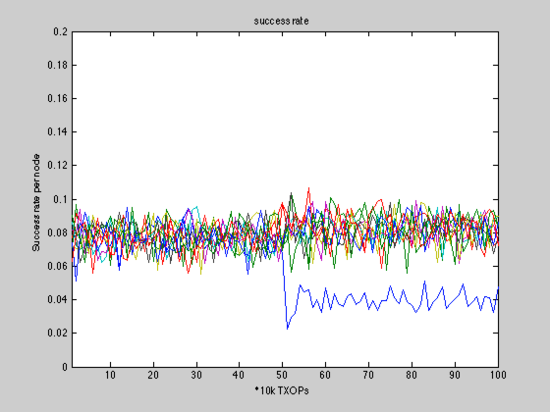

The figure illustrates that the 2x node drops to about half number of successes after having doubled its CWmin and CWmax, and that the other nodes gain slightly at that point.

When one of the nodes is a video node (VI), and CWmin and CWmax of one of the other nodes are multiplied by 2, the effect on the success rate is as follows:

#active nodes (1 VI) | 5 | 10 | 20 | 40 | 60
success rate for 1x | 0.087 | 0.044 | 0.022 | 0.010 | 0.007
success rate for 2x | 0.044 | 0.024 | 0.012 | 0.006 | 0.003
TXOP ratio 2x:1x | 50% | 55% | 56% | 53% | 51%
success rate others 1x | 0.087 | 0.044 | 0.022 | 0.010 | 0.007
success rate others 2x | 0.098 | 0.047 | 0.022 | 0.010 | 0.007
TXOP ratio others | 112% | 106% | 102% | 101% | 102%
success ratio VI 1x | 0.511 | 0.404 | 0.325 | 0.270 | 0.249
success ratio VI 2x | 0.532 | 0.407 | 0.327 | 0.272 | 0.245
TXOP ratio VI | 104% | 101% | 101% | 101% | 100%

The effect of one node going from 1x to 2x CWmin/CWmax in a network with 10 active nodes of which one node is a VI node is illustrated in the figure below.

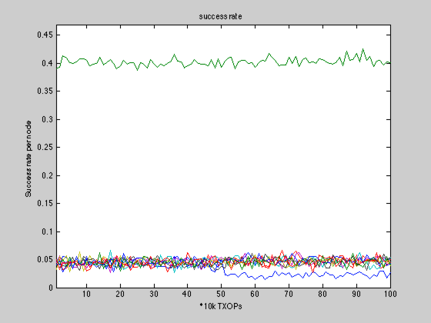

The figure illustrates that the 2x node drops to about half number of successes after having doubled its CWmin and CWmax, and that the other nodes (including the VI node) gain slightly at that point.

The TXOP limit should likely not be allowed to be exceeded by more than a factor 2.

Proposed resolution
Revised. Add the following sentence at the end of clause 9.22.2.8 (TXOP limits), at P1332 L10:

"The TXOP limit may be multiplied by a factor n when the associated CWmin and CWmax are also multiplied by n, where n shall be between 1 and 2."

CID | Identifiers | Comment | Proposed Change
5968 | 8.3.3.9  632.53 | Probe Request and Probe Response have been growing in size, which is undesirable in particular at low rates such as 1 Mbps. | Reduce the size of Probe Request and Probe Response, for example by including only a couple supported rates and by defining a shorthand notation for frequently used configurations.

Discussion
Probe request frames can be very long, while their only purpose is to evoke the transmission of probe responses by nearby APs. In order to be able to send a probe response, the AP only needs to know a couple supported rates, there is no need to include any further capabilities. But, if necessary, a shorthand notation could be defined for commonly used sets of capabilities and abbreviated by a pseudo rate. For example, for the HT and VHT PHYs the respective membership selector can be used with the MSB equal to 0 (i.e. not contained in the basic rate set).

The way this would operate is as follows:

- A minimal set of information is inserted into the Probe Request, enough for an AP to have some choice for the response rate
- One or more membership selectors are added, to allow the AP to abbreviate its Probe Response by also including membership selectors
- Optionally add a request element, ANQP elements, proprietary elements, etc.

In other words, when an AP does not recognize the membership selector, then it responds with a full Probe Response as usual. But when the AP does recognize the the membership selector, then it can respond with a reduced Probe Response.

Proposed resolution
Revised. Add the following paragraph at the end of 10.1.4.3.2 (Active scanning procedure for a non-DMG STA), at P1540 L57:

"The elements included in a Probe Request frame may be limited to an SSID element, a Supported Rates element, and optionally a DS element. The Supported Rates element may indicate a reduced set of supported rates. The Supported Rates element may include Membership Selector values with the MSB set to '0' (e.g. not a basic rate) as a shorthand for support of the mandatory portions of a specific PHY."

Add the following paragraph at the end of 10.1.4.3.5 (Contents of a probe response), at P1544 L9:

"When the received Probe Request frame contained a Membership Selector with the MSB set to '0', then the capability indication in the Probe Response frame may be limited to the same Membership Selector, as a shorthand for support of the mandatory portions of the specific PHY."

