IEEE P802.11
Wireless LANs
DMG Unified Header
Date: 14 March 2016
Author(s):
Name | Company | Address | Phone | Email
Payam Torab | Broadcom Ltd. |  |  | payam.torab@broadcom.com
Carlos Cordeiro | Intel |  |  | carlos.cordeiro@intel.com
Alecsander Eitan | Qualcomm |  |  | eitana@qti.qualcomm.com

Abstract
This submission proposes to use the DMG SC mode header encoding and modulation for DMG low-power SC (LPSC) mode headers, to enable “SC-only” DMG devices to decode the PHY header of LPSC mode transmissions and understand the packet structure including duration. Some editorial corrections related to DMG OFDM mode are also included.

The changes are relative to Draft P802.11REVmc_D5.0. This contribution is provided as resolution to CID 7173 and 7175.

Discussion

The current text defines 4 DMG PHY modes: Single Carrier (SC), low-power SC (LPSC), OFDM and Control. All DMG STAs are required to support Control and SC modes.

Support for OFDM mode and LPSC mode is optional. OFDM and LPSC modes use headers that are different from the SC mode. This leads to the situation that compliant DMG devices that support only Control and SC modes (“SC-only” devices) will be unable to decode the OFDM mode and LPSC mode packet headers, and as a result unable to calculate the duration of these packets.

There is wide interest to deprecate or remove the DMG OFDM mode. This submission focuses on the DMG LPSC mode and proposes to change the LPSC mode PHY header to SC mode header. The LPSC mode preamble is already the same as SC mode.

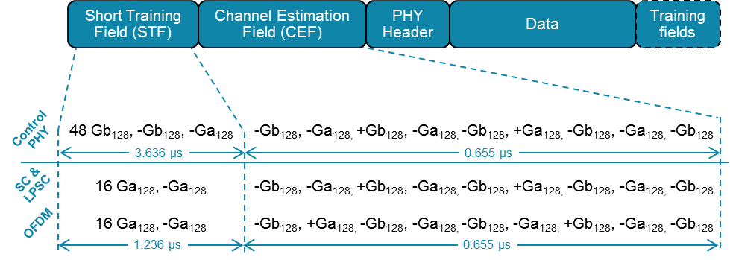

Revision History

Rev 0: Initial revision
Rev 1: Fixed boilerplate
Rev 2: Limited the contribution scope to DMG LPSC mode, but kept editorial changes for DMG OFDM mode
Rev 3: Editorial changes; corrections to section numbering

Torab Jahromi, Payam | 7173 | 2471.01 | 20.7.2.2 | DMG LPSC mode PHY header is transmitted using Reed-Solomon coding, which makes it not decodable to Single Carrier only (SC-only) DMG devices, creating serious coexistence issues. DMG LPSC mode has not been productized to the best of my knowledge and as it is defined today will interfere with SC-only devices that will ship in very large quantities. | Transmit the LPSC PHY header using SC modulation and coding; text will be provided. | GEN | DMG PHY

20.1 DMG PHY introduction
20.1.1 Scope
...
[DMG OFDM mode preamble is unfortunately different but has a similar structure (in terms of type and number of Golay sequences) to SC and LPSC mode; also header is now common to all DMG PHY modes.]
All DMG modulation methods share a similar preamble (see 20.3.6 (Common preamble)).

20.3.4 Timing-related parameters
...
[Change the following row in Table 21-4.]

T_{HEADER}: Header Duration | 0.242 μs=TSYM (OFDM)  0.582 μs =2 × 512 × Tc (SC and low-power SC)

20.7.2.2.2 Header encoding and modulation
[LPSC PHY Header Change -- Replace the entire text under 20.7.2.2.2 with the following sentence.]
The DMG low-power SC mode header is encoded and modulated as defined in 20.6.3.1.4 (Header encoding and modulation).

[Correct table titles in Section 20 following accepted CID 6270 naming and make them consistent.]

Table 20-10—DMG control mode modulation and coding schemes
Table 20-11—DMG control mode header fields
Table 20-12—DMG control mode EVM requirements
Table 20-13—DMG OFDM mode header fields
Table 20-14—DMG OFDM mode modulation and coding schemes
Table 20-16—DMG OFDM mode EVM requirements
Table 20-17—DMG SC mode header fields
Table 20-18—DMG SC mode modulation and coding schemes
Table 20-21—DMG SC mode EVM requirements
Table 20-22—DMG low-power SC mode modulation and coding schemes
Table 20-23—Zero filling for DMG SC mode BRP packets

[Update the informative Appendix I.]

I.4 DMG example data vectors
[Editorial clean up in the first paragraph]
... Text files referenced by these subclauses are contained in the DMGEncodingExamples.zip file embedded in the IEEE 802.11 Working Group document 11-12/0751r0, located at
https://mentor.ieee.org/802.11/dcn/12/11-12-0751-00-00ad-dmg-encoding-examples.docx.

[Fix #6270 implementation error (section title).]
I.6.2 DMG SC mode header

[Fix #6270 implementation error (section title).]
I.6.3 DMG SC mode payload

[Fix #6270 implementation error (section title).]
I.7.2 DMG OFDM mode header

[Replace “DMG LP SC mode” with “DMG low-power SC mode” in L.8 and all its subsections.]

I.8.2 DMG low-power SC mode header
[Replace the entire text in this section (including subsections I.8.2.1 through I.8.2.6) with the following sentence.]
DMG low-power SC mode header fields are the same as DMG SC mode header fields. The DMG low-power SC mode header is encoded and modulated in the same way as the DMG SC mode header.

