IEEE P802.11
Wireless LANs
DMG Unified Header
Date: 10 November 2015
Author(s):
Name | Company | Address | Phone | Email
Payam Torab | Broadcom |  |  | ptorab@broadcom.com

Abstract
This submission proposes to use the DMG SC mode header encoding and modulation for DMG OFDM mode and DMG low-power SC mode headers, to ensure that all DMG devices can decode any DMG packet header and understand its structure including duration. Some editorial corrections are also included.

The changes are relative to Draft P802.11REVmc_D4.2.

Discussion

The current text defines 4 DMG PHY modes: Single Carrier (SC), low-power SC (LPSC), OFDM and Control. All DMG STAs are required to support Control and SC modes.

Support for OFDM mode and LPSC mode is optional. OFDM and LPSC modes use headers that are different from the SC mode. This leads to the situation that compliant DMG devices that support only Control and SC modes (“SC-only” devices) will be unable to decode the OFDM mode and LPSC mode packet headers, and as a result unable to calculate the duration of these packets.

This submission proposes to change the OFDM mode and LPSC mode headers to SC mode header. The preambles are kept the same.

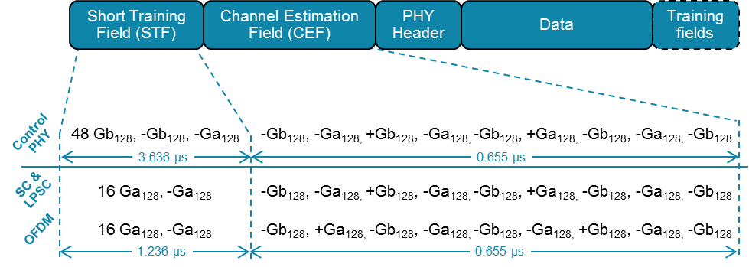

We observe that there may be SC-only implementations that despite this change will not decode an OFDM mode header, because they do not implement or exercise any OFDM decoding function. These devices identify an OFDM packet from its different CEF, and assuming they are unable to decode the packet header (which is sent in OFDM according to the current text) will drop the packet.

This proposal does NOT make any difference for these devices. Any DMG device is free to discard OFDM packets based on its different CEF, with implicit assumptions about the PPDU length, with or without this change.

However, any SC-only DMG device that is willing to burn more power to look into the packet header to determine the PPDU duration is fundamentally unable to decode the header beacsue it is transmitted in OFDM for OFDM packets, and in LPSC for LPSC packets. These devices will be able to use the different CEF as advance notice of an upcoming OFDM payload and switch to OFDM decoding at the payload boundary.

The diagram below illustarate the benefit of this change for SC-only devices in the presence of OFDM transmissions – with ZERO impact on any existing SC-Only device.

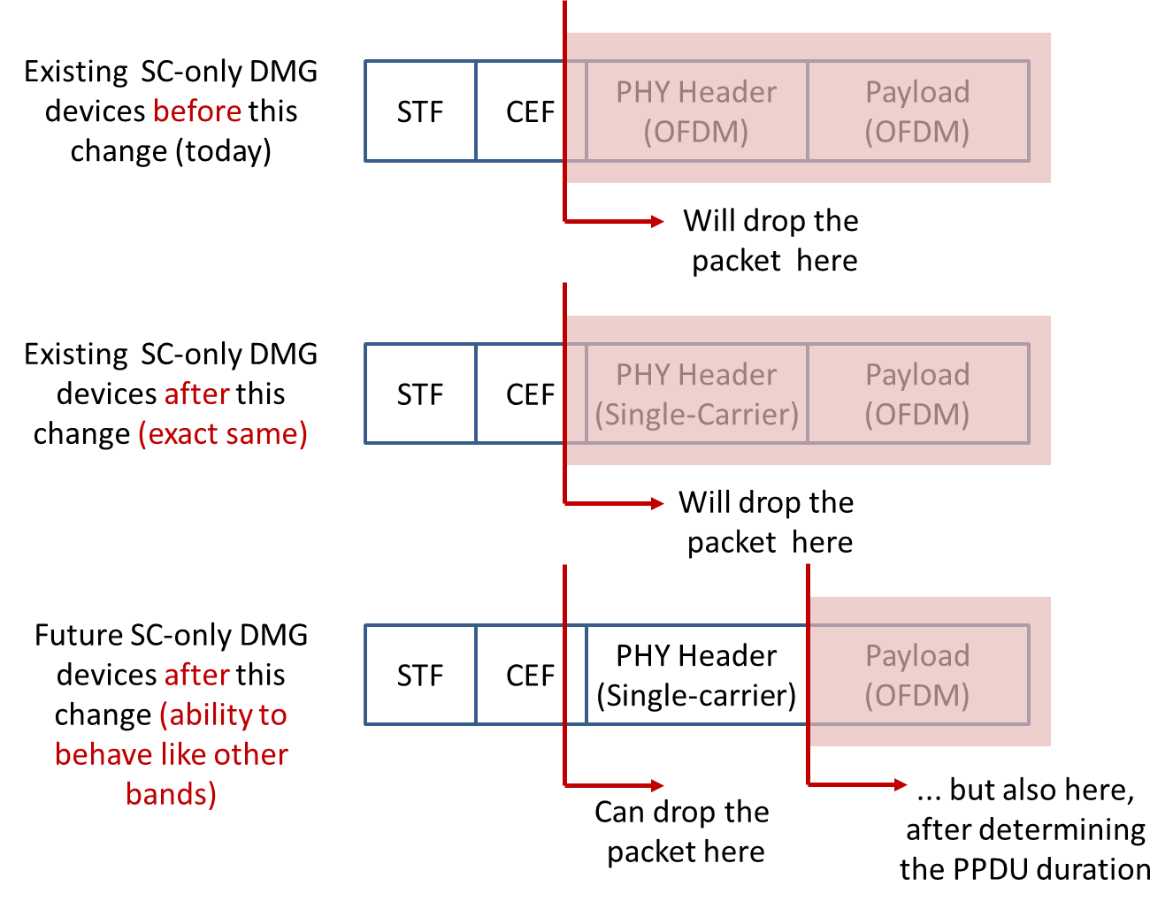

We also observe that the current universal practice of securing TXOPs through RTS/CTS exchnages (that use DMG Control mode and uderstandable to every implementation) significantly mitigates this issue for current devices, and the proposed change will show its merits with widespread DMG OFDM or LPSC PHY deployments.

Some editorial corrections are also included.

This document is submitted in relationship to CID 5857 and CID 5995.

Revision History

Rev 0: Initial revision

CID | Commenter | LB | Clause Number | Type of Comment | Page | Line | Clause | Resn Status | Comment | Proposed Change
5857 | Eitan, Alecsander | 1000 | 21.5 | T | 2535.31 | 31 | 21.5 | J | "Since DMG OFDM was not implemented and deployed, and it has several | 1. Remove section 21.5  2. Remove the DMG OFDM from other places and tables as one of the DMG options
5995 | Kasher, Assaf | 1000 | 21.3.6.3 | T | 2406.01 | 1 | 21.3.6.3 |  | When the data is sent in OFDM, there is a different channel estimate field, therefore Single Carrier devices cannot use this field to decode the header. Therefore SC only devices cannot decode the header (which is also sent in OFDM) and therefore cannot determine the length of the packet. | We propose to send in the beacons an indication of OFDM intolerance. Details will come in a different presentation.

21.1 DMG PHY introduction
21.1.1 Scope
...
[DMG OFDM mode and DMG SC mode preambles are different but share a common structure (type and number of Golay sequences); also header is now common to all DMG PHY modes.]
All DMG modulation methods share a common preamble structure (see 21.3.6 (Common preamble)) and a common header.

21.3.4 Timing-related parameters
...
[Change the following row in Table 21-4.]

T_{HEADER}: Header Duration | 0.582 μs =2 × 512 × Tc

21.5.3.1.4 Header encoding and modulation
[OFDM PHY Header Change -- Replace the entire text under 21.5.3.1.4 with the following sentence.]
The header is encoded and modulated as defined in 21.6.3.1.4 (Header encoding and modulation).

21.7.2.2.2 Header encoding and modulation
[LPSC PHY Header Change -- Replace the entire text under 21.7.2.2.2 with the following sentence.]
The header is encoded and modulated as defined in 21.6.3.1.4 (Header encoding and modulation).

[Correct table titles in Section 21 following #6270 naming and make them consistent.]

Table 21-10—DMG control mode modulation and coding schemes
Table 21-11—DMG control mode header fields
Table 21-12—DMG control mode EVM requirements
Table 21-13—DMG OFDM mode header fields
Table 21-14—DMG OFDM mode modulation and coding schemes
Table 21-16—DMG OFDM mode EVM requirements
Table 21-17—DMG SC mode header fields
Table 21-18—DMG SC mode modulation and coding schemes
Table 21-21—DMG SC mode EVM requirements
Table 21-22—DMG low-power SC mode modulation and coding schemes
Table 21-23—Zero filling for DMG SC mode BRP packets

[Update the informative Appendix L.]

L.4 DMG example data vectors
[Editorial clean up in the first paragraph]
... Text files referenced by these subclauses are contained in the DMGEncodingExamples.zip file embedded in the IEEE 802.11 Working Group document 11-12/0751r0, located at
https://mentor.ieee.org/802.11/dcn/12/11-12-0751-00-00ad-dmg-encoding-examples.docx.

[Fix #6270 implementation error (section title).]
L.6.2 DMG SC mode header

[Fix #6270 implementation error (section title).]
L.6.3 DMG SC mode payload

[Fix #6270 implementation error (section title).]
L.7.2 DMG OFDM mode header
[Replace the entire text in this section (including all subsections L.7.2.1 through L.7.2.5) with the following sentence.]
DMG OFDM mode header fields are defined in Table 21-13 (DMG OFDM mode header fields). DMG OFDM mode header is encoded and modulated in the same way as DMG SC mode header.

[Delete the entire Section L.7.3 and renumber the subsequent L.7.x sections accordingly.]

[Replace “DMG LP SC mode” with “DMG low-power SC mode” in L.8 and all its subsections.]

L.8.2 DMG low-power SC mode header
[Replace the entire text in this section (including all subsections L.8.2.1 through L.8.2.6) with the following sentence.]
DMG low-power SC mode header fields are the same as DMG SC mode header fields. DMG low-power SC mode header is encoded and modulated in the same way as DMG SC mode header.

