IEEE P802.11
Wireless LANs
Resolutions for some comments on 11mc/D4.0
Date: 2015-07-31
Author(s):
Name | Affiliation | Address | Phone | email
Graham SMITH | SRT Wireless | Davie, FL, USA. | 916 799 9563 | gsmith@srtrl.com
Abstract
This submission proposes resolutions for CIDs 5096, 5097, 5098, 6099, 6100, 5171, 5226, 5227, 6029, 6030, 6031, 6042, 6046, 6870, 6896, 6897, 6898, 6877 on 11mc/D4.0.
Green indicates material agreed to in the group,
yellow material to be discussed, red material rejected by the group and
cyan material not to be overlooked.

The “Final” view should be selected in Word.

Identifiers | Comment | Proposed change
CID 5096  Yang, Yunsong  8.2.4.1.4  565.56 | Under Table 8-3, the third paragraph seems to contradict to the "all" statement made by the second paragraph. | Change the second paragraph to "In all Control frames, To DS and From DS are both zero, except the following:"; and indent the third paragraph so that it appears as an exception of the previous "all" statement.
CID 6099  Mark Hamilton  8.2.4.1.4  565.59 | Under Table 8-3, the third paragraph seems to contradict to the "all" statement made by the second paragraph. | Change the second paragraph to start, "In all Control frames with subtype not equal to Control Frame Extension, the ..."

Discussion:
Here is the section in question.

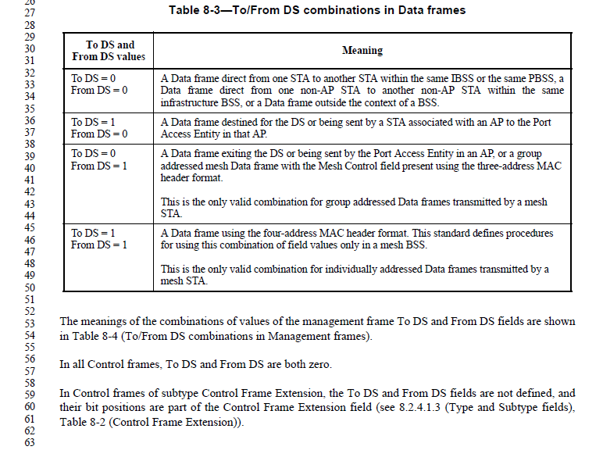
Second para states “In all Control frames, To DS and From DS are both zero.” But para 3 states “the To DS and From DS are not defined” for subtype Control Frame Extension. In fact they are simply not there!

For a Control Frame Extension the Type is 1 and the subtype is 6 (0110). Here are the two Frame Control fields and we see clearly that B8 and B9 are not To DS or From DS in Figure 8-3. Hence, the statement “not defined” is actually “they ain’t there”, “they ain’t needed”.
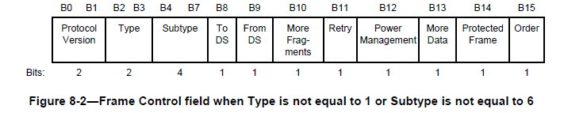

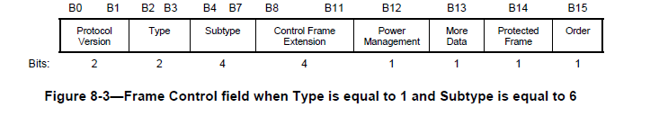
For a Control Frame Extension the Type is 1 and the subtype is 6 (0110). The two Frame Control fields are shown above and we see clearly that B8 and B9 are not To DS or From DS in Figure 8-3. Hence, the statement “not defined” is actually “they ain’t there”, “they ain’t needed”. In fact why refer to them at all?

There is an argument to be made that the third para should be deleted because why talk about bits that are not present?

Two solutions come to mind:
- In Control frames, To DS and From DS, when present, are both zero.
And delete para 3, as why refer to something that is not there?

OR
- Use the existing terminology to indicate a control field that is not a Control Field extension
And delete para 3, as why refer to something that is not there?

Maybe we have a straw poll on which approach? I have used the second option at the moment below

Proposed Resolution
REVISED,
Make the following changes:
P565 L56 edit as follows:
“In Control frames, To DS and From DS, when present, are both zero.”

Page 565 Line 59 change to:
“NOTE - In Control frames of subtype Control Frame Extension, the To DS and From DS fields are not present, and their bit positions are part of the Control Frame Extension field (see 8.2.4.1.3 (Type and Subtype fields), Table 8-2 (Control Frame Extension)).”

CID 6100  Mark Hamilton  8.2.4.1.5  566.24 | Under Table 8-4, the second paragraph seems to contradict to the "all" statement made by the last sentence of the first paragraph. Same problem in 8.2.4.1.6. | Add to the end of the last setence of the first paragraph, "except Control frames of subtype Control Frame Extension." Same change to similar sentence in first paragraph of 8.2.4.1.6.
CID 5097  Yang, Yunsong  8.2.4.1.5  566.24 | The second paragraph under this subclause should be an exception of the "all" statement made by the last sentence in the first paragraph. | Change the last sentence in the first paragraph to "It is set to 0 in all other frames, except the following:"; and indent the second paragraph so that it appears as an exception of the previous "all" statement.

Discussion:

8.2.4.1.5 More Fragments field
The More Fragments field is 1 bit in length and is set to 1 in all Data or Management frames that have another fragment of the current MSDU or current MMPDU to follow. It is set to 0 in all other frames.

In Control frames of subtype Control Frame Extension, the More Fragments field is not defined, and its bit position is part of the Control Frame Extension field (see 8.2.4.1.3 (Type and Subtype fields), Table 8-2
(Control Frame Extension)).

The More Fragments bit is Bit 10 and only used in Frame Control fields that are not Control Frame Extensions.

Proposed changes:
Options:
- If present, it is set to 0 in all other frames.
- (As per below.)

As per discussion in previous CID s, the More Fragment bit is not there and hence why refer to it? The Figure 8-3 is clear.

Proposed resolution:
REVISED
P566 L22 edit as follows:
The More Fragments field is 1 bit in length and is set to 1 in all Data or Management frames that have another fragment of the current MSDU or current MMPDU to follow. It is set to 0 in all other frames in which the More Fragments field is present.

Edit P566 L26 to L41:
NOTE - In Control frames of subtype Control Frame Extension, the More Fragments field is not present, and its bit position is part of the Control Frame Extension field (see 8.2.4.1.3 (Type and Subtype fields), Table 8-2 (Control Frame Extension)).

CID 5098  Yang, Yunsong  8.2.4.1.6  566.36 | The second paragraph under this subclause should be an exception of the "all" statement made by the second last sentence in the first paragraph. | .

Discussion:

8.2.4.1.6 Retry field
The Retry field is 1 bit in length and is set to 1 in any Data or Management frame that is a retransmission of an earlier frame, except as specified in 9.24.3 (Data and acknowledgment transfer using immediate block ack policy and delayed block ack policy). It is set to 0 in all other frames. A receiving STA uses this indication to aid in the process of eliminating duplicate frames.

In Control frames of subtype Control Frame Extension, the Retry field is not defined, and its bit position is part of the Control Frame Extension field (see 8.2.4.1.3 (Type and Subtype fields), Table 8-2 (Control Frame Extension)).

Retry bit is Bit 11 and hence part of the Control Frame Extension b8 – b11).

Proposed changes:
Same arguments as before
- It is set to 0 in all other frames in which the Retry field is present.

Proposed Resolution
REVISED
P566 L33 edit as follows:
The Retry field is 1 bit in length and is set to 1 in any Data or Management frame that is a retransmission of an earlier frame, except as specified in 9.24.3 (Data and acknowledgment transfer using immediate block ack policy and delayed block ack policy). It is set to 0 in all other frames in which the Retry field is present. A receiving STA uses this indication to aid in the process of eliminating duplicate frames.

Edit at P566 L40
NOTE: In Control frames of subtype Control Frame Extension, the Retry field is not present, and its bit position is part of the Control Frame Extension field (see 8.2.4.1.3 (Type and Subtype fields), Table 8-2 (Control Frame Extension)).

Identifiers | Comment | Proposed change
CID 5171  Adachi, Tomoko  B.4.4.1  2668.6 | I don't think the condition of M/O for FST is related to SAE. | Change "PC39:M" in Status column to "PC40:M".

Discussion:
First, display Page 2668. Note that:
- PC40.1 is “FST Setup”
- PC40 is “Multi-band Operation” refers to 10.33.
- PC39 is Simultaneous authentication of equals (SAE). Refers to 11.3 Authentication using a password.

In D4.1 the Editor noted, why is PC40 and PC40.1 referenced to SAE which is a Mesh Feature?

Reading 10.33 “Multiband operation” (let’s look at it) at P1817, at line 41 it talks about “FST session”.
Then at 10.33.2 we have “FST set up protocol”
Clearly then, FST is part of Multiband operation, or else we have a lot of changes to make.

Hence, the commentor is right.

Furthermore this also applies to PC40.2, 40.3

Proposed resolution:
REVISED
At 2668.6 Change "PC39:M" in Status column to "PC40:M".
Page 2668 line 39 change “PC39.1:M” to “PC40.1:M”
Page 2669 line 8 change “PC39.1:O” to “PC40.1:O”
Page 2669 line 13 change “PC39.1:M” to “PC40.1:M”

Identifiers | Comment | Proposed change
CID 5226  Adachi, Tomoko  C.3  2910.00 | Isn't dot11RSNABIPMICErrors the same with dot11RSNAStatsCMACICVErrors? The reason of thinking like that is because, in 11.4.4.6 BIP reception d), it is said that "... If the result does not match the received MIC value, then the receiver shall discard the frame and increment the *dot11RSNAStatsCMACICVErrors* counter by 1, and terminate BIP processing for this reception." and BIP uses CMAC integrity check. The parameter, dot11RSNAStatsCMACICVErrors, is the counter that is used when there is an error in BIP CMAC integrity check and dot11RSNABIPMICErrors seems to be unnecessary. | Delete dot11RSNABIPMICErrors.

Discussion:
dot11RSNABIPMICErrors is never mentioned in text at all, hence it could be considered a good candidate for deletion. Hence I agree with the commenter
Ask expert as to whether this should be the dot11 referred to at 1920 line 16.

At 1920.16 we have:
“Extract and save the received MIC value, and compute the a verifier over the concatenation of AAD, the management frame body and MME, with the MIC field masked to 0 in the MME. For BIPCMAC- 128, the verifier is AES-128-CMAC; for BIP-CMAC-256, the integrity value is 128-bits and is computed using AES-256-CMAC; for BIP-GMAC-128, the verifier is AES-128-GMAC; and, for BIP-GMAC-256, the verifier is AES-256-GMAC. If the result does not match the received MIC value, then the receiver shall discard the frame and increment the dot11RSNAStatsCMACICVErrors counter by 1, and terminate BIP processing for this reception.

Now see 2909.51
“dot11RSNAStatsCMACICVErrors OBJECT-TYPE
"This is a status variable.
It is written by the MAC when …
The number of received MPDUs discarded by the CMAC integrity check algorithm."

Hence this dot11RSNAStatsCMACICVErrors is the correct MIB. (mentioned twice in text, 784.10 and 1920.16)

The only thing still worrying me is what about GMAC CIC Errors (see 1920)? There is no GMAC integrity check algorithm. Without doubt it will work as proposed. If we replace at 1920 with dot11RSNABIPMICErrors, Could be that dot11RSNAStatsCMACICVErrors is replaced with dot11RSNABIPMICErrors, and deleted at 2909.51 to 61’

Proposed resolution:
REVISED
Deprecate: dot11RSNABIPMICErrors.
Delete “dot11RSNABIPMICErrors” at the following locations:
P2907 line 65
P2910 Lines 21 to line 31,
P3314 Line 51

ALTERNATIVE
Replace in 8 places dot11RSNAStatsCMACBIPMICVErrors with dot11RSNABIPMICErrors
AND delete 2909.51 to .61

Identifiers | Comment | Proposed change
CID 5227  Adachi, Tomoko  C.3  2907.00 | In Dot11RSNAStatsEntry, there is no counter to count MIC errors of unicast robust management frames. Such kind of counter seems to be necessary. There are 3 counters for 11w, which are dot11RSNAStatsCMACICVErrors (when a MIC error occurs in 11w groupcast), dot11RSNAStatsCMACReplays (when IPN is not sequential in 11w groupcast), and dot11RSNAStatsRobustMgmtCCMPReplays (when PN number in CCMP header is not sequential for robust management frames). That is, there are two counters, dot11RSNAStatsCMACICVErrors and dot11RSNAStatsCMACReplays, for 11w groupcast, but only 1 counter, dot11RSNAStatsRobustMgmtCCMPReplays, lacking the one for MIC errors, for 11w unicast. | Add a counter that is counted up when a MIC error occurs in a unicast robust management frame.

Discussion:
This is line 41.

Dot11RSNAStatsEntry is an entry in the dot11RSNAStatsTable.
The entries referred to by the commenter are in the StatsEntry list.

The complaint is that a counter ‘seems to be necessary” for unicast. dot11RSNAStatsRobustMgmtCCMPReplays is looking at sequential PNs (packet numbers) and increments when not in sequence.

11.4.3.4.3 Decrypted CCMP MPDU
The decapsulation process succeeds when the calculated MIC matches the MIC value obtained from decrypting the received encrypted MPDU.

The text has no mention of counting MIC failures.
The next section is 11.4.4. BIP and 11.4.4.6 mentions these counters. This is BIP (Broadcast/Multicast Integrity Protocol). Hence, MIC errors only appear to be for BIP and no mention of required for unicast can I find.

Hence, adding a counter for unicast MIC counter is a brand new requirement which the founding writers did not appear to find necessary. My inclination is therefore to reject this unless the commentor wants to bring forth a full proposal with reasons and details.

Proposed resolution:
REJECT
(GEN: 2015-08-20 12:46:39Z) The existing text does not mention the requirement to count MIC errors for unicast MMPDUs. It does for BIP. Adding such a new requirement would require a proposal and details. Comment fails to identify changes in sufficient detail so that the specific wording of the changes that will satisfy the commenter can be determined.

Identifiers | Comment | Proposed change
CID 6031  Bahr, Michael  13.2.4  2078.56 | This text specifies a certain situation where the comparison takes place. The clause, however, describes when mesh STA configurations are the same independent from the situation. This should be reflected in this parameter. | change text into: "For VHT mesh STAs, the Basic VHT-MCS and NSS fields are identical."If you want to keep the specifics of the new text, add them as a specific situation / example. ("During Mesh Peering Management, these are the Basic VHT-MCS and NSS fields in the VHT Operation element of the MLME-START.request and the Basic VHT-MCS and NSS fields in the VHT Operation element received in the MLME-MESHPEERINGMANAGEMENT.indication."

Discussion:
13.2.4 Mesh STA configuration
The mesh STA configuration consists of the mesh profile (see 13.2.3 (Mesh profile)), the Supported Rates and BSS Membership Selectors element, the Extended Supported Rates and BSS Membership Selectors element, the HT Operations element (if present), and the VHT Operations element (if present).

Mesh STA configurations are identical if the following conditions hold:
- The mesh profiles are identical.
- The BSSBasicRateSet parameter of the MLME-START.request is identical to the basic rate set indicated by the Supported Rates and BSS Membership Selectors element and Extended Supported Rates and BSS Membership Selectors element, if present, received in the MLMEMESHPEERINGMANAGEMENT.indication.
- For HT mesh STAs, the Basic MCS Set field of the HT Operation parameter of the MLMESTART.request is identical to the HT Operation element received in the MLMEMESHPEERINGMANAGEMENT.indication.
- For VHT mesh STAs, the Basic VHT-MCS and NSS fields in the VHT Operation element of the MLME-START.request are identical to the Basic VHT-MCS and NSS fields in the VHT Operation element received in the MLME-MESHPEERINGMANAGEMENT.indication.

The cited text refers to the fourth bullet.

My first question: is “are Mesh STA configurations identical if ANY of the following conditions, or ALL of the following conditions hold?” I suspect it is ANY.

My second question: Do we use the term “hold”? Should it not be “are true”?
The term ‘hold’ should to be used as referring to possessing something “hold” or keep something steady. , e.g. “hold CCA busy for…”
Places where it is used with the “are true” context are only in three places P1884 L24 and L28; P2078 L 42, P2159 L48.

OK back to the comment:
I have read this over and over and have to admit I do not see the comment’s point. The cited “problem” appears to be that the bullet is referring to a situation, in this case Mesh Peering Management rather than a straight comparison of fields? I read it as comparing two sets of fields present in two places. I feel that changing the text as proposed does reference the comparison to a specific moment in time, that may be true, but I don’t know if always true.

Hence, my inclination is to reject this. Maybe a Mesh expert needs to confirm?

Proposed resolution:
REJECT
The text is unambiguous. The primitive being compared is correct and also compared in the prior list items.

ACTION: Inform commentor and ask for further light

Identifiers | Comment | Proposed change
CID 6042  Bahr, Michael  8.4.2.106  979.5 | It is confusing to read about the MCCAOP Setup Request element in the clause on the MCCAOP Setup _Reply_ element. (although it is correct, if you have read the clause on the MCCAOP Setup Request element and spent a second thought). | Since the MCCAOP Setup Request element corresponds to an MCCAOP reservation, replace "MCCAOP Setup Request element" with "MCCAOP reservation" (page 979, lines 5 and 7). Make a similar replacement in the clause on the MCCAOP Setup Request element. (page 978, lines 5 and 7)

Discussion:
I note that CID 2069 affected this same text but that was editorial (adding ‘element’)

MCCAOP Set up Request is 8.4.2.105.1 which preceeds. Both the Setup Request and Setup reply have the “MCCAOP Reservation ID”

The cited text is:
If this MCCAOP Setup Request element is for an individually addressed transmission, the MCCAOP Reservation ID is between 0 and 127. If this MCCAOP Setup Request element is for a group addressed transmission, the MCCAOP Reservation ID is between 128 to 254. The value 255 is not used to identify a single MCCAOP reservation.”

Obviously the use of the word “this” seems strange, but probably because the Request preceeded the Reply, but the text is clearly referring to the values in the CCAOP Reservation ID and it is copied from the Request.

Proposed changes:
Although the commenter’s proposal is correct it results in duplication of the previous section. P978 L4-11.

Proposed resolution:
REVISED
Although the commenter’s proposal is correct it results in duplication of the previous section. P978 L4-11.

Edit P979 L4 as follows:
The MCCAOP Reservation ID field is an eight bit unsigned integer that represents the ID for the requested
series of MCCAOPs. It is determined by the MCCAOP owner and copied from the MCCAOP Setup
Request element (see 8.4.2.105.1).

Identifiers | Comment | Proposed change
CID 6046  Bahr, Michael  9.23.3.7.2  1352.30 | lines 30-37: The 3 terminology definitions of TX-RX, broadcast, and interference report are actually backward definitions. The TX-RX / broadcast / interference report are the set of TX-RX / broadcast /interference periods that are reported in the TX-RX / broadcast / interference report field. The content of the report fields is derived from the reports, the reports are NOT defined by the content of the report fields! Keep in mind that this section is on the originater of an MCCA advertisement. So the reports are its MCCAOP reservations transmitted to its neighbors. | change text into:  "-- TX-RX report: the TX-RX periods of the mesh STA to be reported in the TX-RX Periods Report field of an MCCAOP element  -- Broadcast report: the broadcast periods of the mesh STA to be reported in the Broadcast Periods Report field of an MCCAOP element  -- Interference report: the interference periods of the mesh STA to be reported in the Interference Periods Report field of an MCCAOP element"

Discussion:
Original text:
The following terminology is used in this subclause:
- TX-RX report: an MCCAOP Reservation field contained in the TX-RX Periods Report field of an MCCAOP element
- Broadcast report: an MCCAOP Reservation field contained in the Broadcast Periods Report field of an MCCAOP element
- Interference report: an MCCAOP Reservation field contained in the Interference Periods Report field of an MCCAOP element

In the MCCAOP Advertisement Element Information field (8.4.2.108.2 Figure 8-467, P981 L34 also look at P980 L46) we have the “TX-RX Report present” bit. Similarly the Broadcast Report Present bit, and the Interference Report Present bit. True the text makes it clear that “TX-RX Report” then refers to the TX-RX Periods Report field, Broadcast Periods Report, and the Interference Periods Report. But suffice it to say that the use of the term “TX-RX Report” is clear (at least to me).

In the cited text we have a similar situation and the term “Report” is used exactly the same way, i.e. to indicate the presence of a “Period Report field”. Hence, it seems to me that this is quite clear in its intention and is following exactly how it was defined in the “Report Present” context.

The only possible problem is with the term “MCCAOP element” as I can’t find such a beast anywhere else but here. From what I can see the correct reference should be to the MCCAOP Advertisement element.

Proposed resolution:
REVISED
The term TX-RX Report is used as a ‘shorthand’ term for part of an MCCAOP Advertisement element and such usage can be seen throughout subclause 9.23.3.7.2. It does not refer to the contents of a period.

Change P 1352 L 30 to 37 as follows:
- TX-RX report: an MCCAOP Reservation field contained in the TX-RX Periods Report field of an MCCAOP Advertisement element
- Broadcast report: an MCCAOP Reservation field contained in the Broadcast Periods Report field of an MCCAOP Advertisement element
- Interference report: an MCCAOP Reservation field contained in the Interference Periods Report field of an MCCAOP Advertisement element

Identifiers | Comment | Proposed change
CID 6870  Bahr, Michael  9.35.3  1440.00 | The text talks about "Address 3 and Address 4 correspond to the destination end station and the source end station of a mesh path." This is technically correct. However, the term destination/source end station is used in all other occurences as the destination/source of the end-to-end path potentially being longer than the mesh path (see Figure 9-54). This possible terminology confusion should be avoided by using destination/source mesh station for the mesh path. | Change text into: "Address 3 and Address 4 correspond to the destination mesh station and the source mesh station of a mesh path."

Discussion:
At Line 51
“In individually addressed Mesh Data and Multihop Action frames, Address 1 and Address 2 correspond to the mesh STA receiver address (RA) and the mesh STA transmitter address (TA) for a particular mesh link. Address 3 and Address 4 correspond to the destination end station and the source end station of a mesh path.”

9.35.4.1 is pretty clear
- Address 1: The address of the next-hop mesh STA (toward the destination mesh STA according to the forwarding information—see 9.35.2 (Forwarding information))
- Address 2: The address of the transmitter mesh STA
- Address 3: The address of the destination mesh STA
- Address 4: The address of the source mesh STA

Proposed resolution:
REVISED
Change text P1440 L53:
From “Address 3 and Address 4 correspond to the destination end station and the source end station of a mesh path.”
To
“Address 3 and Address 4 correspond to the destination mesh STA and the source mesh STA of a mesh path.”

Identifiers | Comment | Proposed change
CID 6877  Thomas, Angela  8.4.2.24.2  819.00 | The OUI field should be able to contain either an OUI or CID. The WG may choose to keep the field name, but make it clear that the field may also contain a CID. | Assuming field name is preserved, change to read: "The order of the OUI field is described in 8.2.2 (Conventions). The OUI field value may contain either an OUI (organizationally unique identifier) or a CID (Company ID).

Discussion:
Here is the text
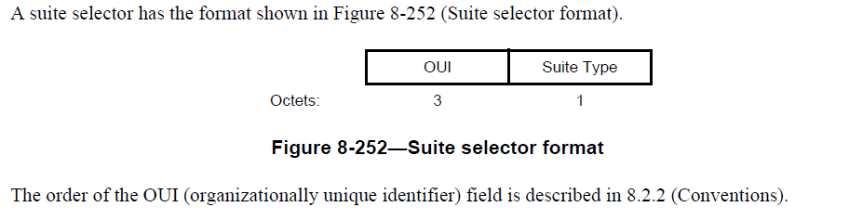

The field is the OUI field. There is no reference to what is put in there other than the order as per 8.2.2.

“Organizationally unique identifiers (OUIs) and Organization Identifiers are specified in two forms: an ordered sequence of octets, and a numeric form. Treating the OUI or Organization Identifier as an ordered sequence of octets, the leftmost octet is always transferred first. This is equivalent to transmitting the most significant octet of the numeric form first.”

To satisfy the comment we would need to add a new sentence. Something like:
“The OUI field is 3 octets in length and contains an organizationally unique identifier (OUIs) or company ID (CID).”
We should also add CID words to 8.2.2.

See discussion on next CIDs

Proposed resolution:
REVISE
Page 819 insert as the first senence at line 25 the following:
“The OUI field contains an OUI or CID.”

Identifiers | Comment | Proposed change
CID 6896  Thomas, Angela  8.42.68.5  921.42 | not found with OUI search delete organizationally | delete organizationally
CID 6897  Thomas, Angela  8.6.6  1106.32 | not found with OUI search delete organizationally | delete organizationally
CID 6898  Thomas, Angela  8.6.6  1120.62 | not found with OUI search delete organizationally | delete organizationally

Background
Reference https://standards.ieee.org/faqs/regauth.html

There are currently 3 different size blocks of MAC Addresses:
- MA-L (MAC Address Block Large), previously named OUI
  - 2^24
- MA-M (MAC Address Block Medium)
  - 2^20
- MA-S (MAC Address Block Small)
  - 2^12
There is also a CID (Company ID) a unique 24 bit identifier. A CID cannot be used to generate iniversally unique MAC addresses.

OUI is “Organizationally Unique Identifier” and is “referenced by various standards”. An OUI is assigned with a MA-L identifer block. So nothing wrong with sticking to “OUI”.

Beginning 1/1/2014 CID or OUI may be used as a globally unique 24 bit identifier of a company, entity or manufacturer. So do we use both terms or should we start using MA-L?

EUI is “Extended unique identifier”.
A 48-bit universally unique MAC address is EUI-48. A 64-bit universally unique MAC address is EUI-64.

Let’s now look at the cited text:

P921.42
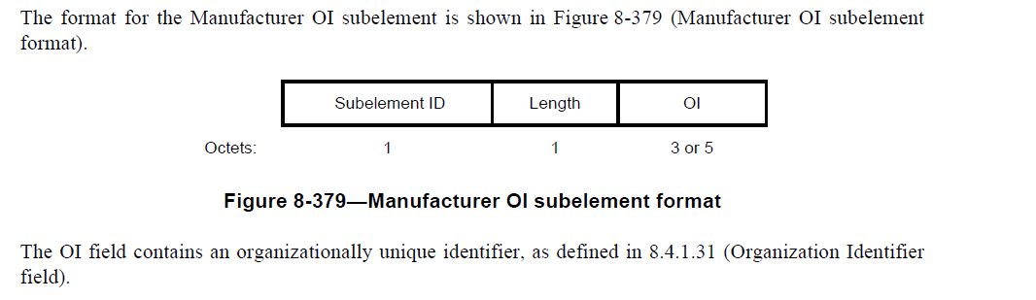

This seems clear enough and is saying that the OI contains an OUI, which it does. Question is do we have to also say OUI or CID?
The OI field contains an organizationally unique identifier (OUI), or a company ID (CID) as defined ….”

So let’s look at the OI field.

8.4.1.31 Organization Identifier field
The Organization Identifier field contains a public organizationally unique identifier assigned by the IEEE. The order of the Organization Identifier field is described in 8.2.2 (Conventions). The IEEE has assigned public organizationally unique identifiers both of 24-bit length (OUI) and longer length. In the latter case specific OUI values are shared over multiple organizations, e.g., using 36-bit length identifiers (OUI-36) (see IEEE Registration Authority [B19]). The length of the Organization Identifier field (j) is the minimum number of octets required to contain the entire organizationally unique identifier (see Figure 8-97 (Organization Identifier field)), and the first 3 octets contain the OUI portion of the identifier. Thus, the Organization Identifier field is 3 octets in length if the organizationally unique identifier is an OUI, or 5 octets in length if the organizationally unique identifier is 36 bits in length. The IEEE assigns 36-bit organizationally unique identifiers such that the OUI portion indicates that total length of the identifier is 36 bits.

So the OI field contains an OUI and maybe 2 other octets.
“The IEEE Regitsraion Authority also recognizes and assignes an OUI-36 which is specified in various standards”. So clearly 3 or 5 octets is still an “OUI”, an organizationally unique identifier.

Proposed changes:
I see nothing wrong with text as is. It is clear and correct.
The OI field is clearly limited to 3 or 5 octets so it is the OUI not the EUI, which would enforce a change.

Only possible change might be to add “or CID” where appropriate?

Proposed resolution:
REVISED
Page 921 line 42, P 1106 L32, and P1120 L62
“The OI field contains an organization identifier, as defined in 8.4.1.31 (Organization Identifier field).

