IEEE P802.11
Wireless LANs
Comment Resolutions for CID 5183 and 6778
Date: 2015-05-14
Author:
Name | Affiliation | Address | Phone | Email
Carlos Aldana | Qualcomm Corporation |  |  | caldana@qca.qualcomm.com
Brian Hart | Cisco Systems |  |  | brianh@cisco.com

Abstract
This contribution addresses CIDs 5183 and 6778.

It uses Draft 4.0 as a baseline.

Revision history:
v0 : Initial submission
Pertinent Comments :
CID | Draft | Clause Number |  | Page | Line | Type of Comment | Comment | Proposed Change
5183 | 4 | 10.24.6.4 | 1738 |  | 22 | E | Replace "Burst Timeout" with "Burst Duration" in the Figure, as Burst Period is no longer defined. Do this for Figures 10-35 and 10-36 as well. | As in comment
6778 | 4 | 10.24.6 |  |  |  | E | Fix the FTM figures to follow normal style (no colours, nice fonts, etc.) | As it says in the comment

NOTE TO EDITOR :
Please make the changes in red and replace Figures 10-34, 10-35, and 10-36 with the following figures:

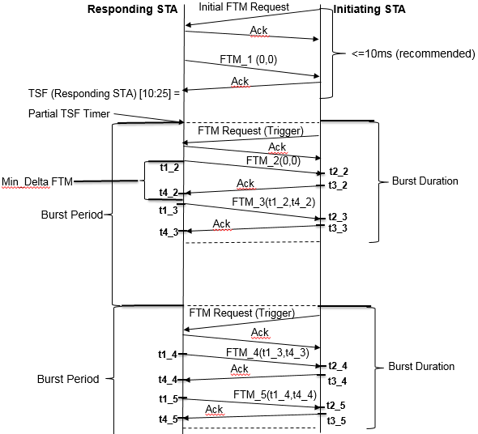

Figure 10-34—Example negotiation and measurement exchange sequence, ASAP=0 and FTMs per Burst = 2

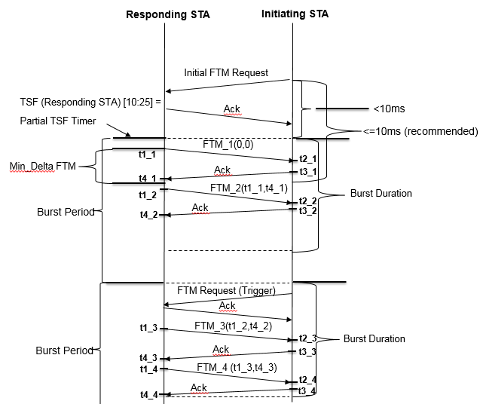
Figure 10-35—Example negotiation and measurement exchange sequence, ASAP=1 and FTMs per Burst = 2
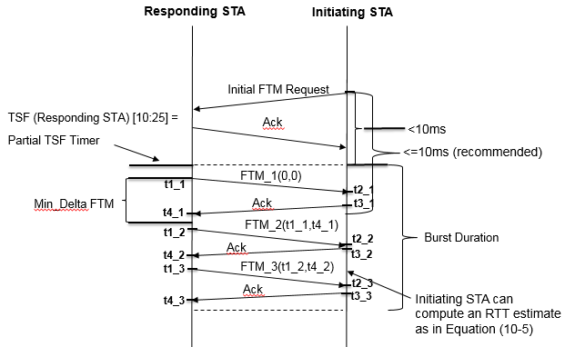

Figure 10-36—Example negotiation and measurement exchange sequence for a single
burst instance, ASAP=1, FTMs per Burst = 3

