IEEE P802.11
Wireless LANs
Clause 8.4.2.1 Comment Resolutions
Date: 2015-05-12
Author(s):
Name | Affiliation | Address | Phone | email
SK Yong | Apple Inc
Abstract
This document provides proposed comment resolutions for follow comments:
CID #, #, #,

CID | Commenter | Clause Number(C) | Page (C) | Line (C) | Type of Comment | Assignee | Comment | Proposed Change
1628 | Robert Slater | 8.4.2.1 | 8 | 7 | T | SK Yong | Table 8-83 columns in P802.11REVmc_D4.0 do not match those in this document | Add "Element ID Extension" column after "Element ID", and fill with <ANA> for all rows under the title row.
1399 | Koichi Ishihara | 8.4.1. | 8 | 6 | G | SK Yong | I am not sure whether table number 8-83 is correct. | Please double check
1362 | Jouni Malinen | 8.4.2.1 | 8 | 6 | T | SK Yong | P802.11aq/D1.0 is described as being an amendment to P802.11-REVmc/D4.0. However, the Table number or contents for the "Element IDs" table does not match that base document. Table 8-74 (not Table 8-83) is "Element IDs" in P802.11-REVmc/D4.0. In addition, that table has a new "Element ID Extension" column which is not included in P802.11aq/D1.0. | Replace "Table 8-83" with "Table 8-74" and add "Element ID Extension" column with appropriate values for the elements added in P802.11aq.
1356 | Yasuhiko Inoue | 8.4.1. | 8 | 6 | G | SK Yong | I am not sure whether table number 8-83 is correct. | Please double check

`

Proposed resolution: Counter

Update Table 8-83 as follows:

Element | Element ID | Element ID Extension | Extensible
Service Hint ( see 8.4.2.171) | <ANA>
Service Advertisement (see 8.4.2.172) | <ANA>
Service Hash (see 8.4.2.173) | <ANA> | N/A
Supported ULP (see 8.4.2.174) | <ANA> | N/A

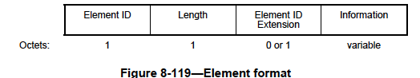

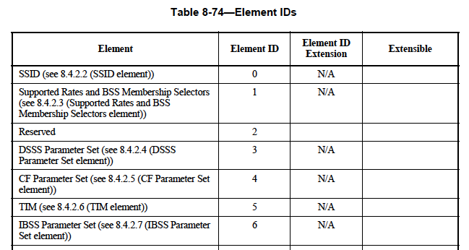

CID | Commenter | Clause Number(C) | Page (C) | Line (C) | Type of Comment | Assignee | Comment | Proposed Change
1505 | Richard Roy | 8.4.2.1 | 9 | 5 | T | SK Yong | The text "(i.e., the receiving STA can respond to queries with and without proxying the query to a server in an external network)." seems out of place and context. | Reword it or remove it.

Proposed resolution: Reject

The comment is invalid as section 8.4.2.1 does not have the aforementioned text.

CID | Commenter | Clause Number(C) | Page (C) | Line (C) | Type of Comment | Assignee | Comment | Proposed Change
1504 | Richard Roy | 8.4.2.1 | 9 | 4 | G | SK Yong | Change: "The ANQP-SD supports service information retrieval using ANQP-elements." | to: "The ANQP-SD supports user service information retrieval using ANQP-elements."

Proposed resolution: Reject

There is no justification for the change. Service information has nothing to do with user.

CID | Commenter | Clause Number(C) | Page (C) | Line (C) | Type of Comment | Assignee | Comment | Proposed Change
1395 | Santosh Abraham | 8.4.2.1 | 8 | 6 7 | T | SK Yong | Service Hint, Service Advertisement, Service Hash perform the same functionality of conveying service "name" information. Three ANA codes need not be used up. | Define a single element with a control field that conveys these different methods of indicating the service name or names information

Proposed resolution: Reject

Service Hint, Service Advertisement, Service Hash

