IEEE P802.11  
Wireless LANs

|  |  |  |  |  |
| --- | --- | --- | --- | --- |
| IEEE 802.11 TGax  May 2015 Vancouver Meeting Minutes | | | | |
| Date: 2015-05-30 | | | | |
| Author(s): | | | | |
| Name | Affiliation | Address | Phone | email |
| Yasuhiko Inoue | NTT | 1-1 Hikari-no-oka, Yokosuka, Kanagawa 239-0847 Japan | +81 46 859 5097 | inoue.yasuhiko@lab.ntt.co.jp |
|  |  |  |  |  |

Abstract

Minutes of the TGax full meetings from the IEEE 802.11 Vancouver session, May 11th – 15th, 2015.

Minutes from the TGax ad hoc sessions are contained in the following documents.

* PHY ad hoc:
  + <https://mentor.ieee.org/802.11/dcn/15/11-15-0651-02-00ax-tgax-may-2015-vancouver-phy-ad-hoc-meeting-minutes.docx>
* MAC ad hoc:
  + <https://mentor.ieee.org/802.11/dcn/15/11-15-0637-00-00ax-may-2015-vancouver-tgax-mac-ad-hoc-meeting-minutes.docx>
* Multiuser ad hoc:
  + <https://mentor.ieee.org/802.11/dcn/15/11-15-0679-00-00ax-mu-ad-hoc-meeting-minutes-may-2015.docx>
* Spatial Reuse ad hoc:
  + <https://mentor.ieee.org/802.11/dcn/15/11-15-0662-01-00ax-tgax-may-2015-vancouver-spatial-reuse-ad-hoc-meeting-minutes.docx>

**IEEE 802.11 Task Group ax**

**May 2015 Vancouver Meeting**

**Hyatt Regency Vancouver, BC, Canada**

**May 11th – 15th, 2015**

**Monday, May 11th, 2015, AM2 TGax Session (10:30-12:30)**

1. The meeting called to order by Osama Aboul-Magd (Huawei Technologies), the chair of the TGax, @10:30
   1. About 160 people are in the room.
2. Announcement
   1. Agenda Doc.11-15/0500r2 on the server. Rev. 3 is the working document.
   2. Meeting Protocol: Please announce your affiliation when you first address the group during a meeting slot.
   3. Attendance reminder.
      1. The attendance server: https://imat.ieee.org/
      2. See 11-09-0517r0 for more information.
3. The chair reviewed the mandatory 5 slides of P&P.
   1. Instructions for the WG Chair.
   2. Participants, Patents, and Duty to Inform.
   3. Patent Related Links.
   4. Call for potentially essential patents.
      1. Chair asked if anyone is aware of potentially essential patents.
      2. **No potentially essential patents reported.**
   5. Other Guidelines for IEEE WG Meetings.
4. Agenda items for the week
   1. Approve TG and Teleconferences minutes since March 2015 meeting.
   2. Continue to advance task group documents.
      1. Simulation Scenarios, Evaluation Methodology
      2. Channel Model, Function Requirements
      3. Specification Framework
   3. Hold Ad Hoc group meetings.
   4. Technical Presentations and related straw polls and/or motions.
      1. Chair identified 50+ submissions so far.
   5. Schedule Teleconference times.
5. General Flow of the meeting
   1. Slides 13 and 14 of the 15/0500r2 contain general flow of the meeting.
   2. There are eight meeting slots planed for TGax.

|  |  |  |  |  |  |  |  |
| --- | --- | --- | --- | --- | --- | --- | --- |
|  | Monday | | Tuesday | | Wednesday | | Thursday |
| AM1 |  | |  | |  |  | TGax |
| AM2 | TGax | | TGax  (SR) | TGax  (MU) |  | |  |
| PM1 | TGax  (PHY) | TGax  (MAC) | TGax  (PHY) | TGax  (Ad Hoc) | TGax  (Ad Hoc) | TGax  (Ad Hoc) | TGax |
| PM2 |  | |  | | TGax | |  |
| PM3 | TGax | |  | |  | |  |

1. Agenda for Monday, May 11th, AM2 (10:30 – 12:30).
   1. Proposed Agenda for Monday AM2 session:
      1. Call meeting to order
      2. Patent policy, etc.
      3. Call for submissions
      4. Set Ad Hoc Groups schedule and approve agenda
      5. Summary from March 2015 meeting
      6. SFD review - Editor
      7. Timeline Reminder
      8. TG motions
         1. Approve TG meeting and Telecon minutes since September meeting.
         2. Approve the latest SFD revision.
      9. Ad Hoc group Rules
      10. Presentations
      11. Recess
   2. Chair asked if there are any other items – No items proposed. Meeting will be conducted based on this order.
2. Call for submissions – slides 16 to 20 of 15/0500r2 contains current submission lists
   1. PHY – 14 submissions
      1. 11-15/0550, “L-preamble issues for UL-OFDMA,” Katsuo Yunoki (KDDI Labs)
      2. 11-15/0553, “Enhancing Performance of Hybrid-ARQ with Linear Constellation Precoding,” Muhammad Mehboob Fareed (King Abdullah Univ. of Science and Technology)
      3. 11-15/0569, “Performance of 1x, 2x, and 4x HE-LTF,” Kome Oteri (InterDigital)
      4. 11-15/0572, “Inefficiency of 256-FFT per 20MHz,” Heejung Yu (Yeungnam Univ./Newracom)
      5. 11-15/0574, “SIG structure for UL PPDU,” Young Hoon Kwon (Newracom)
      6. 11-15/0575, “Preamble Structure in 802.11ax,” Yujin Noh (Newracom)
      7. 11-15/0577, “Pilot Design for 11ax,” Daewon Lee (Newracom)
      8. 11-15/0579, “Preamble design and auto-detection,” Hongyuan Zhang (Marvell)
      9. 11-15/0580, “11ax coding discussion,” Hongyuan Zhang (Marvell)
      10. 11-15/0584, “Considerations on LTF Sequence Design,” Sungho Moon (Newracom)
      11. 11-15/0600, “Non Uniform Constellations for 1024QAM,” Daniel Schneider (Sony)
      12. 11-15/0602, “HE-LTF sequence for UL MU-MIMO,” Qinghua Li (Intel)
      13. 11-15/0621, “Design Principles for HE Preamble,” John Son (WILUS)
      14. 11-15/0381, “HE-STF Proposal,” Yakun Sun (Marvell)
   2. MAC – 6 submissions
      1. 11-15/0567, “Multi-STA BA for SU Transmissions,” Xiaofei Wang (InterDigital)
      2. 11-15/0604, “Random Access with Trigger Frames using OFDMA,” Chittabrata Ghosh (Intel)
      3. 11-15/0611, “Multi-STA Block ACK Protection,” Jinsoo Ahn (Yonsei Univ.)
      4. 11-15/0615, “UL OFDMA Bandwidth,” Liwen Chu (Marvell)
      5. 11-15/0617, “Duration and MAC Padding for UL MU PPDUs,” Gang Ding (Qualcomm)
      6. 11-15/0626, “Further consideration for Multi-STA Block ACK frame,” Jeongki Kim (LG)
   3. SR – 5 submissions
      1. 11-15/0543, “Simulation Scenario changes for Frequency Re-use,” Graham Smith (SR Technologies)
      2. 11-15/0544, “Proposed text additions to 14/980 for frequency re-use,” Graham Smith (SR Technologies)
      3. 11-15/0548, “Enterprise Scenario and DSC,” Graham Smith (SR Technologies)
      4. 11-15/0588, “CCA revisited II,” Amin Jafarian (Newracom)
      5. 11-15/0595, “Discussion on The Receiver Behavior for CCAC/DSC with BSS Color,” Yasuhiko Inoue (NTT)
   4. MU – 7 submissions
      1. 11-15/0378, “Channel Sensing in UL OFDMA,” Reza Hedayat (Newracom)
      2. 11-15/0568, “Frequency Selective Scheduling (FSS) for TGax OFDMA,” Kome Oteri (InterDigital)
      3. 11-15/0586, “Frequency Diversity Options in OFDMA,” Reza Hedayat (Newracom)
      4. 11-15/0587, “Uplink ACK and BA Multiplexing,” Reza Hedayat (Newracom)
      5. 11-15/0597, “Beamformed HE PPDU,” Yongho Seok (Newracom)
      6. 11-15/0608, “Regarding trigger frame in UL MU,” Tomo Adachi (Toshiba)
      7. 11-15/0612, “Multi Channel availability for UL-OFDMA,” Woojin Ahn (Yonsei Univ.)
   5. Simulation and TG
      1. 11-15/0551, “OBSS Preamble Detection,” Suhwook Kim (LG Electronics)
      2. 11-15/0552, “IEEE 802.11 performance in dense, cellular-like, outdoor deployments,” Richard Edgar (Imagination Technologies)
      3. 11-15/0330, “OFDMA Numerology and Structure,” Sharnaz Azizi (Intel)
      4. 11-15/0583, “OBSS Preamble Error Probability,” Jiyong Pan (Huawei)
      5. 11-15/0590, “Traffic Model Updates to Evaluation Methodology,” Phil Barber (Huawei)
      6. 11-14/1392, “Simulation results for Box-5 calibration,” Suhwook Kin (LG Electronics)
      7. 11-15/0581, “LSP Correlation Clarification for Scenario 4,” Daewon Lee (Newracom)
      8. 11-15/0582, “Clarifications to Box 2 MIMO simulation calibrations,” Daewon Lee (Newracom)
      9. 11-15/0373, “Mixed traffic configurations on simulation scenarios,” Yingpei Lin (Huawei)
      10. 11-15/0610, “Simulation Results for Box 5 Calibration,” Vida Ferdowsi (Newracom)
      11. 11-15/0613, “Box 5 Calibration Result,” Chinghwa Yu (MediaTek)
      12. 11-15/0623, “TGax simulation scenario “Box 5” – calibration results,” Guido Hiertz (Ericsson)
      13. 11-15/0316, “Power Save Calibrations,” Hyeyoung Choi (LG Electronics)
      14. 11-15/0564, “802.11ax Calibration and Modeling Adjacent Channel Interference,” Naveen Kakani (CSR)
      15. 11-15/0576, “Latency and Power Consumption in State Transitions,” Chittabrata Ghosh (Intel)
      16. 11-15/0592, “More Power Save Calibration Results,” Eric Wong (Apple)
      17. 11-15/0598, “U-APSD Enhancement for HE,” Jarkko Kneckt (Nokia)
      18. 11-15/0603, “Calibration Results for PSP and U-APSD,” Chittabrata Ghosh (Intel)
3. Summary from March 2015 Meeting
   1. Passed a number of motions affecting the TG specification Framework
      1. Passed 5 PHY motions. Motions are related to LTF design and SIG-B
      2. Passed 3 MAC motions related to MU BA and UL MU Procedure
      3. Passed 3 MU motions related to ACK multiplexing.
   2. The new revision of the SFD is available on mentor
      1. https://mentor.ieee.org/802.11/dcn/15/11-15-0132-04-00ax-spec-framework.docx
   3. Approved new revisions of Simulation Scenarios and Evaluation Methodology TG documents.
      1. https://mentor.ieee.org/802.11/dcn/14/11-14-0571-08-00ax-evaluation-methodology.docx
      2. https://mentor.ieee.org/802.11/dcn/14/11-14-0980-09-00ax-simulation-scenarios.docx
4. Timeline (Reminder)

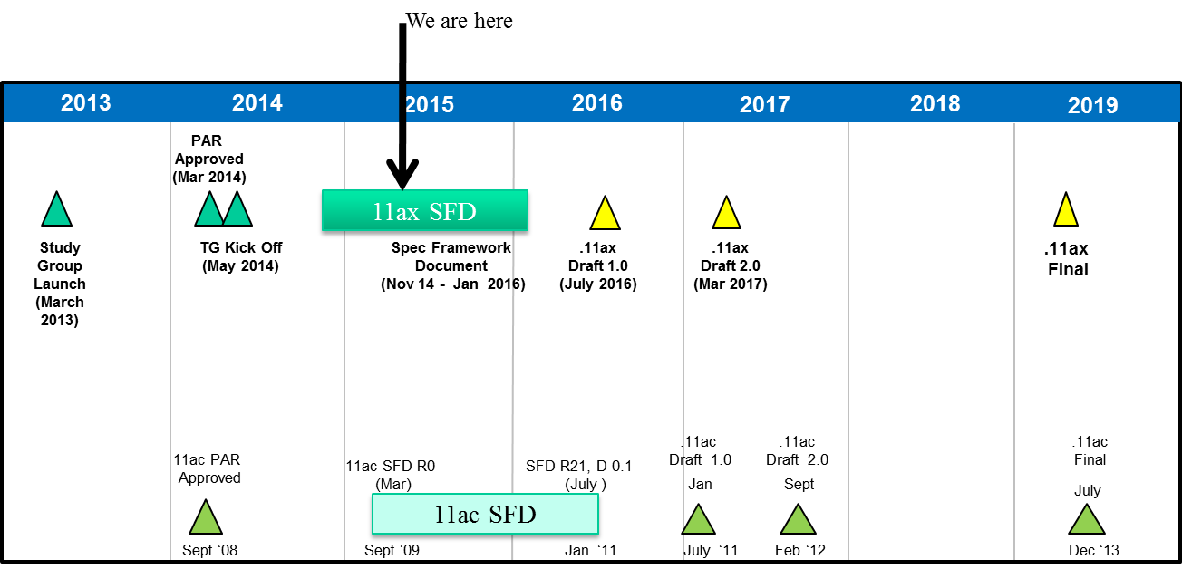

1. Approval of TG Minutes (March 2015 Meeting and Telecon Minutes)
   1. **Motion: Approve TGax minutes of meetings and teleconferences from March 2015 plenary meeting to today:** 
      1. [**https://mentor.ieee.org/802.11/dcn/15/11-15-0309-01-00ax-tgax-march-2015-berlin-meeting-minutes.docx**](https://mentor.ieee.org/802.11/dcn/15/11-15-0309-01-00ax-tgax-march-2015-berlin-meeting-minutes.docx)
      2. [**https://mentor.ieee.org/802.11/dcn/15/11-15-0399-00-00ax-march-2015-berlin-tgax-mac-ad-hoc-meeting-minutes.docx**](https://mentor.ieee.org/802.11/dcn/15/11-15-0399-00-00ax-march-2015-berlin-tgax-mac-ad-hoc-meeting-minutes.docx)
      3. [**https://mentor.ieee.org/802.11/dcn/15/11-15-0585-00-00ax-tgax-march-2015-berlin-phy-ad-hoc-meeting-minutes.docx**](https://mentor.ieee.org/802.11/dcn/15/11-15-0585-00-00ax-tgax-march-2015-berlin-phy-ad-hoc-meeting-minutes.docx)
      4. [**https://mentor.ieee.org/802.11/dcn/15/11-15-0606-00-00ax-minutes-of-the-march-2015-meeting-of-the-ieee-802-11ax-spatial-reuse-ad-hoc-group.docx**](https://mentor.ieee.org/802.11/dcn/15/11-15-0606-00-00ax-minutes-of-the-march-2015-meeting-of-the-ieee-802-11ax-spatial-reuse-ad-hoc-group.docx)
   2. **Moved by Yasu Inoue, Seconded by Simone Merlin**
   3. **Result: Motion approved with no objection.**
2. SFD Review
   1. Robert Stacy, the editor of TGax, presented the latest version of the specification framework document.
   2. **Motion: Move to accept document 11-15/0132r4 as the current revision of the TG Specification Framework document.**
      1. **Moved by Robert Stacy, Seconded by Simone Merlin**
      2. **Result: Motion accepted with no objection.**
3. Ad Hoc Group Rules
   1. A straw poll needs to achieves at least 75% at the ad-hoc level to be converted to a motion at the TG level.
   2. In the case a consensus can not be reached within an Ad Hoc group (a stalemate that prohibits further progress), the subject is moved to the Task group, if an Ad Hoc straw poll vote to move the subject to the Taskgroup achieves >50% approval.
   3. A straw poll affecting the Spec Framework has to start with,
      1. Do you agree to add to the TG Specification Frame work document?
         1. x.y.z. <feature description>
   4. For further details, please see 11-15-0075r0
   5. Ad hoc produces minutes.
   6. Ad Hoc Group Meetings for this afternoon (room assignments)
      1. PHY Ad Hoc: Regency C/D
      2. MAC Ad Hoc: Regency A
4. Presentations - Simulation and Calibration category
   1. Chinghwa Yu (MediaTek) presented “Box 5 Calibration Result,” based on the submission 11-15/0613r0
      1. Summary
         1. Chinghwa presented simulation results of box 5 calibration conducted by MediaTek.
         2. Assumed the single BSS scenario agreed during March 2015 session.
      2. Discussions:
         1. No discussions.
         2. Chair suggested the next presentation from the same author.
   2. Guido Hiertz (Ericsson) presented “TGax simulation scenario “Box 5” – calibration results,” based on the submission 11-15/0623r1
      1. Summary
         1. Simulation results similar to other submissions.
         2. Little distance variation leads to limited path loss variation in BSS B
         3. Fixed Modulation and Coding Scheme selection as required by “Box 5” test results in equal throughput distribution in BSS A
      2. Discussions:
         1. No discussion.
   3. Reza Hedayt (Newracom) presented “Simulation Results for Box 5 Calibration,” based on the submission 11-15/0610r0.
      1. Summary
         1. Simulation results of DL and UL traffic scenarios presented.
         2. The results are well aligned with other simulation results.
      2. Discussions:
         1. A member asked for clarification on MCS selection. The answer was they used MCS 5 as agreed in the offline discussion during the last meeting.
         2. Another member mentioned that they also have similar results and suggested inclusion of their results in the graph.
   4. Chris Hartman (Apple) presented “More Power Save Calibration Results,” based on the submission 11-15/0592r0.
      1. Summary
         1. Simulation results for power save calibration test results for PSP and U-APSD presented.
      2. Discussions:
         1. No discussions.
   5. Chittabrata Ghosh (Intel) presented “Power Consumption and Latency Values in State Transitions for IEEE 802.11ax Simulation,” based on the submission 11-15/0576r1.
      1. Summary
         1. Two sleep states have been introduced in namely, shallow sleep and deep sleep.
         2. Discussed the latency and power consumption values for every possible state transition.
         3. Proposed to modify the Simulation Scenarios by including a table specifying the power and latency parameters for enhanced state transition modeling.
      2. Discussions:
         1. A member asked for clarification on slide 6 – why power consumption is 55 mW while transition time is 0 ms.
      3. **Straw Poll: Do you agree to include the Table on Power and Latency Transitions Between States discussed in Slide 6 under Common Power Model Parameters for all simulation Scenarios in the Simulation Scenarios document?**
         1. **Discussion**
         2. **Result: Y/N/A = 23/0/66**
   6. Jarkko Kneckt (Nokia) presented “U-APSD Enhancements for HE,” based on the submission 11-15/0598r1.
      1. Summary
         1. Submission 15-0326r0 presented two enhancements to U-APSD in March 2015 meeting.
         2. The U-APSD enhancements make power save performance more reliable and tolerable to other STAs transmissions.
         3. The U-APSD enhancements are simple and increase the time STAs can operate in sleep state.
      2. Discussions:
         1. A member questioned what happens if ACK is transmitted but the STA failed to receive it?
      3. **Straw Poll: Do you agree that the presented U-APSD enhancements reduce power consumption of a non-AP STA in the presented scenario?**
         1. **Discussion**
         2. **Result: 3/0/many**
   7. Dmitry Akhmetov (Intel) presented “Calibration Results for PSP and U-APSD,” based on the submission 11-15/603r0.
      1. Summary
         1. Power save calibration test results presented.
         2. Results for enhanced power state modelling with consideration of power consumption and latency values during state transitions provided.
      2. Discussions:
         1. The precision of the simulation results and number of events discussed.
5. Logistics
   1. For PM1
      1. PHY ad hoc to meet here
      2. MAC ad hoc to meet in Regency A
6. TGax meeting recessed @ 12:25 AM until PM1 (13:30) for ad hocs sessions and EVE for TG full session.

**Monday, May 11th, 2015, PM1 TGax Session (13:30-15:30)**

* PHY and MAC ad hoc sessions
  + Minutes are contained in separate documents.
    - PHY Ad Hoc: 11-15/651r1 TGax PHY
    - MAC Ad Hoc:

**Monday, May 11th, 2015, PM3 TGax Session (19:30-21:30)**

1. Meeting called to order by Osama Aboul-Magd, the chairperson of TGax @ 19:33.
   1. The agenda is contained in 11-15/0500r3
      1. Rev 4 is the working document.
   2. There were more than 150 people in the room.
2. Reminder
   1. Chair reminded the IEEE 802 and IEEE 802.11 Policy and Procedure.
   2. Chair asked people to state name and affiliation when addressing for the first time in the session.
   3. Chair also reminded attendance.
3. Proposed agenda for this session
   1. Proposed Agenda for Monday PM3:
      1. Call meeting to order.
      2. Reminder;
         1. IEEE 802 and 802.11 Patent policy, etc.
         2. Attendance
      3. Summary of Progress
      4. Presentations
         1. 11-15/0564, “802.11ax Calibration and Modeling Adjacent Channel Interference”
         2. 11-15/0316r7, “Power Save Calibration”
         3. 11-15/0330, “OFDMA Numerology and Structure”
         4. 11-15/0581, “LSP Correlation Clarification for Scenario 4”
      5. Recess
   2. Chair asked if there is any objection to accept this agenda. 🡪 No objection. The agenda was accepted.
4. Summary from progress from PM1 ad hoc sessions
   1. PHY ad hoc
      1. 5 submissions heard.
      2. 9 submissions left.
      3. One straw poll passed.
   2. MAC ad hoc
      1. Heard 6 presentations.
      2. 5 straw polls passed.
   3. Ad hoc planning
      1. AM2: SR and MU
      2. PM1: PHY and SR

|  |  |  |  |  |  |  |  |
| --- | --- | --- | --- | --- | --- | --- | --- |
|  | Monday | | Tuesday | | Wednesday | | Thursday |
| AM1 |  | |  | |  |  | TGax |
| AM2 | TGax | | TGax  (SR) | TGax  (MU) |  | |  |
| PM1 | TGax  (PHY) | TGax  (MAC) | TGax  (PHY) | TGax  (SR) | TGax  (Ad Hoc) | TGax  (Ad Hoc) | TGax |
| PM2 |  | |  | | TGax | |  |
| PM3 | TGax | |  | |  | |  |

* + 1. Members suggested Tuesday PM1 to be TGax full session.
    2. If SR and MU ad hoc groups finish their work, PM1 will be TGax full session.
       1. In this case, chair will announce it by email.
    3. Room assignment
       1. MU – here
       2. SR – Regency A

1. Presentations
   1. Naveen Kakani (CSR) presented “802.11ax Calibration and Modeling Adjacent Channel Interference,” based on the submission 11-15/0564r0.
      1. Summary
         1. Box 1 Calibration results for all Simulation of Scenarios.
         2. Adjacent Channel interference shows degradation in BSS throughput.
         3. Recommend to include Adjacent Channel Interference Modeling in Simulation Scenarios.
      2. Discussions
         1. There were discussions on spectrum mask,
   2. Hyeyoung Choi (LG Electronics) presented “Power Save Calibration,” based on the submission 11-15/0316r2
      1. Summary
         1. Simulation results for power save calibration presented.
         2. Some text changes in simulation scenario are needed:
            1. In PSM Test of current SSD, insert text as:

In Following event sequence is assumed:

The first DL DATA arrives at 200us

The first DTIM Beacon is sent at 100ms

* + 1. Discussions
       1. No discussion.
    2. **Straw Poll: Do you agree to add the following text into Test 5 (Power Save Mechanism) of the latest Simulation Scenarios document?**
       1. **Following event sequence is assumed:**
          1. **The first DL DATA arrives at 200us**
          2. **The first DTIM Beacon is sent at 100ms**
       2. **Discussion**
       3. **The presenter help Simone to where and what exactly added to the simulation scenario document.**
       4. **Result: Y/N/A = 13/0/many.**
  1. Sharnaz Azizi (Intel) presented “OFDMA Numerology and Structure,” based on the submission 11-15/0330r3
     1. Summary
        1. Need consideration for minimum size of the resource unit, consistent structure for 20 MHz, 40 MHz and 80 MHz, and 2.4 GHz and 5 GHz of the frequency bands.
     2. Discussions
        1. (Slide 29): A member asked for the reason of the proposed resource allocation. 🡪 Decided from the simulation results (in Appendix).
        2. Discussed about the reason of requirements of 7 DC nulls and 40 ppm CFO.
        3. A member commented that this proposal does not match with the legacy spectrum masks as pointed out during the March 2015 meeting. The proposal has not changed since then. Would like to see coexistence simulation result to support this idea.
        4. A member asked for the reason that the 1 MHz pilot tone of 802.11ah is adopted.
     3. **Straw Poll #1: Do you agree to add the following in 11ax SFD?**
        1. **The tone structure of the Data field of the HE PPDU is as follows:**

**(6,5) guard tones and 3 DC tones for a 20MHz HE-SA-PPDU or HE-SA-MU-PPDU**

**(6,5) guard tones and 7 DC tones for 20MHz OFDMA PPDU**

**(12,11) guard tones and 5 DC tones for a 40MHz HE-SA-PPDU or HE-SA-MU-PPDU**

**(12,11) guard tones and 5 DC tones for a 40MHz OFDMA PPDU**

**(12,11) guard tones and 5 DC tones for an 80MHz HE-SA-PPDU or HE-SA-MU-PPDU**

**(12,11) guard tones and 7 DC tones for an 80MHz OFDMA PPDU**

**a) This means a total of 994 = (484+26+484) usable tones for an 80 MHz OFDMA PPDU**

* + - * 1. **Discussion on this straw poll – No discussion.**
        2. **Result: Y/N/A = 77/38/21, did not meet 75% requirement.**
    1. **Straw Poll #2: Do you agree to define 20MHz, 40 MHz, 80MHz, and 160MHz OFDMA building blocks as follows?**

1. **26-tone, 52-tone and 106-tone as defined in slide #25, and at fixed positions as shown in slides #26 (or 27), #28 and #29**

* **An OFDMA PPDU can carry a mix of different tone unit sizes within each 242 tone unit boundary**

1. **242-tone as defined in slide #25, and at fixed positions as shown in slides #28 and #29**
2. **484-tone as defined in slide #25, and at fixed positions as shown in slide #29**
3. **996-tone as defined in slide #25 for 160MHz OFDMA (note that 996-tone is defined for 80MHz HE-SA-PPDU or 80MHz HE-SA-MU-PPDU)**
   * + 1. **Note that 40MHz OFDMA is two replicas of 20MHz, 80MHz OFDMA is two replicas of 40MHz plus one central 26-tone, and 160MHz OFDMA is two replicas of 80 MHz tone plan (OFDMA or non-OFDMA).**
       2. **The following is TBD:** 
          1. **Exact location of extra four leftover tones within a 242 unit**
       3. **Discussion**
          1. **(Slide 28) 106 + 26 🡪 4 tones are missing. Amendment suggested.**
          2. **Left over position will be determined if fixed position is determined.**
          3. **Presenter asked for deferral of the straw poll to modify the figure.**
          4. **Additional modification on slide 18 suggested.**
       4. **Result: as the result of long discussions, straw poll deferred.**

Chair suggested Wednesday PM2 to revisit this topic..

Chair asked for if there is any presentation that fits the rest of the time.

* 1. Daewon Lee (NEWRACOM) presented “LSP Correlation Clarification for Scenario 4” based on the submission 11-15/0581r0.
     1. Summary
        1. Necessary information to implement the channel for scenario 4 is missing, which is how the large scale parameter correlation should be applied to APs and STAs.
     2. Discussions
        1. No discussion.
        2. There is related presentation and straw poll to be given later.

1. Plans for tomorrow
   1. Ad hoc session during AM2.
2. Recess @ 21:26 until AM2 tomorrow.

**Tuesday, May 12th, 2015, AM2 TGax Ad Hoc Session (10:30-12:30)**

* Multiuser ad hoc
* Spatial Reuse ad hoc

**Tuesday, May 12th, 2015, PM1 TGax Ad Hoc Session (13:30-15:30)**

* PHY ad hoc
* Spatial Reuse ad hoc

**Wednesday, May 13th, 2015, PM1 TGax Ad Hoc Session (13:30-15:30)**

TGax ad hoc sessions.

Minutes are contained in separate documents.

**Wednesday, May 13th, 2015, PM2 TGax Session (16:00-18:00)**

1. Meeting called to order by Osama Aboul-Magd (Huawei Technologies), chair of TGax, @ 16:00.
   1. The agenda document 11-15/0500r5 is on the server.
      1. Rev 6 is the working document.
      2. There were 190+ people in the room.
2. Administrative Items
   1. Chair reminded the IEEE 802 and IEEE 802.11 Policy and Procedures.
   2. Chair asked people to state name and affiliation when addressing for the first time.
   3. Chair also reminded people to do attendance.
3. Agenda setting
   1. Proposed agenda for this session:
      1. Meeting call to order
      2. Reminder
         1. IEEE 802 and IEEE 802.11 P&P.
         2. Attendance
      3. Presentations
         1. 11-15/0330, “SP2 revisit,” Sharnaz Azizi (Intel)
         2. 11-15/0381, “HE-STF Proposal,” Yakun Sun (Marvell)
         3. ~~11-14/1392, “Simulation Results for Box5 Calibration,” Suhwook Kim (LG)~~
         4. 11-15/0582, “Clarification to Box2 MIMO Simulation Calibration,” Daewon Lee (NEWRACOM)
         5. ~~11-15/0373, “Mixed Traffic Configurations on Simulation Scenarios,” Yinpei Lin (Huawei)~~
         6. 11-15/0551, “OBSS Preamble detection,”
         7. 11-15/0583, “OBSS Preamble Error Probability,”
      4. Recess
   2. Chair asked if there is any objection to proceed with this agenda. No objection.
      1. The agenda for Wednesday PM2 was approved.
4. Presentations
   1. Sharnaz Azizi (Intel) presented “OFDMA Numerology and Structure,” based on the submission 15/0330r4.
      1. Summary:
         1. Sharnaz explained the changes made to the previous version.
         2. Slide 19, Number of Guard Tones, Slide 50, Annex E, etc.
      2. Discussions
         1. No question.
      3. **Straw Poll: Do you agree to** 
         1. **define 20MHz OFDMA building blocks as follows**

* **26-tone with 2 pilots, 52-tone with 4 pilot and 106-tone with 4 pilots and with 7 DC Nulls and (6,5) guard tones, and at locations shown in the picture below**

**An OFDMA PPDU can carry a mix of different tone unit sizes within each 242 tone unit boundary**

**The following is TBD:**

* **Exact location of extra leftover tones**

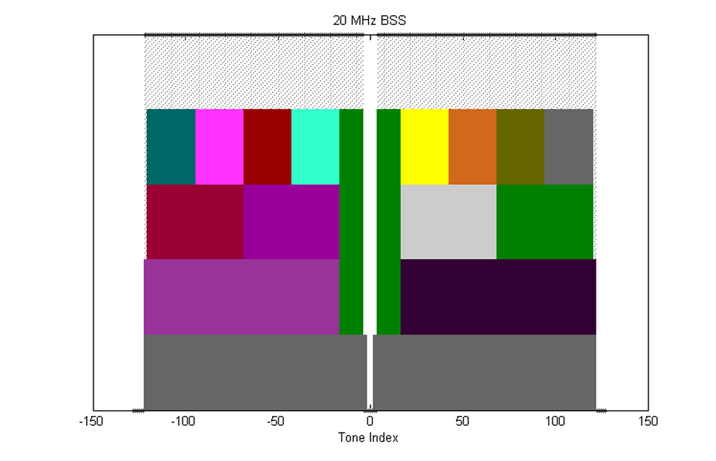

* + - 1. **define 40MHz OFDMA building blocks as follows**
* **26-tone with 2 pilots, 52-tone with 4 pilots, 106-tone with 4 pilots and 242-tone with 8 pilots and with 5 DC Nulls and (12,11) guard tones, and at locations shown in the picture below**

**The following is TBD:**

* **Exact location of extra leftover tones**

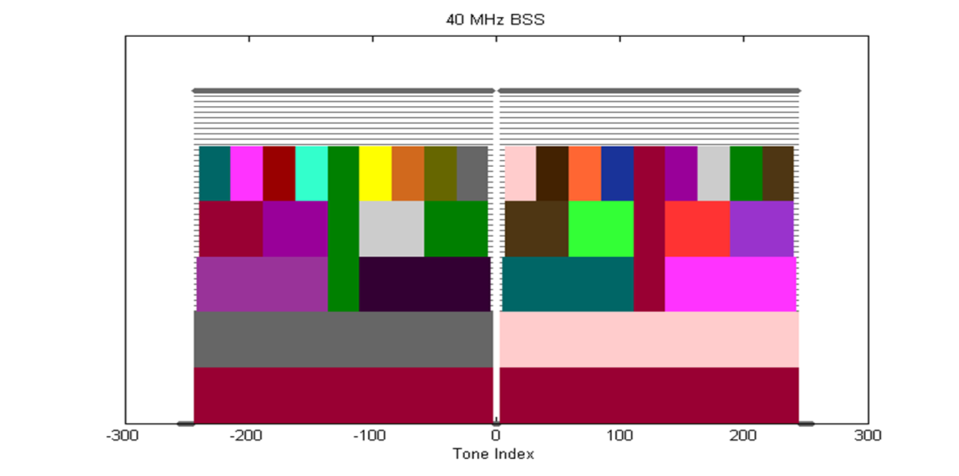

* + - 1. **define 80MHz OFDMA building blocks as follows**
* **26-tone with 2 pilots, 52-tone with 4 pilots, 106-tone with 4 pilots, 242-tone with 8 pilots and 484-tone with 16 pilots and with 7 DC Nulls and (12,11) guard tones, and at locations shown in the picture below**

**The following is TBD:**

* **Exact location of extra leftover tones**

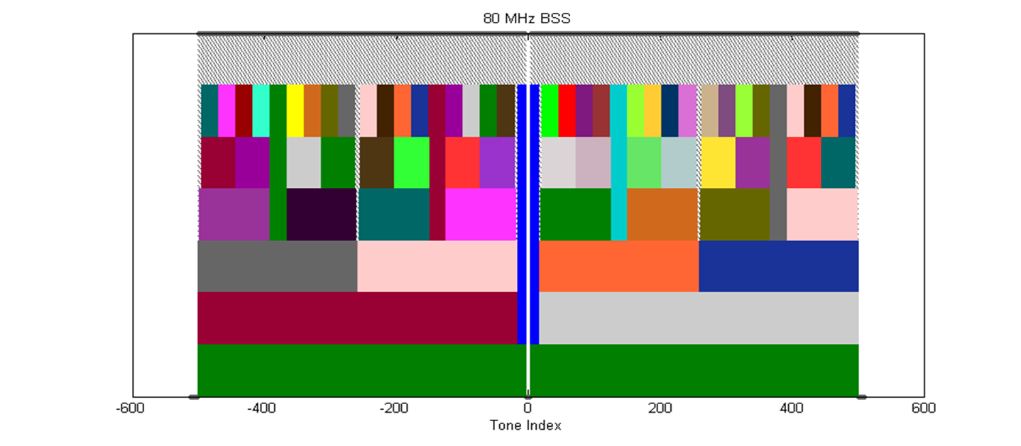

* + - 1. **define 160MHz/80+80MHz OFDMA building blocks as follows**
* **26-tone with 2 pilots**
* **52-tone with 4 pilots**
* **106-tone with 4 pilots**
* **242-tone with 8 pilots**
* **484-tone with 16 pilots**
* **996-tone with 16 pilots (note that 996-tone is defined for 80MHz HE-SA-PPDU or 80MHz HE-SA-MU-PPDU)**

**The following is TBD:**

* **Exact location of extra leftover tones**
  + - 1. **Discussions:**
         1. **Would like to propose to reconsider the DC tone issue.**
         2. **A member commented it not clear if this affects SFD 🡪 text modified.**
      2. **Result: Y/N/A = 88/0/47, the straw poll to be converted to a motion.**

* 1. Yakun Sun (Marvell) presented “HE-STF Proposal,” based on the submission 15/0381r1.
     1. Summary of the changes:
        1. Slide 11: HE-STF Periodicity
        2. Slide 31: Impact on Timing and Power Offset – simulation result
     2. Discussions
        1. No discussion.
     3. **Straw Poll #2: Do you support the HE-STF of a trigger-based PPDU has a periodicity of 1.6 µs with 5 periods?**
* **A trigger-based PPDU is an UL PPDU sent in response to a trigger frame**
  + - 1. **Result: Y/N/A = 73/0/42,**
    1. **Straw Poll #3: Do you support the HE-STF tone positions are defined in Equation 1 where *NSTF_sample*= 16 for a non-trigger-based PPDU and *NSTF_sample*= 8 for a trigger-based PPDU?**



* + - 1. **Result: Y/N/A = 74/0/46**
  1. Daewon Lee (Newracom) presented “Clarifications to Box 2 MIMO simulation calibrations” based on the submission 15/0581r0.
     1. Summary
        1. The methodology document is missing text regarding how MIMO calibration is being performed for box 2.
        2. Proposed to add missing equations.
     2. Discussions
        1. This goes to evaluation methodology document.
        2. It is up to each company to choose the receiver architecture.
     3. **Straw Poll: Do you agree to add the highlighted text in 11-15/0581r0 in the simulation scenario document?**
        1. **Discussion – Is it part of the model? 🡪 It is a part of channel model.**
        2. **Result: No objection. The straw poll will be converted into a motion.**
     4. **Straw Poll #2: Do you agree to add the highlighted text in 11-15/0582r0 in the Evaluation Methodology document?**
        1. **Discussion: No discussion.**
        2. **Result: No objection.**
  2. Jiyoung Pan (Huawei Technologies) presented “OBSS Preamble Error Probability” based on the submission 15/0583r1.
     1. Summary
        1. The OBSS preamble detection probability impacts much on the overall network behavior.
        2. The OBSS preamble error probability via Integrated Simulator where it was found that the error probability was related closely to the simulation configuration.
     2. Discussions
        1. C: If the second signal has enough high power compared to the first one, the second packet can be received.
        2. Q: Is the collision between the RTS frames considered? 🡪 Yes.
        3. Q: Preamble error: Only for data frames? 🡪 No. It is calculated for all frames.
        4. C: Have similar results for the case RTS is on.
        5. Q: MCS selection? 🡪 Assumed Jini scheme.
  3. Suhwook (LG Electronics) presented “OBSS Preamble Detection Evaluation” based on the submission 15/0551r4.
     1. Summary
        1. OBSS preamble detection evaluated using PHY/MAC integrated simulator.
        2. Following trends were observed:
           1. Preamble error prob. of Data frame is HIGHER than ACK frame
           2. Preamble error prob. of DL Data frame is HIGHER than UL Data frame
           3. On the other hand, preamble error prob. of DL ACK frame is LOWER than UL ACK frame
           4. Preamble error prob. is generally higher in mixed DL&UL traffic model
           5. Preamble of DL ACK is almost decoded successfully (~99%)
     2. Discussions
        1. .
  4. AoB
     1. Presentation by Reza Hedayat (Newracom) “Frequency Diversity Option in OFDMA,” based on 11-15/0586r1.
        1. Summary
        2. Discussions
           1. C: The straw poll text - not clear enough.
           2. C: Not sure why it is only for MU. It could be applied to SU.
           3. C: Suggest discussion whether non-contiguous allocation can be allowed.
           4. C: Would like to understand the benefit of this compared to the random allocation. 🡪 Concerned by the interference from the OBSS.
           5. C: Having multiple way of resource allocation introduces additional complexity. Would like to see more analysis.
        3. **Straw Poll: Do you agree that:**

**“a frequency diversity mode for DL OFDMA that is optionally present in a DL OFDMA PPDU.**

**Note: *Frequency diversity mode is a mode that allows to exploit the frequency diversity across the transmission bandwidth of a PPDU.*”**

* + - 1. **Discussion:**
         1. **Would like to see more analytical results and to abstain for now.**
      2. **Result: 26/20/50**

1. Recess until tomorrow AM1 (Thursday, 8:00 AM)

**Thusday, May 14th 2015, AM1 Session (8:00 - 10:00 AM)**

1. The meeting called to order by Osama Aboul-Magd (Huawei Technologies), the chair of TGax, @8:00 AM.
   1. Agenda 11-15/0500r6 is on the server. Rev 4 is working document.
   2. There were 200+ people in the room.
2. Administrative Items
   1. Chair reminded the IEEE 802 and IEEE 802.11 P&P.
   2. Chair asked people to state name and affiliation when addressing for the first time in the session.
   3. Attendance!
3. Agenda for today’s session
   1. Thursday AM1
      1. Call Meeting to order
      2. Reminder
         1. IEEE 802 and 802.11 IPR Policy and procedure.
         2. Attendance
      3. Presentations
         1. 11-15/0590 Traffic Model Updates to Evaluation Methodologies (60 min)
         2. 11-15/0552 IEEE 802.11 Performance in Dense, Cellular-like, Outdoor Deployments (30 min)
         3. 11-15-0674– Joint submission for Box 5 calibration (15 min)
         4. 11-15/330 SP#1-modified (15 min)
      4. Group input on how many time slots to request for next meeting
      5. Recess
   2. Thursday PM1
      1. Call Meeting to order
      2. IEEE 802 and 802.11 IPR Policy and procedure.
      3. TG Motions – to be included in the 15/0500r7 to be placed on the server after AM1 session.
      4. Presentations
      5. Goals for July 2015 session
      6. Teleconference Planning
      7. Adjourn
   3. Chair asked if there are any modifications to the agenda for AM1.
   4. Agenda for AM1 approved without objections.
4. Presentation
   1. Phillip Barber (Huawei Technologies) presented “Traffic Model Updates to Evaluation Methodologies,” based on 15/0590r2
      1. Summary
      2. Discussions
      3. Straw Polls
         1. **Straw Poll #1: Do you agree to modify the Evaluation Methodology document IEEE 802.11-15/571r8 as provided in IEEE 802.11-15/0590r2?**
            1. **Discussion: Phil will work with Ron to update EVM docuemnt.**
            2. **Result: No objection.**
         2. **Straw Poll #2: Do you agree to modify the Simulation Scenarios document IEEE 802.11-15/980r10 as provided in IEEE 802.11-15/0373r4?**
            1. **Discussion: Again, Phil will work with Ron to update the EVM document.**
            2. **Result: No objection.**
   2. Marcin Filo (Univ. of Surrey) presented “IEEE 802.11 performance in dense, cellular-like, outdoor deployments,” based on 15/0552r1
      1. Summary
         1. Performance of IEEE 802.11 in dense, out-door, cellular-like deployments is investigated.
         2. Several issues related to IEEE 802.11 operation in such environments are highlighted.
            1. Dependency of performance on a number of parameters – hard to optimize
            2. Unfairness
            3. Inefficiency due to the increased overhead
      2. Discussion
         1. No discussion
   3. Suhwook Kim (LG Electronics) presented “Joint submission for Box 5 Calibration,” based on 15/0674r1
      1. Summary
         1. Joint contribution of updated simulation results for Box-5 calibration by members.
         2. Simulation results are getting close to each other, but still need some work to be aligned.
         3. To speed up the Box-5 calibration, members agreed some detail implementations which are summarized in slide 13.
      2. Discussion
         1. No discussion.
   4. Sharnaz Azizi (Intel) presented “OFDMA Numerology and Structure,” based on 15/0330r4
      1. Summary
         1. Simplified Straw Poll proposed.
      2. Discussion
         1. A member commented that this straw poll failed on Monday and it is not valid to have the same straw poll again. 🡪 The straw poll is quiet different from the one that failed.
            1. Chair mentioned we need to understand the difference.
            2. Sharnaz explained the difference that this is for the single user case only.
         2. SU case is a subset of OFDMA.
         3. Another member also mentioned that we need more time to think about.
         4. Chair ruled not to allow the straw poll without having something new.
   5. AOB – Jiyong Pan has a material to present
      1. Jiyong Pan (Huawei Technologies) presented “Reference Box5 Calibration Assumptions and Parameters,” based on 15/0680r0.
      2. Summary
         1. For Box5 calibration, details of the assumptions and parameters were discussed by interested members.
         2. PHY and MAC parameters and scenario are described in slides 4 to 7.
         3. Proposed edits contained in 15/681r0.
      3. Discussion
         1. Why do we need to take simulation scenario from 802.11ac? 🡪 Current scenario in 14/980 is too complicated. 802.11ac simulation scenario is much simpler and suitable for the calibration purpose.
      4. **Straw Poll: Do you agree that the proposed text as per 15/0681r0 for Box5 calibration is added to the Simulation Document 11-14/0980r10?**
         1. **Discussion: No discussion.**
         2. **Result: No objection.**

We finished all items in this meeting slot having additional presentation from Jiyong.

Chair will upload the revised agenda document including the motions we will conduct this afternoon.

* Please check if the motion text is correct.

1. AOB
2. Recess @ 9:47 until PM1 this afternoon.

**Thusday, May 14th 2015, PM1 Session (13:30 - 15:50)**

1. The meeting called to order by Osama Aboul-Magd (Huawei Technologies), the chair of TGax, @13:30.
   1. Agenda 11-15/0500r6 is on the server. Rev 4 is working document.
   2. There were 200+ people in the room.
2. Administrative Items
   1. Chair reminded the IEEE 802 and IEEE 802.11 P&P.
   2. Chair asked people to state name and affiliation when addressing for the first time in the session.
   3. Attendance!
3. Agenda Setting
   1. Proposed agenda for this session - Thursday PM1
      1. Call Meeting to order
      2. IEEE 802 and 802.11 IPR Policy and procedure.
      3. Agenda Setting
      4. TG Motions
         1. Based on SPs from the different Ad Hoc groups
         2. SSD and EMD motions
      5. Presentations
      6. Goals for July 2015
      7. Telecon Schedule
      8. Adjourn
   2. Chair asked if there are any objections to proceed with this agenda – no objections.
      1. The agenda approved.
4. TG Motions
   1. **PHY Motions #9**
      1. **Move to add to the TG Specific Framework:**

**3.y.z UL MU PPDU shall not include HE-SIG-B field if it is sent as an immediate response to a Trigger frame sent by an AP**

* + 1. **Move: Young Hoon Kwon Second: Yongho Seok**
    2. **Result: Y/N/A = 28/20/34, motion fails.**
  1. **PHY Motion #10**
     1. **Move to add to the SFD:**

**1. define 20MHz OFDMA building blocks as follows**

**- 26-tone with 2 pilots, 52-tone with 4 pilots and 106-tone with 4 pilots and**

**with 7 DC Nulls and (6,5) guard tones, and at locations shown in the picture below**

**- An OFDMA PPDU can carry a mix of different tone unit sizes within each 242 tone unit boundary**

**- The following is TBD:**

**Exact location of extra leftover tones**

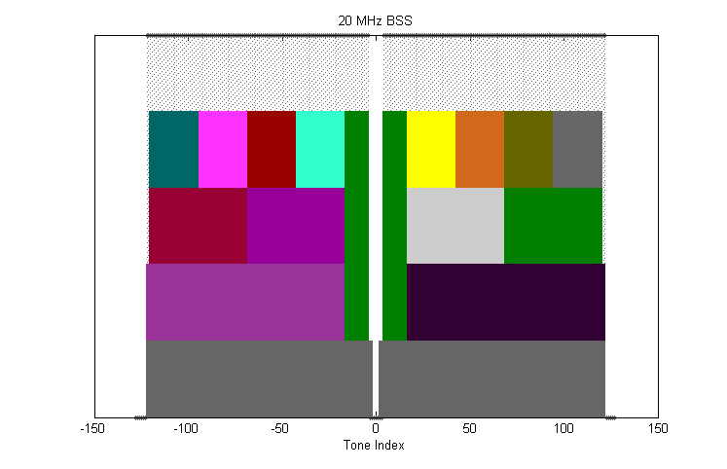

**2. define 40MHz OFDMA building blocks as follows**

* + **26-tone with 2 pilots, 52-tone with 4 pilots, 106-tone with 4 pilots and 242-tone with 8 pilots and with 5 DC Nulls and (12,11) guard tones, and at locations shown in the picture below**

**The following is TBD:**

* + **Exact location of extra leftover tones**

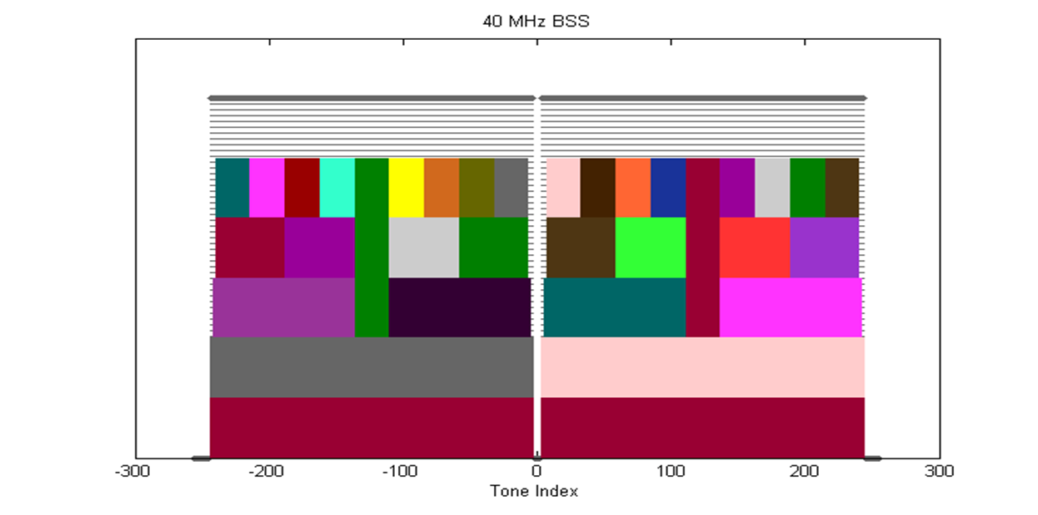

**3. define 80MHz OFDMA building blocks as follows**

* + **26-tone with 2 pilots, 52-tone with 4 pilots, 106-tone with 4 pilots, 242-tone with 8 pilots and 484-tone with 16 pilots and with 7 DC Nulls and (12,11) guard tones, and at locations shown in the picture below**

**The following is TBD:**

* + **Exact location of extra leftover tones**

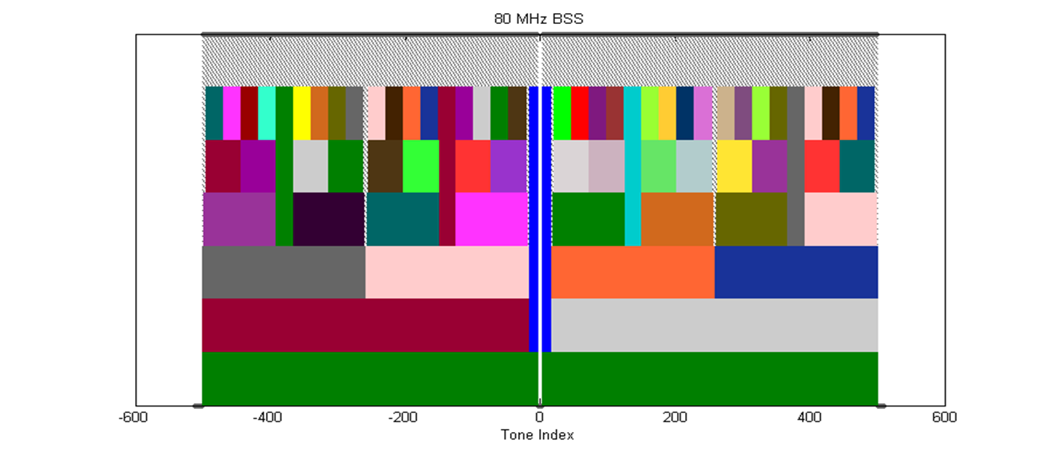

**4. define 160MHz/80MHz+80MHz OFDMA building blocks as follows**

* **26-tone with 2 pilots**
* **52-tone with 4 pilots**
* **106-tone with 4 pilots**
* **242-tone with 8 pilots**
* **484-tone with 16 pilots**
* **996-tone with 16 pilots (note that 996-tone is defined for 80MHz HE-SA-PPDU or 80MHz HE-SA-MU-PPDU)**

**The following is TBD:**

* + **Exact location of extra leftover tones**
    1. **Moved by Sgarnaz Azizi, Seconded by Robert Stacy**
    2. **Result: Y/N/A = 63/0/30, motion passes.**
  1. **PHY Motion #11**
     1. **Move to add to the SFD:**

**HE-STF of a non-trigger-based PPDU has a periodicity of 0.8 µs with 5 periods?**

**- A non-trigger-based PPDU is not sent in response to a trigger frame**

* + 1. **Move: Yakun Sun, Second: Kaushik Josiam**
    2. **Result: Y/N/A = 63/0/30, motion passes.**
  1. **PHY Motion #12**
     1. **Move to add to the SFD:**

**The HE-STF of a trigger-based PPDU has a periodicity of 1.6 µs with 5 periods?**

**- A trigger-based PPDU is an UL PPDU sent in response to a trigger frame**

* + 1. **Move: Yakun Sun, Second: Robert Stacy**
    2. **Result: Y/N/A = 58/0/37, motion passes.**
  1. **PHY Motion #13**
     1. **Move to add to the SFD:**

**The HE-STF tone positions are defined in Equation 1 where NSTF_sample = 16 for a non-trigger-based PPDU and NSTF_sample = 8 for a trigger-based PPDU?**



* + 1. **Move: Yakun Sun, Second: Lei Wang**
    2. **Result: Y/N/A = 66/0/25, motion passes.**
  1. **PHY Motion #14**
     1. **Move to add the following text into 11ax SFD:**

**3.2.z HE-SIG-B shall use a DFT period of 3.2us and subcarrier spacing of 312.5kHz.**

* + 1. **Move: John Son, Second: Ronny Kim**
    2. **Discussion – No discussion**
    3. **Result: Y/N/A = 28/1/54, motion passes.**
  1. **MAC Motion #5**
     1. **Move to add the following text to SFD:**

**- UL OFDMA PPDUs shall end at the time indicated in trigger frame, by adding padding if necessary**

* + 1. **Move: Simone Merlin, Second: Phillip Barber**
    2. **Discussion**
       1. **Trigger frame is not defined in SFD and its contents are not clear. Suggest this motion to be discussed in the next session. 🡪 This motion defines the behavior that we want. If we agree this motion, it makes a content of trigger frame.**
       2. **This motion is about the concept of the UL OFDMA PPDU and does not discusses details.**
       3. **We also agreed this direction.**
       4. **Chair asked to if there is any objection to table this motion 🡪 No objection.**
    3. **Result: Motion tabled.**
  1. **MAC Motion #6**
     1. **Move to add the following text to SFD:**

**- U** **The MAC padding for UL MU OFDMA PPDUs is done by using the 11ac A-MPDU padding procedure**

* + 1. **Result: This motion also deferred.**
  1. **MAC Motion #7**
     1. **Move to add the spec framework:**

**- The spec shall define a Trigger frame that allocates resources for random access.**

* + 1. **Moved by Chittabrata Ghosh, Second: Laurent Cariou**
    2. **Discussion:**
       1. **(Against) This topic is interesting, however, it is not well discussed and well understood.**
          1. **It is not clear the reason is technical one or procedural one.**
       2. **(In favor)This motion does not talk about details of procedure and would like to know if the commenter objects the concept of this motion.**
       3. **(Against) It is not clear if this replaces the scheduled access.**
       4. **(In favor) This is just one mechanism to use trigger frame for the random access and does not replace any other mechanism.**
       5. **(Against) Not clear the concept of trigger frame and what will happen after a collision occurs. Would like to see simulation results.**
       6. **(In favor) It is good to start high level concept to specify a technology.**
    3. **Result: Y/N/A = 62/27/17, motion fails.**
  1. **MAC Motion #8**
     1. **Move to add the following to SFD:**

**- UL OFDMA MPDU/A-MPDU is the acknowledgement of the trigger frame.**

* **When the AP receives UL MPDU/A-MPDU correctly from at least one STA indicated by trigger frame, the frame exchange initiated by the trigger frame is successful**
* **An AP shall not allocate UL subchannel in any 20MHz channel that is not occupied by the Trigger frame. In each 20MHz channel occupied by the Trigger frame, there is at least one allocated subchannel**
  + 1. **Moved by Liwen Chu, Second: David Yang**
    2. **Discussion:**
       1. **(Against) This motion comprised of two parts. From the first part, concerned that MPDU/A-MPDU at least one STA mean the transmission is successful, the second part is already in 802.11ac spec.**
       2. **(In favor)**
       3. **(Against) Just one part of success does not mean that the transmission was successful especially in OBSS environment.**
       4. **(In favor) This is a new frame sequence which does not exist in 802.11ac spec.**
    3. **Motion: Motion to divide MAC motion #8**

**Move to divide the MAC Motion #8 to:**

**Move to add the following to SFD:**

* + - * + **UL OFDMA MPDU/A-MPDU is the acknowledgement of the trigger frame.**

**When the AP receives UL MPDU/A-MPDU correctly from at least one STA indicated by trigger frame, the frame exchange initiated by the trigger frame is successful**

**And,**

**Move to add the following to SFD:**

**An AP shall not allocate UL subchannel in any 20MHz channel that is not occupied by the Trigger frame. In each 20MHz channel occupied by the Trigger frame, there is at least one allocated subchannel**

* + - 1. **Moved by Lei Wang, Second: Stuart Kerry**
      2. **Motion accepted with no objection.**
  1. **Motion #9: Move to add the following to SFD:**
* **UL OFDMA MPDU/A-MPDU is the acknowledgement of the trigger frame.**
  + **When the AP receives UL MPDU/A-MPDU correctly from at least one STA indicated by trigger frame, the frame exchange initiated by the trigger frame is successful**
    1. **Moved by Liwen Chu, seconded by Lei Wang**
    2. **Result: Y/N/A = 71/25/9, motion fails.**
  1. **Motion #10: Move to add the following to SFD:**

**An AP shall not allocate UL subchannel in any 20MHz channel that is not occupied by the Trigger frame. In each 20MHz channel occupied by the Trigger frame, there is at least one allocated subchannel**

* + - 1. **Moved by Liwen Chu, seconded by Lei Wang**
      2. **Result: Y/N/A = 74/0/13, motion passes.**
  1. **MAC Motion #11: Move to modify the sub-clause 7.2 in 11ax SFD as follows**

**- 7.2 Multi-STA BA**

**- …**

**- If B11 in the per-TID info field is set, then the BlockAck bitmap and the SC subfields in the BA Info field are not present and this BA Info field indicates an ACK ~~for~~ of either single MPDU or all MPDUs carried in the eliciting PPDU that was transmitted by the STA whose ~~the STA with~~ AID is indicated in the per-TID info field**

* + 1. **Moved by Kiseon Ryu, seconded by Suhwook Kim**
    2. **Result: Y/N/A = 67/0/27, motion passes.**
  1. **MU Motion #5: Move to add the following to the TG specification framework document:**

**4.x Multi-user (MU) features**

**The amendment shall define a sounding procedure for reporting DL CSI feedback using UL MU mode.**

* + 1. **Moved by Yongho Seok, seconded by Young Hoon Kwon**
    2. **Discussion:**
       1. **Any simulation results to understand the gain? 🡪 It is included in the document.**
       2. **Do not understand what the DL CSI is. 🡪 The STAs return the CSI as the feedback.**
       3. **Need to understand the complexity and feasibility.**
       4. **The benefit of having this mechanism is it contributed to improve MAC efficiency.**
    3. **Result: Y/N/A = 34/20/34, motion fails.**
  1. **Evaluation Methodology Document**
     1. **Ron Porat explained the update on EVM.**
        1. **Changes are Traffic model and SINR calculation.**
     2. **Motion**

**Move to accept document 11-14/0571r9 as the current revision of the TG evaluation Methodology document.**

* + - 1. **Moved by Ron Porat, seconded by Phillp Barber**
      2. **Result: Motion accepted with no objection.**
  1. **Motion: Simulation Scenario Document**
     + 1. **Simone Merlin (Qualcomm) explained the document.**
          1. **Some tables updated.**
       2. **Discussion:**
          1. **A member asked to update the table for Box 5 using 15/861.**
          2. **Simone agree to include the contents of 15/861 in**
          3. **The motion to approve updated SSD was deferred.**

1. Goals for July 2015
   1. Continue to advance the TG documents based on submissions.
      1. Expectation is more submissions affecting the TG specification framework document will be considered.
   2. Technical Presentations
2. Teleconference scheduling
   1. Continue to advance the TG documents based submissions.
      1. Expectation is more submissions affecting the TG specification framework document will be considered.
   2. Technical Presentations
3. Teleconference Planning
   * 1. .Thursday, June 18th, 10:00 – 12:00 ET.
4. AOB

None.

1. Adjourn
   1. TGax adjourned for the week @ 15:28.