IEEE P802.11
Wireless LANs
Normative DS SAP proposal
Date: 2015-05-07
Author(s):
Name | Affiliation | Address | Phone | email
Mark Hamilton | Ruckus Wireless | 350 W Java Dr.  Sunnyvale, CA 94089 | +1-303-818-8472 | mark.hamilton@ruckuswireless.com

Discussion
Revision History
R0 – First revision.
Abstract
This document is a follow-up to 11-14/1218, with a proposal to make the DS SAP (and thusly, Annex R) normative text.

The concept of making the DS SAP normative has been under discussion for many months (over a year?) between 802.11 ARC SC and 802.1 IWK (in the context of 802.1AC). There is general agreement between the groups that this is necessary and useful to support the architectural connection between 802.1Q and 802.11, especially for 802.11 Portals.

In discussions in the ARC SC, it is agreed that making this text normative will not be a burden on existing implementations, since any SAP such as this, is only a logical interface, and no externally visible behavior requirements are being created with this change. However, the change does have value in the 802.11 Standard, as it allows the 802.1 Standards (802.1AC at least, perhaps 802.1Q) to reference this SAP interface cleanly, to aid readers’ and implementers’ understanding of how the Standards work together.

This document contains a proposal to accomplish this change, and is submitted for consideration and review by the 802.11 ARC SC, with intent to forward to 802.11 REVmc.

Background

Document 11-14/0497 provides background material, including several figures to help understand architectural figures including the DS SAP, and why this SAP is useful to 802.1AC. This document concludes with a recommendation to make 802.11 Annex R normative text (which would include moving it into the main body of the Standard instead of an Annex). This has received general support in both the ARC SC and TGmc.

Document 11-14/1213 expands on this, noting that a new term “DSAF” would be helpful in describing an AP’s architecture and clarifying how it relates to the DS SAP. This document also points out that the existing Figure R-1, in 802.11 Annex R, is confusing and misleading as currently drawn. Thus, it is suggested that Figure R-1 be updated to be similar to the figures used in 11-14/0497 and 11-14/1213. Both the DSAF concept, and redrawing Figure R-1 have also received general support in ARC SC and TGmc. That is, instead of this:
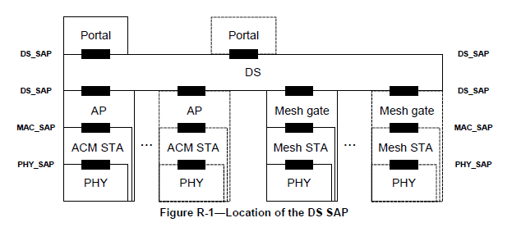

Use something more like this (probably without the color):
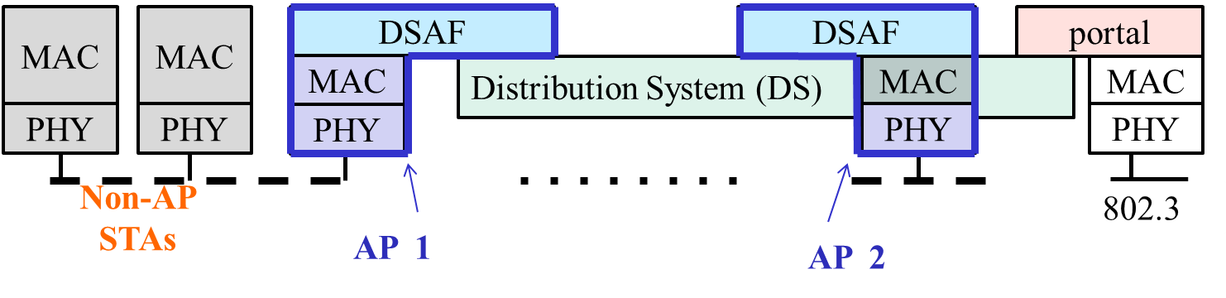

Proposed changes

- Move Annex R into the main body of the Standard, to become a new clause following clause 6, renumber the clauses that follow. (This means there are clauses all in a row, for: MAC (data) Service, (effectively) MAC Mgmt service; Distribution System Service; PHY service. Make the following changes to this text, as it is moved:
  - Delete the first sentence, “
  - Note that CID 3507 had approved resolution which included the following change: Replace all occurrences of “DSSDU” in Annex R with “MAC service tuple”. This was not done, completely, and should be done now.
- Replace Figure R-1 with this figure, and NOTE:

Figure R-1 -- Location of the DS SAP

NOTE—In Figure R-1, the DS has four users, two APs, a mesh gate, and a portal, so the DS is shown passing behind the MAC/PHYs of the STAs.

- Add a new term, “Distribution System Access Function (DSAF)”, by the following changes:
  - Add a definition in 3.1:
distribution system access function (DSAF): A function within an AP or mesh gate which uses the MAC service and distribution service to provide access between the DS and the WM.
  - Add to the definition of AP (in 3.1), as shown:
access point (AP): An entity that contains one station (STA) and provides access to the distribution services, via the wireless medium (WM) for associated STAs. An AP comprises a STA and a DSAF.
  - Change the definition of mesh gate as shown:
mesh gate: Any entity that has mesh station (STA) functionality and DSAF functionality to provide access to one or more distribution systems, via the wireless medium (WM) for the mesh basic service set (MBSS).
  - Change the sentence in 4.3.5.1, as shown:
An access point (AP) is any entity that has STA functionality and a distribution system access function (DSAF), to enable access to the DS, via the WM for associated STAs.
  - Change the sentence in 4.3.5.1, as shown:
Data move between a BSS and the DS via the DSAF in an AP.
  - Change the following sentence in 4.3.18.4, as shown:
Thus, the mesh gate is the logical point at which MSDUs from an MBSS enter the IEEE Std 802.11 DS, via the DSAF.

