IEEE P802.11
Wireless LANs
Proposed text to TGax Simulation Scenarios PSM/PSP test
Date: March 12, 2015
Author(s):
Name | Affiliation | Address | Phone | email
Hyeyoung Choi | LG Electronics | 19, Yangjea-daero 11gil, Seocho-gu, Seoul 137-130, Korea | +82-2-6912-6589 | hy0117.choi@lge.com
Suhwook Kim | LG Electronics |  |  | suhwook.kim@lge.com
Kiseon Ryu | LG Electronics |  |  | kiseon.ryu@lge.com
Jeongki Kim | LG Electronics |  |  | jeongki.kim@lge.com
HanGyu Cho | LG Electronics |  |  | hg.cho@lge.com

Summary:

The following changes are suggested for the MAC simulator section of the simulation scenario document [1]:
- MAC overhead of Beacon frame is 272 octet(including TIM:250 octet)
- Following event sequence is assumed:
- The first DL DATA arrives at 100us
- The first DTIM Beacon is sent at 100ms
- When PS STA detects that the bit corresponding to its AID is 0 in DTIM Beacon frame, STA enters the sleep state and STA remains the sleep state until STA enters the Awake state to receive the next DTIM Beacon frame.

Proposed text changes in <Test 5: Power Save Mechanism Test>

PSM test:

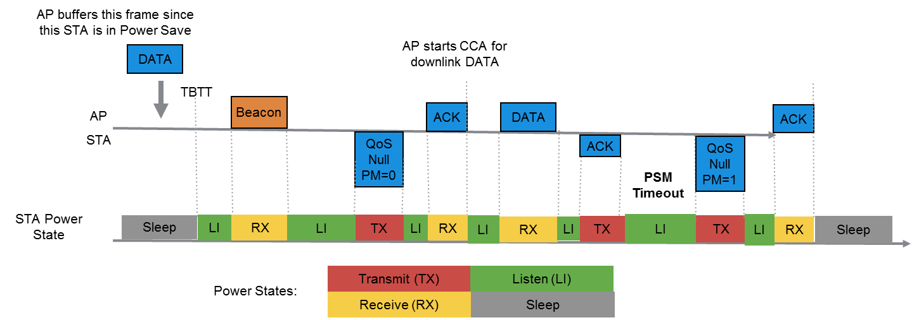

Figure 11 – Example of the frameflow in PSM scenario and non-AP STA Power States. •MSDU length: 1500 bytes with CWmin=15 downlink every 200 ms
•RTS/CTS [ OFF ]
•AIFS=DIFS=34us
•MCS = [ 0 ]
•No A-MPDU aggregation
•DTIM = [ 3 ]
• MAC overhead of Beacon frame=272 byte
•PSM timeout = [ 100 ] ms
• Following event sequence is assumed:
- The first DL DATA arrives at 100us
- The first DTIM Beacon is sent at 100ms

When PS STA detects that the bit corresponding to its AID is 0 in DTIM Beacon frame, STA enters the sleep state and STA remains the sleep state until STA enters the Awake state to receive the next DTIM Beacon frame.

PSP test:

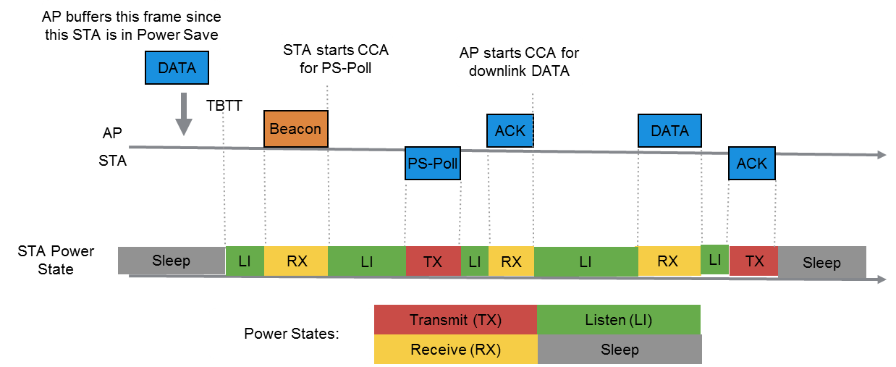
Figure 12 – Example of the frameflow in PSP scenario and non-AP STA Power States.

•MSDU length: 1500 bytes with CWmin=15 downlink every 200 ms
•RTS/CTS [ OFF ]
•AIFS=DIFS=34us
•MCS = [ 0 ]
•No A-MPDU aggregation
•DTIM = [ 3 ]
• MAC overhead of Beacon frame=272 byte
• Following event sequence is assumed:
- The first DL DATA arrives at 100us
- The first DTIM Beacon is sent at 100ms

When PS STA detects that the bit corresponding to its AID is 0 in DTIM Beacon frame, STA enters the sleep state and STA remains the sleep state until STA enters the Awake state to receive the next DTIM Beacon frame.

References:
[1] 11-14/0980r06, “TGax Simulation Scenarios”, Simone Merlin (Qualcomm)

