IEEE P802.11
Wireless LANs
Further Clarifications to FTM Protocol
Date: 2015-05-13
Author:
Name | Affiliation | Address | Phone | Email
Carlos Aldana | Qualcomm Corporation |  |  | caldana@qca.qualcomm.com
Brian Hart | Cisco Systems |  |  | brianh@cisco.com

Abstract
This contribution addresses some concerns about Fine Timing Measurement Protocol. In particular it addresses CIDs 5172, 5173, 5175, 5176, 5178, 5180, 5181, 5183, 5186, 5187, 5189, 5670, 5859, 6048, 6231, 6232, 6778, 6780, 6781, and 6790.

It uses Draft 4.0 as a baseline.

We propose to reject comments 6780 and 6790 and make the changes (shown in red) in this document to address the remaining ones.

Revision history:
v0 : Initial submission for PTSF value to avoid conflict between FTM trigger frame and initial Fine Timing Measurement frame.
v1 : Addressing CIDs for SB
v2 : Added Brian Hart as co-author.
Pertinent Comments :
CID | Draft | Clause Number |  | Page | Line | Type of Comment | Comment | Proposed Change
5172 | 4 | 8.4.2.36 | 855 |  | 13 | T | dot11FineTimingMsmtActivated no longer exists. | Replace with dot11FineTimingMsmtRespActivated
5173 | 4 | 10.24.6.4 | 1737 |  | 24 | T | In ASAP=0 case, how do we ensure that the FTM trigger frame is not transmitted before the successful transmission of FTM_1? | We could set a bound to the Partial TSF Timer that is greater or equal to K*Min Delta FTM + TXTIME(FTM_1) + aSIFSTime+ TXTIME(Ack), where K is the maximum number of FTM_1 retransmissions the responding STA will attempt.
5175 | 4 | 8.4.2.166 | 1053 |  | 37 | T | The "No preference" field in Table 8-247 should only be allowed in the associated state. In the unassociated state, it is hard for the responding STA to know the initiating STA's capability. | Fix as in comment and add corresponding language in 10.24.6
5176 | 4 | 8.6.8.33 | 1138 |  | 57 | T | Since TOA Not Continuous is always equal to TOD Not Continuous, let's remove the TOA Not Continuous field from Figure 8-666 and make it a reserved field. After doing this, we should change the language associated with "TOD Not Continuous" to say "The TOD Not Continuous field indicates that the TOD value is with respect to a different underlying time base than the last transmitted TOA value." | Fix as in comment.
5178 | 4 | 10.24.6.4 | 1741 |  | 36 | T | Since FTM can be used for both ranging and synchronization and 802.1AS is already thinking about incorporating FTM, we should add a NOTE similar to the one in section 10.24.5 (Timing Measurement Procedure) that relates FTM to Clause 12 of IEEE P802.1AS. | As in comment
5180 | 4 | 8.6.8.33 | 1139 |  | 53 | T | Since Usage rules in Figure 8-219 contains the "Retransmission Allowed" bit, it should be included as part of FTM_1. Add Usage Rules to the following clause as in :"which either indicates the LCI of the transmitting STA and includes the Z and Usage Rules/Policy subelement" | As in comment
5181 | 4 | 10.24.6.3 | 1736 |  | 43 | E | Replace "that the a request" with "that the request" | As in comment
5183 | 4 | 10.24.6.4 | 1738 |  | 22 | E | Replace "Burst Timeout" with "Burst Duration" in the Figure, as Burst Period is no longer defined. Do this for Figures 10-35 and 10-36 as well. | As in comment
5186 | 4 |  |  |  |  | T | Please clarify ASAP Capable to mean "Capable of doing ASAP=1". Rewrite the sentence "The ASAP Capable field indicates whether the STA is capable of capturing timestamps associated with an  initial Fine Timing Measurement frame and sending them in the following Fine Timing Measurement frame" to "The responding STA sets the ASAP Capable  field to 1 to indicate the STA's capability to send a Fine Timing Measurement frame as soon as possible : the STA is capable of capturing timestamps associated with an  initial Fine Timing Measurement frame and sending them in the following Fine Timing Measurement frame" | As in comment
5187 | 4 | 10.24.6.3 | 1736 |  | 58 | T | When the initiating STA requests "no preference" for FTMs per Burst and Burst Duration is not set to a value of 15, it means the responding STA should try to meet its Burst Duration request subject the responding STA's retransmission policy. Similarly, when the initiating STA requests "no preference" for Burst Duration and does not request a value of 0 for FTMs per Burst, it means the responding STA should meet the FTMs per Burst request. | As in comment
5189 | 4 | 10.24.6.4 | 1741 |  | 39 | E | We should clarify that an FTM retransmission has a new Sequence Number in MAC header. | As in comment
5670 | 4 | 10.24.6.4 | 1737 |  | 38 | E | "value indicated by the ... field": fields don't indicate things, but their values do. | Replace "indicated by the" with "indicated by the value of the".
5859 | 4 | 10.24.6.4 | 1737 |  | 39 | E | Typo. "fieldin" | Change "fieldin" to "field in".
6048 | 4 | 10.24.6.4 | 1737 |  | 10 | T | the PTSF is a 16bit long field of bits 25:10 of the TSF which defines the start time of the burst instances. Since it is a TU granularity it is not well defines the lower 10bits of the TSF time at the start of the burst instance.  Recommendation : define the lower 10bits of the TSF to be set to 0 for burst instances. | Define the lower 10bits of the TSF to be set to 0 for burst instances.
6231 | 4 | 8.4.2.166 | 1054 |  | 54 | T | It is not clear exactly what instant in time the PTT refers to, if the PTT is "lower" (modulo wrap-around) than the current corresponding bits of the TSF timer | Specify that the PTT shall always be considered to be in the future
6232 | 4 | 8.4.2.166 | 1054 |  | 54 | T | It is not clear exactly what instant in time the PTT refers to, as regards the lsbs of the TSF | Specify that the PTT shall always be considered to start at the time where the least significant 10 bits of the TSF are all zero
6778 | 4 | 10.24.6 |  |  |  | E | Fix the FTM figures to follow normal style (no colours, nice fonts, etc.) | As it says in the comment
6781 | 4 |  |  |  |  | E | It says "Within the fine timing measurement procedure, a STA, to request the Location Civic a responding STA that advertises Fine Timing Measurement capability" | Add "of" before "a responding STA"

Comment 6780
6780 | 4 | 10.24.6 |  |  | E | "The first Fine Timing Measurement frame in the FTM session is called the initial Fine Timing Measurement frame. [...] This initial Fine Timing Measurement frame shall include the Fine Timing Measurement Parameters element." duplicates stuff just before it. | Remove the duplication

Discussion:
The “stuff just before it” refers to the initial Fine Timing Measurement Request frame, not the initial Fine Timing Measurement frame.

Proposed Resolution : Reject.
Comment 6790
6790 | 4 | 10.24.6 |  |  | T | Does FTM format and bandwidth apply to FTM_1 when non-ASAP? | Clarify

Discussion:
We have the language “The responding STA should transmit Fine Timing Measurement
frames with the requested format and bandwidth.” This includes FTM_1, so there is no reason to add any additional language.
Proposed Resolution : Reject.

NOTE TO EDITOR : Please make the changes shown in red.
Clause 8.4.2.36 (Neighbor Report element)
The FTM field is set to 1 to indicate that the AP represented by this BSSID is an AP that has set the Fine
Timing Measurement field of the Extended Capabilities element to 1. The FTM field is set to 0 to indicate
either that the reporting AP has dot11FineTimingMsmtRespActivated equal to false, or the reported AP has not
set the Fine Timing Measurement Responder field of the Extended Capabilities element to 1 or that the Fine Timing Measurement field of the reported AP is not available to the reporting AP at this time.

Clause 8.4.2.166 (Fine Timing Measurement Parameters element)
The Partial TSF Timer field in an initial Fine Timing Measurement frame indicates the partial value of the
responding STA's TSF timer at the start of the first burst instance of an FTM session. The responding STA's TSF timer at the start of the first burst instance of an FTM session is limited to less than 62/64 of 65536 TUs (<63488 TUs) ahead of the TSF time at which the STA transmits the Fine Timing Measurement frame and 1/64 of 65536 TUs earlier (inclusive) (>=1024 TUs) than the TSF time at which the STA transmits the Fine Timing Measurement frame, as shown in Figure xxx. The Partial TSF Timer value is derived as follows, so as to have units of TUs: from the 64 TSF timer bits at the start of the first burst instance of an FTM session, where the 10 least significant bits equal 0, remove the most significant 38 bits and the least significant 10 bits.

NOTE- 1024 TUs out of the full range of the Partial TSF Timer field are not used in order to allow the recipient to resolve ambiguity arising from 1) imperfect synchronization between the initiating and responding STAs, and 2) retries of the initial Fine Timing Measurement Request frame or retransmissions of the initial Fine Timing Measurement frame.
Figure xxx: Calculation of Partial TSF Timer field

NOTE TO EDITOR : Please add the above Figure.
The ASAP Capable field indicates whether that the responding STA is capable of sending a Fine Timing Measurement frame as soon as possible; that is, the STA is capable of capturing timestamps associated with an initial Fine Timing Measurement frame and sending them in the following Fine Timing Measurement frame. This field is reserved in the initial Fine Timing Measurement Request frame.
The FTM Format And Bandwidth field indicates the requested or allocated packet format and bandwidth used by all Fine Timing Measurement frames in an FTM session and is shown in Table 8-247 (FTM Format And Bandwidth field). The value 0 indicates no preference by the initiating STA in the associated state and is not used by the responding STA. The value 0 is not used by the initiating STA in the unassociated state.

Clause 8.6.8.33 (Fine Timing Measurement frame format)

NOTE TO EDITOR : Please remove TOA Not Continuous reference and make B15 in Figure 8-666 a reserved bit.

The TOD Not Continuous field indicates that the TOD value is with respect to a different underlying time base than the last transmitted TOD TOA value. It is set to 1 when a discontinuity is present. Otherwise, it is set to 0.

The TOA Not Continuous field indicates that the TOA value is with respect to a different underlying time
base than the last transmitted TOA value. It is set to 1 when a discontinuity is present. Otherwise, it is set to
0.

The LCI Report field is optionally present. If present, it contains a Measurement Report element with
Measurement Type equal to LCI (see Table 8-104 (Measurement Type definitions for measurement
reports)), which either indicates the LCI of the transmitting STA and includes the Z and Usage Rules/Policy subelement or indicates an unknown LCI (see 10.24.6.7 (LCI and Location Civic retrieval using fine timing measurement procedure)).

Clause 10.24.6.3 (Fine timing measurement procedure negotiation)

In order to initiate a fine timing measurement procedure, a STA that supports the fine timing measurement
procedure as an initiator (referred to as an initiating STA) shall transmit a Fine Timing Measurement
Request frame. This frame is called the initial Fine Timing Measurement Request frame. After transmission of this frame, the initiating STA shall be ready to receive a Fine Timing Measurement frame.

A STA that supports the fine timing measurement procedure as a responder (referred to as a responding
STA) shall not transmit Fine Timing Measurement frames addressed to a peer STA unless the peer STA
supports the fine timing measurement procedure as initiator and the responding STA has received an initial
Fine Timing Measurement Request frame from the peer STA.

The initial Fine Timing Measurement Request frame shall have:
— the Trigger field set to 1,
— a set of scheduling parameters in a Fine Timing Measurement Parameters element that describe the
initiating STA’s availability for measurement exchange.

The first Fine Timing Measurement frame in the FTM session is called the initial Fine Timing Measurement
frame. The responding STA should transmit an initial Fine Timing Measurement frame within 10 ms in
response to the initial Fine Timing Measurement Request frame. This initial Fine Timing Measurement
frame shall include the Fine Timing Measurement Parameters element. The value of the Status Indication
field indicates if the request was successful, incapable or failed.

If the request was successful
— If the responding STA is ASAP capable, the responding STA’s selection of ASAP should be the
same as that requested by the initiating STA.
— The responding STA’s selection of the Min Delta FTM value shall be greater than or equal to the
corresponding value requested by the initiating STA.
— The responding STA's selection of the Number of Bursts Exponent value shall be 0 when the
initiating STA requests it to be 0.
— The responding STA's selection of the Burst Duration value should be less than or equal to the one requested by the initiating STA when the requested FTMs per Burst field value is set to a value of No Preference subject to the suggested formula for Burst Duration.
NOTE—When Number of Bursts Exponent is set to 0 and ASAP is set to 1, it is recommended that the Burst Duration be set to a value greater than or equal to
when V>1 and
when V=1
where
V is set to the value of FTMs per Burst * (K+1),
K is the maximum number of Fine Timing Measurement frame retransmissions the responding STA might attempt,
T_{MDFTM} is the value of the Min Delta FTM field of the Fine Timing Measurement Parameters field of FTM_1,
T_{FTM_X(X>1)} is the duration of the non initial Fine Timing Measurement frame,
T_{FTM_1} is the duration of FTM_1,
T_{Ack} is the duration of the Ack frame expected as a response.

Otherwise, it is recommended that the Burst Duration be set to a value greater than or equal to
.
where
T_{FTM_R} is the duration of FTM Trigger
T_{ACCESS_FTM} is the estimated medium access time for the first FTM frame in a burst.

— The responding STA's selection of FTMs per Burst field value should be the same as the one requested by the initiating STA when the Burst Duration requested is set to a value of No Preference (see Table 8-246 Burst Duration field encoding) subject to the responding STA’s policy on maximum FTMs per Burst field value.

NOTE—In an initial Fine Timing Measurement frame, the responding STA might indicate that the a request

Clause 10.24.6.4 (Measurement exchange)
The initiating STA shall transmit an FTM trigger frame as soon as it is available on channel at the beginning of the burst. This indicates to the responding STA its availability for the remainder of the burst instance. Following this FTM trigger frame the responding STA shall transmit an Ack frame and should transmit
FTMs per Burst Fine Timing Measurement frames before the Burst Duration elapses. In addition, the initiating STA shall be ready to receive a Fine Timing Measurement frame. These Fine Timing Measurement frames shall not include a Fine Timing Measurement Parameters element (for additional constraints on the Fine Timing Measurement frame see 10.24.6.7 (LCI and Location Civic retrieval using fine timing measurement procedure)). Within a burst instance, consecutive Fine Timing Measurement frames shall be spaced at least Min Delta FTM apart. Within a burst instance the initiating STA shall perform fine timing measurement on each Fine Timing Measurement frame addressed to it, except the last Fine Timing Measurement frame in a burst. The initiating STA may perform fine timing measurement on the last Fine Timing Measurement frame in a burst.

NOTE- If the initiating STA successfully transmits a non-initial Fine Timing Measurement Request frame (i.e. FTM trigger frame) late in a burst instance, fewer than FTMs Per Burst might be successfully transmitted by the responding STA in the burst instance.

The first burst instance shall start at the value indicated by the value of the Partial TSF Timer fieldin field in the initial Fine Timing Measurement frame, regardless of the ASAP field’s value. When ASAP is set to 1 by the responding STA, the Partial TSF Timer field value shall be set to a value less than 10 ms from the reception of the most recent initial Fine Timing Request frame.

The initiating STA may also request a single burstof burst of fine timing measurements to be taken as soon as
possible, in which case it sets the Number of Bursts Exponent field to 0 and the ASAP field to 1. This is illustrated in Figure 10-36 (Example negotiation and measurement exchange sequence for a single burst
instance, ASAP=1).

The round trip time (RTT) is defined by Equation (10-5).
RTT = [(t4’ – t1’) – (t3 – t2)] (10-5)

where t1’ and t4’ are the time at which the Fine Timing Measurement frame was transmitted and the time at
which the Ack frame was received, respectively, as determined by the initiating STA.
NOTE—The mechanism by which t1’ and t4’ are derived from the TOD and TOA fields, and the mechanism by which t2 and t3 are determined, are implementation dependent.

The Fine Timing Measurement protocol can also be used to synchronize a local clock between STAs. One higher-layer protocol for synchronizing a local clock time between STAs is specified in IEEE Std 802.1AS. The SME at the initiating STA may estimate the offset of the local clock relative to that at the responding STA using
clock offset = [(t2 – t1’) – (t4’ – t3)]/2 (10-6).

If the Ack frame for a transmitted Fine Timing Measurement frame is not received, the responding STA
shall not retry the frame. Instead,it can In order to send the frame again, the responding STA shall send a Fine Timing Measurement Frame with a new Dialog Token and the same Follow Up Dialog Token as with the same Action frame body as the Fine Timing Measurement Frame for which the Ack frame was not received, except for an updated Dialog Token. The Sequence Number in the MAC header is also updated. This is called an FTM retransmission.

Discussion:
For ASAP=0 case, we need to make sure that FTM_1 retransmissions do not conflict with the FTM Trigger frame:

A responding STA that transmits a Fine Timing Measurement frame with the ASAP field set to 0 shall set the Partial TSF Timer field to a value P_{TSF} from the time of the end of the transmission of the Ack to the last Fine Timing Measurement Request frame from the initiating STA subject to:
P_{TSF} >= K_1 x T_{MDFTM} + T_{FTM_}1 + aSIFSTime + T_{Ack} + T_{ACCESS_FTM1}
where
K_1 is the maximum number of initial Fine Timing Measurement frame (FTM_1) retransmissions the responding STA might attempt
T_{MDFTM} is the value of the Min Delta FTM field of the Fine Timing Measurement Parameters field of FTM_1
T_{Ack} is the duration of the Ack frame expected as a response
T_{ACCESS_FTM1} is the estimated medium access time for FTM_1.
NOTE—This value of the Partial TSF Timer field ought to result in the FTM trigger frame not being transmitted before a successful transmission of FTM_1.

If the time indicated by the Partial TSF Timer field is reached and neither an Ack frame to FTM_1 nor an FTM trigger frame has been received, by the responding STA, it shall send a Fine Timing Measurement frame with Dialog Token field set to 0. This terminates the FTM session with the initiating STA.

Please replace Figures 10-34, 10-35, and 10-36 with the following figures:
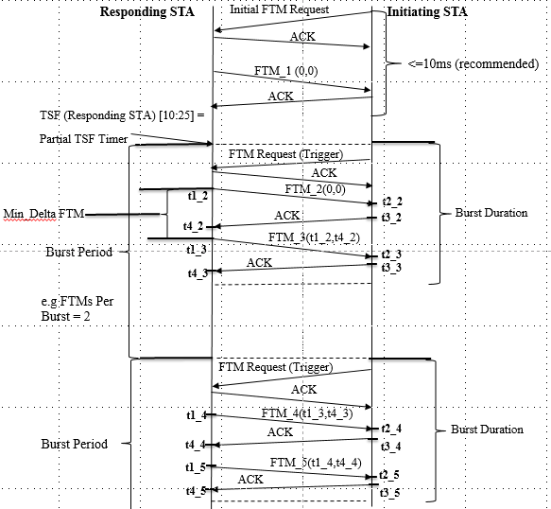
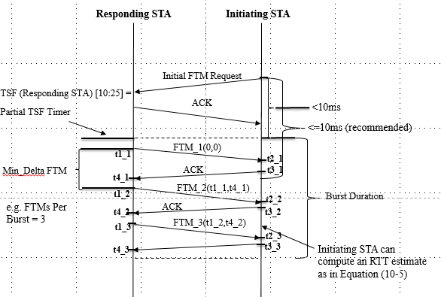
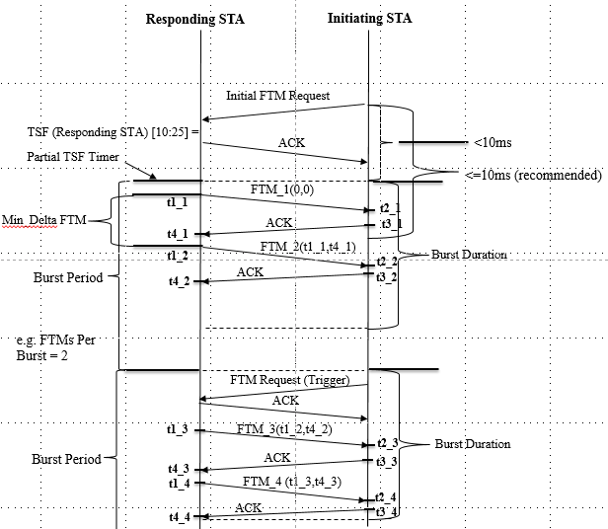

10.24.6.7 LCI and Location Civic retrieval using fine timing measurement procedure
Within the fine timing measurement procedure, a STA, to request the LCI of a responding STA that
advertises Fine Timing Measurement capability (see 8.4.2.26 (Extended Capabilities element)), shall
include a Measurement Request element with Measurement Type equal to LCI within the Fine Timing
Measurement Request frame.

Within the fine timing measurement procedure, a STA, to request the Location Civic of a responding STA that
advertises Fine Timing Measurement capability (see 8.4.2.26 (Extended Capabilities element), shall include
a Measurement Request element with Measurement Type equal to Location Civic within the Fine Timing
Measurement Request frame.

