IEEE P802.11
Wireless LANs
Clarification to Partial TSF Timer for ASAP=0 Case
Date: 2015-01-15
Author:
Name | Affiliation | Address | Phone | Email
Carlos Aldana | Qualcomm Corporation |  |  | caldana@qca.qualcomm.com
Brian Hart | Cisco Systems |  |  | brianh@cisco.com

Abstract
This contribution is to specify partial TSF timer value for the non-ASAP case so as to prevent ambiguity with the incoming FTM Trigger frame.

Clause 10.24.6.4 (Measurement exchange)
Discussion:
For ASAP=0 case, we need to make sure that FTM_1 retransmissions do not conflict with the FTM Trigger frame:

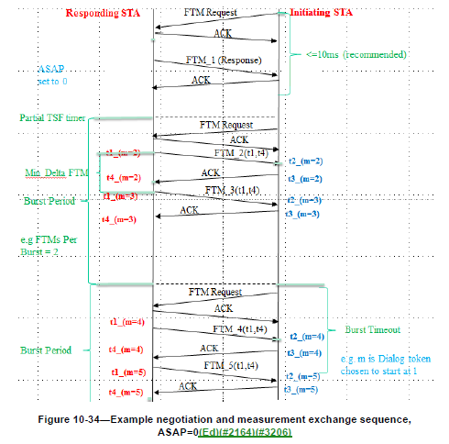

NOTE TO EDITOR : Add the following statements (in blue) at the end of clause 10.24.6.4:

Instead, it can may send a new Fine Timing Measurement Frame with a new Dialog Token and the same Follow Up Dialog Token as with the same action frame body as the Fine Timing Measurement Frame for which the Ack was not received, except for an updated Dialog Token. This is called an FTM retransmission.

When the ASAP field is set to 0 by a responding STA, to ensure the FTM trigger frame is not transmitted before the successful transmission of FTM_1, the responding STA shall set the Partial TSF Timer field to a value that is greater or equal to K*Min Delta FTM + TXTIME(FTM_1) + aSIFSTime+ TXTIME(Ack)+estimated medium access time from the time of the end of the transmission of the Ack to the last FTM Request frame from the initiating STA, where K is the maximum number of FTM_1 retransmissions the responding STA will attempt.

If the time indicated by the Partial TSF Timer is reached and neither an Ack to FTM_1 frame nor an FTM trigger frame has been received, the responding STA shall send a Fine Timing Measurement frame with Dialog Token field set to 0 to terminate the FTM session with the initiating STA.

