IEEE P802.11
Wireless LANs
Response to Editor’s Note related to FTM
Date: 2015-01-14
Author:
Name | Affiliation | Address | Phone | Email
Edward Au | Marvell Semiconductor |  |  | edwardau@marvell.com

Abstract
This contribution is to suggest text for selected subclauses in Clauses 8 and 10 marked with Editor’s Note.

Clause 8.4.2.20.19 (Fine Timing Measurement Range Request)
Discussion:
There is an Editor’s Note wondering whether the reference for the Subelement ID field value of Maximum Age fied is correct or not. Referring to the text below:
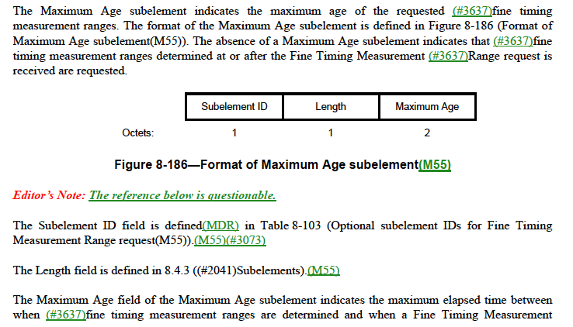

and Table 8-103:
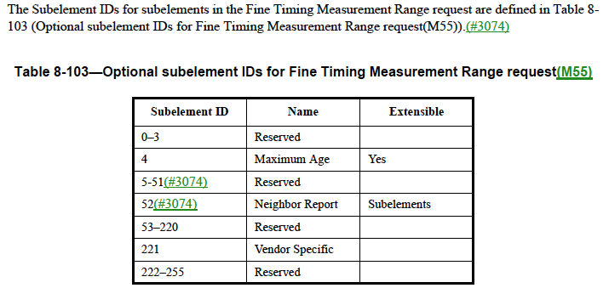
The reference is actually correct. It is because subelement ID of maximum age for fine timing measurement range request can be obtained from Table 8-103.

Editorial Instruction:

TGmc Editors: Please apply the following changes:
Remove the Editor’s Note at line 54, page 782.
Clause 10.11.9.11 (Fine Timing Measurement Range report)
Discussion:
There is an Editor’s Note asking for the meaning of the second shall in the following paragraph:

Editorial Instruction:

TGmc Editors: Please apply the following changes on line 37, Page 1702:
Replace the following paragraph
“If dot11RMFineTimingMsmtRangeRepActivated is false, a STA shall reject any Fine Timing Measurement request and shall respond with a Raido Measurement Report frame including a Measurement Report element with the Incapable field set to 1.”
with
“If dot11RMFineTimingMsmtRangeRepActivated is false, a STA shall reject any fine timing measurement request by responding with a Radio Measurement Report frame that includes a Measurement Report element with the Incapable field set to 1.”

Clause 8.6.8.32 (Fine Timing Measurement Request frame format)
Discussion:
There is an Editor’s Note mentioning that there is no such thing as “Fine Timing Measurement Request trigger frames”.

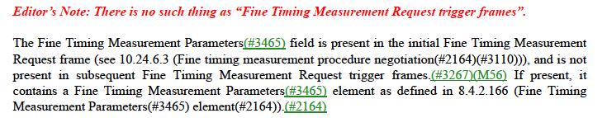

Actually, these should be “Fine Timing Measurement Request frames” that include a Trigger field.
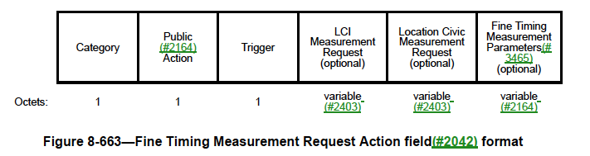

Editorial Instruction:

TGmc Editors: Please apply the following changes on line 49, Page 1161:
Replace “Fine Timing Measurement Request trigger frames” with “FTM trigger frames”.

