IEEE P802.11
Wireless LANs
Response to Editor’s Note related to FTM
Date: 2015-01-14
Author:
Name | Affiliation | Address | Phone | Email
Edward Au | Marvell Semiconductor |  |  | edwardau@marvell.com

Abstract
This contribution is to suggest text for selected subclauses in Clauses 8 and 10 marked with Editor’s Note.

Clause 8.4.2.20.19 (Fine Timing Measurement Range Request)
Discussion:
There is an Editor’s Note wondering whether the reference for the Subelement ID field value of Maximum Age fied is correct or not. Referring to the text below:
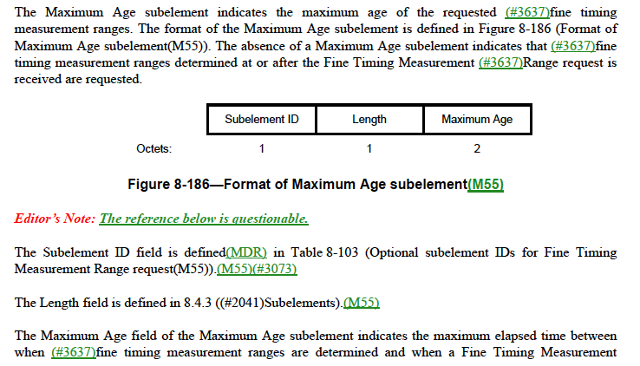

and Table 8-103:
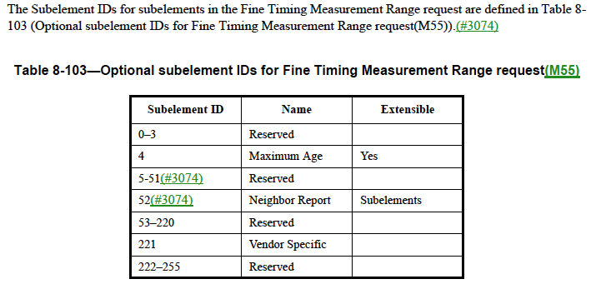
The reference is actually correct. It is because subelement ID of maximum age for fine timing measurement range request can be obtained from Table 8-103.

Editorial Instruction:

TGmc Editors: Please apply the following changes:
Remove the Editor’s Note at line 54, page 782.
Clause 8.4.2.21.18 (Fine Timing Measurement Range Report)
Discussion:
There is an Editor’s Note asking what’s the point in describing the following scenarios: (1) Extensible = Yes and (2) Extensible = subelement because neither of them are applied in Table 8-127.
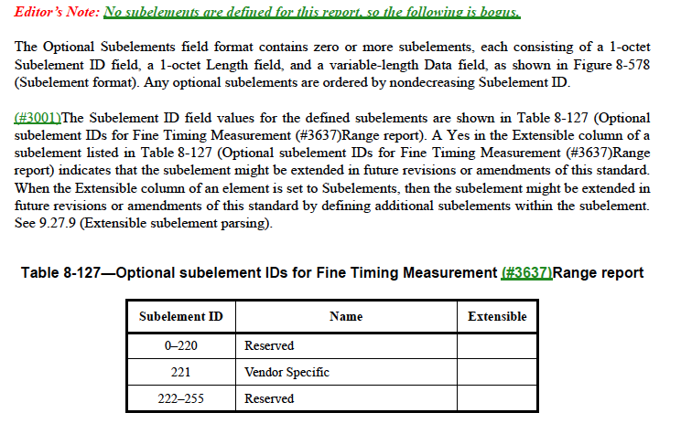
The Editor’s note makes sense. Actually, the description should be moved to the paragraph related to Table 8-103 in Clause 8.4.2.20.19 (Fine Timing Measurement Range Request) because such a description is missing there.

Editorial Instruction:

TGmc Editors: Please apply the following changes on line 28, Page 833:
Replace the following paragraph
“The Subelement ID field values for the defined subelements are shown in Table 8-127 (Optional subelement IDs for Fine Timing Measurement Range Report). A Yes in the Extensible column of a subelement listed in Table 8-127 (Optional subelement IDs for Fine Timing Measurement Range Report) indicates that the subelement might be extended in future revisions or amendments of this standard. When the Extensible column of an element is set to Subelements, then the subelement might be extended in future revisions or amendments of this standard by defining additional subelements within the subelement. See 9.27.9 (Extensible subelement parsing).”
with
“The Subelement ID field values for the defined subelements are shown in Table 8-127 (Optional subelement IDs for Fine Timing Measurement Range Report).”

TGmc Editors: Please apply the following changes on line 1, Page 782:
Replace the following paragraph
“The Subelement IDs for subelements in the Fine Timing Measurement Range request are defined in Table 8-103 (Optional subelement IDs for Fine Timing Measurement Range request.”
with
“The subelement IDs for subelements in the fine timing measurement range request are defined in Table 8-103 (Optional subelement IDs for Fine Timing Measurement Range request. A Yes in the Extensible column of a subelement listed in Table 8-103 (Optional subelement IDs for Fine Timing Measurement Range Report) indicates that the subelement might be extended in future revisions or amendments of this standard. When the Extensible column of an element is set to Subelements, then the subelement might be extended in future revisions or amendments of this standard by defining additional subelements within the subelement. See 9.27.9 (Extensible subelement parsing).”

Clause 10.11.9.11 (Fine Timing Measurement Range report)
Discussion:
There is an Editor’s Note asking for the meaning of the second shall in the following paragraph:

Editorial Instruction:

TGmc Editors: Please apply the following changes on line 37, Page 1702:
Replace the following paragraph
“If dot11RMFineTimingMsmtRangeRepActivated is false, a STA shall reject any Fine Timing Measurement request and shall respond with a Raido Measurement Report frame including a Measurement Report element with the Incapable field set to 1.”
with
“If dot11RMFineTimingMsmtRangeRepActivated is false, a STA shall reject any fine timing measurement request by responding with a Radio Measurement Report frame that includes a Measurement Report element with the Incapable field set to 1.”

Clause 8.6.8.32 (Fine Timing Measurement Request frame format)
Discussion:
There is an Editor’s Note mentioning that there is no such thing as “Fine Timing Measurement Request trigger frames”.

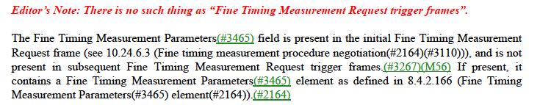

Actually, these should be “Fine Timing Measurement Request frames” that include a Trigger field.
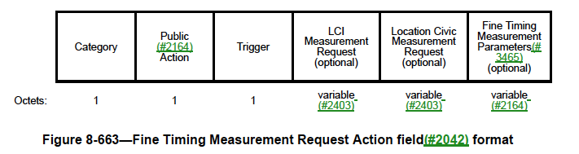

Editorial Instruction:

TGmc Editors: Please apply the following changes on line 49, Page 1161:
Replace “Fine Timing Measurement Request trigger frames” with “Fine Timing Measurement Request frames”.

