IEEE P802.11  
Wireless LANs

|  |  |  |  |  |
| --- | --- | --- | --- | --- |
| **Specification Framework for TGax** | | | | |
| **Date:** 2015-09-18 | | | | |
| **Author(s):** | | | | |
| **Name** | **Affiliation** | **Address** | **Phone** | **email** |
| Robert Stacey | Intel | 2111 NE 25th Ave, Hillsboro OR 97124, USA | +1-503-724-893 | [robert.stacey@intel.com](mailto:robert.stacey@intel.com) |

Abstract

This document provides the framework from which the draft TGax amendment will be developed. The document provides an outline of each the functional blocks that will be a part of the final amendment. The document is intended to reflect the working consensus of the group on the broad outline for the draft specification. As such it is expected to begin with minimal detail reflecting agreement on specific techniques and highlighting areas on which agreement is still required. It may also begin with an incomplete feature list with additional features added as they are justified. The document will evolve over time until it includes sufficient detail on all the functional blocks and their inter-dependencies so that work can begin on the draft amendment itself.

# Revision history

|  |  |  |
| --- | --- | --- |
| Revision | Date | Changes |
| 0 | January 13, 2015 | As approved by TG motion at the November 2014 meeting [1] |
| 1 | January 13, 2015 | Added motioned text from PM1 session January 13, 2015 |
| 2 | January 15, 2015 | Added motioned text from January 14, 2014 |
| 3 | March 27, 2015 | Added motioned text from PM1 session March 12, 2015 |
| 4 | March 27, 2015 | Some corrections to the March PHY motion numbers and missing statement added. |
| 5 | May 14, 2015 | Removed duplicate statement on OFDMA operation in bandwidths less than 20 MHz. Added text for motions passed during the May 2015 session. |
| 6 | July 9, 2015 | Fixed typo in reference #14. Tomo Adachi notified the editor by email that MU Motion 5 was added in error since the motion failed. Text removed. |
| 7 | July 16, 2015 | Added text for motions passed July 16, 2015 |
| 8 | September 18, 2015 | Nrow 🡪 Nrot (per email from Youhan Kim). Grouped statements in appropriate subsections. Added missing MAC Motion 23 from July (thanks again Tomo Adachi). Added text that passed motion on September 17, 2015 as found in 15/0987r6. |
|  |  |  |

# 1 Definitions

# 2 Abbreviations and acronyms

HE High Efficiency

UL Uplink

DL Dowlink

OFDMA Orthogonal Frequency-Division Multiple Access

# 3 High Efficiency (HE) Physical Layer

## 3.1 General

Section 3 describes the functional blocks in the physical layer.

## 3.2 HE preamble

### 3.2.1 General

An HE PPDU shall include the legacy preamble (L-STF, L-LTF and L-SIG), duplicated on each 20 MHz, for backward compatibility with legacy devices. [PHY Motion #3, January 2015, see [2]]

In an HE PPDU, both the first and second OFDM symbols immediately following the L-SIG shall use BPSK modulation.

NOTE–This is to spoof all legacy (11a/n/ac) devices to treat an HE PPDU as a non-HT PPDU.

[PHY Motion 15, July 16, 2015, see [3]]

MU-MIMO shall only be supported on allocations sizes ≥ 106 tones. [PHY Motion 35, July 16, 2015, see [4]]

The spec shall define an HE-NDP for DL Sounding. The frame format of HE-NDP is based on the 11ax SU PPDU format and is shown in Figure 1. The presence and duration of packet extension at the end of HE-NDP is TBD.



Figure 1 - HE-NDP PPDU format

[PHY Motion 37, September 17, 2015, see [5]]

### 3.2.2 L-SIG and repeated L-SIG

In L-SIG, the L_LENGTH field is set to a value not divisible by 3. The value of L_LENGTH mod 3 will be used for signaling of one bit of TBD information.

[PHY Motion 52, September 17, 2015, see [6]]

The 11ax preamble shall have a 4 µs symbol repeating the L-SIG content right after the legacy section. This symbol shall be modulated by BPSK and rate ½ BCC.

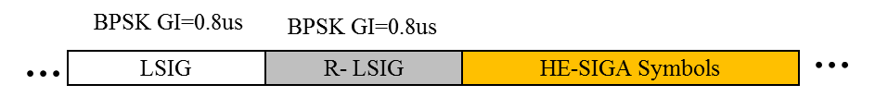

Figure 2 -- Repeated L-SIG

[PHY Motion 51, September 17, 2015, see [6]]

### 3.2.3 HE-SIG-A

HE-SIG-A (using a DFT period of 3.2 µs and subcarrier spacing of 312.5 kHz) is duplicated on each 20 MHz after the legacy preamble to indicate common control information. [Motion #4, January 2015, see [2]]

HE-SIG-A is present in all 11ax packets and is two OFDM symbols long when it uses MCS0

* Information bits in HE-SIG-A are jointly encoded as in VHT-SIG-A (using 48 tones or 52 tones is TBD).
* SU packets and UL Trigger based packets do not contain HE-SIG-B symbols.

[PHY Motion 16, July 16, 2015, see [7]]

HE-SIG-A shall include the following fields in an SU PPDU (the size of each field is TBD and other fields are TBD):

* Format indication
* TXOP duration
* BW
* Payload GI
* PE
* MCS
* Coding
* LTF Compression
* NSTS
* STBC
* BF
* CRC
* Tail

[PHY Motion 43, September 17, 2015, see [8]]

HE-SIG-A shall include the following fields in an MU DL PPDU the size of each field is TBD and other fields are TBD):

* Format indication
* TXOP duration
* Number of HE-SIG-B symbols
* MCS of HE-SIG-B
* CRC
* Tail

[PHY Motion 44, September 17, 2015, see [8]]

HE-SIG-A shall include the following fields in an MU UL PPDU the size of each field is TBD and other fields are TBD):

* Format indication
* TXOP duration
* CRC
* Tail

[PHY Motion 45, September 17, 2015, see [8]]

The spec shall support adding a BSS Color field in the HE-SIG-A field. The BSS Color field is an identifier of the BSS (size TBD).

[PHY Motion 46, September 17, 2015, see [9]]

An UL/DL Flag field is present in the HE-SIG-A field of an HE SU PPDU. The UL/DL Flag field indicates whether the frame is UL or DL. The value of this field for TDLS is TBD.

[PHY Motion 48, September 17, 2015, see [9]]

HE-SIG-A includes a 1-bit DCM indication.

[PHY Motion 54, September 17, 2015, see [10]]

HE-SIG-A shall have a repetition mode for range extension. In the repetition mode, HE-SIG-A symbols are repeated once in time. The bit interleaver is bypassed in the repeated HE-SIG-A symbols. The repetition mode is indicated before HE-SIG-A.

[PHY Motion 55, September 17, 2015, see [11]]

### 3.2.4 HE-SIG-B

Downlink HE MU PPDU shall include HE-SIG-B field, and the number of OFDM symbols of HE-SIG-B field is variable.

NOTE—The HE-SIG-B field includes information required to interpret HE MU PPDU, and detail is TBD.

[PHY Motion #8, March 2015, see [12]]

HE-SIG-B shall use a DFT period of 3.2 µs and subcarrier spacing of 312.5 kHz. [Motion #14, May 2015]

HE-SIG-B does not have any OFDM symbol duplicated in each 20 MHz of the PPDU bandwidth. [PHY Motion 18, July 16, 2015, see [7]]

HE-SIG-B is encoded on a per 20 MHz basis using BCC with common and user blocks separated in the bit domain. [PHY Motion 22, July 16, 2015, see [13]]

For bandwidths ≥ 40 MHz, the number of 20 MHz subbands carrying different content is two and with structure as shown in Figure 1. Each square in the figure represents 20 MHz subband and 1/2 represents different signalling information. [PHY Motion 23, July 16, 2015, see [13]]

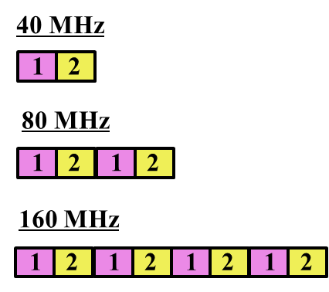

Figure 3 - 20 MHz subchannel content for HE-SIG-B for bandwidths ≥ 40 MHz

HE-SIG-B has a common field followed by a user specific field, where

* The common field includes the information for all of designated STAs to receive the PPDU in corresponding bandwidth
* The user specific field consists of multiple sub-fields that do not belong to the common field, where one or multiple of those sub-fields are for each designated receiving STA
* The boundary between the common and the user specific field is at the bit level and not the OFDM symbol level

[PHY Motion 19, July 16, 2015, see [14]]

The common field in HE-SIG-B contains Resource Unit (RU) allocation.

[PHY Motion 20, July 16, 2015, see [14]]

HE-SIG-B includes resource unit assignment and MCS per station for DL-OFDMA PPDU.

PHY Motion 21, July 16, 2015, see [15]]

The encoding structure of each BCC in HE-SIG-B is shown in Figure 3 and described below:

* Two users are grouped together and jointly encoded in each BCC block in the user specific section of HE-SIG-B
* The CRC in the common block is TBD
* The last user information is immediately followed by tail bits (regardless of whether the number of users is odd or even) and padding bits are only added after those tail bits

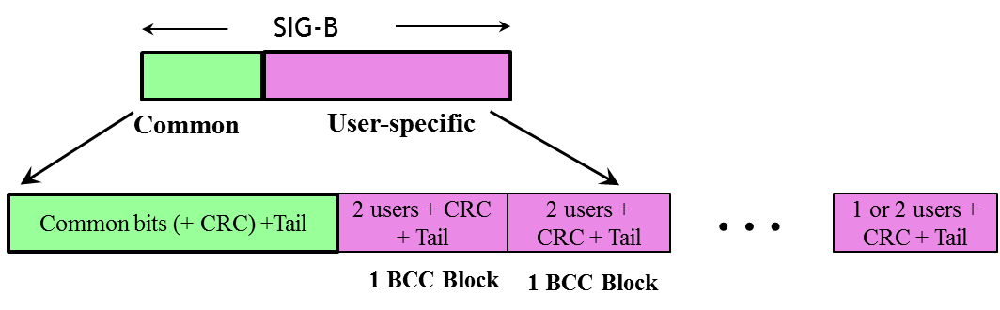

Figure 4 -- Encoding structure in HE-SIG-B

[PHY Motion 39, September 17, 2015, see [16]]

The user specific subfields of HE-SIG-B containing the per user dedicated information include the following fields:

* STA-ID
* For single-user allocations in an RU: NSTS (Number of Spatial Streams), TxBF (transmit beamforming ), MCS (Modulation and Coding Scheme) and Coding (Use of LDPC)
* For each user in a multi-user allocation in an RU: Spatial Configuraiton Fields, MCS and Coding.
* Other fields are TBD.

[PHY Motion 40, September 17, 2015, see [17]]

For MU-MIMO allocation of RU size > 20 MHz, the user-specific subfields is dynamically split between two HE-SIG-B content channels (1/2) and the split is decided by the AP (on a per case basis).

[PHY Motion 41, September 17, 2015, see [17]]

The RU allocation signaling in the common field of HE-SIG-B signals an 8 bit, per 20 MHz PPDU BW for signaling

* The RU arrangement in frequency domain
* Number of MU-MIMO allocations: The RUs allocated for MU-MIMO and the number of users in the MU-MIMO allocations.
  + The exact mapping of the 8 bit to the RU arrangement and the number of MU-MIMO allocations is TBD.
  + Signaling for the center 26 unit in 80 MHz is TBD

[PHY Motion 64, September 17, 2015, see [17]]

The length of the user specific subfield in HE-SIG-B for a single-user allocation is equal to the length of the user specific subfield of each user in a multi-user allocation.

[PHY Motion 65, September 17, 2015, see [17]]

### 3.2.5 HE-STF

HE-STF of a non-trigger-based PPDU has a periodicity of 0.8 µs with 5 periods.

* A non-trigger-based PPDU is not sent in response to a trigger frame

[PHY Motion #11, May 2015, see [18]]

The HE-STF of a trigger-based PPDU has a periodicity of 1.6 µs with 5 periods.

* A trigger-based PPDU is an UL PPDU sent in response to a trigger frame

[PHY Motion #12, May 2015, see [18]]

The HE-STF tone positions are defined in Equation 1 where *NSTF_sample* = 16 for a non-trigger-based PPDU and *NSTF_sample* = 8 for a trigger-based PPDU



[PHY Motion #13, May 2015, see [18]]

### 3.2.6 HE-LTF

The HE-LTF shall adopt a structure of using P matrix in the data tones as in 11ac. In the data tones, every space-time stream is spread over all HE-LTF symbols by one row of the P matrix as defined in 11ac. Different space-time streams use different rows in P matrix. [PHY Motion #5, March 2015, see [19]]

The HE PPDU shall support the following LTF modes:

* HE-LTF symbol duration of 6.4 µs excluding GI
  + Equivalent to modulating every other tone in an OFDM symbol of 12.8 µs excluding GI, and then removing the second half of the OFDM symbol in time domain
* HE-LTF symbol duration of 12.8 µs excluding GI

[PHY Motion #6, March 2015, see [19]]

In an HE PPDU, the HE-LTF section shall start at the same point of time and end at the same point of time across all users. [PHY Motion #7, March 2015, see [19]]

In an OFDMA PPDU using *N* HE-LTF symbols, an RU with *Nsts,total* shall use the first *Nsts,total* rows of the *N × N* P matrix. [PHY Motion 29, July 16, 2015, see [20]]

Single stream pilot (like 11ac) in HE-LTF shall be used for SU, DL and UL OFDMA as well as in DL MU-MIMO transmissions. [PHY Motion 26, July 16, 2015, see [21]]

The HE-LTF sequences for UL MU-MIMO shall be generated as follows. For each stream, a common sequence shall be masked repeatedly in a piece-wise manner by a distinct row of an 8x8 orthogonal matrix. When the length of the LTF sequence is not divisible by 8, the last *M* elements of the LTF sequence (*M* being the remainder after the division of LTF length by 8) shall be masked by the first *M* elements of the orthogonal matrix row.

[PHY Motion 56, September 17, 2015, see [22]]

The orthogonal matrix used to mask the HE-LTF sequence in SP1 is the 8x8 P-matrix used in 11ac.

[PHY Motion 57, September 17, 2015, see [22]]

## 3.3 HE Data field

### 3.3.1 General

The Data field in UL MU transmissions shall immediately follow the HE-LTF section.

[PHY Motion 17, July 16, 2015, see [7]]

Data symbols in an HE PPDU shall use a DFT period of 12.8 µs and subcarrier spacing of 78.125 kHz. [PHY Motion #1, January 2015, see [23]]

Data symbols in an HE PPDU shall support guard interval durations of 0.8 µs, 1.6 µs and 3.2 µs. [PHY Motion #2, January 2015, see [23]]

HE PPDUs shall have single stream pilots in the data section

* All streams use the same pilot sequence even in UL MU-MIMO

[PHY Motion 24, July 16, 2015, see [24]]

### 3.3.2 Tone plan

### 3.3.2.1 Resource unit, edge and DC tones

HE-PPDU for UL-OFDMA shall support UL data transmission below 20 MHz for an HE STA. [MU Motion #3, March 2015]

Define 20 MHz OFDMA building blocks as follows:

* 26-tone with 2 pilots, 52-tone with 4 pilot and 106-tone with 4 pilots and with 7 DC Nulls and (6,5) guard tones, and at locations shown in Figure 2
* An OFDMA PPDU can carry a mix of different tone unit sizes within each 242 tone unit boundary
* ~~The following is TBD: Exact location of extra leftover tones~~ *[Ed: deleted, see 3.3.2.2]*

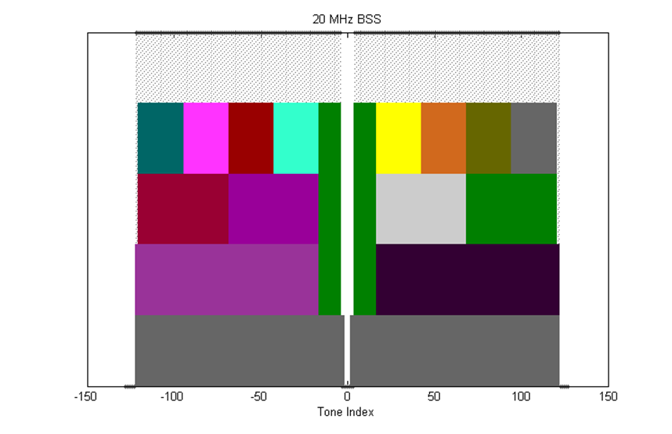

Figure 5 – 20 MHz tone plan

Define 40 MHz OFDMA building blocks as follows

* 26-tone with 2 pilots, 52-tone with 4 pilots, 106-tone with 4 pilots and 242-tone with 8 pilots and with 5 DC Nulls and (12,11) guard tones, and at locations shown in Figure 3
* ~~The following is TBD: exact location of extra leftover tones~~ *[Ed: deleted, see 3.3.2.2]*

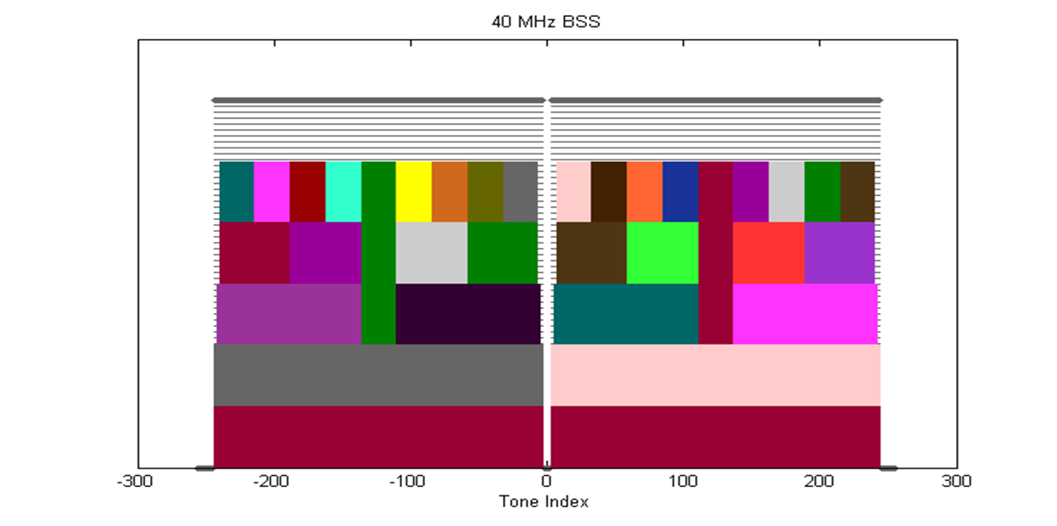

Figure 6 – 40 MHz tone plan

Define 80 MHz OFDMA building blocks as follows:

* 26-tone with 2 pilots, 52-tone with 4 pilots, 106-tone with 4 pilots, 242-tone with 8 pilots and 484-tone with 16 pilots and with 7 DC Nulls and (12,11) guard tones, and at locations shown in Figure 4
* ~~The following is TBD: exact location of extra leftover tones~~ *[Ed: deleted, see 3.3.2.2]*

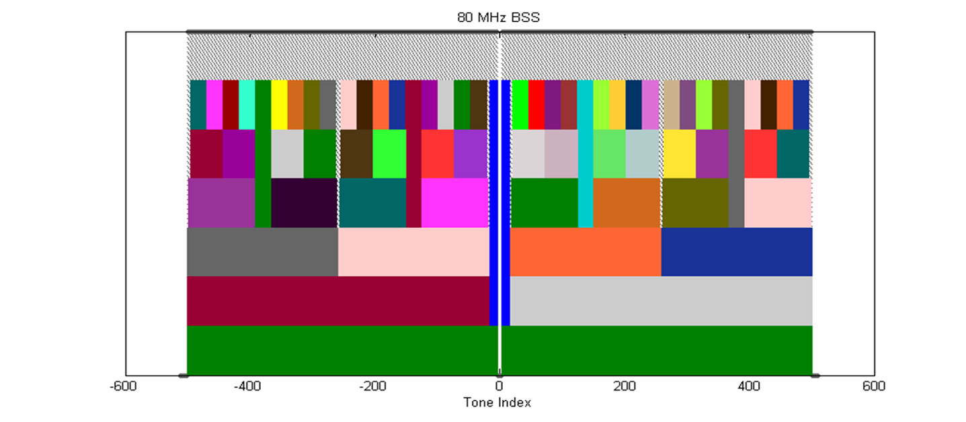

Figure 7 - 80 MHz tone plan

Define 160 MHz/80 MHz+80 MHz OFDMA building blocks as follows:

* 26-tone with 2 pilots
* 52-tone with 4 pilots
* 106-tone with 4 pilots
* 242-tone with 8 pilots
* 484-tone with 16 pilots
* 996-tone with 16 pilots (note that 996-tone is defined for 80 MHz HE-SA-PPDU or 80 MHz HE-SA-MU-PPDU)
* The following is TBD: exact location of extra leftover tones

[PHY Motion #10, May 2015, see [25]]

### 3.3.2.2 Left over tones

The left over tone locations for the 20 MHz, 40 MHz and 80 MHz tone plans are shown in Figure 5, Figure 6 and Figure 7 respectively.

NOTE—Left over tones have zero energy

[PHY Motion 25, July 16, 2015, see [21]]

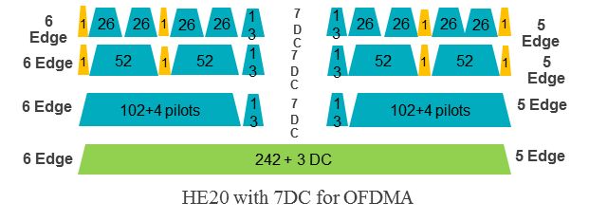

Figure 8 – Left over tone locations for 20 MHz

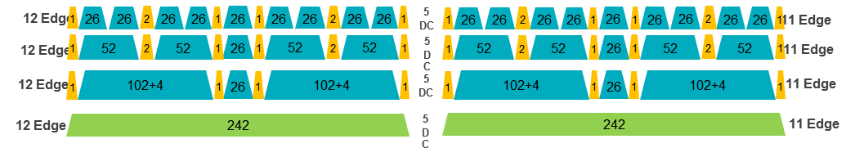

Figure 9 – Left over tone locations for 40 MHz

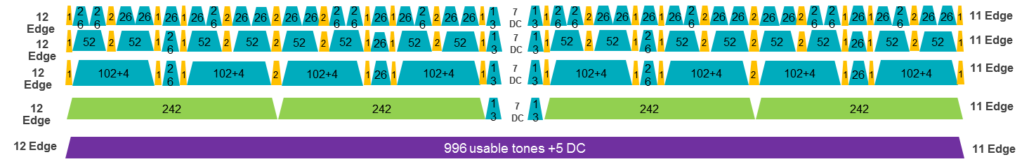

Figure 10 – Left over tone locations for 80 MHz

### 3.3.2.3 Pilot tones

All pilot tones in 4x data OFDMA symbol are at even indices. If pilots present in 4x HE-LTF, their tone indices shall be the same as those pilots in 4x data symbol. If pilots present in 2x HE-LTF, their tone indices shall be the same as the indices of those pilots in 4x data symbol divided by 2. [PHY Motion 27, July 16, 2015, see [21]]

The pilot tone locations for 20 MHz, 40 MHz and 80 MHz bandwidth are as shown in Figure 8, Figure 9 and Figure 10 respectively.

Note—80 MHz pilot positions are enumerated below for reference:

RU-26 pilots: ±10, ±24, ±38, ±50, ±64, ±78, ±92, ±104, ±118, ±130, ±144, ±158, ±172, ±184, ±198, ±212, ±226, ±238, ±252, ±266, ±280, ±292, ±306, ±320, ± 334, ±346, ±360, ±372, ±386, ±400, ±414, ±426, ±440, ±454, ±468, ±480, ± 494

RU-106/242/484 pilots: ±24, ±50, ±92, ±118, ±158, ±184, ±226, ±252, ±266, ±292, ±334, ±360, ±400, ±426, ±468, ±494

RU-996 pilots: ±24, ±92, ±158, ±226, ±266, ±334, ±400, ±468

The pilot locations for 160 MHz or 80+80 MHz use the same structure as 80 MHz for each half of the BW.

[PHY Motion 28, July 16, 2015, see [21]]

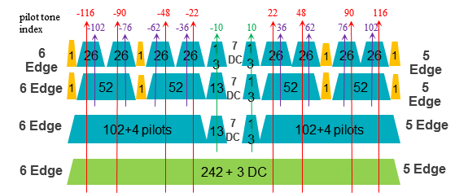

Figure 11 – Pilot tone locations for 20 MHz

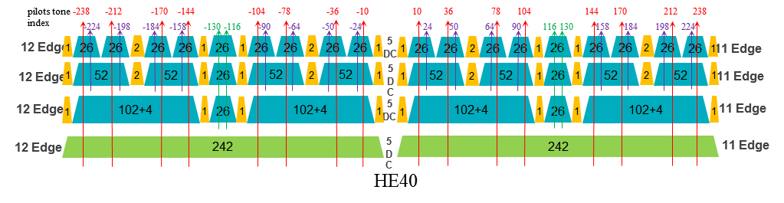

Figure 12 – Pilot tone locations for 40 MHz

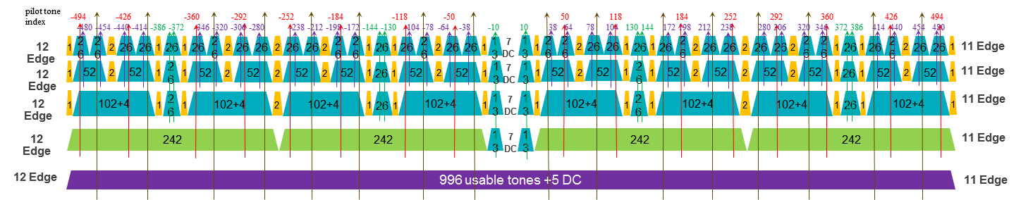

Figure 13 – Pilot tone locations for 80 MHz

### 3.3.3 Coding

LDPC is the only coding scheme in the HE PPDU Data field for allocation sizes of 484 tones, 996 tones and 996*2 tones.

[PHY Motion 30, July 16, 2015, see [26], modified with PHY Motion 36, September 17, 2015, see [27]]

Support of BCC code is limited to less than or equal to four spatial streams (per user in case of MU-MIMO), and is mandatory (for both TX and RX) for RU sizes less than or equal to 242 tones (20MHz).

Support of LDPC code for both TX and RX is mandatory for HE STAs declaring support for at least one of HE 80/160/80+80 SU-PPDU bandwidths, or for HE STAs declaring support for more than 4 spatial streams. Otherwise, support of LDPC code for either TX or RX is optional. [PHY Motion 31, July 16, 2015, see [26]]

The 11ax MCS table shall not have any MCS exclusion and, when LDPC is applied, *NDBPS* is computed as follows

$N_{DBPS}=\left\lfloor N_{CBPS}R\right\rfloor$, where *R* is the coding rate

[PHY Motion 32, July 16, 2015, see [26]]

The BCC interleaver and LDPC tone mapper parameters are defined in Table 1.

Table 1 - BCC interleaver and LDPC tone mapper parameters

|  |  |  |  |
| --- | --- | --- | --- |
| **RU size (tones)** | **BCC** | | **LDPC** |
|  | ***Ncol*** | ***Nrot*** | ***DTM*** |
| 26 | 8 | 2 | 1 |
| 52 | 16 | 11 | 3 |
| 106 | 17 | 29 | 6 |
| 242 | 26 | 58 | 9 |
| 484 | - | - | 12 |
| 996 | - | - | 20 |

[PHY Motion 33, July 16, 2015, see [26]]

### 3.3.4 Modulation

1024-QAM is an optional feature for SU and MU using resource units equal to or larger than 242 tones in 11ax.

[PHY Motion 42, September 17, 2015 see [28]]

Dual sub-carrier modulation (DCM) is an optional modulation scheme for the HE-SIG-B and Data fields. DCM is only applied to BPSK, QPSK and 16-QAM modulations.

[PHY Motion 53, September 17, 2015, see [10]]

### 3.3.5 Padding and packet extension

An 11ax SU  PPDU should apply the MAC/PHY pre-FEC padding scheme as in 11ac, to pad toward the nearest of the four possible boundaries (*a-factor*) in the last Data OFDM symbol(s), and then use post-FEC padding bits to fill up the last OFDM symbol(s).

* Packet Extension (PE) field is defined at the end of HE PPDU
* PE should have the same average power as data field

[PHY Motion 58, September 17, 2015, see [29]]

11ax shall define the max packet extension modes of 8 µs and 16 µs, correspond to the short symbol segment padding boundaries (*a-factor*) according to the following PE duration (TPE) values:

* Max packet extension mode 8 µs: *TPE* = [0 0 4 8] µs for a = 1~4 respectively;
* Max packet extension mode 16 µs: *TPE* = [4 8 12 16] µs for a = 1~4 respectively.

HE Capability field shall define two constellation level thresholds (*threshold16* and *threshold8*) for a given {NSS, BW} combination, to determine if and when max packet extension modes 8 µs and 16 µs are applied, i.e.

* 3 bits are used to specify each threshold as the table below.
* If constellation ≥ *threshold16* apply max PE 16 µs mode, else if constellation ≥ *threshold8* apply max PE 8 µs mode, else no packet extension.
* If no PE is required for all constellations both *threshold8* and *threshold16* are set to 111
* If only max PE 8 µs mode is required, set *threshold16* to be 111, and *threshold8* to be the constellation at which max PE 8 µs mode starts
* If only max PE 16 µs mode is required, set *threshold16* to be the constellation at which max PE 16 µs mode starts, and *threshold8* to be 111
* When ≥80 MHz is supported, no thresholds are defined for RU size less than or equal to 242 tones (20 MHz); otherwise, thresholds are defined down to a TBD RU size.
* Table 2 - Threshold encoding in HE capability

|  |  |
| --- | --- |
| Constellation | Threshold Encoding in HE Capability |
| BPSK | 000 |
| QPSK | 001 |
| 16QAM | 010 |
| 64QAM | 011 |
| 256QAM | 100 |
| 1024QAM (TBD) | 101 |
| None | 111 |

[PHY Motion 59, September 17, 2015, see [29]]

The number of uncoded bits for each of the first 3 short symbol segments (a=1~3) equals to the number of uncoded bits corresponding to *NSD.short* subcarriers as specified by the following table, and the number of uncoded bits for the last short symbol segment (a=4) equals to the number of bits of the whole OFDM symbol subtracting the total number of uncoded bits of the first three short symbol segments.

Table 3 - NSD.short

|  |  |
| --- | --- |
| **RU Size** | ***NSD.short*** |
| 26 | 6 |
| 52 | 12 |
| 106 | 24 |
| 242 | 60 |
| 484 | 120 |
| 996 | 240 |
| 996x2 | 492 |

[PHY Motion 60, September 17, 2015, see [29]]

HE-SIG-A field contains an a-factor field of 2 bits and a PE Disambiguity field of 1 bit that are set as described below.

In L-SIG, the L-LENGTH field is set by:

$$L_LENGTH=\left\lceil \frac{TXTIME-20}{4}\right\rceil ×3-3+m,m=1 or 2$$

where

$$TXTIME=T_{L_PREAMBLE}+T_{HE_DATA}+T_{PE}$$

$$T_{HE_DATA}=T_{HE_SYM}×N_{SYM}=(12.8+T_{GI})×N_{SYM}$$

$T_{PE}$ is the PE duration

In HE-SIG-A,

* The a-factor field ecoding is defined in Table 4.

Table 4 - A Factor field encoding

|  |  |
| --- | --- |
| *a-factor* value | a-factor field encoding |
| 1 | 01 |
| 2 | 10 |
| 3 | 11 |
| 4 | 00 |

* The PE Disambiguity field is set as follows:
* If $T_{PE}+4×\left(\left\lceil \frac{TXTIME-20}{4}\right\rceil -\left(\frac{TXTIME-20}{4}\right)\right)≥T_{SYM}$, where $T_{SYM}=12.8+T_{GI}$, then this field is set to 1; otherwise this field is set to 0.
* At the receiver, the following equations are used to compute *NSYM* and *TPE* respectively: $$N_{SYM}=\left\lfloor \frac{\left(\frac{L_LENGTH-m+3}{3}×4-T_{HE_PREAMBLE}\right)}{T_{SYM}}\right\rfloor -b_{PE_Disabbiguity} \\ T_{PE}=\left\lfloor \frac{\left(\frac{L_LEGNTH-m+3}{3}×4-T_{HE_PREAMBLE}\right)-N_{SYM}×T_{SYM}}{4}\right\rfloor ×4$$

[PHY Motion 61, September 17, 2015, see [29]]

When the AP transmits a DL MU PPDU:

* All users use the same *NSYM* and *a-factor* values according to the user with the longest span
* Based on the *a-factor* value and each user’s PE capabilities, compute the PE duration for each user, *TPE,u*, and the PE duration of the DL MU PPDU, *TPE* = max*u*(*TPE,u*)
* In HE-SIG-A field, the a-factor field, the PE Disambiguity field and the LDPC Extra Symbol field are common to all users

[PHY Motion 62, September 17, 2015, see [29]]

For an UL MU PPDU transmission:

* The AP indicates its desired *NSYM*, *a-factor*, LDPC extra symbol indication and PE duration values in the Trigger frame
* Possible PE values for UL MU are TBD
* Each user transmitting an UL MU PPDU shall encode and conduct PHY padding using the following parameters:
  + *NSYM* as indicated in the Trigger frame
  + *a-factor* as indicated in the Trigger frame
  + LDPC Extra Symbol as indicated in the Trigger frame
  + Append PE specified in the Trigger frame

[PHY Motion 63, September 17, 2015, see [29]]

# 4 Multi-user (MU) features

## 4.1 General

This section describes MU related features. MU features include UL and DL OFDMA and UL and DL MU-MIMO.

A TXOP can include both DL MU and UL MU transmissions.

[MAC Motion 14, July 16, 2015, see [30]]

The spec shall include the definition of a cascading TXOP structure, allowing alternating DL and UL MU PPDUs starting with a DL MU PPDU in the same TXOP

* The TXOP sequence has only one DL transmitter
* The TXOP sequence may have different UL transmitters within each UL MU PPDU
* The TXOP sequence may have a different set of transmitters in an UL MU PPDU as compared to the DL MU PPDU that follows the UL MU PPDU within the same TXOP

[MAC Motion 15, July 16, 2015, see [30]]

DL/UL OFDMA can multiplex different types of unicast frames in frequency domain. Types of frames can be data frame/control frame/management frame.

[MAC Motion 16, July 16, 2015, see [30]]

DL/UL MU-MIMO can multiplex different types of unicast frames in spatial domain. Types of frames can be data frame/control frame/management frame. Different types of frames are to/from different users. [MAC Motion 17, July 16, 2015, see [30]]

The transmission for all the STAs in a DL MU (MIMO, OFDMA) PPDU shall end at the same time.

The A-MPDU padding per each STA follows the 11ac procedure.

[MAC Motion 22, July 16, 2015, see [31]]

The transmission from all the STAs in an UL MU PPDU shall end at the time indicated in Trigger frame.

The A-MPDU padding per each STA follows the 11ac procedure.

[MAC Motion 23, July 16, 2015, see [31]]

DL-OFDMA may reuse the same sharing mechanism of an EDCA TXOP as DL MU-MIMO.

[MAC Motion 36, September 17, 2015, see [32]]

A STA shall consider CCA status to respond to a Trigger frame under a non-null TBD set of conditions.

[MU Motion 14, September 17, 2015, see [33]]

The spec shall allow multiple TIDs in a single PSDU between AP and a STA for DL/UL OFDMA/MU-MIMO. Multiple TIDs aggregation rules are TBD if necessary.

[MU Motion 16, September 17, 2015, see [34]]

The spec shall support fragmentation negotiation in A-MPDUs for HE STAs.

[MU Motion 19, September 17, 2015, see [35]]

## 4.2 DL MU operation

The amendment shall include a mechanism to multiplex BA/ACK responses to DL MU transmission. [MU Motion #4, March 2015, see [36]]

In each payload within a DL MU PPDU a Trigger frame may be present that carries the information that enables the recipient of the STA to send its ACK/BA response frame a TBD IFS after the DL MU PPDU. [MU Motion 11, July 16, 2015, see [37]]

A unicast Trigger frame for a single user may be included in an A-MPDU for that user in the DL MU PPDU that precedes the UL MU transmission by TBD IFS. [MAC Motion 20, July 16, 2015, see [38]]

Broadcast trigger transmitted in a subchannel of DL OFDMA shall not include the resource allocation information of the STAs which are recipients of frames in the other subchannels of the DL OFDMA. The subchannel of the broadcast trigger frame is identified by TBD signaling. [MAC Motion 21, July 16, 2015, see [38]]

The spec shall allow that the schedule information for OFDMA acknowledgement from STAs is contained in the MAC header of DL MPDU.

[MU Motion 23, September 17, 2015, see [39]]

The contents of the scheduling information for an UL OFDMA ACK/BA includes UL PPDU Length (9 bits) and RU Allocation (TBD).

[MU Motion 24, September 24, 2015, see [39]]

## 4.3 UL MU operation

An UL MU PPDU (MU-MIMO or OFDMA) is sent as an immediate response (IFS TBD) to a Trigger frame (format TBD) sent by the AP. [MAC Motion #3, March 2015]

The CP length for UL OFDMA/MU-MIMO transmissions shall be explicitly indicated by AP in the Trigger frame that allocates resources for the UL OFDMA/MU-MIMO transmission. The value of CP length for all users addressed by the Trigger frame shall be the same. [PHY Motion 34, July 16, 2015, see [40]]

An UL OFDMA MPDU/A-MPDU is the acknowledgement of the trigger frame. When the AP receives MPDU correctly from at least one STA indicated by trigger frame, the frame exchange initiated by the trigger frame is successful. [MAC Motion 13, July 16, 2015, see [41]]

The amendment shall define a mechanism for multiplexing DL acknowledgments sent in response to UL MU transmissions. [MU Motion #1, January 2015, see [42]]

An AP shall not allocate UL subchannel in any 20 MHz channel that is not occupied by the immediately preceding DL PPDU that contains trigger information. In each 20 MHz channel occupied by the immediately preceding DL PPDU that contains trigger information, there is at least one allocated subchannel. [MAC Motion #10, May 2015, see [43], modified with MAC Motion 40, September 17, 2015, see [44]]

Non-AP STAs support using the QoS Control field in QoS Data and QoS Null frames to report per-TID Buffer Status information.

[MAC Motion 37, September 17, 2015, see [45]]

An AP can poll STAs for buffer status reports using the frame carrying the trigger info. The poll can request for specific buffer status information with TBD granularity.

[MAC Motion 38, September 17, 2015, see [45]]

A STA that is polled from a Trigger frame for UL MU transmission considers the NAV in determining whether to respond unless one of the following conditions is met

* The NAV was set by a frame originating from the AP sending the trigger frame
* The response contains ACK/BA and the duration of the UL MU transmission is below a TBD threshold
* Other condition TBD

[MU Motion 15, September 17, 2015, see [46]]

## 4.4 MU RTS/CTS procedure

The spec shall define a frame that solicits simultaneous CTS responses from multiple STAs to protect DL MU transmission. [MU Motion 6, July 16, 2015, see [47]]

The scrambler seed of a simultaneous CTS is same as the scrambler seed of the frame that triggers the simultaneous CTS. The transmission rate of a simultaneous CTS shall use the primary rate based on the rate or MCS of the frame that triggers the simultaneous CTS. [MU Motion 7, July 16, 2015, see [47]]

## 4.5 UL OFDMA-based random access

The spec shall define a Trigger frame that allocates resources for random access. [MU Motion 8, July 16, 2015, see [48]]

An HE AP is allowed to broadcast a TBD parameter in the trigger frame to the STAs so that STAs can initiate the random access process after the trigger frames.

[MAC Motion 41, September 17, 2015, see [49]]

When an STA has a frame to send, it initializes its OBO (OFDMA Back-off) to a random value in the range 0 to CWO (OFDMA Contention window). For an STA with non-zero OBO value, it decrements its OBO by 1 in every RU assigned to AID value TBD within the TF-R. For a STA, its OBO decrements by a value, unless OBO=0, equal to the number of RUs assigned to AID value TBD in a TF-R. OBO for any STA can only be 0 once every TF-R. A STA with OBO decremented to 0 randomly selects any one of the assigned RUs for random access and transmits its frame.

[MU Motion 27, September 17, 2015, see [50]]

The spec shall indicate cascaded sequence of Trigger frames for random access by using a bit in the Trigger frame.

[MU Motion 21, September 17, 2015, see [51]]

The spec shall include a mechanism that allows the Beacon frame to indicate the target transmission time(s) of one or more Trigger frame(s) that allocate resources for random access.

[MU Motion 22, September 17, 2015, see [51]]

## 4.6 Sounding protocol

The amendment shall include a CSI feedback mechanism which allows for a minimum feedback granularity of less than 20 MHz.

[MU Motion 9, July 16, 2015, see [52]]

The amendment shall define a mechanism to enable multiplexing of the Compressed Beamforming Action frame (CSI feedback) from multiple stations using UL MU (MIMO or OFDMA) mode.

[MU Motion 17, September 17, 2015, see [53]]

The amendment shall define a new channel sounding sequence that includes trigger information in order to facilitate UL MU mode of Compressed Beamforming Action frame from multiple STAs.

[MU Motion 18, Spetember 17, 2015, see [53]]

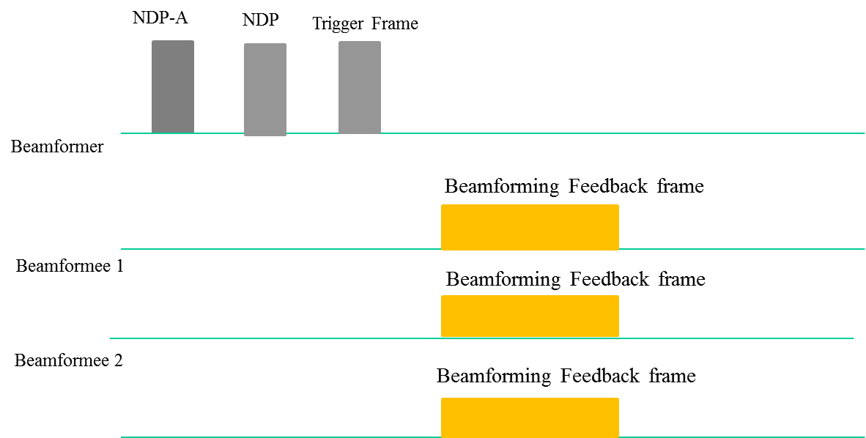

Figure 14 -- Illustration of DL Sounding Sequence

[MU Motion 20, September 17, 2015, see [54]]

The amendment shall define a mechanism to reduce the MIMO compressed beamforming feedback overhead.

[MU Motion 25, September 17, 2015, see [55]]

## 4.7 GCR BA operation

The amendment shall include a mechanism to multiplex acknowledgment frames in response to Multicast receptions under GCR BA operation.

[MU Motion 12, September 17, 2015, see [56]]

# 5 Coexistence

This section describes the functional blocks that support coexistence.

## 5.1 Features for operation in dense environments

This section describes features that improve overlapping BSS (OBSS) operation in dense environments. This includes features such as deferral rules and CCA levels.

The STA determines whether the detected frame is an inter-BSS or an intra-BSS frame by using BSS color or MAC address in the MAC header. If the detected frame is an inter-BSS frame, under TBD condition, uses TBD OBSS PD level that is greater than the minimum receive sensitivity level

*NOTE–Maybe extra rules need to be added to ensure that all 11ax STAs can make the decision in a consistent manner.*

[MAC Motion 34, September 17, 2015, see [57]]

A STA should regard an Inter-BSS PPDU with a valid PHY header and that has a receive power/RSSI below the OBSS PD level used by the receiving STA and that meets additional TBD conditions, as not having been received at all (e.g., should not update its NAV), except that the medium condition shall indicate BUSY during the period of time that is taken by the receiving STA to validate that the PPDU is from an Inter-BSS, but not longer than the time indicated as the length of the PPDU payload. The OBSS PD level is greater than the minimum receive sensitivity level.

[SR Motion 1, September 17, 2015, see [58]]

The amendment shall include one or more mechanisms to improve spatial reuse by allowing adjustments to one or more of the CCA-ED, 802.11 Signal Detect CCA, OBSS_PD or TXPWR threshold values. The constraints on selecting threshold values are TBD.

[SR Motion 2, September 17, 2015, see [59]]

The specification to consider a procedure that may revise the NAV depending on TBD conditions at the recipient of the ongoing OBSS frame.

[SR Motion 3, September 17, 2015, see [60]]

An 11ax STA regards a valid OBSS PPDU as not having been received at all (e.g., should not update its NAV), except that the medium condition shall indicate BUSY during the period of time that is taken by the receiving STA to validate that the PPDU is from an Inter-BSS, but not longer than the time indicated as the length of the PPDU payload if the RXPWR of the received PPDU is below the OBSS_PD threshold and TBD conditions are met, noting that the OBSS_PD threshold is accompanied by a TXPWR value and a reduction in the TXPWR may be accompanied by an TBD increase in the OBSS_PD threshold value.

[SR Motion 4, September 17, 2015, see [61]]

# 6 MAC

## 6.1 General

This section describes general MAC functional blocks.

The amendment shall define a mechanism to allow the AP to configure the use of RTS/CTS initiated by non-AP STA.

[MAC Motion #1, January 2015, see [62]]

In 2.4 GHz HE STAs should send beacon and probe (request & response) frames at rates ≥ 5.5 Mb/s. [MAC Motion 24, 2015, see [63]]

HE STAs shall support the Multiple BSSID Set.

[MAC Motion 28, September 17, 2015, see [64]]

When a STA receives a CF-End from an OBSS STA, if the last NAV update was caused by an Intra-BSS frame, the STA should not reset its NAV.

[MAC Motion 33, September 17, 2015, see [65]]

## 6.2 Target Wake Time (TWT)

The spec shall include a mechanism that allows a target transmission time for a Trigger frame to be indicated. The mechanism is based on implicit TWT operation and additionally enables:

* Broadcast triggered TWT by including a TWT element in the Beacon
* Solicited triggered TWT by using implicit TWT negotiation procedure

[MAC Motion 25, July 16, 2015, see [66]]

When the broadcast triggered TWT is enabled, STA and AP may exchange TWT request/response to indicate the target Beacon frame to be monitored by the PS STA.

[MAC Motion 26, July 16, 2015, see [66]]

## 6.3 Power Save

An HE non-AP STA may enter the Doze state until the end of an HE DL MU PPDU if both the following conditions are true:

* The value of the PPDU’s BSS Color field is equal to the BSS color of its BSS
* The value derived from any of the STA identifiers in the HE-SIG-B field does not match its own identifier or that of a broadcast/multicast identifier

An HE non-AP STA may enter the Doze state until the end of an HE UL MU PPDU if:

* The value of the PPDU’s BSS Color field is equal to the BSS color of its BSS

[PHY Motion 47, September 17, 2015, see [9]]

An HE STA may enter the Doze state until the end of an HE SU PPDU if both the following conditions are true:

* The value of the PPDU’s BSS Color field is equal to the BSS color of its BSS
* The value of the UL/DL Flag field indicates that the frame is UL

[PHY Motion 49, September 17, 2015, see [9]]

HE STA may use a notification of its operating mode changes for 802.11ax power saving mechanism.

[MAC Motion 30, September 17, 2015, see [67]]

The spec shall define a mechanism for a transmitting STA to indicate its RX operating mode, i.e. RX NSS, RX channel width, in a transmitted DATA type MAC header, so that the responding STA shall not transmit a subsequent PPDU using an NSS or channel width value not indicated as supported in the RX operating mode of the transmitting STA. The responding STA shall not adopt the new NSS and BW until a time TBD.

[MAC Motion 32, September 17, 2015, see [68]]

# 7 Frame formats

## 7.1 Fields

### 7.1.1 HT Control field

The spec shall define an HE variant (of the VHT variant) of the HT Control field that carries one or more control fields for HE control information

* B0 and B1 of the HT Control field in this case are set to 1
* The control fields can be called HE Control field

[MAC Motion 39, September 17, 2015, see [69]]

## 7.2 Frames

### 7.2.1 Trigger frame

The spec shall define a new control frame format that carries sufficient information to identify the STAs transmitting the UL MU PPDUs and allocating resources for the UL MU PPDUs. The format of the new frame is given in Figure 11. The presence of A1 is TBD. [MAC Motion 19, July 16, 2015, see [70]]



Figure 15 - Trigger frame

### 7.2.2 Multi-STA BA frame

The spec shall define a multi-STA BA frame by using the Multi-TID BlockAck frame format with the following changes:

* Add an indication that the frame is a multi-STA BA (TBD)
* Each BA Information field can be addressed to different STAs
* B0-B10 of the Per TID Info field carry a (Partial) AID identifying the intended receiver of the BA Information field

[MAC Motion #1, March 2015, see [71]]

The spec shall define a signaling in the Multi-STA BA frame that can indicate an ACK, as follows:

* If B11 in the per-TID info field is set, then the BlockAck bitmap and the SC subfields in the BA Info field are not present and this BA Info field indicates an ACK of either single MPDU or all MPDUs carried in the eliciting PPDU that was transmitted by the STA whose AID is indicated in the per-TID info field. [Modifed with MAC Motion #8, May 2015, see [72]]

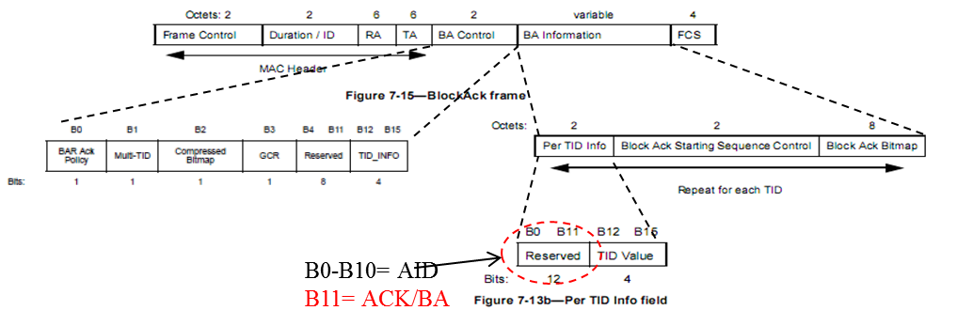

Figure 16 - Multi-STA BA frame

[MAC Motion #2, March 2015, see [71]]

### 7.2.3 MU-BAR frame

The spec shall define a MU-BAR frame to solicit BA/ACKs from multiple STAs in UL MU transmissions.

[MU Motion 13, September 17, 2015, see [73]]

## 7.3 Sounding feedback

802.11ax spec shall not support *Ng = 1* for sounding feedback.

*NOTE*—*The tone grouping factor, Ng is defined with respect to data tones of the HE PPDU.*

[PHY Motion 38, September 17, 2015, see [74]]

# References

|  |  |
| --- | --- |
| [1] | Robert Stacey (Intel), “14/1453r2 Spec Framework Proposal”. |
| [2] | Jiayin Zhang (Huawei), “15/0101r1 Preamble structure for 11ax system”. |
| [3] | Hongyuan Zhang (Marvell), “15/0579r3 Preamble Design and Autodetection”. |
| [4] | Jiayin Zhang (Huawei), “15/0832r1 Performance evaluation of SU/MU MIMO in OFDMA”. |
| [5] | Young Hoon Kwon (Newracom), “15/1051r1 HE NDP frame for sounding”. |
| [6] | Hongyuan Zhang (Marvell), “15/0579r4 Preamble Design and Autodetection”. |
| [7] | Jianhan Liu (Mediatek Inc.), “15/0822r2 SIG-A Structure in 11ax Preamble”. |
| [8] | Jiayin Zhang (Huawei), “15/1077r0 HE-SIG-A Content”. |
| [9] | Alfred Asterjadhi (Qualcomm Inc.), “15/1122r0 Identifiers in HE PPDUs for power saving”. |
| [10] | Jianhan Liu (Mediatek), “15/1068r1 Reliable Transmission Schemes for HE-SIG-B and Data”. |
| [11] | Jiayin Zhang (Huawei), “15/0826r3 HE-SIG-A transmission for range extension”. |
| [12] | Young Hoon Kwon (Newracom), “15/0344r2 SIG Field Design Principle for 11ax”. |
| [13] | Ron Porat, “15/0873r0 SIG-B Encoding Structure”. |
| [14] | Joonsuk Kim (Apple), “15/0821r2 HE SIG-B Structure”. |
| [15] | Katsuo Yunoki (KDDI R&D Laboratories), “15/0827r2 Considerations on HE-SIG-A and B”. |
| [16] | Ron Porat (Broadcom), “15/1059r1 SIG-B Encoding Structure Part II”. |
| [17] | Kaushik Josiam (Samsung), “15/1066r0 HE-SIG-B Contents”. |
| [18] | Yakun Sun (Marvell), “15/0381r1 HE-STF Proposal”. |
| [19] | Hongyuan Zhang (Marvell), “15/0349r2 HE-LTF Proposal”. |
| [20] | Yakun Sun (Marvell), “15/0817r0 P Matrix for HE-LTF”. |
| [21] | Bin Tian (Qualcomm), “15/0819r1 11ax OFDMA Tone Plan Leftover Tones and Pilot Structure”. |
| [22] | Xiaogang Chen (Intel), “15/0602r6 HE-LTF squence for UL MU-MIMO”. |
| [23] | Sriram Venkateswaran (Broadcom), “15/0099r4 Payload Symbol Size for 11ax”. |
| [24] | Sameer Vermani (Qualcomm), “15/0812r1 Pilot Design for Data Section”. |
| [25] | Shahrnaz Azizi (Intel), “15/0330r5 OFDMA Numerology and Structure”. |
| [26] | Hongyuan Zhang (Marvell), “15/0580r1 11ax coding discussion”. |
| [27] | Hongyuan Zhang (Marvell), “15/0580r2 11ax coding discussion”. |
| [28] | Eunsung Park (LG Electronics), “15/1070r3 1024 QAM Proposal”. |
| [29] | Hongyuan Zhang (Marvell), “15/0810r1 HE PHY Padding and Packet Extension”. |
| [30] | David Xun Yang (Huawei), “15/0841r0 Cascading Structure”. |
| [31] | Simone Merlin (Qualcomm), “15/0876r1 Duration and MAC Padding for MU PPDUs”. |
| [32] | Jinsoo Ahn (Yonsei Univ.), “15/1116r1 Trigger Frame Channel Access”. |
| [33] | Kiseon Ryu (LG Electronics), “15/1058r0 CCA consideration for UL MU transmission”. |
| [34] | Chao-Chun Wang (Mediatek), “15/1065r1 11ax uplink Multi-TID aggregation”. |
| [35] | Chittabrata Ghosh (Intel), “15/1102r0 Fragmentation with MU Operation”. |
| [36] | Reza Hedayat (Newracom), “15/0379r1 DL OFDMA Performance and ACK Multiplexing”. |
| [37] | Reza Hedayat (Newracom), “15/0829r3 Uplink ACK and BA Multiplexing”. |
| [38] | Liwen Chu (Marvell), “15/0831r2 Broadcast and Unicast in DL MU”. |
| [39] | Liwen Chu (Marvell), “15/1123r1 acknowledgement to DL MU”. |
| [40] | Zhigang Rong (Huawei), “15/0813r0 CP Indication for UL MU Transmission”. |
| [41] | Liwen Chu (Marvell), “15/0615r3 UL OFDMA Bandwidth”. |
| [42] | Tomoko Adachi (Toshiba), “15/0064r1 Consideration on UL-MU overheads”. |
| [43] | Liwen Chu (Marvell), “15/0615r2 UL OFDMA Bandwidth”. |
| [44] | Young Hoon Kwon (Newracom), “15/1052r0 Bandwidth for UL MU transmission”. |
| [45] | Alfred Asterjadhi (Qualcomm Inc.), “15/1120r0 Buffer Status Report”. |
| [46] | Po-Kai Huang (Intel), “15/1062r1 NAV Consideration for UL MU Response to Trigger frame”. |
| [47] | Po-Kai Huang (Intel), “15/0867r1 MU-RTS/CTS for DL MU”. |
| [48] | Chittabrata Ghosh (Intel), “15/0875r1 Random Access with Trigger Frames using OFDMA”. |
| [49] | Russell Huang (MediaTek), “15/1137r1 Triggered OFDMA Random Access Observations”. |
| [50] | Chittabrata Ghosh (Intel), “15/1105r0 UL OFDMA-based Random Access Procedure”. |
| [51] | Chittabrata Ghosh (Intel), “15/1107r0 Power Save with Random Access”. |
| [52] | Kome Oteri (InterDigital), “15/0818r1 Further Analysis of Feedback and Frequency Selective Scheduling (FSS) for TGax OFDMA”. |
| [53] | Narendar Madhavan (Toshiba), “15/1097r1 Reducing Channel Sounding Protocol Overhead for 11ax”. |
| [54] | Chittabrata Ghosh (Intel), “15/1103r0 DL Sounding Sequence with UL MU Feedback”. |
| [55] | Filippo Tosato (Toshiba), “15/1129r1 Feedback overhead in DL-MU-MIMO”. |
| [56] | Kazuyuki Sakoda (Sony Electronics), “15/1043r1 Overall Protocol of UL MU BA for Multicast Transmission”. |
| [57] | Chao-Chun Wang (MediaTek), “15/1063r1 11ax Channel access procedure”. |
| [58] | Rossi Jun Luo(Huawei), “15/1109r1 OBSS NAV and PD Threshold Rule for Spatial Reuse”. |
| [59] | Filip Mestanov (Ericsson), “15/1138r1 To DSC or not to DSC”. |
| [60] | Reza Hedayat (Newracom), “15/1104r3 TXOP Considerations for Spatial Reuse”. |
| [61] | James Wang (Mediatek), “15/1069r3 Adaptive CCA and TPC”. |
| [62] | Sigurd Schelstraete (Quantenna), “15/0059r1 Uplink RTS/CTS Control”. |
| [63] | Guido R. Hiertz (Ericsson), “15/0874r0 Minimal data rates management frame transmissions in 2.4 GHz”. |
| [64] | Guido R. Hiertz (Ericsson), “15/1014r0 Multiple BSSID element”. |
| [65] | Jeongki Kim (LG Electronics), “15/1067r0 MU TXOP truncation”. |
| [66] | Alfred Asterjadhi (Qualcomm Inc.), “15/0880r2 Scheduled Trigger frames”. |
| [67] | Yongho Seok (NEWRACOM), “15/1034r0 Notification of Operating Mode Changes”. |
| [68] | Eric Wong (Apple), “15/1060r0 Receive Operating Mode Indication for Power Save”. |
| [69] | Alfred Asterjadhi (Qualcomm Inc.), “15/1121r0 HE A-Control field”. |
| [70] | Simone Merlin (Qualcomm), “15/0877r0 Trigger Frame Format”. |
| [71] | Simone Merlin (Qualcomm), “15/0366r2 Multi-STA BA”. |
| [72] | Jeongki Kim (LG Electronics), “15/0626r1 Further consideration on Multi-STA Block ACK”. |
| [73] | Guoqing Li (Apple), “15/1053r1 Multiuser Block ACK Request (MU-BAR)”. |
| [74] | Sameer Vermani (Qualcomm), “15/1071r2 Tone Grouping Factors and NDP format for 802.11ax”. |