IEEE P802.11  
Wireless LANs

|  |  |  |  |  |
| --- | --- | --- | --- | --- |
| **Specification Framework for TGax** | | | | |
| **Date:** 2015-07-20 | | | | |
| **Author(s):** | | | | |
| **Name** | **Affiliation** | **Address** | **Phone** | **email** |
| Robert Stacey | Intel | 2111 NE 25th Ave, Hillsboro OR 97124, USA | +1-503-724-893 | [robert.stacey@intel.com](mailto:robert.stacey@intel.com) |

Abstract

This document provides the framework from which the draft TGax amendment will be developed. The document provides an outline of each the functional blocks that will be a part of the final amendment. The document is intended to reflect the working consensus of the group on the broad outline for the draft specification. As such it is expected to begin with minimal detail reflecting agreement on specific techniques and highlighting areas on which agreement is still required. It may also begin with an incomplete feature list with additional features added as they are justified. The document will evolve over time until it includes sufficient detail on all the functional blocks and their inter-dependencies so that work can begin on the draft amendment itself.

# Revision history

|  |  |  |
| --- | --- | --- |
| Revision | Date | Changes |
| 0 | January 13, 2015 | As approved by TG motion at the November 2014 meeting [1] |
| 1 | January 13, 2015 | Added motioned text from PM1 session January 13, 2015 |
| 2 | January 15, 2015 | Added motioned text from January 14, 2014 |
| 3 | March 27, 2015 | Added motioned text from PM1 session March 12, 2015 |
| 4 | March 27, 2015 | Some corrections to the March PHY motion numbers and missing statement added. |
| 5 | May 14, 2015 | Removed duplicate statement on OFDMA operation in bandwidths less than 20 MHz. Added text for motions passed during the May 2015 session. |
| 6 | July 9, 2015 | Fixed typo in reference #14. Tomo Adachi notified the editor by email that MU Motion 5 was added in error since the motion failed. Text removed. |
| 7 | July 16, 2015 | Added text for motions passed July 16, 2015 |
|  |  |  |
|  |  |  |

# 1 Definitions

# 2 Abbreviations and acronyms

HE High Efficiency

UL Uplink

DL Dowlink

OFDMA Orthogonal Frequency-Division Multiple Access

# 3 High Efficiency (HE) Physical Layer

## 3.1 General

Section 3 describes the functional blocks in the physical layer.

## 3.2 HE preamble

### 3.2.1 General

An HE PPDU shall include the legacy preamble (L-STF, L-LTF and L-SIG), duplicated on each 20 MHz, for backward compatibility with legacy devices. [PHY Motion #3, January 2015, see [2]]

In an HE PPDU, both the first and second OFDM symbols immediately following the L-SIG shall use BPSK modulation.

NOTE–This is to spoof all legacy (11a/n/ac) devices to treat an HE PPDU as a non-HT PPDU.

[PHY Motion 15, July 16, 2015, see [3]]

MU-MIMO shall only be supported on allocations sizes ≥ 106 tones. [PHY Motion 35, July 16, 2015, see [4]]

### 3.2.2 HE-SIG-A

HE-SIG-A (using a DFT period of 3.2 µs and subcarrier spacing of 312.5 kHz) is duplicated on each 20 MHz after the legacy preamble to indicate common control information. [Motion #4, January 2015, see [2]]

HE-SIG-A is present in all 11ax packets and is two OFDM symbols long when it uses MCS0

* Information bits in HE-SIG-A are jointly encoded as in VHT-SIG-A (using 48 tones or 52 tones is TBD).
* SU packets and UL Trigger based packets do not contain HE-SIG-B symbols.

[PHY Motion 16, July 16, 2015, see [5]]

### 3.2.3 HE-SIG-B

Downlink HE MU PPDU shall include HE-SIG-B field, and the number of OFDM symbols of HE-SIG-B field is variable.

NOTE—The HE-SIG-B field includes information required to interpret HE MU PPDU, and detail is TBD.

[PHY Motion #8, March 2015, see [6]]

HE-SIG-B shall use a DFT period of 3.2 µs and subcarrier spacing of 312.5 kHz. [Motion #14, May 2015]

HE-SIG-B does not have any OFDM symbol duplicated in each 20 MHz of the PPDU bandwidth. [PHY Motion 18, July 16, 2015, see [5]]

HE-SIG-B is encoded on a per 20 MHz basis using BCC with common and user blocks separated in the bit domain. [PHY Motion 22, July 16, 2015, see [7]]

For bandwidths ≥ 40 MHz, the number of 20 MHz subbands carrying different content is two and with structure as shown in Figure 1. Each square in the figure represents 20 MHz subband and 1/2 represents different signalling information. [PHY Motion 23, July 16, 2015, see [7]]

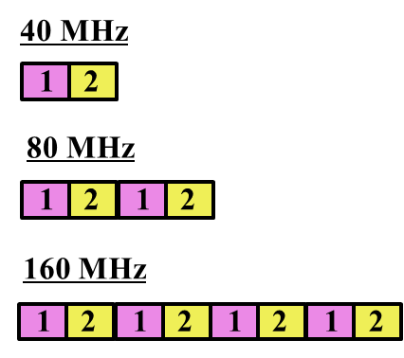

Figure 1 - 20 MHz subchannel content for HE-SIG-B for bandwidths ≥ 40 MHz

HE-SIG-B has a common field followed by a user specific field, where

* The common field includes the information for all of designated STAs to receive the PPDU in corresponding bandwidth
* The user specific field consists of multiple sub-fields that do not belong to the common field, where one or multiple of those sub-fields are for each designated receiving STA
* The boundary between the common and the user specific field is at the bit level and not the OFDM symbol level

[PHY Motion 19, July 16, 2015, see [8]]

The common field in HE-SIG-B contains Resource Unit (RU) allocation.

[PHY Motion 20, July 16, 2015, see [8]]

HE-SIG-B includes resource unit assignment and MCS per station for DL-OFDMA PPDU.

PHY Motion 21, July 16, 2015, see [9]]

### 3.2.4 HE-STF

HE-STF of a non-trigger-based PPDU has a periodicity of 0.8 µs with 5 periods.

* A non-trigger-based PPDU is not sent in response to a trigger frame

[PHY Motion #11, May 2015, see [10]]

The HE-STF of a trigger-based PPDU has a periodicity of 1.6 µs with 5 periods.

* A trigger-based PPDU is an UL PPDU sent in response to a trigger frame

[PHY Motion #12, May 2015, see [10]]

The HE-STF tone positions are defined in Equation 1 where *NSTF_sample* = 16 for a non-trigger-based PPDU and *NSTF_sample* = 8 for a trigger-based PPDU



[PHY Motion #13, May 2015, see [10]]

### 3.2.5 HE-LTF

The HE-LTF shall adopt a structure of using P matrix in the data tones as in 11ac. In the data tones, every space-time stream is spread over all HE-LTF symbols by one row of the P matrix as defined in 11ac. Different space-time streams use different rows in P matrix. [PHY Motion #5, March 2015, see [11]]

The HE PPDU shall support the following LTF modes:

* HE-LTF symbol duration of 6.4 µs excluding GI
  + Equivalent to modulating every other tone in an OFDM symbol of 12.8 µs excluding GI, and then removing the second half of the OFDM symbol in time domain
* HE-LTF symbol duration of 12.8 µs excluding GI

[PHY Motion #6, March 2015, see [11]]

In an HE PPDU, the HE-LTF section shall start at the same point of time and end at the same point of time across all users. [PHY Motion #7, March 2015, see [11]]

In an OFDMA PPDU using *N* HE-LTF symbols, an RU with *Nsts,total* shall use the first *Nsts,total* rows of the *N × N* P matrix. [PHY Motion 29, July 16, 2015, see [12]]

Single stream pilot (like 11ac) in HE-LTF shall be used for SU, DL and UL OFDMA as well as in DL MU-MIMO transmissions. [PHY Motion 26, July 16, 2015, see [13]]

## 3.3 HE Data field

### 3.3.1 General

The Data field in UL MU transmissions shall immediately follow the HE-LTF section.

[PHY Motion 17, July 16, 2015, see [5]]

Data symbols in an HE PPDU shall use a DFT period of 12.8 µs and subcarrier spacing of 78.125 kHz. [PHY Motion #1, January 2015, see [14]]

Data symbols in an HE PPDU shall support guard interval durations of 0.8 µs, 1.6 µs and 3.2 µs. [PHY Motion #2, January 2015, see [14]]

HE PPDUs shall have single stream pilots in the data section

* All streams use the same pilot sequence even in UL MU-MIMO

[PHY Motion 24, July 16, 2015, see [15]]

### 3.3.2 Tone plan

### 3.3.2.1 Resource unit, edge and DC tones

Define 20 MHz OFDMA building blocks as follows:

* 26-tone with 2 pilots, 52-tone with 4 pilot and 106-tone with 4 pilots and with 7 DC Nulls and (6,5) guard tones, and at locations shown in Figure 2
* An OFDMA PPDU can carry a mix of different tone unit sizes within each 242 tone unit boundary
* ~~The following is TBD: Exact location of extra leftover tones~~ *[Ed: deleted, see 3.3.2.2]*

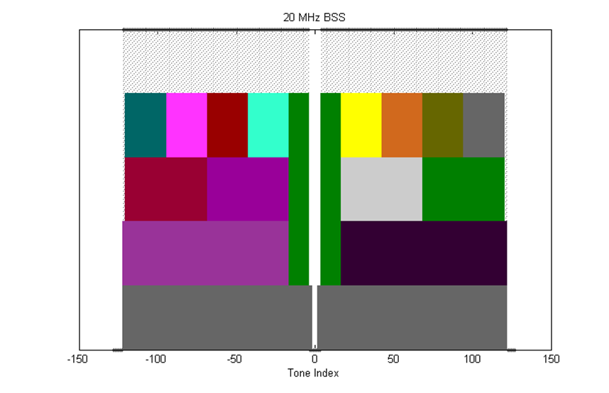

Figure 2 – 20 MHz tone plan

Define 40 MHz OFDMA building blocks as follows

* 26-tone with 2 pilots, 52-tone with 4 pilots, 106-tone with 4 pilots and 242-tone with 8 pilots and with 5 DC Nulls and (12,11) guard tones, and at locations shown in Figure 3
* ~~The following is TBD: exact location of extra leftover tones~~ *[Ed: deleted, see 3.3.2.2]*

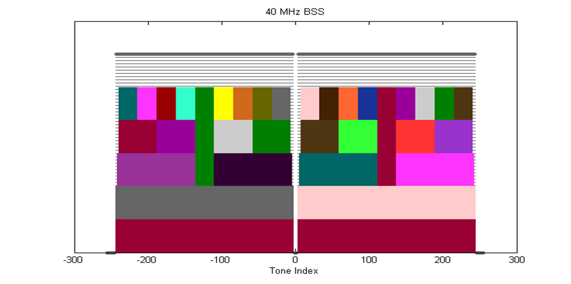

Figure 3 – 40 MHz tone plan

Define 80 MHz OFDMA building blocks as follows:

* 26-tone with 2 pilots, 52-tone with 4 pilots, 106-tone with 4 pilots, 242-tone with 8 pilots and 484-tone with 16 pilots and with 7 DC Nulls and (12,11) guard tones, and at locations shown in Figure 4
* ~~The following is TBD: exact location of extra leftover tones~~ *[Ed: deleted, see 3.3.2.2]*

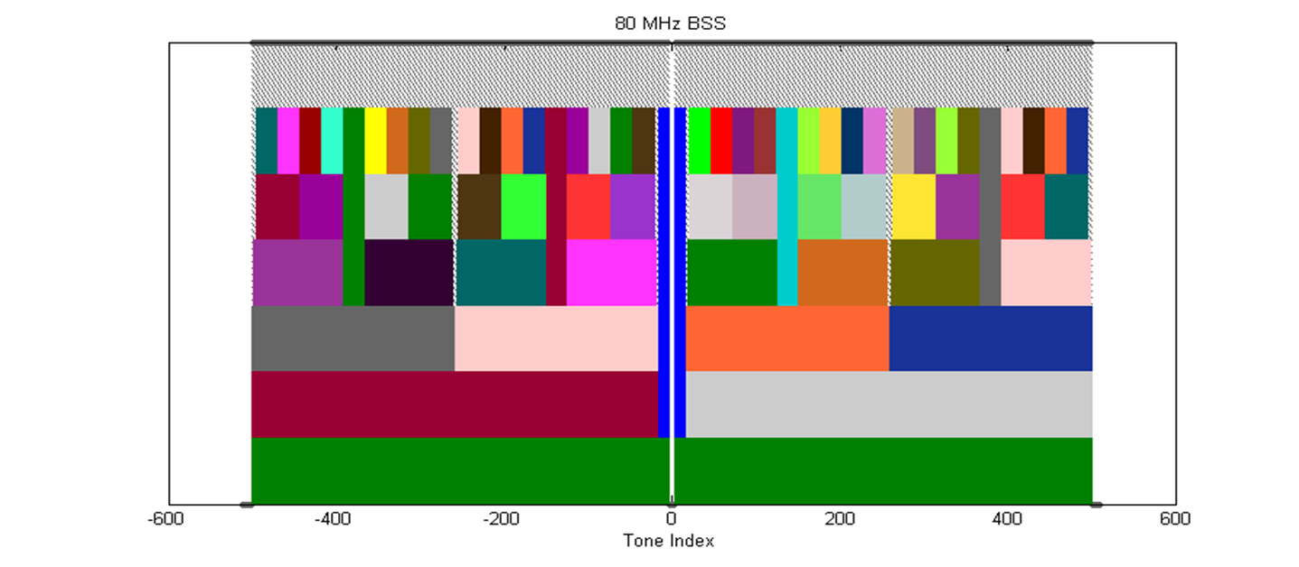

Figure 4 - 80 MHz tone plan

Define 160 MHz/80 MHz+80 MHz OFDMA building blocks as follows:

* 26-tone with 2 pilots
* 52-tone with 4 pilots
* 106-tone with 4 pilots
* 242-tone with 8 pilots
* 484-tone with 16 pilots
* 996-tone with 16 pilots (note that 996-tone is defined for 80 MHz HE-SA-PPDU or 80 MHz HE-SA-MU-PPDU)
* The following is TBD: exact location of extra leftover tones

[PHY Motion #10, May 2015, see [16]]

### 3.3.2.2 Left over tones

The left over tone locations for the 20 MHz, 40 MHz and 80 MHz tone plans are shown in Figure 5, Figure 6 and Figure 7 respectively.

NOTE—Left over tones have zero energy

[PHY Motion 25, July 16, 2015, see [13]]

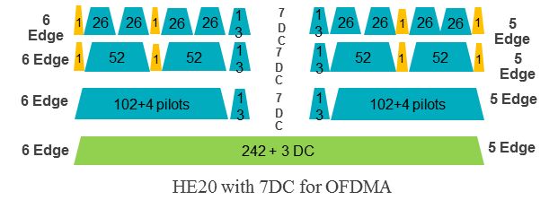

Figure 5 – Left over tone locations for 20 MHz

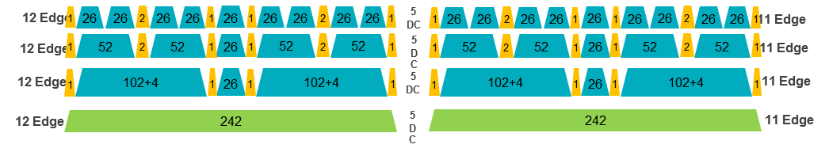

Figure 6 – Left over tone locations for 40 MHz

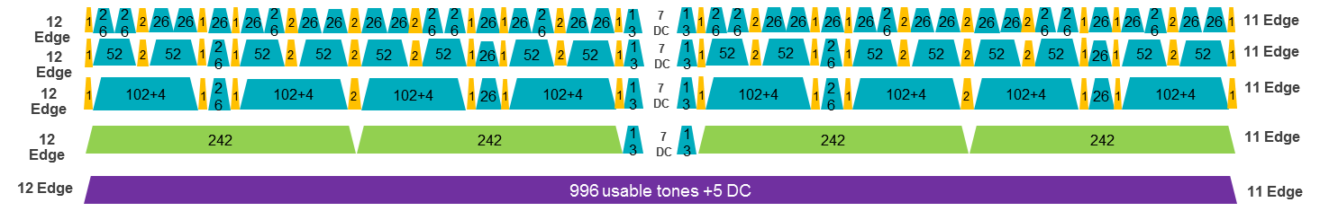

Figure 7 – Left over tone locations for 80 MHz

### 3.3.2.3 Pilot tones

All pilot tones in 4x data OFDMA symbol are at even indices. If pilots present in 4x HE-LTF, their tone indices shall be the same as those pilots in 4x data symbol. If pilots present in 2x HE-LTF, their tone indices shall be the same as the indices of those pilots in 4x data symbol divided by 2. [PHY Motion 27, July 16, 2015, see [13]]

The pilot tone locations for 20 MHz, 40 MHz and 80 MHz bandwidth are as shown in Figure 8, Figure 9 and Figure 10 respectively.

Note—80 MHz pilot positions are enumerated below for reference:

RU-26 pilots: ±10, ±24, ±38, ±50, ±64, ±78, ±92, ±104, ±118, ±130, ±144, ±158, ±172, ±184, ±198, ±212, ±226, ±238, ±252, ±266, ±280, ±292, ±306, ±320, ± 334, ±346, ±360, ±372, ±386, ±400, ±414, ±426, ±440, ±454, ±468, ±480, ± 494

RU-106/242/484 pilots: ±24, ±50, ±92, ±118, ±158, ±184, ±226, ±252, ±266, ±292, ±334, ±360, ±400, ±426, ±468, ±494

RU-996 pilots: ±24, ±92, ±158, ±226, ±266, ±334, ±400, ±468

The pilot locations for 160 MHz or 80+80 MHz use the same structure as 80 MHz for each half of the BW.

[PHY Motion 28, July 16, 2015, see [13]]

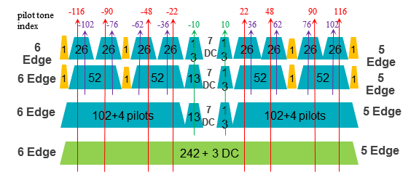

Figure 8 – Pilot tone locations for 20 MHz

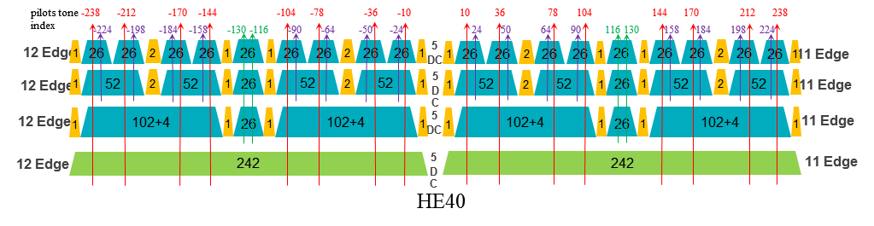

Figure 9 – Pilot tone locations for 40 MHz

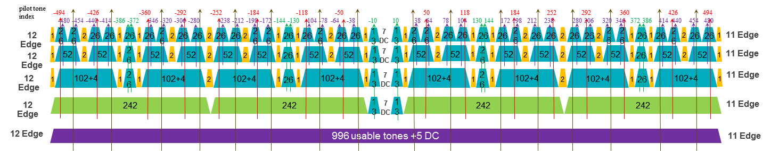

Figure 10 – Pilot tone locations for 80 MHz

### 3.3.3 Coding

LDPC is the only coding scheme in the HE PPDU Data field for allocation sizes of 996 tones and 996*2 tones. [PHY Motion 30, July 16, 2015, see [17]]

Support of BCC code is limited to less than or equal to four spatial streams (per user in case of MU-MIMO), and is mandatory (for both TX and RX) for RU sizes less than or equal to 242 tones (20MHz).

Support of LDPC code for both TX and RX is mandatory for HE STAs declaring support for at least one of HE 80/160/80+80 SU-PPDU bandwidths, or for HE STAs declaring support for more than 4 spatial streams. Otherwise, support of LDPC code for either TX or RX is optional. [PHY Motion 31, July 16, 2015, see [17]]

The 11ax MCS table shall not have any MCS exclusion and, when LDPC is applied, *NDBPS* is computed as follows

$N_{DBPS}=\left\lfloor N_{CBPS}R\right\rfloor$, where *R* is the coding rate

[PHY Motion 32, July 16, 2015, see [17]]

The BCC interleaver and LDPC tone mapper parameters are defined in Table 1.

Table 1 - BCC interleaver and LDPC tone mapper parameters

|  |  |  |  |
| --- | --- | --- | --- |
| **RU size (tones)** | **BCC** | | **LDPC** |
|  | ***Ncol*** | ***Nrow*** | ***DTM*** |
| 26 | 8 | 2 | 1 |
| 52 | 16 | 11 | 3 |
| 106 | 17 | 29 | 6 |
| 242 | 26 | 58 | 9 |
| 484 | - | - | 12 |
| 996 | - | - | 20 |

[PHY Motion 33, July 16, 2015, see [17]]

# 4 Multi-user (MU) features

## 4.1 General

This section describes MU related features. MU features include UL and DL OFDMA and UL and DL MU-MIMO.

The amendment shall define a mechanism for multiplexing DL acknowledgments sent in response to UL MU transmissions. [MU Motion #1, January 2015, see [18]]

An UL MU PPDU (MU-MIMO or OFDMA) is sent as an immediate response (IFS TBD) to a Trigger frame (format TBD) sent by the AP. [MAC Motion #3, March 2015]

The CP length for UL OFDMA/MU-MIMO transmissions shall be explicitly indicated by AP in the Trigger frame that allocates resources for the UL OFDMA/MU-MIMO transmission. The value of CP length for all users addressed by the Trigger frame shall be the same. [PHY Motion 34, July 16, 2015, see [19]]

HE-PPDU for UL-OFDMA shall support UL data transmission below 20 MHz for an HE STA. [MU Motion #3, March 2015]

The amendment shall include a mechanism to multiplex BA/ACK responses to DL MU transmission. [MU Motion #4, March 2015, see [20]]

An AP shall not allocate UL subchannel in any 20 MHz channel that is not occupied by the Trigger frame. In each 20 MHz channel occupied by the Trigger frame, there is at least one allocated subchannel. [MAC Motion #10, May 2015, see [21]]

In each payload within a DL MU PPDU a Trigger frame may be present that carries the information that enables the recipient of the STA to send its ACK/BA response frame a TBD IFS after the DL MU PPDU. [MU Motion 11, July 16, 2015, see [22]]

An UL OFDMA MPDU/A-MPDU is the acknowledgement of the trigger frame. When the AP receives MPDU correctly from at least one STA indicated by trigger frame, the frame exchange initiated by the trigger frame is successful. [MAC Motion 13, July 16, 2015, see [23]]

A TXOP can include both DL MU and UL MU transmissions. [MAC Motion 14, July 16, 2015, see [24]]

The spec shall include the definition of a cascading TXOP structure, allowing alternating DL and UL MU PPDUs starting with a DL MU PPDU in the same TXOP

* The TXOP sequence has only one DL transmitter
* The TXOP sequence may have different UL transmitters within each UL MU PPDU
* The TXOP sequence may have a different set of transmitters in an UL MU PPDU as compared to the DL MU PPDU that follows the UL MU PPDU within the same TXOP

[MAC Motion 15, July 16, 2015, see [24]]

DL/UL OFDMA can multiplex different types of unicast frames in frequency domain. Types of frames can be data frame/control frame/management frame. [MAC Motion 16, July 16, 2015, see [24]]

DL/UL MU-MIMO can multiplex different types of unicast frames in spatial domain. Types of frames can be data frame/control frame/management frame. Different types of frames are to/from different users. [MAC Motion 17, July 16, 2015, see [24]]

A unicast Trigger frame for a single user may be included in an AMPDU for that user in the DL MU PPDU that precedes the UL MU transmission by TBD IFS. [MAC Motion 20, July 16, 2015, see [25]]

Broadcast trigger transmitted in a subchannel of DL OFDMA shall not include the resource allocation information of the STAs which are recipients of frames in the other subchannels of the DL OFDMA. The subchannel of the broadcast trigger frame is identified by TBD signaling. [MAC Motion 21, July 16, 2015, see [25]]

The transmission for all the STAs in a DL MU (MIMO, OFDMA) PPDU shall end at the same time.

The A-MPDU padding per each STA follows the 11ac procedure. [MAC Motion 22, July 16, 2015, see [26]]

## 4.2 MU RTS/CTS procedure

The spec shall define a frame that solicits simultaneous CTS responses from multiple STAs to protect DL MU transmission. [MU Motion 6, July 16, 2015, see [27]]

The scrambler seed of a simultaneous CTS is same as the scrambler seed of the frame that triggers the simultaneous CTS. The transmission rate of a simultaneous CTS shall use the primary rate based on the rate or MCS of the frame that triggers the simultaneous CTS. [MU Motion 7, July 16, 2015, see [27]]

## 4.3 UL OFDMA-based Random Access

The spec shall define a Trigger frame that allocates resources for random access. [MU Motion 8, July 16, 2015, see [28]]

## 4.4 Sounding protocol

The amendment shall include a CSI feedback mechanism which allows for a minimum feedback granularity of less than 20 MHz. [MU Motion 9, July 16, 2015, see [29]]

# 5 Coexistence

This section describes the functional blocks that support coexistence.

## 5.1 Features for operation in dense environments

This section describes features that improve overlapping BSS (OBSS) operation in dense environments. This includes features such as deferral rules and CCA levels.

# 6 MAC

## 6.1 General

This section describes general MAC functional blocks.

The amendment shall define a mechanism to allow the AP to configure the use of RTS/CTS initiated by non-AP STA. [MAC Motion #1, January 2015, see [30]]

In 2.4 GHz HE STAs should send beacon and probe (request & response) frames at rates ≥ 5.5 Mb/s. [MAC Motion 24, 2015, see [31]]

The spec shall include a mechanism that allows a target transmission time for a Trigger frame to be indicated. The mechanism is based on implicit TWT operation and additionally enables:

* Broadcast triggered TWT by including a TWT element in the Beacon
* Solicited triggered TWT by using implicit TWT negotiation procedure

[MAC Motion 25, July 16, 2015, see [32]]

When the broadcast triggered TWT is enabled, STA and AP may exchange TWT request/response to indicate the target Beacon frame to be monitored by the PS STA. [MAC Motion 26, July 16, 2015, see [32]]

## 6.2 Power Save

# 7 Frame formats

## 7.1 Trigger frame

The spec shall define a new control frame format that carries sufficient information to identify the STAs transmitting the UL MU PPDUs and allocating resources for the UL MU PPDUs. The format of the new frame is given in Figure 11. The presence of A1 is TBD. [MAC Motion 19, July 16, 2015, see [33]]



Figure 11 - Trigger frame

## 7.2 Multi-STA BA

The spec shall define a multi-STA BA frame by using the Multi-TID BlockAck frame format with the following changes:

* Add an indication that the frame is a multi-STA BA (TBD)
* Each BA Information field can be addressed to different STAs
* B0-B10 of the Per TID Info field carry a (Partial) AID identifying the intended receiver of the BA Information field

[MAC Motion #1, March 2015, see [34]]

The spec shall define a signaling in the Multi-STA BA frame that can indicate an ACK, as follows:

* If B11 in the per-TID info field is set, then the BlockAck bitmap and the SC subfields in the BA Info field are not present and this BA Info field indicates an ACK of either single MPDU or all MPDUs carried in the eliciting PPDU that was transmitted by the STA whose AID is indicated in the per-TID info field. [Modifed with MAC Motion #8, May 2015, see [35]]

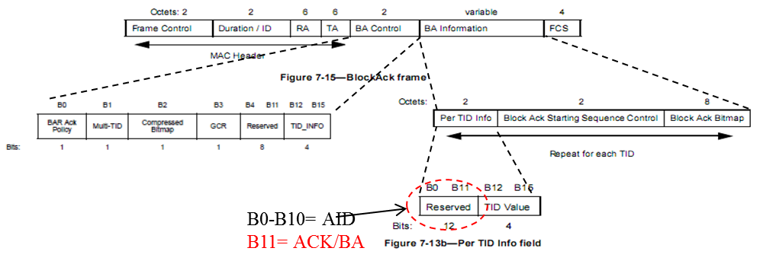

Figure 12 - Multi-STA BA format

[MAC Motion #2, March 2015, see [34]]

# References

|  |  |
| --- | --- |
| [1] | Robert Stacey (Intel), “14/1453r2 Spec Framework Proposal”. |
| [2] | Jiayin Zhang (Huawei), “15/0101r1 Preamble structure for 11ax system”. |
| [3] | Hongyuan Zhang (Marvell), “15/0579r3 Preamble Design and Autodetection”. |
| [4] | Jiayin Zhang (Huawei), “15/0832r1 Performance evaluation of SU/MU MIMO in OFDMA”. |
| [5] | Jianhan Liu (Mediatek Inc.), “15/0822r2 SIG-A Structure in 11ax Preamble”. |
| [6] | Young Hoon Kwon (Newracom), “15/0344r2 SIG Field Design Principle for 11ax”. |
| [7] | Ron Porat, “15/0873r0 SIG-B Encoding Structure”. |
| [8] | Joonsuk Kim (Apple), “15/0821r2 HE SIG-B Structure”. |
| [9] | Katsuo Yunoki (KDDI R&D Laboratories), “15/0827r2 Considerations on HE-SIG-A and B”. |
| [10] | Yakun Sun (Marvell), “15/0381r1 HE-STF Proposal”. |
| [11] | Hongyuan Zhang (Marvell), “15/0349r2 HE-LTF Proposal”. |
| [12] | Yakun Sun (Marvell), “15/0817r0 P Matrix for HE-LTF”. |
| [13] | Bin Tian (Qualcomm), “15/0819r1 11ax OFDMA Tone Plan Leftover Tones and Pilot Structure”. |
| [14] | Sriram Venkateswaran (Broadcom), “15/0099r4 Payload Symbol Size for 11ax”. |
| [15] | Sameer Vermani (Qualcomm), “15/0812r1 Pilot Design for Data Section”. |
| [16] | Shahrnaz Azizi (Intel), “15/0330r5 OFDMA Numerology and Structure”. |
| [17] | Hongyuan Zhang (Marvell), “15/0580r1 11ax coding discussion”. |
| [18] | Tomoko Adachi (Toshiba), “15/0064r1 Consideration on UL-MU overheads”. |
| [19] | Zhigang Rong (Huawei), “15/0813r1 CP Indication for UL MU Transmission”. |
| [20] | Reza Hedayat (Newracom), “15/0379r1 DL OFDMA Performance and ACK Multiplexing”. |
| [21] | Liwen Chu (Marvell), “15/0615r2 UL OFDMA Bandwidth”. |
| [22] | Reza Hedayat (Newracom), “15/0829r3 Uplink ACK and BA Multiplexing”. |
| [23] | Liwen Chu (Marvell), “15/0615r3 UL OFDMA Bandwidth”. |
| [24] | David Xun Yang (Huawei), “15/0841r0 Cascading Structure”. |
| [25] | Liwen Chu (Marvell), “15/0831r2 Broadcast and Unicast in DL MU”. |
| [26] | Simone Merlin (Qualcomm), “15/0876r1 Duration and MAC Padding for MU PPDUs”. |
| [27] | Po-Kai Huang (Intel), “15/0867r1 MU-RTS/CTS for DL MU”. |
| [28] | Chittabrata Ghosh (Intel), “15/0875r1 Random Access with Trigger Frames using OFDMA”. |
| [29] | Kome Oteri (InterDigital), “15/0818r1 Further Analysis of Feedback and Frequency Selective Scheduling (FSS) for TGax OFDMA”. |
| [30] | Sigurd Schelstraete (Quantenna), “15/0059r1 Uplink RTS/CTS Control”. |
| [31] | Guido R. Hiertz (Ericsson), “15/0874r0 Minimal data rates management frame transmissions in 2.4 GHz”. |
| [32] | Alfred Asterjadhi (Qualcomm Inc.), “15/0880r2 Scheduled Trigger frames”. |
| [33] | Simone Merlin (Qualcomm), “15/0877r0 Trigger Frame Format”. |
| [34] | Simone Merlin (Qualcomm), “15/0366r2 Multi-STA BA”. |
| [35] | Jeongki Kim (LG Electronics), “15/0626r1 Further consideration on Multi-STA Block ACK”. |