IEEE P802.11
Wireless LANs
Specification Framework for TGax
Date: 2015-01-15
Author(s):
Name | Affiliation | Address | Phone | email
Robert Stacey | Intel | 2111 NE 25th Ave, Hillsboro OR 97124, USA | +1-503-724-893 | robert.stacey@intel.com

Abstract
This document provides the framework from which the draft TGax amendment will be developed. The document provides an outline of each the functional blocks that will be a part of the final amendment. The document is intended to reflect the working consensus of the group on the broad outline for the draft specification. As such it is expected to begin with minimal detail reflecting agreement on specific techniques and highlighting areas on which agreement is still required. It may also begin with an incomplete feature list with additional features added as they are justified. The document will evolve over time until it includes sufficient detail on all the functional blocks and their inter-dependencies so that work can begin on the draft amendment itself.

Revision history
Revision | Date | Changes
0 | January 13, 2015 | As approved by TG motion at the November 2014 meeting
1 | January 13, 2015 | Added motioned text from PM1 session January 13, 2015
2 | January 15, 2015 | Added motioned text from January 14, 2014
3 | March 27, 2015 | Added motioned text from PM1 session March 12, 2015

1 Definitions

2 Abbreviations and acronyms

HE High Efficiency
UL Uplink
DL Dowlink
OFDMA Orthogonal Frequency-Division Multiple Access

3 High Efficiency (HE) Physical Layer

3.1 General

Section 3 describes the functional blocks in the physical layer.

HE-PPDU for UL-OFDMA shall support UL data transmission below 20 MHz for an HE STA. [MU Motion #3, March 2015]

3.2 HE preamble

An HE PPDU shall include the legacy preamble (L-STF, L-LTF and L-SIG), duplicated on each 20 MHz, for backward compatibility with legacy devices. [PHY Motion #3, January 2015]

HE-SIG-A (using a DFT period of 3.2 µs and subcarrier spacing of 312.5 kHz) is duplicated on each 20 MHz after the legacy preamble to indicate common control information. [Motion #4, January 2015]

The HE-LTF shall adopt a structure of using P matrix in the data tones as in 11ac. In the data tones, every space-time stream is spread over all HE-LTF symbols by one row of the P matrix as defined in 11ac. Different space-time streams use different rows in P matrix. [Motion #4, March 2015]

The HE PPDU shall support the following LTF modes:
- HE-LTF symbol duration of 6.4us excluding GI
  - Equivalent to modulating every other tone in an OFDM symbol of 12.8 µs excluding GI, and then removing the second half of the OFDM symbol in time domain
- HE-LTF symbol duration of 12.8 µs excluding GI
[Motion #5, March 2015]

In an HE PPDU, the HE-LTF section shall start at the same point of time and end at the same point of time across all users. [Motion #6, March 2015]

3.3 HE Data field

Data symbols in an HE PPDU shall use a DFT period of 12.8 µs and subcarrier spacing of 78.125 kHz. [PHY Motion #1, January 2015]

Data symbols in an HE PPDU shall support guard interval durations of 0.8 µs, 1.6 µs and 3.2 µs. [PHY Motion #2, January 2015]

4 Multi-user (MU) features

This section describes MU related features. MU features include UL and DL OFDMA and UL and DL MU-MIMO.

The amendment shall define a mechanism for multiplexing DL acknowledgments sent in response to UL MU transmissions. [MU Motion #1, January 2015]

An UL MU PPDU (MU-MIMO or OFDMA) is sent as an immediate response (IFS TBD) to a Trigger frame (format TBD) sent by the AP. [MAC Motion #3, March 2015]

HE-PPDU for UL-OFDMA shall support UL data transmission below 20 MHz for an HE STA. [MU Motion #3, March 2015]

The amendment shall include a mechanism to multiplex BA/ACK responses to DL MU transmission. [MU Motion #4, March 2015]

5 Coexistence

This section describes the functional blocks that support coexistence.

5.1 Features for operation in dense environments

This section describes features that improve overlapping BSS (OBSS) operation in dense environments. This includes features such as deferral rules and CCA levels.

6 MAC

This section describes general MAC functional blocks.

The amendment shall define a mechanism to allow the AP to configure the use of RTS/CTS initiated by non-AP STA. [MAC Motion #1, January 2015]

6.1 Power Save

7 Frame formats

7.2 Multi-STA BA

The spec shall define a multi-STA BA frame by using the Multi-TID BlockAck frame format with the following changes:
- Add an indication that the frame is a multi-STA BA (TBD)
- Each BA Information field can be addressed to different STAs
- B0-B10 of the Per TID Info field carry a (Partial) AID identifying the intended receiver of the BA Information field
[MAC Motion #1, March 2015]

The spec shall define a signaling in the Multi-STA BA frame that can indicate an ACK, as follows:
- If B11 in the per-TID info field is set, then the BlockAck bitmap and the SC subfields in the BA Info field are not present and this BA Info field indicates an ACK for the STA with AID indicated in the per-TID info field

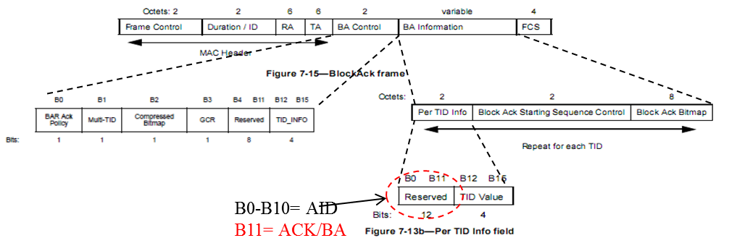
Figure 1 - Multi-STA BA format
[MAC Motion #2, March 2015]

References:
14/1453r2 Proposed Spec Framework Document for TGax
15/0099r4 Payload Symbol Size for 11ax
15/0101r1 Preamble structure for 11ax system
15/0064r1 Consideration on UL-MU overheads
15/0059r1 Uplink RTS/CTS Control
15/0349r2 HE-LTF Proposal
15/0354r1 Bandwidth granularity on UL-OFDMA data allocation
15/0336r2 Multi-STA BA
15/0344r2 SIG Field Design Principle for 11ax
15/0379r1 DL OFDMA Performance and ACK Multiplexing

