IEEE P802.11
Wireless LANs
Proposed Changes to the P802.11mc D3.4 (no associated CIDs)
Date: 2015-01-14
Author(s):
Name | Affiliation | Address | Phone | email
Mitsuru Iwaoka | Yokogawa Electric Corporation | 2-9-32 Nakacho, Musashino-shi  Tokyo, 180-8750  Japan | +81-422-52-5519 | mitsuru.iwaoka.1961  @ieee.org
Abstract
This submission proposes text changes to the IEEE P802.11mc D3.4 to fix following issues:

- 8.6.13.4 (TDLS Setup Confirm Action field format): incorrect reference to 8.4.2.157
- 9.14 (PPDU duration constraint): incorrect reference to 6.5.7
- 10.7 (DLS operation): missing descriptions for VHT STAs
- 10.24.13 (BSS max idle period management): undefined MIB variable dot11MaxIdlePeriod

- 8.3.3.9 (Probe Request frame format) and 8.3.3.10 (Probe Response frame format): incorrect condition to place a Request element and Requested elements. [R1]

R1: Remove 1), add 7)
R2: Remove 6), correct to “a VHT” in 4)

- Reference to 8.4.2.157 (VHT Capabilities element) in Table 8-329 (Information for TDLS Setup Confirm Action field) in 8.6.13.4 (TDLS Setup Confirm Action field format) is incorrect. It shall be 8.4.2.158 (VHT Operation element).

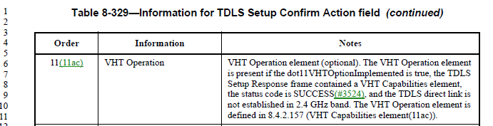

Proposed Change:
Replace “8.4.2.157 (VHT Capabilities element)” in Table 8-329 with “8.4.2.158 (VHT Operation element)”.

- Reference to 6.5.7 (PLME-TXTIME.request) in the first paragraph of 9.14 (PPDU duration constraint) is incorrect. It shall be 6.5.8 (PLME-TXTIME.confirm).

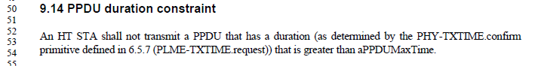

Proposed Change:
Replace “6.5.7 (PLME-TXTIME.request)” in the first paragraph of 9.14 (PPDU duration constraint) with “6.5.8 (PLME-TXTIME.confirm)”.

- There is no descrption for a VHT STA in 10.7 (DLS operation). The VHT STA is an HT STA and optionally supports DLS. It is necessary to specify the DLS operation of the VHT STA.

Proposed Changes:
Change the item a) and item c) of the 6th paragraph of 10.7.1 (General) as follows:

- A STA, STA-1, that intends to exchange frames directly with another non-AP STA and dot11DLSAllowed is true, STA-2, invokes DLS and sends a DLS Request frame to the AP (step 1a in Figure 10-24 (The four steps involved in direct-link handshake)). This request contains the rate set, capabilities of STA-1, and the MAC addresses of STA-1 and STA-2. If STA-1 is an HT STA, this request also contains the HT capabilities of STA-1. If STA-1 is a VHT STA, this response also contains a VHT Capabilities element representing the VHT capabilities of STA-1.

- If STA-2 has dot11DLSAllowed true and accepts the direct stream, it sends a DLS Response frame to the AP (step 2a in Figure 10-24 (The four steps involved in direct-link handshake)), which contains the rate set, (extended) capabilities of STA-2, and the MAC addresses of STA-1 and STA-2. If STA-2 is an HT STA, this response also contains an HT Capabilities element representing the HT capabilities of STA-2. If STA-2 is a VHT STA, this response also contains a VHT Capabilities element representing the VHT capabilities of STA-2.

Change the first paragraph of 10.7.3 (Data transfer after setup) as follows:

For each active direct link, a STA shall record the MAC and PHY features, rates, and MCSs that are supported by the other STA participating in the direct link, according to the Supported Rates, Extended Supported Rates, Capability Information, and HT Capabilities, and VHT Capabilities fields within the DLS Request and DLS Response frames that were used to establish the direct link.

- dot11MaxIdlePeriod used in the first paragraph of 10.24.13 (BSS max idle period management) is not defined in Annex C. It shall be dot11BssMaxIdlePeriod.

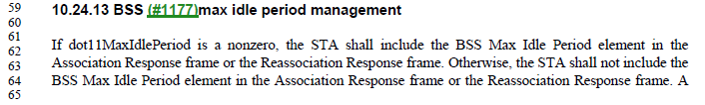

Proposed Change:
Replace “dot11MaxIdlePeriod” in the first paragraph of 10.24.13 (BSS max idle period management) with “dot11BssMaxIdlePeriod”.

- 8.3.3.9 (Probe Request frame format) and 8.3.3.10 (Probe Response frame format): incorrect condition to include Request element and Requested elements.

According to Table 8-33 (Probe Request frame body) in 8.3.3.9 (Probe Request frame format), a Request element optionally present if dot11MultiDomainCapabilityActivated is true.

According to Table 8-34 (Probe Response frame body) in 8.3.3.10 (Probe Response frame format), elements requested by the Request element of the Probe Request frame are present if dot11MultiDomainCapabilityActivated is true.

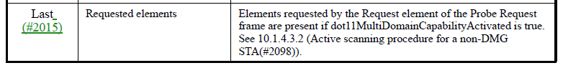

6.3.3.2 (MLME-SCAN.request) specifies different condition to place the Request element in the Probe Request frame. dot11RadioMeasurementActivated is used.

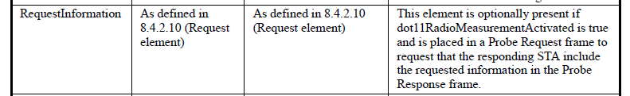

A note in 10.1.4.1 (General) describes that the Request element can be used to request radio measurement information.

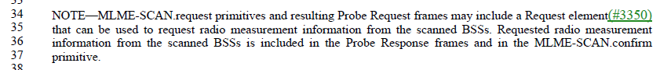

dot11RadioMeasurementActivated shall be used instead of dot11MultiDomainCapabilityActivated.

Proposed changes:
Replace dot11MultiDomainCapabilityActivated with dot11RadioMeasurementActivated in the following places:
    - In the Notes of Request row of Table 8-33
    - In the Notes of Requested elements of Table 8-34

