IEEE P802.11
Wireless LANs
Proposed Changes to the P802.11mc D3.4 (no associated CIDs)
Date: 2015-01-08
Author(s):
Name | Affiliation | Address | Phone | email
Mitsuru Iwaoka | Yokogawa Electric Corporation | 2-9-32 Nakacho, Musashino-shi  Tokyo, 180-8750  Japan | +81-422-52-5519 | mitsuru.iwaoka.1961  @ieee.org
Abstract
This submission proposes text changes to the IEEE P802.11mc D3.4 to fix following issues:
- 8.4.2.10 (Request element): incorrect references to Table 8-42.
- 8.6.13.4 (TDLS Setup Confirm Action field format): incorrect reference to 8.4.2.157
- 9.14 (PPDU duration constraint): incorrect reference to 6.5.7
- 10.7 (DLS operation): missing descriptions for VHT STAs
- 10.24.13 (BSS max idle period management): undefined MIB variable dot11MaxIdlePeriod
- 22.3.20 (PHY receive procedure): incorrect PDU filter out rule.

- Reference to Table 8-42 (Non-AP STA usage of QoS, CFPollable, and CF-Poll Request) in the third paragraph of 8.4.2.10 (Request element) is incorrect. It shall be Table 8-34 (Probe Response frame body).

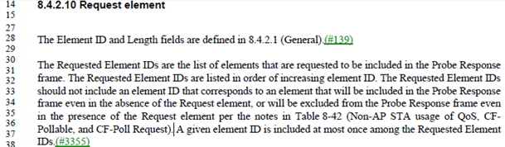

Proposed Change:
Replace “Table 8-42 (Non-AP STA usage of QoS, CFPollable, and CF-Poll Request)” in the third paragraph of 8.4.2.10 (Request element) with “Table 8-34 (Probe Response frame body)”.

- Reference to 8.4.2.157 (VHT Capabilities element) in Table 8-329 (Information for TDLS Setup Confirm Action field) in 8.6.13.4 (TDLS Setup Confirm Action field format) is incorrect. It shall be 8.4.2.158 (VHT Operation element).

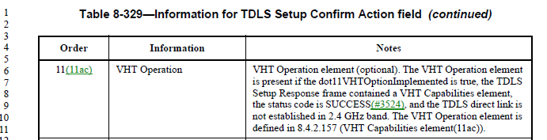

Proposed Change:
Replace “8.4.2.157 (VHT Capabilities element)” in Table 8-329 with “8.4.2.158 (VHT Operation element)”.

- Reference to 6.5.7 (PLME-TXTIME.request) in the first paragraph of 9.14 (PPDU duration constraint) is incorrect. It shall be 6.5.8 (PLME-TXTIME.confirm).

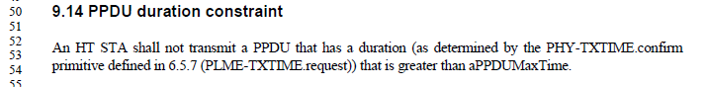

Proposed Change:
Replace “6.5.7 (PLME-TXTIME.request)” in the first paragraph of 9.14 (PPDU duration constraint) with “6.5.8 (PLME-TXTIME.confirm)”.

- There is no descrption for a VHT STA in 10.7 (DLS operation). The VHT STA is an HT STA and optionally supports DLS. It is necessary to specify the DLS operation of the VHT STA.

Proposed Changes:
Change the item a) and item c) of the 6th paragraph of 10.7.1 (General) as follows:

- A STA, STA-1, that intends to exchange frames directly with another non-AP STA and dot11DLSAllowed is true, STA-2, invokes DLS and sends a DLS Request frame to the AP (step 1a in Figure 10-24 (The four steps involved in direct-link handshake)). This request contains the rate set, capabilities of STA-1, and the MAC addresses of STA-1 and STA-2. If STA-1 is an HT STA, this request also contains the HT capabilities of STA-1. If STA-1 is an VHT STA, this response also contains an VHT Capabilities element representing the VHT capabilities of STA-1.

- If STA-2 has dot11DLSAllowed true and accepts the direct stream, it sends a DLS Response frame to the AP (step 2a in Figure 10-24 (The four steps involved in direct-link handshake)), which contains the rate set, (extended) capabilities of STA-2, and the MAC addresses of STA-1 and STA-2. If STA-2 is an HT STA, this response also contains an HT Capabilities element representing the HT capabilities of STA-2. If STA-2 is an VHT STA, this response also contains an VHT Capabilities element representing the VHT capabilities of STA-2.

Change the first paragraph of 10.7.3 (Data transfer after setup) as follows:

For each active direct link, a STA shall record the MAC and PHY features, rates, and MCSs that are supported by the other STA participating in the direct link, according to the Supported Rates, Extended Supported Rates, Capability Information, and HT Capabilities, and VHT Capabilities fields within the DLS Request and DLS Response frames that were used to establish the direct link.

- dot11MaxIdlePeriod used in the first paragraph of 10.24.13 (BSS max idle period management) is not defined in Annex C. It shall be dot11BssMaxIdlePeriod.

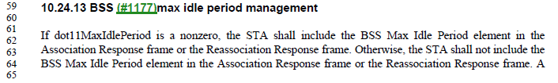

Proposed Change:
Replace “dot11MaxIdlePeriod” in the first paragraph of 10.24.13 (BSS max idle period management) with “dot11BssMaxIdlePeriod”.

- PPDU filter out rule specified in 22.3.20 (PHY receive procedure) is incorrect.

According to Table 7-4 in (7.3.4.4 Vector descriptions), the PHY does not filter out PPDUs with GROUP_ID field equal to NN and LISTEN_TO_GIDNN equal to true (NN is 0 or 63).
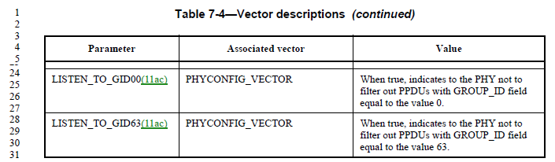

The PPDU filter out rule in 22.3.20 (PHY receive procedure) specifies that the PHY shall not filter out PPDUs with GROUP_ID field equal to NN, LISTEN_TO_GIDNN equal to true and the value of the Partial AID field included in PARTIAL_AID_LIST_GIDNN. If LISTEN_TO_GIDNN is false, the PHY may filter out all PPDUs with GROUP_ID field equal to NN.

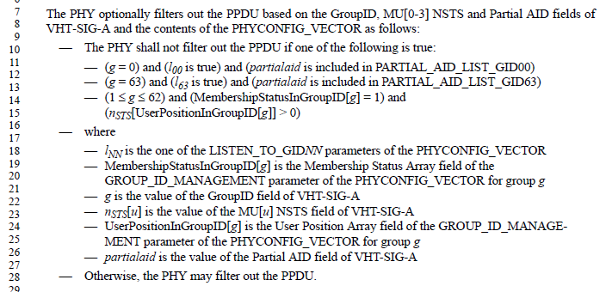

Proposed Change:
Change the following text of 22.3.20 (PHY receive procedure) as follows:

The PHY optionally filters out the PPDU based on the GroupID, MU[0-3] NSTS and Partial AID fields of VHT-SIG-A and the contents of the PHYCONFIG_VECTOR as follows:
- The PHY shall not filter out the PPDU if one of the following is true:
  - (g = 0) and (l00 is true) and or (partialaid is included in PARTIAL_AID_LIST_GID00)
  - (g = 63) and (l63 is true) and or (partialaid is included in PARTIAL_AID_LIST_GID63)
  - ..

