IEEE P802.11
Wireless LANs
Final Report of DSRC Coexistence Tiger Team
Date: 2014-12-11
Authors and Contributors:
Name | Affiliation | Address | Phone | Email
Jim Lansford | CSR Technology | 100 Stirrup Circle, Florissant, CO 80816 | +1 719 286 8660 | Jim.lansford@ieee.org
John Kenney | Toyota InfoTechnology Center, USA | 465 Bernardo Avenue, Mountain View, CA | +1 650-694-4160 | jkenney@us.toyota-itc.com
Peter Ecclesine | Cisco Systems | 170 W. Tasman Dr., MS SJ-14-4, San Jose, CA 95134-1706 | +1-408-527-0815 | pecclesi@cisco.com
Tevfik Yucek | Qualcomm | 1700 Technology Drive, San Jose, CA |  | tyucek@qca.qualcomm.com
Revision History
R0 | Initial draft by Jim Lansford. Portions of this draft were excerpted from a paper presented to the 2013 IEEE Vehicular Networking Conference [1]
R1

Abstract
With the release of FCC NPRM 13-22 (Docket 13-49), the United States Federal Communications Commission has requested comments regarding allowing unlicensed devices such as those using 802.11-based standards to share the 5.9 GHz ITS band, which is currently allocated for DSRC. If sharing is allowed, the FCC would create a new set of rules for the band that would become U-NII-4. This report is a summary of activities in the IEEE 802.11 Regulatory Standing Committee regarding the issues surrounding U-NII-4 band sharing between WLAN and DSRC; this DSRC Coexistence “Tiger Team” has examined some initial ideas for how band sharing could work. This report describes the work of the Tiger Team since its inception in August 2013, summarizes the issues surrounding the proposed band sharing ideas discussed in the group, assesses the level of support for these concepts among the members of the group, and recommends next steps for validating the sharing methods. The goal of this document is to inform regulators about initial discussions regarding the feasibility and practicality of sharing the 5.9 GHz ITS band and outlining future analysis and field testing that needs to take place to assure that these techniques will adequately protect DSRC transmissions when deployed in the mass market.

Background
The FCC allocated 75MHz of spectrum in the 5.9GHz band (5850-5925MHz) for Dedicated Short Range Communications (DSRC) in October 1999. In the FCC NPRM 13-22 (13-49), the FCC requested comments on a potential sharing of the DSRC band, to understand if a feasible sharing solution that protects DSRC users could be developed. DSRC would remain as a primary user of the band, but if sharing is allowed, this new band would be designated U-NII-4. Existing IEEE standards for Wireless Local Area Networks (WLANs) such as 802.11n and 802.11ac could be modified to operate in this new UNII-4 band if such band sharing rules are approved by the FCC.
The FCC did not specify the framework or etiquette by which band sharing would occur; the NPRM requested comments from relevant stakeholders. In August 2013, the IEEE 802.11 Regulatory Standing Committee created a subcommittee called the DSRC Coexistence Tiger Team to convene meetings of stakeholders from WLAN, automotive, regulatory and other communities to explore possible band sharing techniques that could help inform the regulatory process.

Regulatory issues in the 5 GHz bands
As the 2.4 GHz Industrial, Scientific and Medical (ISM) band has become increasingly congested, there has been a great deal of interest in the Wi-Fi industry to use the 5 GHz bands, which generally fall under the Unlicensed National Information Infrastructure (UNII) rules of the US Federal Communications Commission (FCC). As currently implemented, the UNII bands are defined as in TABLE I. :

Band name | Frequency Range (GHz) | Power Level (mW)
U-NII-1 | 5.15-5.25 | 250
U-NII-2 | 5.25-5.35 | 250 (DFS required)
U-NII-2e | 5.47-5.725 | 250 (DFS required)
U-NII-3 | 5.725-5.850 | 1000
Table 1: 5 GHz U-NII Band Allocations in the US
While the 5 GHz bands offer significantly more spectral capacity than the 83.5MHz available in the 2.4 GHz ISM band in the US, there is concern that the rapidly accelerating popularity of the new generations of 802.11 WLAN (Wi-Fi) will lead to massive congestion in these bands as well. These issues will be addressed in subsequent sections.
The US Congress established the Intelligent Transportation System (ITS) program in 1991 [3]. In 1999 the FCC, in response to a petition from the automotive industry, “allocated the 5.9 GHz band [5.850-5.925 GHz] for DSRC-based ITS applications and adopted technical rules for DSRC operations” [4]. DSRC services are co-primary in the 5.9 GHz band with the government radiolocation service and with non-government fixed satellite service uplink operations. In 2003 the FCC adopted licensing and service rules for DSRC [4], including modifications to Parts 90 (for Roadside Units, RSUs) and 95 (for On-Board Units, OBUs) of the Commission’s rules. As shown in Fig. 1, these rules defined a band plan that reserved 5 MHz at the low end of the band (5.850-5.855 GHz) as a guard band and specified seven 10 MHz channels, i.e. Ch. 172 (5.855-5.865 GHz) through 184 (5.915-5.925 GHz). Channel 178 is designated as the Control Channel, while the remaining six channels are designated as Service Channels. The rules also permit two 20 MHz service channels, overlapping respectively with channels 174-176 and 180-182. In 2006 the Commission further refined the DSRC rules by designating Channel 172 “exclusively for vehicle-to-vehicle safety communications for accident avoidance and mitigation, and safety of life and property applications.” In addition, it designated Channel 184 “exclusively for high-power, longer-distance communications to be used for public safety applications involving safety of life and property, including road intersection collision mitigation” [5].
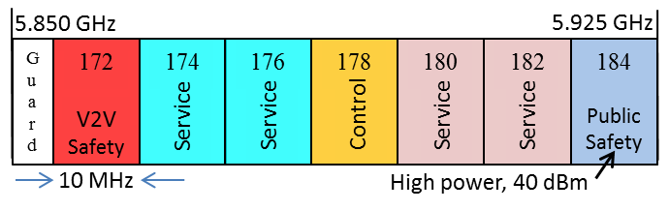
Figure 1: FCC DSRC Band Plan

Dedicated Short Range Communications
DSRC is an ITS technology that enables direct vehicle-to-vehicle (V2V) and vehicle-to/from-infrastructure (V2I) communication [6]. In recent years a consortium of automakers, in cooperation with the US Department of Transportation (DOT), has engaged in research directed at deployment of DSRC systems [7, 8]. The focus of the research is V2V communication of vehicle state information (location, speed, acceleration, heading, etc.) through so-called Basic Safety Messages (BSMs) [9], and the development of collision-avoidance applications that use the BSM data to identify potential collision threats and take appropriate action, e.g. warn the driver or control the vehicle. These applications place stringent robustness and latency requirements on the underlying wireless communication system. While the focus in discussions of DSRC is often on V2V safety communication, the system is capable of supporting a wide variety of other ITS applications, including V2I-based safety, automated driving, efficient mobility, reduced environmental impact, and electronic commerce (e.g. tolling). Many of these services also impose stringent requirements on the wireless communication system.
DSRC systems communicate using a variation on the common IEEE 802.11 Physical (PHY) and Medium Access Control (MAC) protocols. This variation, referred to as Wireless Access in Vehicular Environments (WAVE) is specified in the IEEE 802.11p amendment [10]. The WAVE capability enables ad hoc communication with low latency, as required for scenarios in which high speed vehicles are only in range of one another for a few seconds before a potential collision. The relationship between WAVE DSRC and more conventional uses of the IEEE 802.11 protocols is discussed below. The higher layers of the DSRC protocol stack are based on standards defined by the IEEE 1609 Working Group and by SAE International [11].

The FCC 13-22 NPRM
In response to the rapidly accelerating adoption of Wi-Fi, particularly the emerging 802.11ac standard, the FCC issued a Notice of Proposed Rulemaking (NPRM) in early 2013 that proposed adding 195MHz of additional spectrum for use by unlicensed devices such as Wi-Fi. In addition, the NPRM proposed changes in the existing U-NII-1, U-NII-2, and U-NII-2e bands to make them more useful for unlicensed devices, including making U-NII-1 available outdoors and streamlining the DFS process for U-NII-2 and U-NII-2e (a portion of these new rules have been approved; see [2]). A mapping between the proposed new unlicensed spectrum and Wi-Fi channels is shown in red in Fig. 2. As a reminder, the ITS band is 5.850-5.925 GHz, so the inclusion of this band in the NPRM would permit one additional 80 MHz and one additional 160 MHz channel for Wi-Fi operation. Unlicensed devices following standards other than 802.11 would also be permitted to operate anywhere in the bands labeled “New” in the figure.

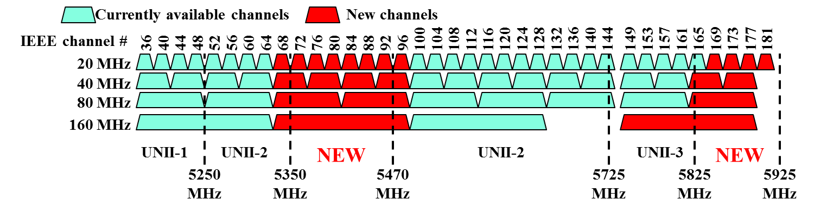
Figure 2: Current and proposed 5 GHz channels for 802.11ac

These new unlicensed bands will be designated as shown in TABLE II.

Frequency (GHz) | Old Name | New Name
5.15-5.25 | U-NII-1 | U-NII-1
5.25-5.35 | U-NII-2 | U-NII-2A
5.35-5.47 |  | U-NII-2B
5.47-5.725 | U-NII-2e | U-NII-2C
5.725-5.850 | U-NII-3 | U-NII-3
5.85-5.925 | ITS | U-NII-4
Table II: Proposed 5 GHz U-NII band designations

From the perspective of the ITS world, the most significant proposed change is allowing the band used by DSRC to be shared with unlicensed devices such as Wi-Fi, which would become the proposed U-NII-4 band. This has led to an initial flurry of dialog between the automotive and WLAN industries, because the ITS band allocation at 5.9 GHz was not expected to be shared with unlicensed devices such as Wi-Fi. The fundamental issue is how to share the band in a “fair” way, given that DSRC has a higher precedence in the band.

Mission and Scope of IEEE 802.11 REG SC DSRC Coexistence Tiger Team
Because of the controversial nature of the FCC’s NPRM that would allow band sharing between DSRC and a possible future variant of 802.11n and/or 802.11ac, the Regulatory Standing Committee of the 802.11 working group created this DSRC Coexistence Tiger Team in August 2013 [12]. The mission of this Tiger Team was to “work toward a document that would describe and quantify possible coexistence mechanisms between DSRC and extensions of the 802.11 base standard into the proposed UNII-4 band, if the FCC allows such band sharing in a future R&O.“[13] Because this is a group within the Regulatory Standing committee, it can take into account the regulatory issues described previously.
Since IEEE is an open standards-defining organization, anyone has been able to participate in this activity, and to date the group has attracted a broad spectrum of participants from the automotive industry, 802.11/Wi-Fi chip and system vendors, and other stakeholders from government and industry.

Goals
The goals of the DSRC Coex TT have been [13]:
- Review of ITS/DSRC field trials
- Review of work to date on coexistence
- Modeling/simulation of possible coexistence approaches
- Testing and presentation of results from proposed prototype approaches

Timeline
The DSRC Coex TT established several milestones [12]:
- Completion of review of field trials and coexistence work
- Call for proposals for coexistence mechanisms [November 2013]
- Snapshot of progress to date [February 2014]
- Complete modeling/simulation of possible coexistence approaches
- Testing and presentation of results from prototype testing
- Final report with evaluation of results and recommendations
There have not been any presentations on modelling, simulation, or testing during the duration of this Tiger Team, so those items are not within the scope of this Report.

Overview of DSRC Coexistence Activities since its inception
As noted previously, the Tiger Team was created in August of 2013. Between the group’s creation and the end of 2014, the group held 25 conference calls, reviewed 12 presentations, and had extended discussions about the issues surrounding band sharing. The following are the types of presentations that the group reviewed:
  - Presentations on use cases
  - Presentations on interference
  - Presentations on CCA
  - Presentations on European activities
  - Presentations on USDoT activities
  - Presentations on proposed coexistence techniques
  - Presentations on DSRC response to proposals
An exact list of presentations with a link to each on the IEEE 802.11 document server called Mentor is listed in Appendix B.

While the presentations on use cases, CCA, and regulatory activities were useful to help frame the discussion, there were presentations on two specific proposals for band sharing which directly addressed the group’s charter:
- “Proposal for U-NII-4 Devices,” Peter Ecclesine, [15] and
- “Proposal for DSRC band Coexistence,” Tevfik Yucek [18]
The remainder of this report will summarize these two proposals and the group’s support for carrying this work forward.

Proposal 1: Sharing using existing DSRC channelzation and CCA in 10MHz channels
Prior to the formation of the DSRC Coexistence TT, there was a presentation in the 802.11 Wireless Next Generation Standing Committee (WNG SC) that outlined some initial ideas for band sharing [14] and addressed the issue of CCA in 10 MHz channels. After the initial DSRC Coexistence TT meeting, a preliminary proposal was brought to the TT in September of 2013. In particular, a document entitled “Proposal for U-NII-4 Devices” [15], also known as the 13/994 proposal, has been reviewed by the group. Highlights of the proposal are:
- Detection in 5850-5925 MHz
- -85dBm detection of 802.11p preambles in 10MHz bandwidth
- Must detect on any of the seven 10MHz channels in the U-NII-4 band – if any channel is busy, then unlicensed devices should defer so they don’t impart co-channel or out-of-channel interference
- >90% detection probability within 8µsec
- Once a 10 MHz preamble (802.11p) has been detected, the medium will be declared busy for at least 10 seconds. During a busy period, the DSRC channels will continue to be monitored, and any new DSRC packet detection will extend the CCA busy state for ten seconds from the time of detection.
- The maximum time of transmission for any packet in the U-NII-4 band will be 3 msec
There are some differences between the timing parameters between 802.11p and 802.11ac; these would need to be resolved [16].
Note that this proposal is a hybrid of traditional CCA and DFS. It uses standard 802.11 CCA (in a 10 MHz bandwidth) for detection of the primary DSRC user, taking advantage of very specific knowledge of the primary signal characteristics. It also employs CCA not only on the channel of intended operation, but also on other DSRC channels. Most importantly, once detection has occurred, the CCA function will define the channel state as busy, i.e. unavailable for unlicensed transmissions, for a relatively long period compared to normal CCA deference. In this way, CCA-based detection resembles DFS in structure. On the other hand, the non-occupancy is likely to be significantly shorter than the 30 minute silence period requirement for DFS. There is also no separate channel availability check as in DFS; this is combined with the 10 second busy holdover time after the previous detection. Finally, there is no distinct channel move time; once a DSRC transmission is detected, unlicensed use of the band ceases immediately.
While this approach specifically leverages commonality between unlicensed Wi-Fi and licensed DSRC signals, it could in theory also be employed by non-Wi-Fi devices wishing to share the band on an unlicensed basis. From a technical perspective, any device can implement this detection function. From a practical perspective, non-Wi-Fi devices would likely not find adding this CCA mechanism cost effective, so sharing based on CCA-detection would likely be limited to Wi-Fi devices.
While no definitive action has been taken on this proposal during the duration of the Tiger Team, the concepts outlined should be carried forward into analysis and simulation studies to determine their merit. Note that the proposed CCA threshold (-85 dBm) is well above the typical sensitivity level of typical 802.11p/DSRC implementations, so this level may have to be revised downward.
There are two issues with this approach:

The scope of changes required to modify the behavior of existing 802.11ac systems is extensive. The current CCA mechanism is not defined for 10MHz channels (although it is for other parts of the 802.11 family such as 802.11a) and, more importantly, the secondary CCA mechanisms defined in 802.11ac do not comprehend secondary devices using Carrier Sense in multiple channels; in the case of DSRC, secondary CCA at Carrier Sense levels (<-85dBm) would have to be performed in multiple channels simultaneously [17]. This would require extensive changes in the base 802.11 specification and would add quite a bit of complexity to existing 802.11ac chipsets.

Even if Carrier Sense could be demonstrated to operate at levels below -90dBm in 10MHz channels, there is no guarantee that modified 802.11ac systems would not impact DSRC operation. Extensive testing would be required to make sure that deployment of these Wi-Fi systems would not impact the critical functions of DSRC systems, particularly collision avoidance.

Proposal 2: Sharing using modified DSRC channelization and CCA in 20MHz channels
Another proposal that has been made in the group suggests far more significant changes to DSRC[18][19]; it would revamp the existing band plan as defined in the FCC Report and Order 03-324 and allow unlicensed devices such as Wi-Fi to share the lower 45MHz portion of the band. It also proposes that DSRC use only 20MHz channels in the lower 40MHz of the band 5855-5895MHz, not the existing 10MHz channels. Figure 3 shows how the proposed new band plan would look.

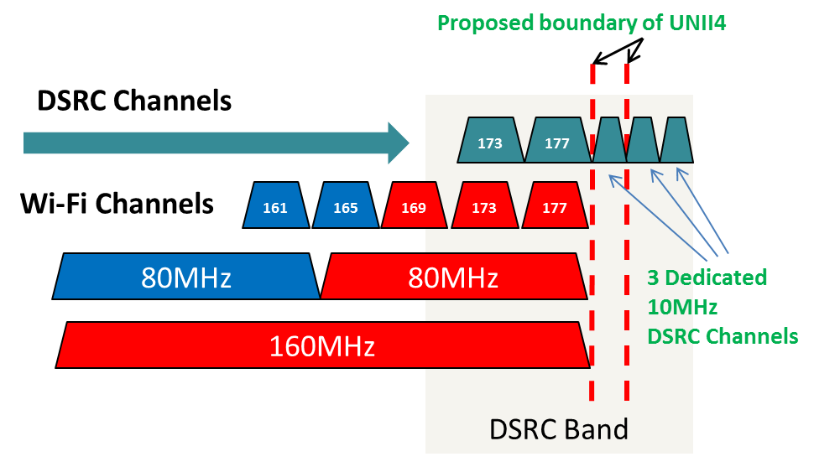
Figure 3: Proposed rebanding of DSRC channels

Clearly, this is a significant change in the way DSRC channels are allocated and would require careful study to insure that the services envisioned for DSRC can be delivered without excessive congestion or interference. This would possibly require a new FCC rulemaking to change the FCC 03-324 band plan, as well as some new testing of DSRC systems to verify that these changes would have little or no impact. Certainly some aspects of the existing tests, such as upper layer messaging (parts of P1609 and J2735), would still be relevant, but the potential for new forms of co-channel interference, adjacent channel interference, and congestion would mean that portions of the testing would have to be re-done. In addition, changing the lower 40MHz portion of the DSRC band to two 20MHz channels instead of four 10MHz channels is not comprehended in the P1609 specification, so that would need to be re-written and tested.
On the other hand, this proposal would allow existing 802.11ac chipsets to be used with 160MHz bandwidth channels to span from U-NII-3 into the new (shared) U-NII-4 band. While the secondary CCA mechanism in 802.11ac currently uses Energy Detect, which is 20dB higher than the thresholds defined for Carrier Sense, modification of the existing 802.11ac standard to incorporated Carrier Sense secondary CCA in the U-NII-4 band would likely not result in a major change to existing standards or chipsets.

Support for the Proposals among Participants
The DSRC Coexistence Tiger Team consisted of xx members who wished to have their names recorded for purposes of the straw poll; their names are listed in Appendix A.
{Insert section on straw poll methodology and results}

Next Steps
As mentioned previously, this report only outlines some proposed band sharing ideas; more detailed analysis, simulation, and – most importantly – field testing will be necessary to adequately verify that unlicensed devices are not causing harmful interference to DSRC systems under a proposed band sharing method. Field trials will be an important part of evaluating DSRC coexistence in the U-NII-4 band; as analysis continues on these proposals beyond the time frame of this Tiger Team, prototype development should occur in parallel. The materials considered in this Tiger Team, particularly the use cases, should be of significant value in designing these field trials. While it is not known if a test bed, such as the one deployed in Ann Arbor (MI) for the US Department of Transportation’s DSRC Model Deployment, will be available for testing of the DSRC coexistence techniques described in this report, it is expected that there will be facilities available to perform “real world” testing to insure that the proposed coexistence approaches achieve satisfactory band sharing performance. It is assumed that stakeholders from the Automotive and Wi-Fi communities, as well as potentially from government agencies, will participate in field testing of any of these candidate spectrum sharing technical solutions.

Conclusion
The 5 GHz band is of great importance to both the Wi-Fi and V2V/V2I industries. With the release of the 13-22 NPRM, the FCC has created the possibility for a substantial increase in available unlicensed spectrum for Wi-Fi, particularly the ability to use 160MHz channels as described in 802.11ac. The proposed sharing of the ITS/DSRC band from 5.85-5.925 GHz poses numerous technical challenges that the WLAN and automotive industries must address to make sure that the applications – including crash avoidance - enabled by DSRC are not harmed by unlicensed users of this band. With the conclusion of this activity, this 802.11 DSRC Coexistence Tiger Team has brought the various stakeholders together and laid the groundwork for field testing which can form the basis of future regulatory policy, standards efforts, and technology deployments.

References
- Lansford, J.; Kenney, J.B.; Ecclesine, P., "Coexistence of unlicensed devices with DSRC systems in the 5.9 GHz ITS band," IEEE Vehicular Networking Conference (VNC), 2013, pp.9-16, 16-18 Dec. 2013.
- “Unlicensed National Information Infrastructure (U-NII) Devices in the 5 GHz Band”,https://www.federalregister.gov/articles/2014/05/01/2014-09279/unlicensed-national-information-infrastructure-u-nii-devices-in-the-5-ghz-band
- Intermodal Surface Transportation Efficiency Act (ISTEA), Public Law 102-240, December 18, 1991.
- FCC 03-324 Report and Order, Dec. 17, 2003.
- FCC 06-110 Memorandum Opinion and Order, July 20, 2006.
- D. Jiang, V. Taliwal, A. Meier, W. Holfelder, and R. Herrtwich ,“Design of 5.9 GHz DSRC-based Vehicular Safety Communication,” IEEE Wireless Communications, Vol. 13, No. 5, pp. 36-43, Oct. 2006.
- Vehicle Safety Communications – Applications (VSC-A) Final Report, US Dept. of Transportation, DOT HS 811 492A, September 2011.
- “Interoperability Issues of Vehicle-to-Vehicle Based Safety Systems Project (V2V-Interoperability),” Project Order 0004, Technical Proposal Statement of Work; US Department of Transportation, National Highway Traffic Safety Administration, Cooperative Agreement DTNH22-05-01277, December 2009.
- “DSRC Message Set Dictionary,” SAE J2735 standard, SAE International, 2009.
- IEEE Standard for Information Technology – Telecommunications and information exchange between systems – Local and metropolitan area networks – Specific requirements; Part 11: Wireless LAN Medium Access Control (MAC) and Physical Layer (PHY) specifications; Amendment 6: Wireless Access in Vehicular Environments, IEEE Std 802.11pTM, July 2010.
- J. Kenney, “DSRC standards in the US,” Proceedings of the IEEE, Vol. 99, Issue 7, pp. 1162-1182, July 2011.
- 802.11 Regulatory Standing Committee Agenda, August 15, 2013, Slide 8. Available at https://mentor.ieee.org/802.11/dcn/13/11-13-0963-00-0reg-august-15th-teleconference-plan-and-agenda.ppt
- 802.11 DSRC Coexistence Tiger Team Agenda, October 3, 2013. Available at https://mentor.ieee.org/802.11/dcn/13/11-13-1261-00-0reg-agenda-for-dsrc-coexistence-tiger-team-call-04oct2013.ppt
- “802.11p-DSRC and 802.11ac Coexistence,” Jim Lansford and John Kenney, Available at https://mentor.ieee.org/802.11/dcn/13/11-13-0552-00-0wng-802-11p-dsrc-and-802-11ac-coexistence.ppt
- “Proposal for U-NII-4 Devices,” Peter Ecclesine, Available at https://mentor.ieee.org/802.11/dcn/13/11-13-0994-00-0reg-proposal-for-u-nii-4-devices.docx
- “ITS Politeness Measures,” Reza Hedayat and Peter Ecclesine, Available at https://mentor.ieee.org/802.11/dcn/14/11-14-1044-00-0reg-its-politeness-measures.docx
- “CCA issues for DSRC Coexistence,” Jim Lansford, Available at https://mentor.ieee.org/802.11/dcn/14/11-14-0532-00-0reg-cca-issues-for-dsrc-coexistence.ppt
- “Proposal for DSRC band Coexistence,” Tevfik Yucek, Available at https://mentor.ieee.org/802.11/dcn/13/11-13-1449-02-0reg-proposal-for-dsrc-band-coexistence.pptx
- “Technical discussion on Re-channelization Proposal for DSRC band coexistence,” Tevfik Yucek, Available at https://mentor.ieee.org/802.11/dcn/14/11-14-0819-00-0reg-technical-discussion-on-re-channelization-proposal-for-dsrc-band-coexistence.pptx

Appendix A: Participants in the DSRC Coexistence Tiger Team
Jim Lansford, Chair
{To be filled in}

Appendix B: Documents submitted to the DSRC Coexistence Tiger Team (Links on IEEE Mentor server)
  - https://mentor.ieee.org/802.11/dcn/13/11-13-0552-00-0wng-802-11p-dsrc-and-802-11ac-coexistence.ppt
  - https://mentor.ieee.org/802.11/dcn/13/11-13-0541-01-0wng-dsrc-applications-tutorial.pptx
  - https://mentor.ieee.org/802.11/dcn/13/11-13-0543-01-0wng-dsrc-support-information.pptx
  - https://mentor.ieee.org/802.11/dcn/13/11-13-0994-00-0reg-proposal-for-u-nii-4-devices.docx
  - https://mentor.ieee.org/802.11/dcn/13/11-13-1276-00-0reg-proposal-for-sharing-in-unii-4-band.pptx
  - https://mentor.ieee.org/802.11/dcn/13/11-13-1309-00-0reg-harmful-interference-to-dsrc-systems.pptx
  - https://mentor.ieee.org/802.11/dcn/13/11-13-1360-00-0reg-dsrc-per-versus-rss-profiles.pptx
  - https://mentor.ieee.org/802.11/dcn/13/11-13-1449-02-0reg-proposal-for-dsrc-band-coexistence.pptx
  - https://mentor.ieee.org/802.11/dcn/14/11-14-0225-00-0reg-use-cases-for-dsrc-coexistence.ppt
  - https://mentor.ieee.org/802.11/dcn/14/11-14-0259-00-0reg-v2v-radio-channel-models.ppt
  - https://mentor.ieee.org/802.11/dcn/14/11-14-0532-00-0reg-cca-issues-for-dsrc-coexistence.ppt
  - https://mentor.ieee.org/802.11/dcn/14/11-14-0550-00-0reg-world-spectrum-sharing.ppt
  - https://mentor.ieee.org/802.11/dcn/14/11-14-0728-00-0reg-communication-and-data-movement-in-connected-vehicles.ppt
  - https://mentor.ieee.org/802.11/dcn/14/11-14-0819-00-0reg-technical-discussion-on-re-channelization-proposal-for-dsrc-band-coexistence.pptx
  - https://mentor.ieee.org/802.11/dcn/14/11-14-1335-01-0reg-dsrc-band-plan-rationale.ppt

The term “Wi-Fi” refers to “Wi-Fi Certified” products. “Wi-Fi Certified” is a trademark of the Wi-Fi Alliance, an industry group that performs certification testing of WLAN devices which are based on IEEE 802.11 specifications. The terms 802.11, Wi-Fi, and WLAN are often used interchangeably.
The rules for U-NII-1 and U-NII-3 were modified in March of 2014 [2]
Dynamic Frequency Selection
In this paper, references to the “NPRM” mean FCC NPRM 13-22, which is Docket 13-49.
The existing spectrum allocation allows two 20MHz channels spanning channels 174-176 and 180-182; these are not implemented in existing DSRC radios, however.

