EEE P802.11
Wireless LANs

TGax Power Save Calibration Scenario
Date: November 6, 2014
Authors and Contributors
Name | Company | Address | Phone | Email
Jarkko Kneckt | Nokia | Otaniementie 19b, 02150 Espoo Finland |  | Jarkko.kneckt@nokia.com
Chinghwa Yu | MediaTek

Abstract

This document describes the calibration scenario for power save and power save related operation parameters. The submission provides operation parameters for power save and describes the calibration scenario.

Common Power Model Parameters for all simulation Scenarios
Instructions to Editor: Make the following changes:
Power State parameters
Power State | Average Power Consumption (mW)  Bandwidth = { 20 MHz }, Band = { 2.4 GHz, 5 GHz }, NSS = { 1 },  Number of TX/RX antennas = { 1 }, TX power per antenna = { 15 dBm }
Transmit
Receive
Listen
Sleep

Voltage = 1.1 V, Bandwidth = { 20 MHz }, Band = { 2.4 GHz, 5 GHz }, NSS = { 1 }, Number of TX/RX antennas = { 1 }, TX power per antenna = { 15 dBm }

Table 1 – Current consumption in each Power State
Power State | Average Current Consumption [mA]
Transmit [mA] | 280
Receive [mA] | 100
Listen [mA] | 50
Sleep [mA] | 0.003

Transmit power state is defined as the state when the STA is sending a PPDU.

Receive power state is defined as the state when the STA is receiving a PPDU.

Listen power state is defined as the state when the STA is performing CCA or actively looking for the presence of a PPDU.

Sleep power state is defined as the state when the STA is in Doze state and receiver is off.

Power Transition parameters
State Transitions | Transition Time (ms) | Average Power Consumption (mW)
Transmit ⬄ Listen | 0 | 0
Receive ⬄ Listen | 0 | 0
Receive ➔Transmit | T_{RT} (e.g. SIFS of 16us) | P_{RT}
Transmit ➔ Sleep | T_{TS} | P_{TS}
Receive ➔ Sleep | T_{RS} | P_{RS}
Listen ⬄ Sleep | T_{LS} | P_{LS}

Power Save Mechanism parameters
Mechanism | Parameter | Definition/Values | Pick one value from the Suggested Set of Simulation Values **
Power save mode (PSM) | Beacon Interval (BI) | 100 TU | 100 TU
 | DTIM | Integer in unit of BI | { 1, 3 }
 | PSM timeout | Length of time before STA goes to sleep | { 50, 100, 200 } ms
Power save polling (PSP) | Beacon Interval | 100 TU | 100 TU
 | DTIM | Integer in unit of BI | { 1, 3 }
Unscheduled automatic power save delivery (U-APSD) | Beacon Interval | 100 TU | 100 TU
 | DTIM | Integer in unit of BI | { 1, 3 }
 | Max SP Length | Indicate the maximum number of buffered MSDUs, A-MSDUs, and MMPDUs that AP may deliver per SP | { 2, 4, 6, ∞ }
 | AC *** | Access Category | All ACs are both delivery and trigger enabled  { VI, VO, BE, BK }

** Simulation results presented should clearly indicated what values are used in the generating the simulation results
*** If U-APSD is enabled for an AC, then that AC is assumed to be both delivery and trigger enabled

Test 5: Power Save Mechanism Test
Instructions to Editor: Make the following changes:
AP
STA
Goal:

This test case is intended to verify the baseline power save mechanism implemented in MAC system simulator

Assumptions:
- PER = 0

PSM test:

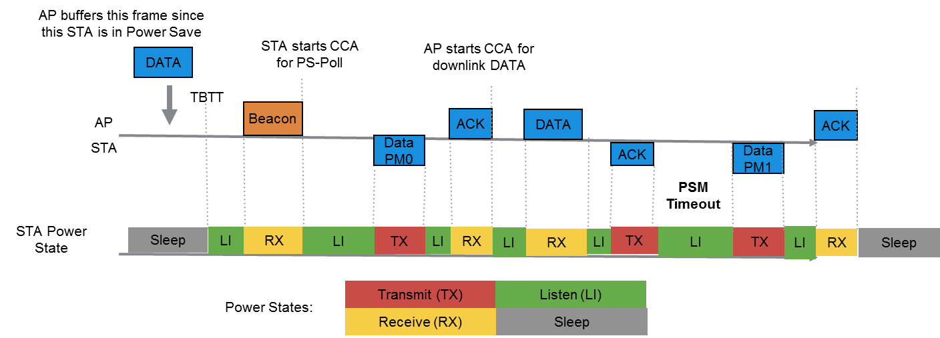
Figure 11 – Example of the frameflow in PSM scenario and non-AP STA Power States.
MSDU length: 1500 bytes with CWmin=15 downlink every 200 ms
•RTS/CTS [ OFF ]
•MCS = [ 0 ]
•No A-MPDU aggregation
•DTIM = [ 3 ]
•PSM timeout = [ 100 ] ms

PSP test:

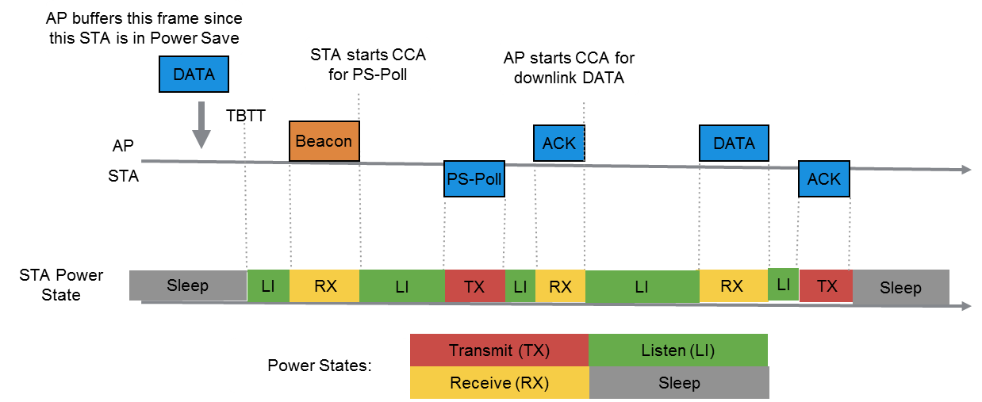
Figure 12 – Example of the frameflow in PSP scenario and non-AP STA Power States.
MSDU length: 1500 bytes with CWmin=15 downlink every 200 ms
•RTS/CTS [ OFF ]
•MCS = [ 0 ]
•No A-MPDU aggregation
•DTIM = [ 3 ]

U-APSD test

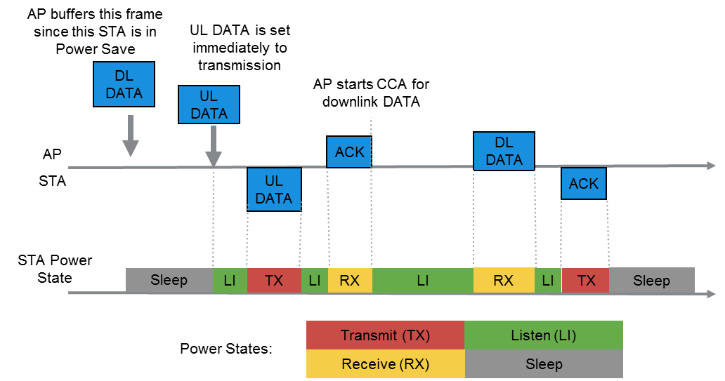
Figure 13 – Example of the frameflow in U-APSD scenario and non-AP STA Power States.

- U-APSD test MSDU length: 120 bytes with CWmin=15 (assuming 24 kbps codec, once every 40 ms) for both AP and STA

Power save test parameters
- MSDU length: [ 120 bytes with CWmin=7 (assuming 24 kbps codec, once every 40 ms) for both AP and STA, 1500 bytes with CWmin=15 downlink every 200 ms ]
- RTS/CTS [ OFF ]
- MCS = [ 0 ]
- Power model = [ PSM, PSP, U-APSD ]
- DTIM = [ 3 ], STA may not receive Beacons for TIM
- Max SP Length = [ 4 ]
- All ACs are trig ered and delivery enabled
- PSM timeout = [ 100 ] ms

Output:

- MAC throughput
- Per STA energy per TX bit
- Per STA energy per RX bit
- Pie chart (breakdown) of time spent in each power state during the course of the simulation
- Pie chart (breakdown) of energy consumed in each power state during the course of the simulation

