IEEE P802.11
Wireless LANs
A Few Corrections to Video Traffic Model
Date: 2014-11-02
Author(s):
Name | Affiliation | Address | Phone | email
Guoqing Li | Apple | Infinity Loop 3, Cupertino, CA 95014 | 1-408-974-9164 | Guoqing_li@apple.com

Abstract
The video traffic model described in Appendix 2 in the Evaluation Methodology document (#11-14-0571r5) was developed based on contributions #11-13-1134 and #11-13-1135 whose primary author was also the author of this document. Recently, it has brought to my attention by a few people that there are mistakes in two parameter settings and thus this contribution serves as corrections to those parameter settings in the video traffic model in Appendix 2 of the Evaluation Methodology Document.

Editor: Please change Appendix 2 as the following:

Appendix 2 – Traffic model descriptions

Wireless Display (lightly compressed video) Traffic Model

Wireless display is a single-hop unidirectional (e.g., laptop to monitor) video application. The video slices (assuming a slice is a row of macro blocks) are generated at fixed slice interval. For example, for 1080p, the slice interval is 1/4080 seconds.

The video slices are typically packetized into MPEG-TS packets in wireless display application. But for 11AX simulation, we will ignore the MPEG-TS packetization process and assume video slices are delivered to MAC layer for transmission directly.

The traffic model for wireless display is modified from [TGad] with modifications below due to the fact that some parameters have dependency on video formats.

- Parameters
  - Set IAT, MaxSliceSize according to video format as Table 4.
  - Normal distribution parameters
    - µ = 15.798 9.19 Kbytes
    - σ = 1.350 Kbytes
    - b = 300 Mbps
- Algorithm for generating each video slice/packet
- Input: target bit rate in Mbps (p)
- Output: slice size in Kbytes (L): At each IAT, generate a slice size L with the following distribution: Normal(µ*(p/b), σ*(p/b))
    - If L > MaxSliceSize, set L= MaxSliceSize

Table 4: Model parameters
Video format | Inter-arrival time (IAT) | MaxSliceSize | p
1080p60 | 1/4080 seconds | 92.160 Kbytes | 300
4K UHD (3840x2160) 60fps | 1/8100 seconds | 184.320 Kbytes | 600
8K UHD (7680x4320) 60fps | 1/16200 seconds | 368.640 Kbytes | 1200
1080p60 3D | 1/4080 seconds | 92.160 Kbytes | 450
Note: the data rate increase from 1080p to higher resolution is not linearly scaling as the uncompressed data rate due to higher redundancy in the images at higher resolution. Similar argument applies to 3D video. A 100% increase is assumed for 4K video as compared to 1080p, and 50% bit rate increase for 3D from 2D video.

Evaluation metric
- MAC throughput, latency

Buffered Video Steaming (e.g., YouTube, Netflix) Traffic Model

Unlike wireless display, video streaming is generated from a video server, and traverses multiple hops in the internet before arriving at AP for transmission to STA. It is a unidirectional traffic from the video server to the station.

Typically, Video streaming application runs over TCP/IP protocol, and video frames will be fragmented at TCP layer before leaving the video server. Since these TCP/IP packets experiences different processing and queuing delay at routers, the inter-arrival time between these TCP/IP packets are not a constant despite the fact that video frames are generated at constant interval at the video application layer.

STA Layering Model
STA layering model is shown in Figure xx. Both AP and STA generate video frames at application layer. The video traffic goes through TCP/IP layer and then to MAC layer. The TCP protocol used for video streaming simulation is the same as other traffic model.

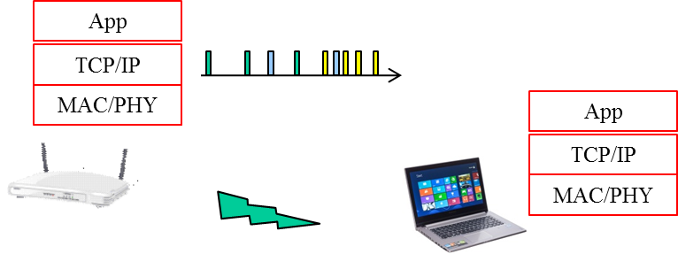
Figure 5: Traffic layering model

Video traffic generation

The video traffic from AP to STA is generated as follows.
Step 1: At application layer, generate video frame size (bytes) according to Weibull distribution with the following PDF.
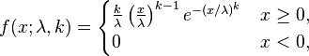

Depending on the video bit rate, the parameters to use are specified in Table 5.

Table 5: Lambda and k parameter for video bit rate
Video bit rate | lambda | k
15.6 Mpbs | 54210 | 0.8099
10Mbps | 34750 | 0.8099
8Mbps | 27800 | 0.8099
6Mbps | 20850 | 0.8099
4Mbps | 13900 | 0.8099
2Mbps | 6950 | 0.8099

Step 2: AT TCP layer, set TCP segment as 1500 bytes and fragment video packet into TCP segments.

Step 3: Add network latency in unit of ms to TCP/IP packets when these segments arrive at AP for transmission. The network latency is generated according to Gamma distribution whose PDF is shown below

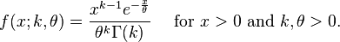

Where
  - k=0.2463
  - theta=60.227 55.928

The mean of the latency with the above parameters is 14.834ms. To simulate longer or shorter network latency, scale theta linearly since mean of Gamma distribution is K*theta

If network latency value is such that the packet arrives at MAC layer after the end of the simulation time, then re-generate another network latency value until the packet arrives at MAC within the simulation window.

Additional steps for variable bit rate coding [TBD]

Evaluation metrics
- MAC throughput, latency
- TCP throughput, latency

Video Conferencing (e.g., Lync) Traffic Model

Unlike buffered video streaming where video traffic is unidirectional and heavily buffered at the receiver, video conferencing is two-way video traffic with limited tolerance for latency. Video traffic is generated at each station, sent to AP, traverses the network/internet, reaches another AP, and then is transmitted to its destination STA.

Station layer model

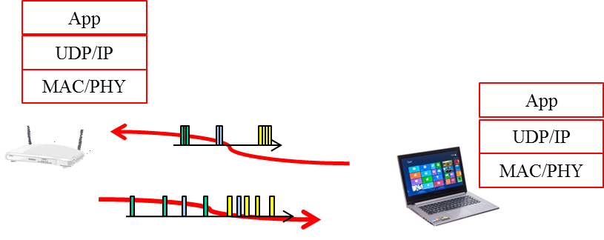
Figure 6: Video conferencing model

Because the traffic from AP to station has experienced network jitter, it can be modelled the same way as the traffic model of video streaming.

For traffic sent from Station to AP, since the traffic has not experienced network jitter, it is a periodic traffic generation as the first two steps described in video streaming.

Video traffic generation

Traffic model from AP to station: use the same model as video streaming.
Traffic model from station to AP: use the first two steps in video streaming traffic model

Evaluation metrics
- MAC throughput, latency

Application event models

Application event model is used to specify the patterns of the application events, i.e., when to start the applications and how long for each application in the simulation. Different use scenarios may choose different application event models in the simulation.
- Poisson model
Poisson model can be used for random application event pattern where there are many users, each generating a little bit of traffic and requesting network access randomly.
Parameters: TBD

- Hyper-exponential model
Hyper-exponential model can be used for peak event pattern where users requesting network access in big spikes from the mean.
Parameters: TBD

Skipping content…

Editor: please correct/add the following references:

References for video traffic models

- 11-13-1334-05-video traffic modeling-
- 11-13-1335-04- video-traffic-modeling-word with details
- 11-13-1162-01-hew-vide-categories-and-characteristics
- 11-13-1059-01-hew-video-performance-requirements-and-simulation-parameters

Skipping rest of the content in the Evaluation Methodology document…

