Additional Test Cases for MAC calibration
Date: 2014-09-16
Author(s):
Name | Affiliation | Address | Phone | email
Gwen Barriac, | Marvell
Qingjiang Tian
Simone Merlin,
George Cherian

Summary:
The following additions are suggested for the section: “Scenarios for Calibration of Mac simulator” in the simulation scenario document: 11-14- 0980-02-00ax Simulation Scenarios.

Test 5a: One BSS with multiple STAs

Goal: Testing deferral on both energy detection and preamble detection within a single BSS

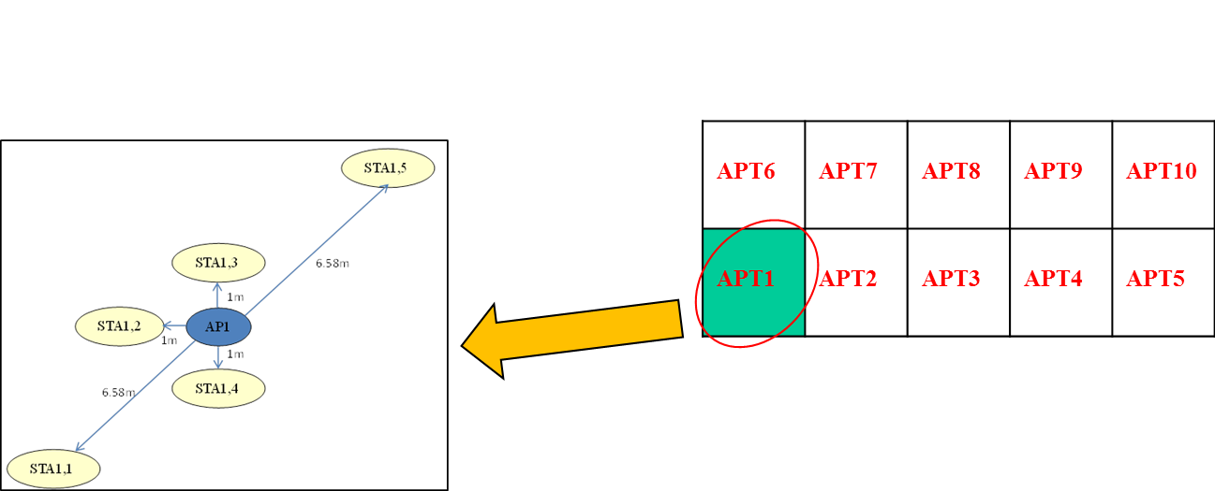

STA2 to STA4 & AP are within ED range of each other;
STA1, 5 is outside of ED range but inside PD range of each other

Parameters:
CCA energy threshold -62 dBm in 20 MHz
Preamble Detection Threshold -82 in 20 MHz
20 MHz channel
Aggregation= 2 MPDUs
MSDU size 1500 bytes
Max number of retries 10
MCS 0
TxPower AP:20 dBm/antenna
TxPower STA: 15 dBm/antenna
1 tx antenna 1 rx antenna
Noise figure 5 dB.
Per curve: AWGN (TBD)
Pathloss file: TBD

Output: MAC tput cdf
- Run the simulation at least 20 times with different random seeds, each run should simulate at least 4 seconds
- Compare 5%-tile,50%-tile,90%-tile, mean throughput of all STAs

Test 5b: Same as test 5a, with RTS/CTS on

Test 6a: Two BSSs with multiple STAs
Goal:
Testing deferral on both energy detection and Preamble detection when there are 2 BSSs

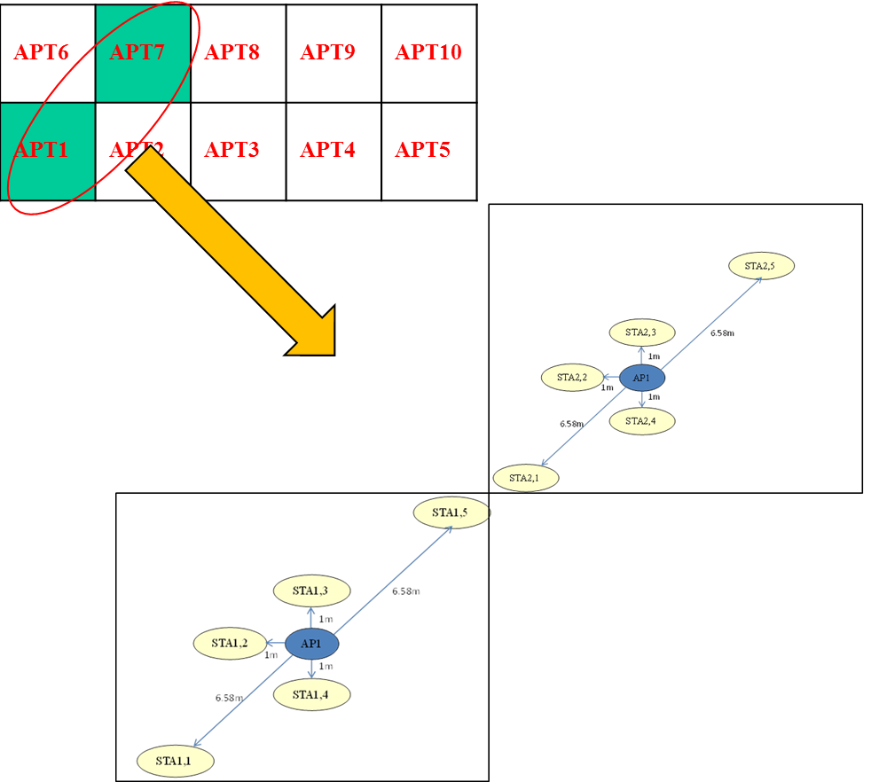

STAi,2 to STAi,4 & APi are within ED range of each other;
STAi,1, STAi,5 are outside of ED but inside PD range of each other
STA1,5 and STA2,1 are within ED range of each other

Parameters: same as test 5
Deferral to OBSS packets:
    - Nodes defer to any received packet received from an OBSS
      - Option 1: Nodes may choose to stop decoding packet if it is from OBSS.
      - Option 2: Nodes decode any packet they lock on to regardless of whether it’s from an OBSS or not.

Output: MAC throughput c.d.f.
-Run the simulation at least 20 times with different random seeds
-5%-tile,50%-tile,90%-tile, mean throughput of all STAs

Test 6b: same as test 6a, with RTS/CTS on

Pathloss Model for Test 5 and 6

Channel model are TGax model:
- No Antenna gain
- No shadowing
- PL=40.05+20*log10(fc/2.4e9)+20*log10(min(d,5))+(d>5)*35*log10(d/5) +5*W
  - d is the distance between two nodes
  - If two nodes are in different apartments, 2 Walls are assumed

Nodes location coordinates (with reference point (0,0) at the left-bottom cornor of apartment 1):

Node Index | Coordinate X(meter) | Coordinate Y(meter)
AP1 | 5 | 5
AP2 | 15 | 15
STA1,1 | 0.5 | 0.2
STA1,2 | 4 | 5
STA1,3 | 5 | 6
STA1,4 | 5 | 4
STA1,5 | 9.5 | 9.8
STA2,1 | 10.5 | 10.2
STA2,2 | 14 | 15
STA2,3 | 15 | 16
STA2,4 | 15 | 14
STA2,5 | 19.5 | 19.8

Pathloss Matrix for Test 5:

 | AP1 | STA1,1 | STA1,2 | STA1,3 | STA1,4 | STA1,5
AP1 | 0.00 | 64.58 | 46.43 | 46.43 | 46.43 | 64.58
STA1,1 | 64.58 | 0.00 | 63.02 | 66.24 | 62.89 | 75.11
STA1,2 | 46.43 | 63.02 | 0.00 | 49.44 | 49.44 | 66.16
STA1,3 | 46.43 | 66.24 | 49.44 | 0.00 | 52.45 | 62.89
STA1,4 | 46.43 | 62.89 | 49.44 | 52.45 | 0.00 | 66.24
STA1,5 | 64.58 | 75.11 | 66.16 | 62.89 | 66.24 | 0.00

Pathloss matrix for Test 6:

 | AP1 | AP2 | STA1,1 | STA1,2 | STA1,3 | STA1,4 | STA1,5 | STA2,1 | STA2,2 | STA2,3 | STA2,4 | STA2,5
AP1 | 0.00 | 86.21 | 64.58 | 46.43 | 46.43 | 46.43 | 64.58 | 76.71 | 85.45 | 86.97 | 85.45 | 92.01
AP2 | 86.21 | 0.00 | 92.01 | 86.97 | 85.45 | 86.97 | 76.71 | 64.58 | 46.43 | 46.43 | 46.43 | 64.58
STA1,1 | 64.58 | 92.01 | 0.00 | 63.02 | 66.24 | 62.89 | 75.11 | 86.21 | 91.50 | 92.54 | 91.49 | 96.21
STA1,2 | 46.43 | 86.97 | 63.02 | 0.00 | 49.44 | 49.44 | 66.16 | 78.15 | 86.21 | 87.66 | 86.28 | 92.53
STA1,3 | 46.43 | 85.45 | 66.24 | 49.44 | 0.00 | 52.45 | 62.89 | 75.34 | 84.61 | 86.21 | 84.70 | 91.49
STA1,4 | 46.43 | 86.97 | 62.89 | 49.44 | 52.45 | 0.00 | 66.24 | 78.09 | 86.28 | 87.72 | 86.21 | 92.54
STA1,5 | 64.58 | 76.71 | 75.11 | 66.16 | 62.89 | 66.24 | 0.00 | 57.07 | 75.25 | 78.09 | 75.34 | 86.21
STA2,1 | 76.71 | 64.58 | 86.21 | 78.15 | 75.34 | 78.09 | 57.07 | 0.00 | 63.02 | 66.24 | 62.89 | 75.11
STA2,2 | 85.45 | 46.43 | 91.50 | 86.21 | 84.61 | 86.28 | 75.25 | 63.02 | 0.00 | 49.44 | 49.44 | 66.16
STA2,3 | 86.97 | 46.43 | 92.54 | 87.66 | 86.21 | 87.72 | 78.09 | 66.24 | 49.44 | 0.00 | 52.45 | 62.89
STA2,4 | 85.45 | 46.43 | 91.49 | 86.28 | 84.70 | 86.21 | 75.34 | 62.89 | 49.44 | 52.45 | 0.00 | 66.24
STA2,5 | 92.01 | 64.58 | 96.21 | 92.53 | 91.49 | 92.54 | 86.21 | 75.11 | 66.16 | 62.89 | 66.24 | 0.00

