Scenarios for calibration of MAC simulator

Common parameters

PHY Parameter | SUGGESTED VALUES
GI: | [long]
Data Preamble: | [11ac]
BW | 20 Mhz

The following parameters are common to the MAC tests unless otherwise stated.

Parameter | SUGGESTED VALUES
Aggregation | A-MPDU  max aggregation size =64  No A-MSDU  immediate BA  (aggregation is assumed to be ON)
Max number of retries | 10
Rate adaptation | Fixed MCS
EDCA parameters | Default params for best effort (CWmin=15)

The follwing parameters are common to the traffic model unless otherwise stated.

Transpot protocol- UDP
Traffic model: full buffer

Test 1a: MAC overhead w/out RTS/CTS

STA 1
AP1

Goal:

designed to verify whether the simulator can correctly handle the basic frame exchange procedure, including DIFS+backoff procedure and A-MPDU+SIFS+BA sequence. Also to make sure the overheads are computed correctly.

Assumptions:
Assumption is that PER is 0

Parameters:
MSDU length:[0:500:2000Bytes]
2 MPDU limit
RTS/CTS off
MCS = [0,8] ( to clarify, run a sweep over MSDU length once for MCS 0, and once for MCS 8.
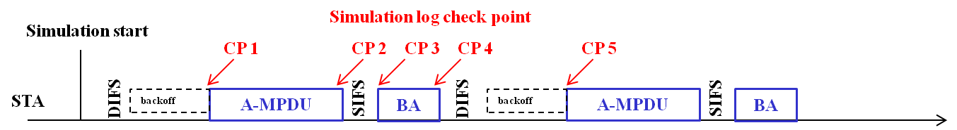

Output metric:
(1) MAC layer Throughput
(2) Time trace of transmitting/Receiving event
CP1 ( check point 1) start of A-MPDU
CP2 end of A-MPDU
CP3 start of ACK
CP4 end of ACK
CP5 start of A-MPDU

Test Items | Check points | Standard definition | Matching?
A-MPDU duration | Tcp2-Tcp1= | ceil((FrameLength*8)/rate/OFDMsymbolduration) * OFDMsymbolduration + PHY Header
SIFS | Tcp3-Tcp2=16 us | 16 us
ACK duration | Tcp4-Tcp3= | ceil((ACKFrameLength*8)/rate/OFDMsymbolduration) * OFDMsymbolduration + PHY Header
Defer & backoff duration | Tcp5-Tcp4= | DIFS(34 us)+backoff (CWmin)  =34us+n*9us

Tcp is the timestamp related with the corresponding simulation event on the check point (CP)

The following is an example calcultation of TPUT when the MSDU size is 1508, and MCS =0
- Number of MPDUs in AMPDU= 2
- Bytes per MPDU:
  - Bytes from application laye:1472
  - MAC header 30 bytes
  - FC=2;Duration=2;Addr1=6;Addr2=6;Addr3=6;SeqContrl=2;QoSCntrl=2; FCS=4
    - Note: Assuming HT control field is not used
  - MPDU delimiter 4 bytes
  - 2 bytes padding
- Bytes per AMPDU
  - Tail bits 1 bytes
  - Service Field 2 Bytes
- Total Bytes per AMPDU: 3091
- Duration of PPDU w/out preamble= 3091/6.5e6=3.804ms
- Duration of PPDU w/ preamble= 3.844ms
- Duration of ACK 68 us
- Expected time waiting for the Medium = 100.5 us (CWmin =15)
- Expected TPUT= 1472*8*2/(3.844ms+68us+16us+100.5us)
- (Note this is application layer tput)

Test 1b: MAC overhead w RTS/CTS

STA 1
AP1

Goal:
This test case is designed to further verify whether the simulator can correctly handle the frame exchange procedure with RTS/CTS protection based on test1a. It also tests whether the correct overhead computation with RTS /CTS.

Assumptions:
Assumption is that PER is 0

Parameters:
MSDU length:[0:500:2000Bytes]
2 MPDU limit
RTS/CTS ON
MCS = [0,8] ( to clarify, run a sweep over MSDU length once for MCS 0, and once for MCS 8.

Output metric:
- MAC layer Throughput
- Time trace of transmitting/Receiving event

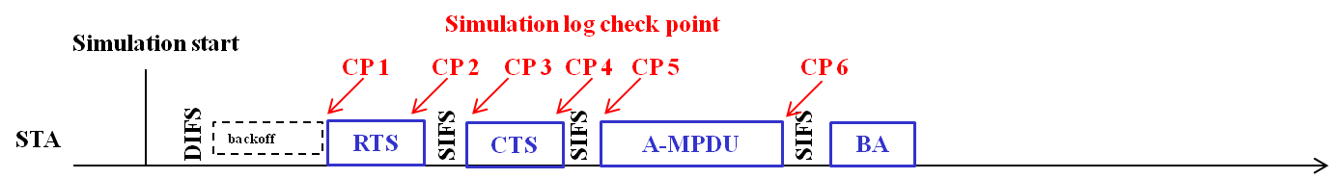

CP1 ( check point 1) : start of RTS
CP2 : end of RTS
CP3: start of CTS
CP4: end of CTS
CP5: start of A-MPDU
CP6: end of A-MPDU

Test Items | Check points | Standard definition | Matching?
RTS duration | Tcp2-Tcp1= | ceil((RTSFrameLength*8)/rate/OFDMsymbolduration) * OFDMsymbolduration + PHY Header
CTS duration | Tcp4-Tcp3= | ceil((CTSFrameLength*8)/rate/OFDMsymbolduration) * OFDMsymbolduration + PHY Header
Frame duration | Tcp6-Tcp5= | ceil((FrameLength*8)/rate/OFDMsymbolduration) * OFDMsymbolduration + PHY Header

The following is an example TPUT calculation when MSDU size is 1508, and MCS =0
- Number of MPDUs in AMPDU= 2
- Bytes per MPDU:
  - Bytes from application layer:1472
  - L4 header: 36 bytes
  - MAC header 30 bytes
  - FC=2;Duration=2;Addr1=6;Addr2=6;Addr3=6;SeqContrl=2;QoSCntrl=2; FCS=4
  - MPDU delimiter 4 bytes
  - 2 bytes padding
- Bytes per AMPDU
  - Tail bits < 1 bytes
  - Service Field 2 Bytes
- Total Bytes per AMPDU: 3091
- Duration of PPDU w/out preamble= 3091/6.5e6=3.804ms
- Duration of PPDU w/ preamble= 3.844ms
- Duration of ACK 68 us
- Duration of RTS 52 us
- Duration of CTS 44 us
- SIFS= 16us
- Expected time waiting for the Medium = 100.5 us (CWmin =15)
- Expected TPUT= 1472*8*2/(3.844ms+68us+16us+100.5us + 52us+44us+2*16us) (Note this is application layer TPUT)

Test 2a: Deferral Test 1

STA 1
AP 2
AP1
STA 2

(AP1 and STA2 are essentially co-located)

Goal:
This test case is designed to verify whether the simulator can correctly handle deferral procedure after collision happens without hidden nodes. It also checks whether deferral because of energy levels is happening correctly.

Assumptions:

All devices are within energy detect range of each other.
When AP1 and AP2 start to transmit on the same slot, both packets are lost (PER= 100%). Otherwise packets get through 100%. PER=0 %

Note:
AP1 and AP2 should defer to each other.
The only packet loss is due to collisions when backoffs end at same time

Parameters:
MSDU length:[0:500:2000Bytes]
2 MPDU limit
RTS/CTS [ OFF, ON]
MCS = [0]

Outputs:
MAC tput.

Test 2b: Deferral Test 2

STA 1
AP 2
AP1
STA 2

Goal:
This test case is designed to verify whether the simulator can correctly the handle deferral procedure after collision happens with the existing of hidden nodes.

Assumptions:
AP1 and AP2 can not hear each other. ( ever)
If MPDUs from AP1 and AP2 overlap, they both fail with 100% probability
If an MPDU from AP1/AP2 is interference free, it succeeds with 100% probability.

Parameters:
MSDU length:[1500Bytes]
RTS/CTS [ OFF]
MCS = [0]

Outputs:
MAC tput.

Test 3 : NAV deferral ( note :should say test 3)

STA 1
AP 2
AP1
STA 2
(AP1 and STA2 are essentially co-located)

Same as test 2b, but with RTS/CTS on.
Goal: This test is designed to test whether NAV deferral is happening properly.

