IEEE P802.11
Wireless LANs
D2.0 Comment Resolutions on CIDs 5140 and 4034
Date: 2014-07-14
Author(s):
Name | Affiliation | Address | Phone | email
Jae Seung Lee | ETRI | 161 Gajeong-dong,  Yuseong-gu, Daejeon, Korea | +82 42 860 1326 | jasonlee@etri.re.kr
Jaewoo Park | ETRI | 161 Gajeong-dong,  Yuseong-gu, Daejeon, Korea | +82 42 860 5635 | parkjw@etri.re.kr
Yu Ro Lee | ETRI | 161 Gajeong-dong,  Yuseong-gu, Daejeon, Korea | +82 42 860 5693 | yurolee@etri.re.kr
Jeeyon Choi | ETRI | 161 Gajeong-dong,  Yuseong-gu, Daejeon, Korea | +82 42 860 5247 | jychoi@etri.re.kr
Il Gyu Kim | ETRI | 161 Gajeong-dong,  Yuseong-gu, Daejeon, Korea | +82 42 860 5490 | igkim@etri.re.kr
Abstract
This document proposes resolutions on CIDs 5140 and 4034.

Changes in the text refer to: Draft P802.11ai/D2.0 and 802.11mc/D3.0
Comments (CID 5140)
CID | Clause | Page | Line | Comment | Proposed Change | Proposed  Resolution
5140 | 8.4.2.174 | 42 | 32 | Same comment with CID 3372 and 3373 (LB198). I have checked the previous discussion document (11-13/1165r1) based on the the resolution.  If a STA wants to receive a Probe Response frame from only a HT capable STA, the STA can transmit a Probe Request frame in HT PPDU format. Similarly VHT PPDU may be used for VHT AP responses  Discussion:  If the HT or VHT PPDU is transmitted, the transmission time of Probe Request will be longer:  PLCP header of the HT PPDU adds at minimum 8 microseconds  PLCP header of the VHT frame adds at minimum 12 microseconds  But, the discussion is missing the critical point.  As you know, the minimum MCS of HT and VHT PPDU is 6.5 Mbps. But, the minimum MCS of 11a/g (OFDM) is 6 Mbps.  The minimum PSDU length of the Probe Request frame is at least about 75 octets. (MAC Header 28 octets, SSID element 2 octets, Supported Rates element 3 octets, HT Capabilities element 28 octets, FILS Request Parameters 3 octets,  Extended Capabilities element 11 octets)  So, if you use the HT or VHT PPDU, you can reduce the PSDU transmission time of at least 8us. The PLCP header overhead of the HT and VHT PPDU is not a problem. Rather than an overhead, you can achieve the gain by reducing the PSDU transmission time. | Remove a HT and VHT Support Criteria field from FILS Criteria field.  Otherwise, please show me why those fields are still needed since I am not convincing the discussion result. | Reject.  Using legacy PPDU format for probe request is better than using HT or VHT PPDU in terms of transmission time and coverage. So, it’s better to keep HT/VHT Criteria bit and transmit probe request in legacy PPDU.  See detailed rationale in 11-14-0939

Discussion on CID 5140
The commenter is pointing out that the previous comment resolution of D1.0 was wrong (CID 3372 and 3373 of LB198).

The previous discussion was as follows: (11-13-1165r1)
HT and VHT support FILS Criteria

  - If a STA wants to receive a Probe Response frame from only a HT capable STA, the STA can transmit a Probe Request frame in HT PPDU format. Similarly VHT PPDU may be used for VHT AP responses
- Discussion:
  - If the HT or VHT PPDU is transmitted, the transmission time of Probe Request will be longer:
    - PLCP header of the HT PPDU adds at minimum 8 microseconds
    - PLCP header of the VHT frame adds at minimum 12 microseconds

Strawpoll (Sept. 2013)

Are you in favour of having of option 1 or option2?
Option 1: use 2 bits to specify that the responder shall be HT or VHT capable as in 802.11ai draft 1.0.
Option 2: use HT PPDU or VHT PPDU to identify the capabilities of the responding AP as proposed by comments.
Results:
Option 1: 6
Option 2: 1

CID 3372 and 3373 were rejected based on the above straw poll.

- Transmission time for Probe Request
- PSDU length of the Probe Request frame: 75 octets

(MAC Header 28 octets, SSID element 2 octets, Supported Rates element 3 octets, HT Capabilities element 28 octets, FILS Request Parameters 3 octets, Extended Capabilities element 11 octets)

- Transmission time of Probe Request frame using legacy PPDU

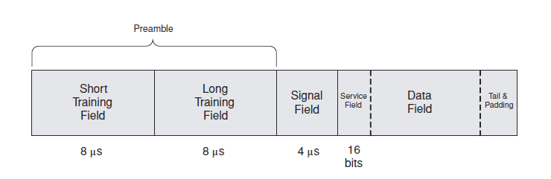
<Legacy (802.11a) PPDU format>

- L-STF: 8 ㎲ (2 symbols)
- L-LTF: 8 ㎲ (2 symbols)
- L-SIG: 4 ㎲ (1 symbol)
- The number of OFDM symbols in the Data field:
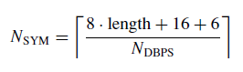
. N_{DBPS} (The number of data bits per OFDM symbol) for minimum MCS of legacy PPDU
(Data rate 6 Mb/s): 24 bits
. PSDU length of the Probe Request frame: 75 octets
- The number of symbols in the Data field = 26 symbols

- Total number of symbols for Probe Request frame in legacy PPDU
= 2 symbols (L-STF) + 2 symbols (L-LTF) + 1 symbol (L-SIG) + 26 symbols (Data Field)
= 31 symbols
- TXTIME = 31 symbols * 4 ㎲ = 124 ㎲

- Transmission time of Probe Request frame using HT PPDU
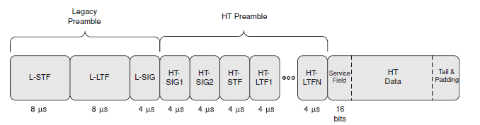
<802.11n PPDU format>

- L-STF: 8 ㎲ (2 symbols)
- L-LTF: 8 ㎲ (2 symbols)
- L-SIG: 4 ㎲ (1 symbol)
- HT-SIG1: 4 ㎲ (1 symbol)
- HT-SIG2: 4 ㎲ (1 symbol)
- HT-STF: 4 ㎲ (1 symbol)
- HT-LTF1: 4 ㎲ (1 symbol)
- The number of OFDM symbols in the Data field:
. N_{DBPS} (The number of data bits per OFDM symbol) for minimum MCS of HT PPDU
(Data rate 6.5 Mb/s): 26 bits
. PSDU length of the Probe Request frame: 75 octets
- The number of symbols in the Data field = 24 symbols

- Total number of symbols for Probe Request frame in HT PPDU
= 2 symbols (L-STF) + 2 symbols (L-LTF) + 1 symbol (L-SIG) + 1 symbol (HT-SIG1) + 1 symbol (HT-SIG2) + 1 symbol (HT-STF) + 1 symbol (HT-LTF1) + 24 symbols (Data Field)
= 33 symbols
- TXTIME = 33 symbols * 4 ㎲ = 132 ㎲ 8 ㎲ longer than using legacy PPDU

(c) Transmission time of Probe Request frame using VHT PPDU

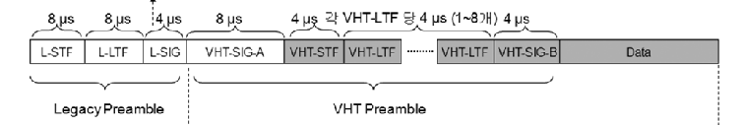

<802.11ac PPDU format>

- L-STF: 8 ㎲ (2 symbols)
- L-LTF: 8 ㎲ (2 symbols)
- L-SIG: 4 ㎲ (1 symbol)
- VHT-SIG-A: 8 ㎲ (2 symbols)
- VHT-STF: 4 ㎲ (1 symbol)
- VHT-LTF: 4 ㎲ (1 symbol)
- VHT-SIG-B: 4 ㎲ (1 symbol)
- The number of OFDM symbols in the Data field:
(STBC is not used, VHT SU PPDU)

. N_{DBPS} (The number of data bits per OFDM symbol) for minimum MCS of VHT PPDU
(Data rate 6.5 Mb/s): 26 bits
. PSDU length of the Probe Request frame: 75 octets
- The number of symbols in the Data field = 24 symbols

- Total number of symbols for Probe Request frame in VHT PPDU
= 2 symbols (L-STF) + 2 symbols (L-LTF) + 1 symbol (L-SIG) + 2 symbols (VHT-SIG-A) + 1 symbol (VHT-STF) + 1 symbol (VHT-LTF) + 1 symbol (VHT-SIG-B) + 24 symbols (Data Field)
= 34 symbols
- TXTIME = 34 symbols * 4 ㎲ = 136 ㎲ 12 ㎲ longer than using legacy PPDU

Considering minimum MCS of HT and VHT PPDU is 6.5 Mbps and the minimum MCS of 11a/g (OFDM) is 6 Mbps, the calculation results show that
- Transmission time of Probe Request in HT PPDU is 8 ㎲ longer than using legacy PPDU
- Transmission time of Probe Request in VHT PPDU is 12 ㎲ longer than using legacy PPDU

- Previous comment resolution of D1.0 was right (CID 3372 and 3373 of LB198)
- Using the legacy PPDU for transmitting the Probe Request is better than using HT or VHT PPDU in terms of transmission time.

- Coverage of Probe Request

Coverage of the Probe Request is very important since the purpose of the active scanning is to find appropriate candidate APs.
Coverage is much more important than transmission time overhead for active scanning.
The coverage of the Probe Request frame should not be reduced by using HT or VHT PPDU.

- If the Probe Request frame is transmitted using HT or VHT PPDU, coverage of the Probe Request is reduced.
- When legacy PPDU is used for transmission, L-LTF is used for channel estimation which is 2 symbols.
- When HT or VHT PPDU is used for transmission, HT-LTF or VHT-LTF is used for channel estimation which is 1 symbol.
- Since L-LTF is 2 symbols duration, using legacy PPDU results in about 3 dB gain by averaging 2 symbols, but HT-LTF or VHT-LTF is just 1 symbol duration, and it does not provide such gain.
- 3 dB degraded Rx sensitivity caused by using HT or VHT PPDU results in reduced coverage (reduced by about 30 %)
- The coverage is reduced and the probability of finding AP is reduced
Therefore, using legacy PPDU for Probe Request better than using HT or VHT PPDU in terms of the coverage.

Proposed resolution:

Reject.

Using legacy PPDU format for probe request is better than using HT or VHT PPDU in terms of transmission time and coverage. So, it’s better to keep HT/VHT Criteria bit and transmit probe request in legacy PPDU.

Comments (CID 4034)
CID | Clause | Page | Line | Comment | Proposed Change | Proposed  Resolution
4034 | 10.1.4.3.3 | 78 | 46 | In "The HT Support Criteria of the FILS Criteria field of the FILS Request Parameters element is 1 and the responding STA is HT STA.", it should be noted that a VHT STA is also a HT STA. So VHT STA should also be included in this bullet. | Suggest to change to: "The HT Support Criteria of the FILS Criteria field of the FILS Request Parameters element is 1 and the responding STA is a HT STA or a VHT STA." | Revised  See proposed text in 11-14-0939

Discussion on CID 4034

A VHT STA is also an HT STA, so VHT STA should also respond with probe response when the HT Support Criteria bit is set to 1.
It is inefficient to use separate bit for signaling HT Support Criteria and VHT Criteria. It is better to combine these separate fields into one.

- Value of 0: PHY Support Criteria is not in use
- Value of 1: STA that supports HT (that is, HT STA, VHT STA, and STA that implements future amendment which also capable of HT)
- Value of 2: STA that supports VHT (that is, VHT STA and STA that implements future amendment which also capable of VHT)
- Value 3 ~ : reserved for future PHY types

For future extension, it is better to allocate 3 bits for PHY Support Criteria indication.

Proposed resolution:

Revised
See following proposed text.

Editing Instructions: Change the sentence in Section 8.4.2.174 and 10.1.4.3.3 of TGai Draft D2.0 as follows:

8.4.2.174 FILS Request Parameters element
….

B0 B2 B3 B4 B5 B5 B6 B7
 | BSS Delay  Criteria | HT Support Criteria  VHT Support Criteria  PHY Support Criteria | Reserved

Bits: 3 1 1 3 3 2
Figure 8-401cp—FILS Criteria field

……..

A PHY Support Criteria field value of 0 indicates that PHY Support Criteria is not in use.

An HT A PHY Support Criteria field value of 1 indicates that a responding FILS STA is HT capable.

A VHT A PHY Support Criteria field value of 12 indicates that a responding FILS STA is VHT capable.

A PHY Support Criteria field value 3 ~ 7 are reserved.

10.1.4.3.3 Sending a probe responseProbe response criteria

……..

2) The HT PHY Support Criteria of the FILS Criteria field of the FILS Request Parameters element is 1 and the responding STA is HT STA not HT capable.

3) The VHT PHY Support Criteria of the FILS Criteria field of the FILS Request Parameters element is 12 and the responding STA is VHT STA not VHT capable.

