**IEEE P802.11aj**

**Wireless Local Area Networks**

|  |  |  |
| --- | --- | --- |
| Project | IEEE P802.11aj Working Group for Wireless Local Area Networks (WLANs) | |
| Title | **Channel Model Description and Channel Generation for IEEE 802.11aj (45GHz)** | |
| Date Submitted | [16 July 2014] | |
| Source | [Haiming WANG] [Southeast University, China] [No. 2, Sipailou, Nanjing 210096, China] | Voice: [+86-25-52091653-301(ext.)] Fax: [+86-25-52091659] E-mail: [hmwang@seu.edu.cn] |
| Re: | This document is a preliminary version of IEEE 802.11aj | |
| Abstract | [This is a discussion document for the IEEE document of the IEEE 802.11aj channel modeling. It provides models for the following frequency ranges and environments: for 45 GHz channels covering the frequency range from 42.3 to 48.4 GHz, it covers indoor Living room, indoor office and conference room environments (usually with a distinction between LOS and NLOS properties). The document also provides MATLAB programs and numerical values for 100 impulse response realizations in each environment | |
| Purpose | [The purpose of this report is to summarize the work of the channel modeling sub-committee and provide some final recommendations on how the channel model can be used to help evaluate PHY submissions to IEEE 802.11aj (45GHz)] | |
| Notice | This document has been prepared to assist the IEEE P802.11aj. It is offered as a basis for discussion and is not binding on the contributing individual(s) or organization(s). The material in this document is subject to change in form and content after further study. The contributor(s) reserve(s) the right to add, amend or withdraw material contained herein. | |
| Release | The contributor acknowledges and accepts that this contribution becomes the property of IEEE and may be made publicly available by P802.11. | |

**Channel Model Description and Channel Generation for IEEE 802.11aj (45GHz)**

**Date: 16 July 2014**

Revision History of Final Recommendations

|  |  |  |
| --- | --- | --- |
| **Revision Ref** | **Date** | **Comments** |
| 893r0 | 16/07/2014 | Creation of first version of Draft recommendations |
|  |  |  |

**Table of Contents**

1. Introduction 4

2. Environments 4

3. Large Scale Channel Characterization 5

3.1 Path Loss (PL) 5

3.2 Shadowing 7

4. Small Scale Channel Characterization 8

4.1 Generic Channel Model 8

4.2 Number of Clusters 10

4.3 Power Delay Profile 10

4.4 Power Azimuth Profile 12

4.5 Small Scale Fading Statistics 12

5. Derivation of NLOS Channel from LOS Channel 14

6. Model Parameterization at 45 GHz Band 14

6.1 List of Parameters 14

6.2 Model Parameterization for 42.3-48.4 GHz 14

6.2.1 Living Room 15

6.2.2 Cubicle Office 15

6.2.3 Conference Room 16

7. Summary and Conclusion 17

8. List of Contributors 17

9. Appendix 18

A Matlab Program for Generation of Channel Impulse Response 18

B Measurement Setups, Procedure, Data Post-Processing and Analysis 19

10. References 20

# Introduction

This document summarizes the activities and recommendations of the channel modeling subgroup of IEEE 802.11aj. The Task Group 802.11aj (TGaj) is aimed to develop a millimeter-wave (mmWave) based physical layer for the IEEE 802.11aj Wireless Local Area Network (WLAN) Standard.

In order to evaluate the performance of different physical layer (PHY) proposals, a commonly agreed upon channel models is a must. The main goal of the newly developed channel models is to allow a fair comparison of different proposals submitted to TGaj in response to the Call for Proposals (CFP).

All the models presented and submitted as recommendation in this document are based on measurements conducted in several environments. The generic structures of these mmWave models are derived based on the clustering model that characterizes both the large and small scale fading (attenuation and dispersion). The large scale fading includes path loss (PL) and shadowing while the small scale fading describes the power delay profile, power azimuth spectrum and amplitude fading statistics.

All the models are continuous in time while the temporal discretization (which is required for any simulation) is left to the implementer. To facilitate the use of the model, this document also includes a MATLAB program for the generation of channel impulse responses (CIR). A set of stored CIR in the form of MATLAB format (.mat) and Microsoft Excel tables (.xls) for each channel model is provided. The use of these stored CIRs is mandatory for the simulations to ensure consistent and fair comparison of systems submitted to 802.11aj.

The remainder of the document is organized as follows: Section 2 gives an overview of the considered environments; Section 3 presents a large scale channel characterization namely, path loss and shadowing effects. Section 4 presents a generic channel model as well as the definitions of the channel parameters that will be used in later sections. Section 5 briefly discusses the generation of NLOS channel model from the LOS channel model. Section 6 lists all the parameterizations for the considered channel models. A summary concludes the report. Appendix A contains a summary of all measurement documents and proposals presented to the group; a MATLAB program for the generation of CIRs, can be found in Appendix A.

# Environments

Due to the resources constraint, only 3 environments will be characterized in this report by the sub-committee. Table 1 summarizes the considered environments with their respective typical layouts, settings and descriptions. The scenario can be classified to line-of-sight (LOS) and non-line-of-sight (NLOS). For LOS, we consider that there are no objects that block the direct path in between the transmitter (Tx) and receiver (Rx), while for NLOS scenario, it can be obstructed LOS or where there is no direct path between the Tx and Rx.

Table 1: List of channel models and descriptions of the environments for TGaj Channel Modeling.

|  |  |  |  |
| --- | --- | --- | --- |
| **Channel Model** | **Scenario** | **Environment** | **Descriptions** |
| CM1 | LOS | Living room | Typical home with multiple rooms and furnished with furniture, TV sets lounges, etc. The size is comparable to the small office room. The walls/floors are made of concrete or wood covered by wallpaper/carpet. There are also windows and wooden door in different rooms within the Living room environment. |
| CM2 | NLOS |
| CM3 | LOS | Cubicle office | Typical office setup furnished with multiple chairs, desks, computers and work stations. Bookshelves, cupboards and whiteboards are also interspersed within the environment. The walls are made by metal or concrete covered by plasterboard or carpet with windows and door on at least one side of the office. |
| CM4 | NLOS |
| CM5 | LOS | Conference room | Typical small size library with multiple desks, chairs and metal bookshelves. Bookshelves are filled with books, magazines, etc. Some tables and chairs were interspersed between the bookshelves. At least one side of room has windows and/or door. The walls are made of concrete. |
| CM6 | NLOS |

The environments listed in Table 1 are not comprehensive given that the broad applications envisaged by the mmWave technology.

# Large Scale Channel Characterization

## Path Loss (PL)

The PL is defined as the ratio of the received signal power to the transmit signal power and it is very important for link budget analysis. The PL for a wideband system such as ultra-wideband (UWB) [7]-[9] or mmWave system, is both distance and frequency dependent. The PL as a function of distance is given by



where (dB) is the average PL and *Xσ* is the shadowing fading, which will be described in Section 3.2 As summarized in [10], several distance dependence PL modeling approaches were reported. The channel sub-group adapted the conventional way to model the average PL as given by



where *d0*, *λ* and *d* denote the reference distance, wavelength and distance, respectively. The PL exponent *n* for mmWave based measurements ranges from 1.2-2.0 for LOS and from 1.97-10 for NLOS, in various different indoor environments. In the presence of wave-guiding effects and reverberation effects which lead to increase in power levels by multipath aggregation, *n* can be smaller than 2. Table 2 summarizes the values of *n* for different environments and scenarios, obtained based on our measurement data.

The PL exponent is obtained by performing least squares linear regression on the logarithmic scatter plot of averaged received powers versus distance according to . The data was segmented into LOS and NLOS scenarios, respectively. The value of *d0*=1m is used in all of the cases as reference distance as listed in Table 2 while the value of *λ* is computed using the mid-band frequency point.

Due to the lack of measurements points for characterizing large scale fading in environments, PL models from literature was adopted in this document.[1]

Table 2: The PL exponent, *n* and standard deviation for shadowing, *σs.*

|  |  |  |  |  |  |  |
| --- | --- | --- | --- | --- | --- | --- |
| Environment | Scenario | *n* | *Ac0* | *σs* | Comment | Reference |
| CM1 | LOS | 2.41 | 30.78 | 0.36 | Tx-60° HPBW, Rx-60° HPBW |  |
| CM2 | NLOS | 0.38 | 59.91 | 1.94 | Tx-60° HPBW, Rx-60° HPBW |  |
| CM3 | LOS | 1.96 | 31.54 | 1.96 | Tx-60° HPBW, Rx-60° HPBW |  |
| CM4 | NLOS | 1.94 | 33.63 | 0.41 | Tx-60° HPBW, Rx-60° HPBW |  |
| CM5 | LOS | 2.25 | 30.69 | 1.40 | Tx-60° HPBW, Rx-60° HPBW |  |
| CM6 | NLOS | 0.18 | 60.64 | 1.03 | Tx-60° HPBW, Rx-60° HPBW |  |

The parameters of the PL model given in Table 2 were derived from measurements using different transmitter antenna gain, *GTx* and receiver antenna gain, *GRx*. To remove the effects of both antenna gains, one can increase the proposed value of the parameter *PL*(*d*0) by a factor of *GTx* + *GRx* as suggested in [11]. For example, the parameters of the PL model in CM1 and CM2, were derived by eliminating the effects of both the Tx gainand Rx gain. These removed gains were compensated or adjusted in the new parameter *PL*(*d*0).

Under such approximation, one can consider to have 0 dBi for the Tx and Rx antennas which allows proposers to use their own antenna gain for link budget analysis. However, the proposed approximation becomes inaccurate when the highly directive antennas were employed since only a limited number of multipath could have reached the antenna, and thus the value of the parameters *n* and *σS* will be different [11].

## Shadowing

Due to the variation in the surrounding environments, the received power will be different from the mean value for a given distance. This phenomenal is called shadowing which causes the PL variation about the mean value given in . Many measurement results reported in the mmWave range have shown that the shadowing fading is log-normal distributed [13]-[16] i.e., *Xσ*[dB]=*N*(0, *σS*) where *Xσ* denotes zero mean, Gaussian random variable in unit dB with standard deviation *σS*. The value of *σS* is site specific as listed in Table 2 for different environments.

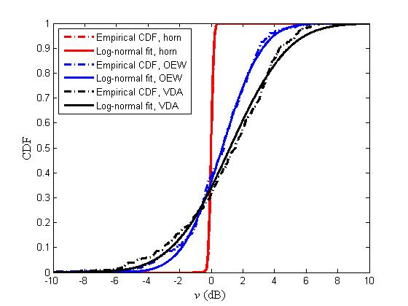

Figure 1: Cumulative distribution function (CDF) of received power fluctuation from local mean.

The shadowing parameters derived here are under the assumption that the channel is static and there is no movement of human. Furthermore, the duration of shadowing effect is relatively long up to several hundreds of milliseconds and this duration increases with number of person within in the environment [16].

# Small Scale Channel Characterization

## Generic Channel Model

Based on the clustering of phenomenon in both the temporal and spatial domains as observed in our measurement data [4], [5], [7], [19], a generic mmWave channel model which takes clustering into account is proposed since it can always be reduced to conventional single cluster channel model as observed in [6], [24], [25]. The proposed cluster model is based on the extension of Saleh-Valenzuela (S-V) model [20] to the angular domain by Spencer [21]. The CIR in complex baseband is given by



where is the dirac delta function, *L* is the total number of clusters and *Kl* is total number of rays in *l*th cluster. The scalars ,  and  and denote the complex amplitude, delay and azimuth of the *kth* ray of the *lth* cluster. Similarly, the scalars and represent the delay and mean angle-of-arrival (AOA) of the of the *lth* cluster. The key assumption used in arriving to equation is that the spatial and temporal domains are independent and thus uncorrelated. However, measurement results in [22] have otherwise shown that there was a correlation between these two domains and was modeled using two joint probability density functions (pdfs). It is also important to note that each of the multipath in will experience distortions due to the frequency dependency of the scatterers [22] but this is not accounted in our model due to lack of information.

Measurement results show that when directive antennas are used in the measurement especially in the LOS scenario, there appeared a distinct strong LOS path on top of the clustering phenomenal described previously [28], [29]. This LOS path can be included by adding a LOS component to as given below



where the second term on the right of is described exactly the same way as in the classical S-V model. accounts for the strict LOS component i.e., the multipath gain of the first arrival path which can be determined deterministically using ray tracing or simple geometrical based method or statistically. In desktop LOS, a two-path response was observed for the LOS component due to reflection off the table. In this case, is modeled statistically as



where





where, ,,, , *h*1 and *h*2 are the path loss in first impulse response, wave-length, attenuation value for NLOS environments, mean distance, reflection coefficient, height of the Tx and Rx, respectively. G*t*1, G*t*2, G*r*1, G*r*2 are the gain of the Tx antenna for path 1 and path 2, and gain of the Rx antenna for path 1 and path 2, respectively.

Equation becomes deterministic for all the considered channels when is set to zero, and becomes statistical when  is non-zero as for the LOS desktop.

Figure 1 pictorially depicts the CIR as described by (4) while Figure 2 shows the measurement results for the desktop environment which demonstrates the two-path response as a LOS component to the conventional S-V model. It can be seen from Figure 2 that the LOS path arrives around 10 ns before the first cluster of paths arriving around 50 ns. The paths that arrive in between 10-50 ns are due to the windowing effect and are -30 dB compare to the LOS path.

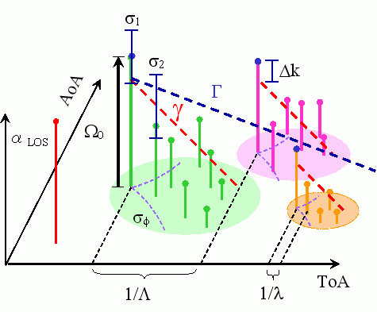

Figure 2: Graphical representation of the CIR as a function of TOA and AOA.

## Number of Clusters

A cluster is defined as a group of multi-path components having similar delays and directions of departure and arrival. The estimated MPCs are grouped into clusters using the K-power-means algorithm wherein the multi-path component distance is used as a distance metric in parameter space. The number of identified clusters ranged from 10 to 16 in STA-STA scenario and 14 to 20 in AP-STA scenario. Figure 3 show typical clustering results for the direction of departure and direction of arrival.

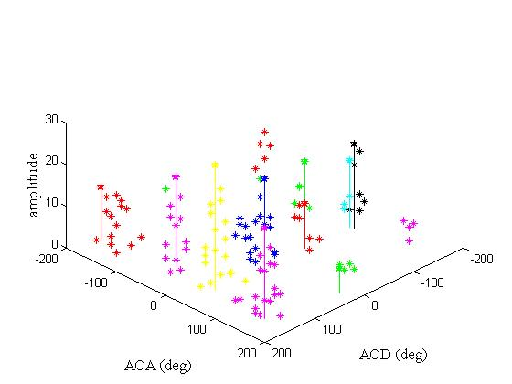

Figure 3: Typical power angle profile.

## Power Delay Profile

The power delay profile of a channel is an average power of the channel as a function of an excess delay with respect to the first arrival path. As the delay and angle can be modeled independently, the delay domain of the proposed models in this report relies on three sets of parameters namely:

1. LOS component,  which is assume to have zero delay
2. Inter-cluster parameters,  that characterize the cluster.
3. Intra cluster parameters,  that characterize the multipath components.

The distribution of the cluster arrival and ray arrival times are described by two Poison processes. According to this model, cluster inter arrival times and ray inter-arrival times are given by two independent exponential pdfs as follows: the cluster arrival time for each cluster is an exponentially distributed random variable conditioned on the cluster arrival time of the previous cluster i.e.,





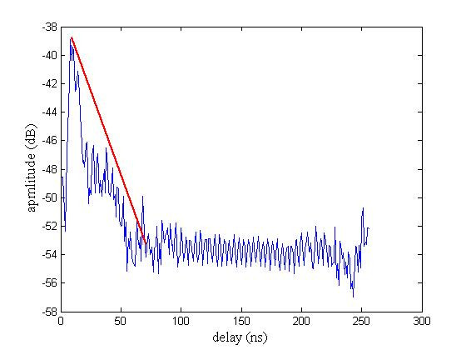

Figure 4: Typical power delay profile.

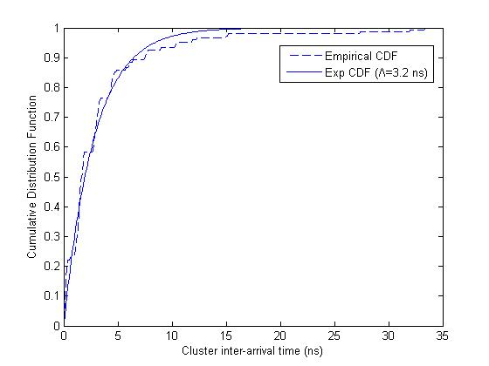

Figure 5: CDF of cluster inter arrival time.

where Λ and λ are the cluster arrival rate and ray arrival rate, respectively. Furthermore, in the classical S-V model,  and  are assumed to be zero and all arrival times are relative with respect to the delay of the first path. In the presence of strong LOS such as using directive antenna as in (4), the concept of S-V model remains valid except that both values of  and  are no not zero since the reference zero point has changed.

## Power Azimuth Profile

The power azimuth profile of a channel is an average power of the channel as a function of an angle of arrival. Again due to independence between the delay and angle domains, the angular domain of the proposed models in this report relies on three sets of parameters namely:

1. LOS component,  with angle of arrival, which can be fixed at zero degree.
2. Inter-cluster parameters,  that characterize the cluster.
3. Intra-cluster parameters,  that characterize the multipath components.

The distribution of the cluster mean AOA, conditioned on the previous cluster mean AOA  derived from all of our measurements can be described by uniform distribution over [0,2π] i.e.,

.

The mean power of the th ray in the th cluster is given by



The cluster AOA are not necessary be the first arrival within the cluster but the mean of all angles of arrival for the cluster. On the other hand, the ray AOAs within each cluster can be modeled either by zero-mean Gaussian or zero-mean Laplacian distributions given by (8) and (9), respectively.





where  is the standard deviation. UWB measurements and spatial modeling reported in [35] also proposed that Laplacian distribution can modeled the AOA information in a wideband channel.

## Small Scale Fading Statistics

Small scale fading is a result of rapid fluctuation of the amplitude and phase of the received signals within a small local area in a given short time period that causes constructive and destructive interference between the multipath components. Over this small local area, the small scale fading is approximately superimposed on the constant large scale fading.

From the analysis of the measurement results, it is found that the both cluster and ray amplitudes can be modeled by log-normal distribution i.e.,



where  and are the mean and variance of the Gaussian . In conventional narrowband system which consists of vector summation of many irresolvable paths due to the limited capability of the system measurement bandwidth, typically the amplitude fading distributions are modeled by Rayleigh and Rician for LOS and NLOS scenarios, respectively. In indoor wideband system, the small scale amplitude fading can take different distributions depending on type of environments, measurement bandwidth and scenario. For example, Rayleigh distribution is used to model LOS library using 1 GHz bandwidth [3], Rayleigh distribution is also used to model LOS for office, home and library environments using 5 GHz bandwidth [6], Weibull distribution is used to model in LOS/NLOS for Living room using 7 GHz bandwidth [27], log-normal distribution is used to model LOS/NLOS for office environment using 2 GHz bandwidth [31]. Nakagami distribution is used to model office LOS using 500 MHz bandwidth [30]. As the bandwidth of the measurement system increases sufficiently, more multipath components can be resolved and thus the effect of small scale fading is expected to become less extreme. The results reported here, however, can be characterized by a log-normal distribution for most of the environments despite with different measurement system bandwidth.

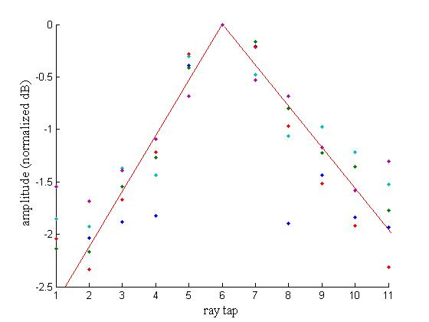

Figure 6: Power-delay distribution of rays

# Derivation of NLOS Channel from LOS Channel

Due to the lack of measurement results available for NLOS scenario and the importance of NLOS scenario for 45 GHz applications, TGaj has decided to derive NLOS channel from the LOS channel counterpart for cases where NLOS data are not available. The generation of NLOS channel is performed by removing the LOS component presence in the statistical LOS channel model derived from measurements. Such approach has been reported in the 45 GHz literature [18] [36]. Note that only CM4 are the statistical NLOS channel modeled based on measurement results.

# Model Parameterization at 45 GHz Band

## List of Parameters

The complete list of parameters used in this report can be summarized as follows:

1. *PL0*, PL at 1m distance
2. *n*, PL exponent
3. σs shadowing standard deviation
4. β, amplitude of the first arrival path
5. *Λ*, inter-cluster (cluster) arrival rate
6. *λ*, intra-cluster (ray) arrival rate
7. *Γ*, inter-cluster (cluster) decay rate
8. *γ*, intra-cluster (ray) decay rate
9. *σc*, cluster lognormal standard deviation
10. *σr*, ray lognormal standard deviation
11. *σφ*, angle spread
12. , average number of clusters
13. *d*, Tx-Rx separation, *h1*, Tx height, *h2* Rx height, *GT*, Tx gain, *GR*, Rx gain, Δ*k*, ray Rician factor, Ω, average power of the first ray of the first cluster (for combined two path and S-V model)

The large scale fading parameters are given in Table 2 while the small scale fading parameters are given in Table 3-6.

## Model Parameterization for 42.3-48.4 GHz

The parameters provided in this section are based on measurements which did not fully cover the full 45 GHz frequency band as well as operating distances as described in the UMD. Hence, these parameters shall be valid only for the specified measurement capability. However it is assumed in this report that these parameters are valid from 42.3-48.4 GHz as well as for all envisioned ranges.

### Living Room

The LOS model for Living room were extracted from measurement that cover a range up to 5 m and frequency bandwidth of 660 MHz centered at 44.955 GHz [5]. The measurement setup and data analysis can be found in [5] and [33].

Table 3: Parameters for LOS and NLOS Living room environment i.e., CM1 and CM2. CM2 shall be derived from CM1.

|  |  |  |  |  |  |  |  |
| --- | --- | --- | --- | --- | --- | --- | --- |
| Living room | LOS (CM1) | | | | | NLOS (CM2) | Comment |
| Tx-360°, Rx-15°  NICT | Tx-60°, Rx-15°  NICT | Tx-30°, Rx-15°  NICT | Tx-15°, Rx-15°  NICT | Tx-360°, Rx-15°  NICTA |
| Λ[1/ns] |  |  |  |  |  |  |  |
| λ[1/ns] |  |  |  |  |  |  |  |
| Γ [ns] |  |  |  |  |  |  |  |
| γ [ns] |  |  |  |  |  |  |  |
| σc [dB] |  |  |  |  |  |  |  |
| σr [dB] |  |  |  |  |  |  |  |
| σφ [degree] |  |  |  |  |  |  |  |
|  |  |  |  |  |  |  |  |
| Δ*k* [dB] |  |  |  |  |  |  |  |
| Ω (*d*) [dB] |  |  |  |  |  |  |  |
| nd |  |  |  |  |  |  |  |
| ANLOS |  |  |  |  |  |  |  |

### Cubicle Office

The models for office were extracted from two different set of measurements. For LOS office, the model was extracted based on measurement that cover a range of 1-10 m and frequency bandwidth of 660 MHz range centered at 44.955 GHz [32]. On the other hand, the NLOS office model was extracted from measurements that cover a range of 10 m and frequency bandwidth of 660 MHz centered at 44.955 GHz [5]. The measurement setup and data analysis can be found in [32] and [33], respectively.

Table 4: Parameters for LOS and NLOS Living room environment i.e., CM3 and CM4.

|  |  |  |  |  |  |  |
| --- | --- | --- | --- | --- | --- | --- |
| Office | LOS (CM3) | | NLOS (CM4) | | | Comment |
| Tx-30°, Rx-30° | Tx-60°, Rx-60° | Tx-360°,  Rx-15° | Tx-30°, Rx-15° | Omni-Tx, Rx-15° |
| Λ[1/ns] |  |  |  |  |  |  |
| λ[1/ns] |  |  |  |  |  |  |
| Γ [ns] |  |  |  |  |  |  |
| γ [ns] |  |  |  |  |  |  |
| σc [dB] |  |  |  |  |  |  |
| σr [dB] |  |  |  |  |  |  |
| σφ [degree] |  |  |  |  |  |  |
|  |  |  |  |  |  |  |
| Δ*k* [dB] |  |  |  |  |  |  |
| Ω (*d*) [dB] |  |  |  |  |  |  |
| nd |  |  |  |  |  |  |
| ANLOS |  |  |  |  |  |  |

### Conference Room

The LOS model for Conference room was extracted from measurements that cover a range from 2-10 m and frequency bandwidth of 660 MHz centered at 44.955 GHz [3]. The measurement setup and data analysis can be found in [3], [19] and [29].

Table 5: Parameters for LOS and NLOS Living room environment i.e., CM5 and CM6. CM6 shall be derived from CM5.

|  |  |  |  |
| --- | --- | --- | --- |
| Conference | LOS (CM5) | NLOS (CM6) | Comment |
| Λ[1/ns] |  |  |  |
| λ[1/ns] |  |  |  |
| Γ [ns] |  |  |  |
| γ [ns] |  |  |  |
| σc [dB] |  |  |  |
| σr [dB] |  |  |  |
| σφ [degree] |  |  |  |
|  |  |  |  |
| KLOS [dB] |  |  |  |

# Summary and Conclusion

This report has presented channel models for performance evaluation of IEEE 802.11ah system proposals. The large scale and small scale fading in each environment were modeled based on two different measurement data. Similarly, the LOS and NLOS models for a given environment were also derived from two different measurement data. Hence, the actual system performance of might not accurate under LOS and NLOS scenario but it gives same relative performance comparison between proposals. Matlab programs are also provided in the Appendix for the convenience of the user.

# List of Contributors

The following have participated in the 802.11aj Channel Modeling activities.

|  |  |  |
| --- | --- | --- |
| Wei Hong | Nianzu Zhang | Jin Zhu |
| Jixin Chen | Xiongsheng Yao | Xiaoming Peng |
|  |  |  |

# Appendix

## Matlab Program for Generation of Channel Impulse Response

The 802.11aj CIR matlab generation script is amended based on the 802.11ad script and briefly descripted below, the inter-cluster model is changed according to real measured results in which the cluster arrival time obeys passion distribution and amplitude obeys exponential distribution. Beamforming algorithm is ignored for the 802.11aj MIMO configuration.

* cr_ch_cfg.m

Configuration function returns structure contained main parameters for channel function cr_ch_model.m generating channel impulse response for Conference Room (CR) environment.

* gen_cr_ch.m

Function returns space-temporal parameters for all inter-clusters and intra-clusters for certain transmitter and receiver position in CR environment, the number of clusters obeys a uniform distribution ranging from 14 to 20.

* ap_gen_inter_cls.m

Function returns NLOS space-temporal clusters parameters: azimuth angles in [deg] relative to LOS direction for TX/RX and elevation angles, times of arrival in [ns] relative to LOS time for LR environment for STA-AP subscenario.

* gen_intra_cls.m

Function returns intra-cluster space-temporal parameters: rays amplitudes, times of arrival in [ns] relative to cluster time, azimuth/elevation angles in [deg] relative to cluster direction for TX/RX in CR environment.

* ct2dt.m

Function returns channel response due to target sample rate.

## Measurement Setups, Procedure, Data Post-Processing and Analysis

The measurement setups and procedures presented in this document vary from one contributor to another. Similarly, different data processing and analysis techniques are used to arrive to the proposed channel models. Table 6 shows an overview of the measurement capability for the measured in different environments. For more information about measurement setups, procedure, data post-processing and analysis, interested readers are referred to the contributions listed in Table 7.

Table 6: Overview of the measurement capability for the contributions.

|  |  |  |  |  |  |  |  |  |  |
| --- | --- | --- | --- | --- | --- | --- | --- | --- | --- |
| Environ-ment | LOS or NLOS | *N*local | Nspatial | *fc* (GHz) | BW  (GHz) | AOA  (Rot./VA) | TX Ant. Type | RX Ant. Type | Pol. |
|  |  |  |  |  |  |  |  |  |  |
|  |  |  |  |  |  |  |  |  |  |
|  |  |  |  |  |  |  |  |  |  |
|  |  |  |  |  |  |  |  |  |  |
|  |  |  |  |  |  |  |  |  |  |
|  |  |  |  |  |  |  |  |  |  |
|  |  |  |  |  |  |  |  |  |  |
|  |  |  |  |  |  |  |  |  |  |
|  |  |  |  |  |  |  |  |  |  |
|  |  |  |  |  |  |  |  |  |  |
|  |  |  |  |  |  |  |  |  |  |

*f*c - center frequency, BW- bandwidth, *N*local - # of Local Measurement points per environment

*N*spatial - # of Spatial Measurement points per Local point

Table 7: References for measurement setups and procedure as well as data processing and analysis.

|  |  |  |
| --- | --- | --- |
| Channel Model | Ref. for Measurement Setups and Procedure | Ref. for Data Post-Processing and Analysis |
| CM1 |  |  |
| CM2 |  |  |
| CM3 |  |  |
| CM4 |  |  |
| CM5 |  |  |
| CM6 |  |  |

# References

1. A. Sadri, “802.15.3c Usage Model Document,” IEEE 802.15-06-0055-21-003c, xxx 2006.
2. P. Pagani *et al.*, “Characterization and Modeling of the 60 GHz Indoor Channel in the Office and Living room Environments,” IEEE 802.15-06-0027-02-003c, Hawaii, USA, Jan 2006.
3. J. Kunisch, E. Zollinger, J. Pamp and A. Winkelmann, “MEDIAN 60 GHz wideband indoor radio channel measurements and model,” *IEEE VTC’99*, pp. 2393-2397, 1997.
4. C. Liu *et al.*, “NICTA Indoor 60 GHz Channel Measurements and Analysis update,” IEEE 802.15-06-0112-00-003c, Denver, USA, Mar 2006.
5. H. Sawada, Y. Shoji and H. Ogawa, “NICT Propagation Data,” IEEE 802.15.06-0012-01-003c, Hawaii, USA, Jan 2006.
6. T. Zwick, T. J. Beukema and H. Nam, “Wideband Channel Sounder With Measurements and Model for the 60 GHz Indoor Radio Channel,” *IEEE Trans. Vech. Technol.* vol. 54, pp. 1266-1277, July 2005.
7. A. Mathewand Z. Lai*,* “Observations of the UMass Measurements,” IEEE 802.15.06-0137-00-003c, Denver, Mar 2006.
8. A. F. Molisch, D. Cassioli, C. –C. Chong, S. Emami, A. Fort, B. Kannan, J. Karedal, J. Kunisch, H. Schantz, K. Siwiak, and M. Z. Win, “A comprehensive standardized model for ultrawideband propagation channels,” *IEEE Trans. Antennas and Propagation*, to appear.
9. C. -C. Chong Y. E. Kim, S. K. Yong and S. S. Lee., “Statistical characterization of the UWB propagation channel in indoor Living room environment,” *Wiley J. Wireless Commun. Mobile Comput. (Special Issue on* *UWB Communications),* vol. 5 no. 5, pp. 503-512, Aug. 2005.
10. S. K. Yong, C. -C Chong and S. S. Lee, “Generalization and Parameterization of the mmWave Channel Models,” IEEE 802.15-05-0261-01-003c, Cairns, Australia, May. 2005.
11. P. Pagani, I. Siaud, N. Malhouroux, W. Li, “Adaptation of the France Telecom 60 GHz channel model to the TG3c framework,” IEEE 802.15-06-0218-00-003c, April 2006.
12. M. Fiacco, M. Parks, H. Radi and S. R. Saunders, “Final Report: Indoor Propagation Factors at 17 and 60GHz,” Tech. report and study carried out on behalf of the Radiocommunications Agency, University of Surrey, Aug. 1998.
13. C. R. Anderson and T.S. Rappaport, “In-Building Wideband Partition Loss Measurements at 2.5 and 60 GHz.” IEEE Trans. Wireless Comm. vol. 3, no. 3, pp. 922-928, May 2004.
14. A. Bohdanowicz, “Wideband Indoor and Outdoor Radio Channel Measurements at 17 GHz” UBICOM Technical Report, Jan 2000
15. H. J. Thomas *et al.*, “An experimental study of the propagation of 55 GHz millimeter waves in an urban mobile radio environment,” *IEEE Trans. Veh. Tech.*, vol. 43, no. 1, pp. 140-146, Feb 1994.
16. H. B Yang, M. H. A. J. Herben and P. F. M. Smulders, "Impact of Antenna Pattern and Reflective Environment on 60 GHz Indoor Radio Channel Characteristics, *"IEEE Antennas and Wireless Propagation Letter*, Vol. 4, 2005.
17. S. Collonge, G. Zaharia and G. E. Zein, “Influence of the human activity on wideband characteristics of the 60GHz indoor radio channel,” *IEEE Trans. Wireless Comm*. vol. 3, no. 6, pp. 2389-2406, Nov 2004.
18. P. F. M. Smulders, “Broadband Wireless LANs: A Feasibility Study,” Ph.D. Thesis, Eindhoven University, 1995
19. A. Sadri, A. Maltsev and A. Davydov*.*, “IMST Time Angular Characteristics Analysis,” IEEE 802.15-06-0141-01-003c, Denver, USA, Mar 2006.
20. A. Saleh and R. Valenzuela, “A Statistical Model for Indoor Multipath Propagation,” *IEEE J. Select. Areas Commun*., Vol. SAC-5, No. 2, pp. 128-137, Feb. 1987.
21. Q. Spencer, B. D., Jeffs, M. A. Jensen and A. L. Swindlehurst, “Modeling the Statistical Time and Angle of Arrival Characteristics,” *IEEE J. Sel. Areas Commun*., Vol. 18, No. 3, pp. 347-360, Mar. 2000.
22. C. -C. Chong, C, -M. Tan. D. I. Laurenson, S. McLaughlin, M. A. Beach, and A. R. Nix, “A new statistical wideband spatio-temporal channel model for 5-GHz band WLAN systems,” *IEEE J. Sel. Areas Commun.*, vol. 21, no. 2, pp. 139–150, Feb. 2003.
23. R. C. Qiu and I. Lu, “Multipath resolving with frequency dependence for wideband wireless channel modeling,” *IEEE Trans. Vech. Technol.*, vol. 48, no. 1, pp. 273–285, Jan 1999.
24. S. Emami, Z. Lai, A. Mathew and B. Gaucher, “Channel Model Based on IBM Measured Data,” IEEE 802.15-06-0191-00-003c.
25. M. S. Choi, G. Grosskopf and D. Rohde,“ Statistical Characteristics of 60 GHz Wideband Indoor Propagation Channel, *IEEE PIMRC’05*, Sept. 2005.
26. M. Steinbauer and A. F. Molisch, “Directional channel models”, Chapter 3.2 (pp. 132-193) of “Flexible Personalized Wireless Communications”, 2001, John Wiley & Sons, U.K..
27. C. -C. Chong and S. K. Yong, “A Generic Statistical-Based UWB Channel Model for High-Rise Apartments,” *IEEE Trans. Antennas Propat.* , vol. 53, no. 8, pp 2389-2399, Aug. 2005.
28. H. Sawada *et al*., “Merging two-path and S-V models for LOS desktop channel environments,” IEEE 802.15-06-0297-02-00-3c, San Deigo, USA, July 2006.
29. A. Maltsev, A. Davydov and A. Sadri, “Saleh-Valenzuela Channel Model Parameters for Library Environment,” IEEE 802.15-06-0141-01-003c, Denver, USA, Mar 2006.
30. A. F. Molisch, M. Z. Win, and D. Cassioli, “The Ultra-Wide Bandwidth Indoor Channel: from Statistical Model to Simulations,” *IEEE J. Sel. Areas Commun.*, vol. 20, pp. 1247-1257, Aug. 2000.
31. M. Pendergrass, “Empirically Based Statistical Ultra-Wideband Channel Model,” IEEE P802.15-02/240-SG3a.
32. H. Sawada *et al*., “LOS office channel model based on TSV model,” IEEE 802.15-06-0377-00-00-3c, Melbourne, Australia, Sept 2006.
33. T. Pollock *et al*., “Office 60 GHz Channel Measurements and Model,” IEEE 802.15-06-0377-00-00-3c, San Diego, USA, Jul 2006.
34. C. Liu *et al.*, “ NICTA Indoor 60 GHz Channel Measurements and Analysis Update,” IEEE 802.15-06-0222-00-00-3c, Denver, USA, May 2006.
35. R. J. Cramer, R. A. Scholtz, and M. Z. Win, “An Evaluation of the Ultra-Wideband Propagation Channel,” *IEEE Trans. Antennas Propagat.*, vol. 50, no. 5, pp. 561-570, May 2002.
36. J. Hübner, S. Zeisberg, K. Koora, J. Borowski and A. Finger, “Simple Channel Model for 60 GHz Indoor Wireless LAN Design Based on Complex Wideband Measurements,” *IEEE VTC’05*, vol.2, pp. 1004-1008, May 1997.
37. T. Manabe, *et*. *al*., Polarization Dependence of Multipath Propagation and High Speed Transmission Characteristics of Indoor Millimeter Channel at 60 GHz, *IEEE Trans. Vech. Technol.*, vol. 44, no. 2, pp. 268–274, May 1995.
38. K. Sato, *et*. *al*., Measurements of Reflection and Transmission of Office Building in the 60 GHz Band, *IEEE Trans. Antennas Propagat.*, vol. 45, no. 12, pp. 1783-1792, Dec 1997.
39. Z. Lai, A. Mathew,S. Rivera and D. Gupta*,* “Statistical 60 GHz Indoor Channel Model Using Circular Polarized Antennas,” IEEE 802.15.06-0398-01-003c, Dallas, USA, Oct. 2006.
40. H. Sawada et al., “NLOS Living room Channel Model Based on TSV Model,” IEEE 802.15.06-0454-00-003c, Dallas, USA, Oct. 2006.
41. H. Harada et al, , “CM MATLAB Release 1.1 Support Document,” IEEE 802.15.06-0559-03-003c, London, UK, Jan. 2007
42. I. Toyoda, “Reference Antenna Model with sidelobe level for TG3c Evaluation,” IEEE 802.15.06-0474-00-003c, Dallas, USA, Oct. 2006.
43. K. Sato *et al*, "A new LOS kiosk channel model based on TSV model," IEEE 802.15.07-0607-01-003c, Orlando, USA, Mar. 2007.
44. H. Harada *et al*, “Channel Model Matlab Code Release,” IEEE 802.15.07-0648-00-003c, Orlando, USA, March. 2007

1. Note that these adopted models were derived based on the different measurement setups and propagation scenarios (even they can be categorized as same environment) and thus do not resemble the actual effects as would be expected. However, the performance of all the proposers will be scaled at the same relative magnitude.