IEEE P802.11
Wireless LANs
Text proposal of a Stadium scenario to ax
Date: 2014-07-13
Author(s):
Name | Affiliation | Address | Phone | email
Hakan Persson | Ericsson | Farogatan 6, Stockholm, Sweden | +46 730 787313 | hakan.z.persson  @ericsson.com
Johan Söder | Ericsson | Färögatan 6, Stockholm, Sweden | +46 722449170 | johan.soder  @ericsson.com
Filip Mestanov | Ericsson | Färögatan 6, Stockholm, Sweden | +46 725 298 161 | filip.mestanov @ericsson.com
Brian Hart | Cisco
Bill Carney | Sony
Kåre Agardh | Sony Mobile
Sean Coffey | Realtek
Naveen Kakani | CSR
Tomoko Adachi | Toshiba
Rakesh Taori | Samsung
Hyunjeong Kang | Samsung
Leif Wilhelmsson | Ericsson
Stephen Rayment | Ericsson
Eric Nordström | Ericsson
Guido R. Hiertz | Ericsson
Abstract
This document contains a text proposal for a Stadium scenario that can be the basis for inclusion in the Simulation scenario document
The following text is suggested to be included to cover a Stadium scenario.

5 - Stadium Scenario

This scenario has the objective to capture the issues and be representative of real-world stadium deployments with a rather low separation between APs and with very high density of STAs:
- In such environments, the network (ESS) is carefully planned. For simulation complexity simplifications, a 2D strip is proposed as a representation of a portion of the seating area. Furthermore, the stip is wrapped round the edges in order to avoid propagation artifacts.
- In such environments the following is to be considered:
  - Interference between APs belonging to the same managed ESS due to high density deployment
  - Interference with unmanaged networks (P2P links)
  - Uplink/Downlink asymmetry covering topology, power levels, range, and carriers sensing aspects

It is important to define a proportion ([50 %]) of legacy devices in this scenario that do not implement the proposed solution under evaluation to ensure that the solution will keep its efficiency in real deployments (some solutions may be sensitive to the presence of legacy devices while others would not). These legacy devices shall simply keep the baseline default parameters and shall not implement the proposed solution under evaluation.

Parameter |  | Value
Topology (A)
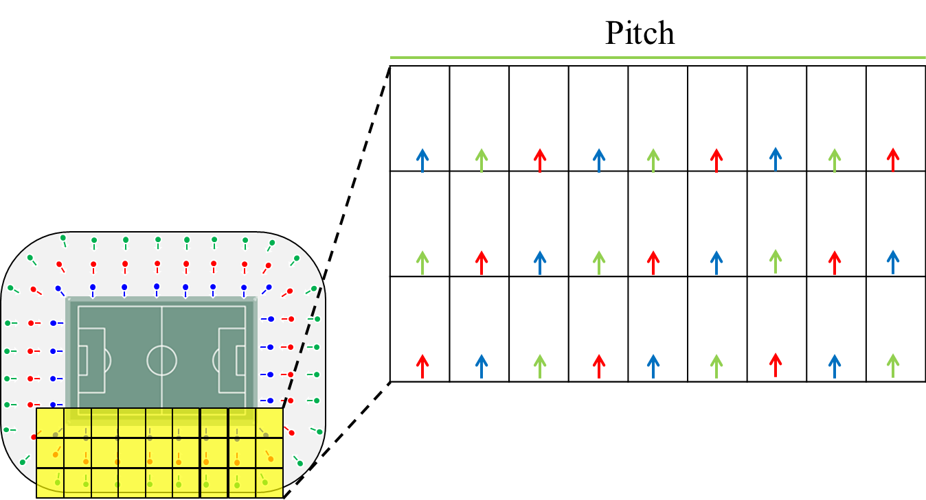
Figure 11 – Stadium section layout

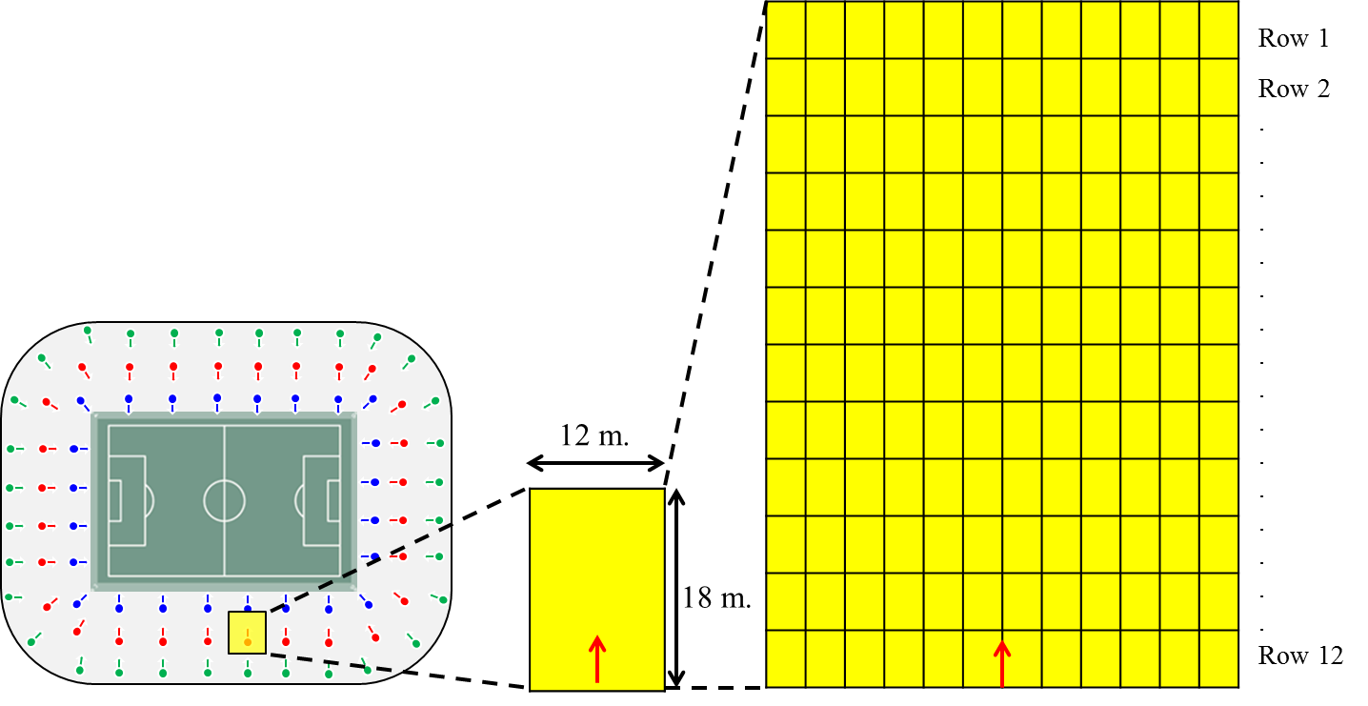
Figure 12 – Sitting area detailed layout

Environment description |  | Stadium deployment operated by a single entity  BSS layout configuration:  Define a grid formed by joining 27 rechtanguar sections, each representing a single BSS, as in Figure 11  Each rechtangle is of size 12 m × 18 m and covers 144 seats (each seat is of size 1 m × 1.5 m), as in Figure 12
APs location |  | Place APs on the low edge (in the center) of each rechtangle with antenna height [3.5] m.
AP Type |  | {802.11ax}
STAs location |  | STAs are placed in each seat location in X-Y plane, with antenna height [0.5] m. More than one STA per seat may be possible.
Number of STA and STAs type |  | STA_1 to STA_{N1}: 11ax  STA_{N1+1} to STA_{N} : 11n or 11ac pending frequency band  (N1= TBD)  Non-11ax = 11n (TBD) in 2.4 GHz  Non-11ax= 11ac (TBD) in 5 GHz  In the rectangle in Figure 12 a number of STAs, N, are randomly dropped, where N is set by:  N = Nseats×N_STA/seat×P, where P is a probability factor between 0 and 1.  Nseats = 144  N_STA/seat = 1.5
Channel Model |  | UMi for AP-STA  For STA-STA and AP-AP, use the same model as is chosen for outdoor  All STAs assumed to be outdoors (UMi specifies a fraction of users to be indoors and outdoors, respectively)
Penetration Losses |  | None
PHY parameters
Center frequency and BW |  | All BSSs either all at 2.4 GHz, or all at 5 GHz  {20 MHz BSS at 2.4 GHz, 80 MHz BSS at 5 GHz}  [20 MHz BSS at 2.4 GHz]
MCS |  | [use MCS0 for all transmissions] or  [use MCS7 for all transmissions]
GI |  | [long]
Data Preamble |  | [2.4 GHz, 11n; 5 GHz, 11ac]
STA TX power |  | [15 dBm]
AP TX Power |  | [18 dBm]
AP #of TX antennas |  | {2, 4}
AP #of RX antennas |  | {2, 4}
STA #of TX antennas |  | {1, 2}
STA #of RX antennas |  | {1, 2}
AP antenna gain | [12 dBi]
STA antenna gain | [0 dBi]
Noise Figure | [7 dB]
MAC parameters
Access protocol parameters |  | [EDCA with default EDCA Parameters set]
Primary channels |  | [Three 20 MHz channels (Ch1, Ch2, Ch3) in the 2.4 GHz band]  [Four 80 MHz channels (Ch1, Ch2, Ch3, Ch4) in the 5 GHz band]  [Primary channel position TBD]
Aggregation |  | [A-MPDU / max aggregation size / BA window size, No A-MSDU, with immediate BA]
Max # of retries |  | [10]
RTS/CTS Threshold |  | [TBD]
Association |  | [X% of STAs are associated with the strongest AP, Y% of STAs are associated with the second-strongest AP, and Z% of STAs are associated with the third-strongest AP. N% of STAs are not associated. Detailed distribution to be decided.]  [X=50, Y=30,Z=20, N=0%]

Traffic model (Per each BSS) - (AP/STA links defined in % of total number of STAs (N) ) -TBD
# | Source/Sink | Name | Traffic definition | Flow specific parameters | AC
Downlink
D1 | AP/STA[10%] | Multicast Video Streaming | T8
D2 | AP/STA[5%] | Internet streaming video/audio
D3 | AP/STA[10%] | 4k video streaming | T4
… | …
DN | AP/STAN
Uplink
U1 | AP/STA[10%] | Internet streaming video/audio | T3
U2 | AP/STA[20%] | Web browsing: – UL TCP ACKs…
… | …
UN | STAN/AP
P2P
P1 | STA1/AP
P2 | STA2/AP
P3 | STA3/AP
… | …
PN | STAN/AP
Idle Management
M1 | AP1 | Beacon | TX
M2 | STA2 | Probe Req. | TY
M3 | STA3
… | …
MN | STAN

References:
IEEE 802.11-14/0621r4
IEEE 802.11-14/0859r0

https://www.abiresearch.com/market-research/product/1016669-adoption-of-80211ac-will-be-a-little-faste/ suggests that the adoption of 802.11ac is roughly 50% three years after market introduction. Numbers seemed to be the same with 802.11n.

