IEEE P802.11
Wireless LANs
Minutes of IEEE 802.11 WG Meetings
May 2014 Beijing, China Interim Session
Date: 2014-05-22
Author(s):
Name | Affiliation | Address | Phone | email
Jon Rosdahl | CSR Technologies Inc. | 10871 N 5750 W  Highland, UT 84003 | 801-492-4023 | jrosdahl@ieee.org
Abstract
Minutes of the IEEE 802.11 WG meetings at the May 2014 Beijing, China Interim Session

- Opening IEEE 802.11 WG Meeting of the IEEE 802.11aj Interim Session Beijing, China
  - Meeting called to order by 802.11 WG 1st Vice-Chair, Jon Rosdahl, at 9:07am May 22, 2014.
  - Introduction of 802.11 WG officers in attendance:
    - Jon ROSDAHL – IEEE 802.11 WG 1st Vice Chair
    - Dorothy STANLEY – IEEE 802.11 WG 2nd Vice Chair
  - Request for who are new members : 6
  - Introduction of all attendees:
    - In interest of time, attendees will introduce as they get opportunity at the microphone
    - See appendix A for list of all Attendees
  - Introduction of Agenda 11-14/0719r0
    - Schedule noted on Slide 3
    - No objection to the proposed schedule or agenda
  - Policies and Procedures
    - Dorothy used 11-14/0499r0 for Patent Policy and Procedures information
    - Attendance access was shown (11-14/0719r0 slide7)
    - Meeting code used was given “802-11aj201405”
  - 802.11 Activities
    - Review of Working Group Session Documents (11-14/0719r0 slide 9)
    - Review of 802.11 pipeline and revisions history (11-14/0719r0 slide 10-11)
    - Review of Summary of Ballots and Comment collections (11-14/0719r0 slide 12)
    - Current Membership Status
      - Membership as of the start of last week’s interim (11-14/0719r0 slide 13)
      - New class of membership status reporting – Ex Officio voting members (11-14/0719r0 slide 14)
      - Recent Voting Member history (11-14/0719r0 slide 15)
    - ANA Status (11-14/0719r0 slide 16)
    - PAR Expiration and Renewal Schedule (11-14/0719r0 slide 17)
      - AH and AI are expiring the end of this year.
      - PAR Extensions were requested by the TG and approved by the WG
        - PAR Extensions will be sent to the IEEE 802 EC for approval in July
    - IEEE Store Contents – May 2014 (11-14/0719r0 slide 18)
    - 802.11 Drafts to ISO/IEC JTC1/SC6 (11-14/0719r0 slide 19)
    - Review Recent Actions approved by 802.11 WG (11-14/0719r0 slide 20-22)
      - 11 motions approved last week
      - Teleconference schedule shown (slide 22)
    - Officers described and explained (11-14-0719r0 Slide 23-24)
      - Indicate 802.11 Officers and appointed 802.11 Officers (slide 23)
      - Review Task Group officers (slide 12)
  - Project status Reports – Dorothy STANLEY (Aruba) 2nd Vice Chair – 11-14/474r1
    - Review Attendance report for May 2014 Interim (11-14/474r1 slide 3-6)
    - Group Type and Group Identification (11-14/474r1 slide 7-8)
    - Status report for each Task group – Closing reports listed starting on slide 9
    - Editor Report
      - Flow of Amendments noted
    - Publicity SC Report (11-14/474r1 slide 15-17)
    - WNG SC Report (11-14/474r1 slide 18-20)
    - ARC SC Report (11-14/474r1 slide 21-26)
    - JTC1 SC report (11-14/474r1 slide 27-34)
      - It appears that ISO/IEC JTC1 is changing their policies for document access Document access will be available to any experts appointed by IEEE 802 (as a liaison organisation)
      - If you would like access to the ISO/IEC JTC1/SC6 document repository as an “IEEE 802 expert” please send an e-mail to amyles@cisco.com
    - Regulatory SC Report (11-14/474r1 slide 35-40)
    - TGmc REV Report (11-14/474r1 slide 41-48)
      - 20-day LB to start soon on D3.0
      - 3GPP Liaison response was prapred, but WG updated it by removing a reference to an additional submission that had not been posted in time for voting last week.
    - TGah Report (11-14/474r1 slide 49-55)
      - PAR Extention request prepared by TG and approved by WG.
      - 30-day LB to start soon on D2.0
    - TGai Report (11-14/474r1 slide 56-65)
      - LB201 received 1186 comments
      - Updated Timeline (11-14/474r1 slide 62)
      - San Diego AdHoc – 10-11 July 2014 (11-14/474r1 slide 63)
      - Special “ah” on slide 65 for nice graphic
    - TGak Report (11-14/474r1 slide 66-70)
      - Resolved 65% of the comments from CC17 and directed Editor to produce a D0.02 incorporating those resolutions.
    - TGaq Report (11-14/474r1 slide 71-73)
    - TGax Report (11-14/474r1 slide 74-81)
      - Timeline shown on slide 79
    - RR-Tag (802.18 to 802.11 Liasion Report (11-14/474r1 slide 82-85)
    - Smart Grid Technical Advisory Group (802.24 TAG) Liaison Report (11-14/474r1 slide 86-88)
    - 802.15 Liaison Report (11-14/474r1 slide 89-108)
    - 802.21 Liaison Report (11-14/474r1 slide 109-116)
    - 802.1CF (OmniRAN) Report (11-14/474r1 slide 117)
  - Other IEEE 802 Information
    - July Tutorials July Plenary Session (11-14/719r1 slide 29-31)
    - BOF Event July Plenary Session (11-14/719r1 slide 32)
    - Early 802.11 Documentation project(11-14/719r1 slide 33-34)
  - Recessed 802.11 Opening Session at 10:10am (11-14/719r1 slide 35)
- Closing 802.11 WG Meeting of 802.11 WG May 2014 Beijing Interim Session
  - Called to order at 10:35am by Jon Rosdahl, IEEE 802.11 1st Vice Chair
  - Note that the opening Agenda and Report was updated 11-14/719r1 and posted to Mentor.
  - Acknowledge update to Interim Schedule is in 11-12/1212r1
    - Action item: Jon to send to Adrian to update webpage.
  - Reviewed the awards for TGac and TGaf.
    - http://www.ieee802.org/11/Photographs/2014/2014%20TGac%20awards/
    - http://www.ieee802.org/11/Photographs/2014/2014%20TGaf%20awards/
  - Reviewed the 2014-05 Bruce Kraemer Recognition Photographs
    - http://www.ieee802.org/11/Photographs/2014/2014%20Bruce%20Kraemer%20Recognition/index.htm
  - Thanks for the good work of TGaj this week
  - Next Meeting for TGaj will be in San Diego – July 14-19, 2014
  - Jon and Dorothy expressed thanks for successful process of TGaj holding these interims and the preparation of the comment resolutions.
  - With the Chair Change, Adrian Stephens will work with the Vice-Chairs to have at least one of us attending the interim each time.
  - Adjourned at 10:52am

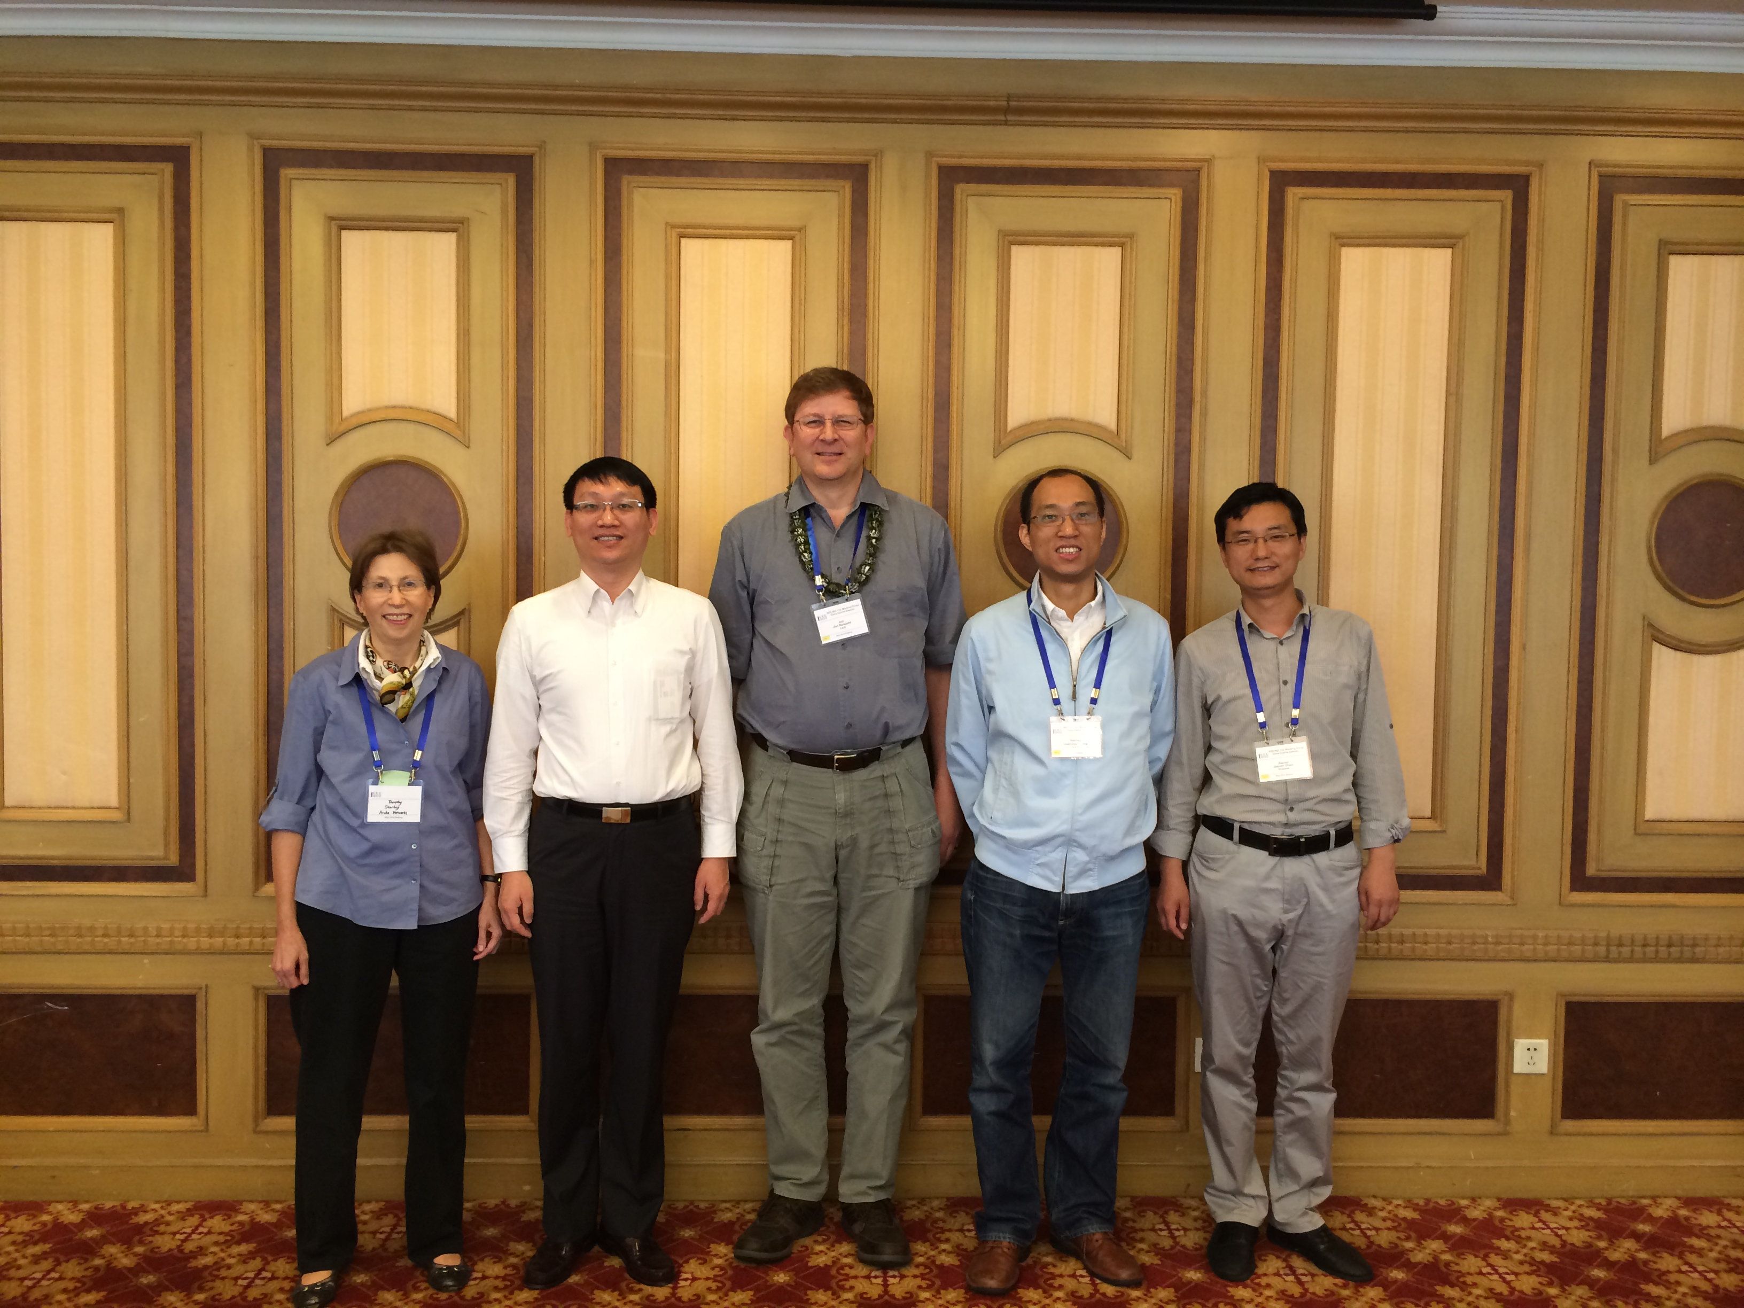

  - Also for the Leadership of 802.11aj and the 802.11 Vice-Chairs
    - Dorothy STANLEY, Xiaoming PENG, Jon Rosdahl, Haiming WANG, Jiamin CHEN

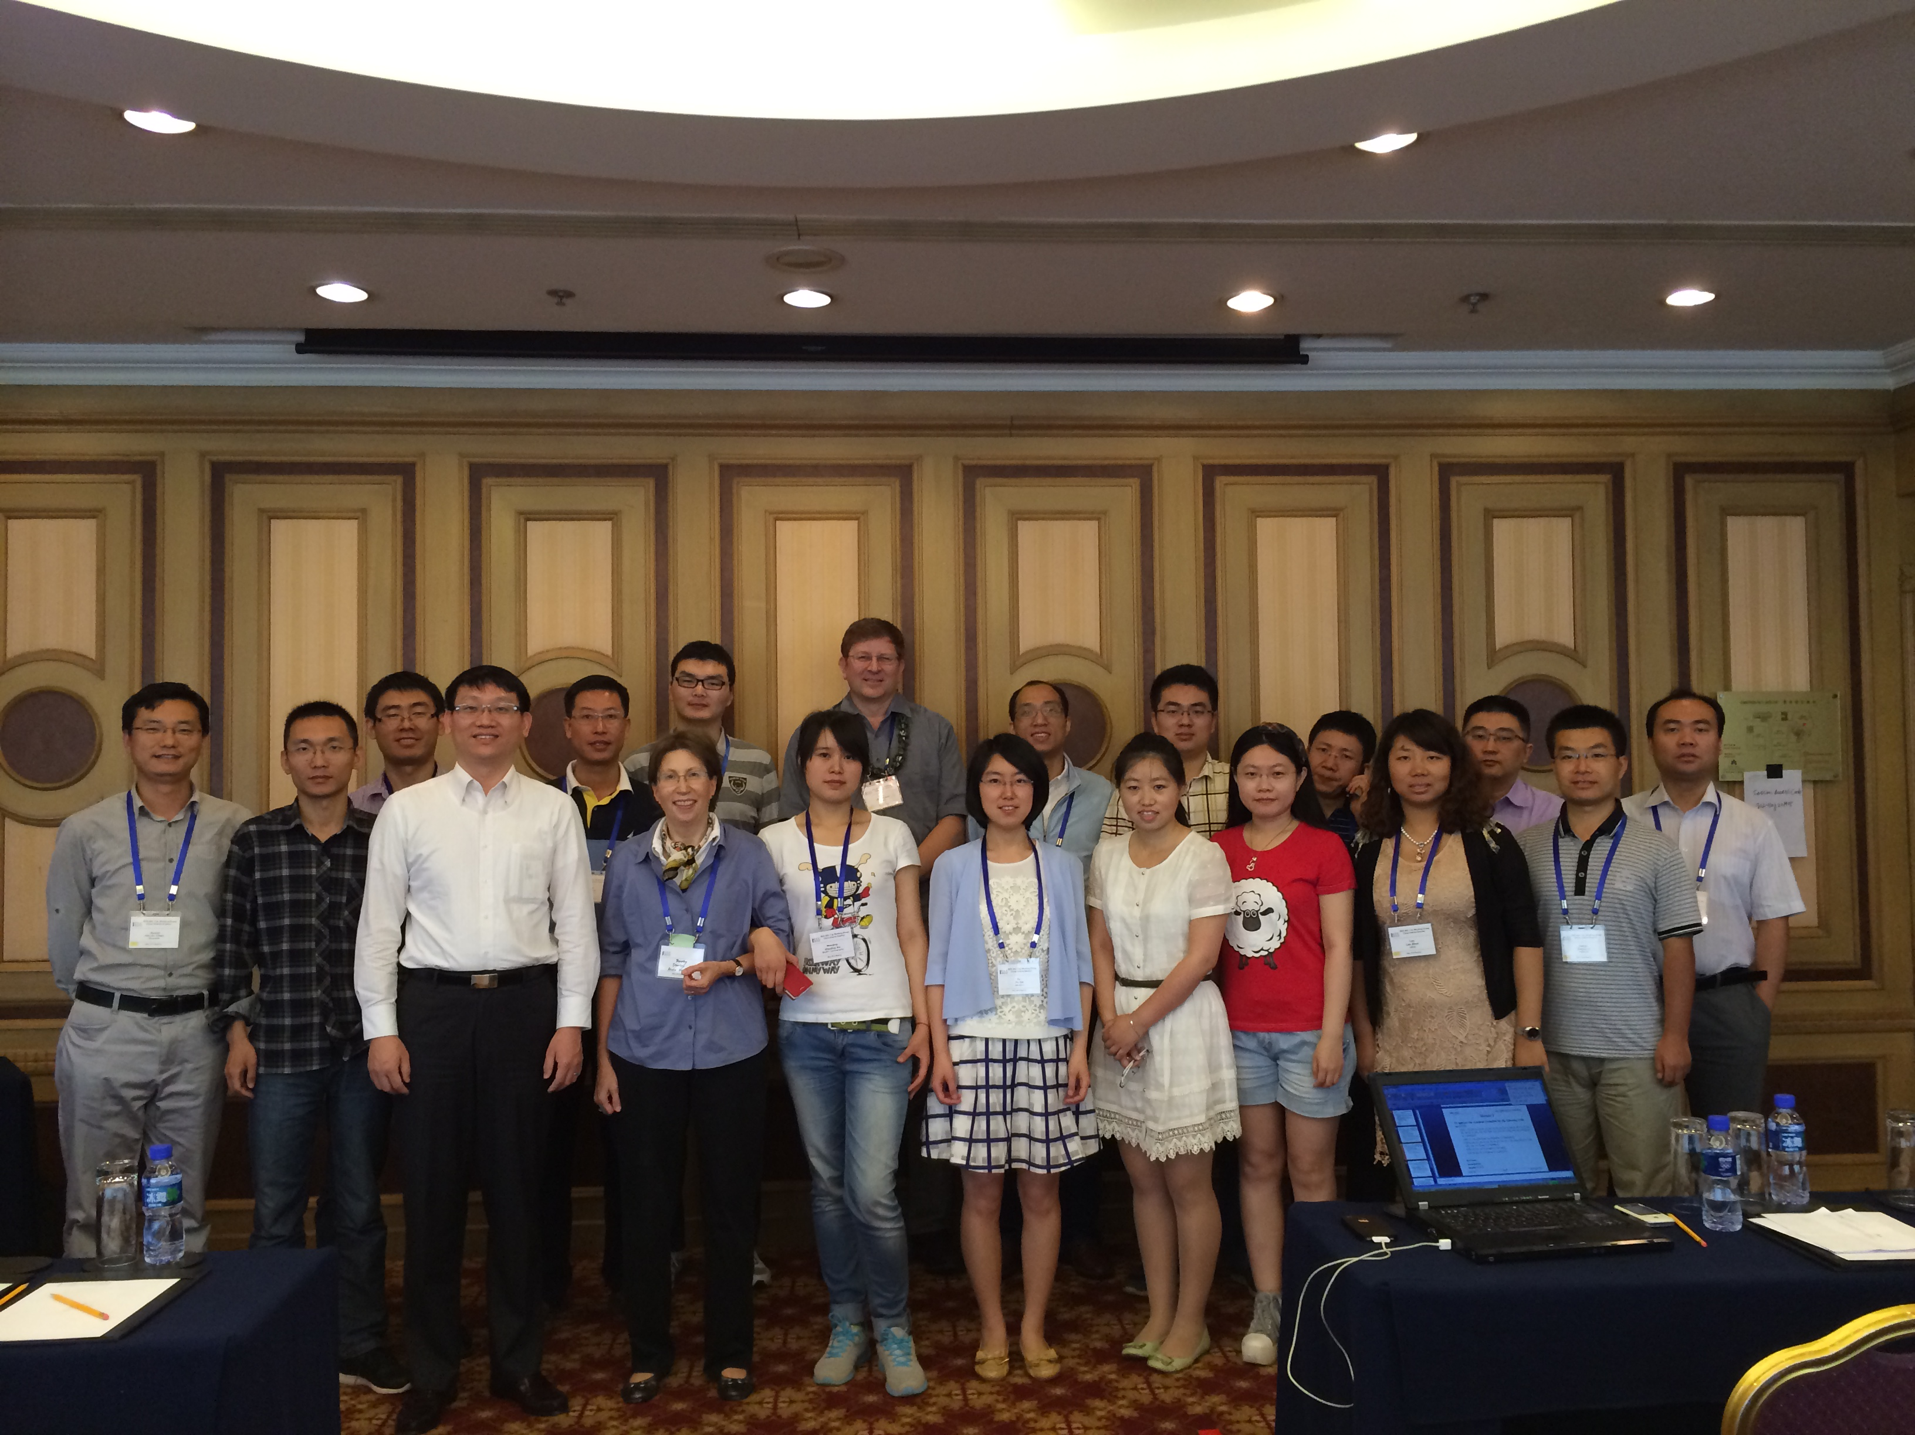
  - A photo opportunity was had for the full group – (See attendance roster in Appendix A)

Appendix A: List of Registered Attendees:
Name | Member Status | Affiliation | Recorded Percentage
Yu CAIYU | Observer | Lenovo | 83.33
Jiamin CHEN | Voting Member | Huawei/HiSilicon | 100.00
Xiaojing FAN | Potential Member | Fujitsu Research & Development Center | 100.00
Wei FENG | Observer | Tsinghua University | 83.33
Bo GAO | Aspirant Member | Tsinghua University | 100.00
Du GUANGLONG | Observer | Beijing University of Posts and Telecommunications (BUPT) | 100.00
Shiwen HE | Potential Member | Southeast University, China | 100.00
Robert JIANG | Observer | Lenovo | 100.00
Dejian LI | Voting Member | Huawei Technologies Co. Ltd | 100.00
Zhiqiang LI | Voting Member | Institute of Microelectronics, Chinese Academy of Sciences | 100.00
Pei LIU | Voting Member | HiSilicon Technologies Co., LTD. | 100.00
XIAOMING PENG | Voting Member | Institute for Infocomm Research | 100.00
Jon ROSDAHL | Voting Member | CSR Technology Inc. | 100.00
Dorothy STANLEY | Voting Member | Aruba Networks, Inc. | 100.00
Kaibo TIAN | Aspirant Member | ZTE | 83.33
Haiming WANG | Voting Member | Southeast University, China | 100.00
Hao WANG | Potential Member | Fujitsu Research & Development Center | 66.67
Xu WENJING | Observer | BUPT | 66.67
Weimin XING | Potential Member | ZTE Corporation | 100.00
Yunxiang XU | Observer | National Engineering Research Center for Broadband Networks & Applications | 100.00
Changming ZHANG | Observer | Tsinghua University | 66.67
lan ZHUO | Voting Member | CESI Group | 100.00

