IEEE P802.11  
Wireless LANs

|  |  |  |  |  |
| --- | --- | --- | --- | --- |
| Edits on Some Traffic Content for HEW SG Simulation Scenarios | | | | |
| Date: May 12, 2014 | | | | |
| Authors and Contributors | | | | |
| Name | Company | Address | Phone | Email |
| Yingpei Lin | Huawei |  |  | linyingpei@huawei.com |
| Phillip Barber | Huawei |  |  | pbarber@broadbandmobiletech.com |
| Jarkko Kneckt | Nokia |  |  |  |
| Edward Au | Huawei |  |  | edward.au@huawei.com |

# Abstract

This document provides traffic content edits to Annex 1 and Annex 2 of the draft Simulations Scenario document IEEE 802.11-13/1001r9

# Problem 1

Annex 2 is missing some detail for streaming video traffic model. 4k video streaming appears as traffic model #T4 in the tables in Annex 1, but is missing from Annex 2 for streaming video bit rates.

Also, need to fix some text for video conferencing traffic model.

# Remedy 1

[Insert row data into the table in Annex 2 as: ]

|  |  |  |
| --- | --- | --- |
| **Video bit rate** | **lambda** | **k** |
| 15.6 Mpbs | 54210 | 0.8099 |
| 10Mbps | 34750 | 0.8099 |
| 8Mbps | 27800 | 0.8099 |
| 6Mbps | 20850 | 0.8099 |
| 4Mbps | 13900 | 0.8099 |
| 2Mbps | 695 | 368.640 Kbytes |

Table 1 lambda and k parameter for video bit rate

# Problem 2

Fix minor text problem for video conferencing traffic model.

# Remedy 2

[Modify the text in Annex 2 as: ]

**Video Conferencing (e.g., Lync) Traffic Model**

Unlike buffered video streaming where video traffic is unidirectional and heavily buffered at the receiver, video conferencing is two-way video traffic with limited tolerance for latency. Video traffic is generated at each station, sent to AP, traverses the network/internet, reaches another AP, and then is transmitted to its destination STA.

**Station layer model**

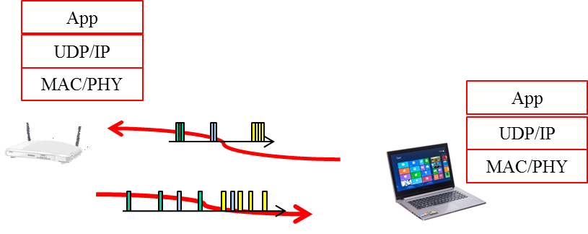

Because the traffic from AP to station has experienced network jitter, it can be modelled the same way as the traffic model of video streaming.

For traffic sent from Station to AP, since the traffic has not experienced network jitter, it is a periodic traffic generation as the first two steps described in video streaming.

**Video traffic generation**

Traffic model from AP to station: use the same model as video streaming.

Traffic model from station to AP: use the first two steps in video streaming traffic model

**Evaluation metrics**

* MAC throughput, latency

# Problem 3

Annex 1 and Annex 2 are missing content for the Gaming traffic model, used in some scenarios.

# Remedy 3

[Insert row data into the tables in Annex 1 as:]

# Annex 1 - Reference traffic profiles per scenario

**Reference traffic profile for Scenario 1**

|  |  |  |  |  |  |
| --- | --- | --- | --- | --- | --- |
| **Traffic Model #** | **Traffic model name** | **Description** | **Application traffic**  **(Forward / Backward)** | **Application Load (Mbps)**  **(Forward / Backward)** | **A-MPDU Size (B)**  **(Forward / Backward)** |
| T1 | Local file transfer | FTP/TCP transfer of large file within local network | FTP file transfer  / FTP TCP ACK | Full buffer /  0.1 | Max A-MPDU / 64 |
| T2 | Lightly compressed video |  |  |  |  |
| T3 | Internet streaming video/audio |  |  |  |  |
| T4 | 4k video streaming |  |  |  |  |
| T5 | Online game server |  |  |  |  |
| T6 | Management: Beacon |  |  |  |  |
| T7 | Management: Probe requests |  |  |  |  |
| T8 | Gaming |  |  |  |  |

**Reference traffic profile for Scenario 3**

|  |  |  |  |  |  |
| --- | --- | --- | --- | --- | --- |
| **Traffic Model #** | **Traffic model name** | **Description** | **Application traffic**  **(Forward / Backward)** | **Application Load (Mbps)**  **(Forward / Backward)** | **A-MPDU Size (B)**  **(Forward / Backward)** |
| T1 | Local file transfer | FTP/TCP transfer of large file within local network | FTP file transfer  / FTP TCP ACK | Full buffer /  0.1 | Max A-MPDU / 64 |
| T2 | Lightly compressed video |  |  |  |  |
| T3 | Internet streaming video/audio |  |  |  |  |
| T4 | 4k video streaming |  |  |  |  |
| T5 | Online game server |  |  |  |  |
| T6 | Management: Beacon |  |  |  |  |
| T7 | Management: Probe requests |  |  |  |  |
| T8 | Multicast Video Streaming | UDP/IP transfer of compressed video streaming | UDP packet transfer/Nothing | 3-6Mbps/Nothing |  |
| T9 | Gaming |  |  |  |  |

[Insert text to the end of Annex 2 as:]

# Annex 2 – Traffic model descriptions

**Gaming Traffic Model**

First Person Shooter (FPS) is a typic representative game of Massively Multiplayer Online (MMO) game. The FPS traffic model is considered to be a typical gaming traffic model, as it has additional requirements on, for instance, real time delay with irregular traffic arrivals. Gaming is a two-way single-hop video traffic.

Gaming traffic can be modeled by the Largest Extreme Value distribution. The starting time of a network gaming mobile is uniformly distributed between 0 and 40 ms to simulate the random timing relationship between client traffic packet arrival and reverse link frame boundary. The parameters of initial packet arrival time, the packet inter arrival time, and the packet sizes are illustrated in the table xx [1]:

|  |  |  |  |  |  |
| --- | --- | --- | --- | --- | --- |
| **Component** | **Distribution** | | **Parameters** | | **PDF** |
| **DL** | **UL** | **DL** | **UL** |
| Initial packet arrival (ms) | Uniform | Uniform | a=0,  b=40 | a=0,  b=40 |  |
| Packet arrival time (ms) | Largest Extreme Value | Largest Extreme Value | a=50,  b=4.5 | a=40,  b=6 |  |
| Packet size (Byte) | Largest Extreme Value | Largest Extreme Value | a=330,  b=82 | a=45,  b=5.7 |  |

* A compressed UDP header of 2 bytes and a IPv4 header of 20 bytes (if use IPv6 here, the header should be 40bytes) has been accounted for in the packet size.

Table xx parameters for gaming traffic model

**Evaluation metrics**

MAC throughput, latency

**References for traffic models**

**[1] IEEE 802.16m-08/004r5, IEEE 802.16m Evaluation Methodology Document (EMD)**