IEEE P802.11
Wireless LANs
ETSI BRAN regulatory test for occupied channel bandwidth and 802.11ac-2013
Date: 2014-04-10
Author(s):
Name | Affiliation | Address | Phone | email
Jens TINGLEFF | Samsung Electronics | Samsung France Research Center.  E-Space Park Bat C  45, Allee des Ormes  06250 Mougins  France | +33 (0)4 89 73 70 14 | j.tingleff@samsung.com
Alexander Thoukydides | Samsung Electronics
Abstract
The ETSI BRAN committee is finalising the next release of the 5 GHz RLAN regulatory testing rules for Europe, EN 301 893. The existing version, rev 1.7.1, is written for 802.11n, i.e. for signal bandwidths up to 40 MHz, and allows partial occupation of the channel (down to 40% of the measured full bandwidth). The most recent published version of the IEEE 802.11 spec is 802.11ac-2013 which defines signal bandwidths up to 160 MHz with mandatory 20 MHz, 40 MHz and 80 MHz partial channel occupation modes. The present document suggests that making a minor edit to EN 301 893 (changing the permitted lower occupation in percent from 40% to 10%) is the best way to take into account the more recent IEEE specification.

Introduction

Vocabulary
“Nominal Channel Bandwith” | The widest signal bandwidth in ETSI.
“Channel Bandwidth” | The CH_BANDWIDTH in IEEE 802.11. See clause 3.2
“Mask Bandwidth” | The bandwidth of the widest signalling from the AP, see clause 3.2. This bandwidth dictates the needs to obtain a Clear Channel Assesment before transmit (i.e. which bandwidth needs to be idle – this can be more than the channel bandwidth)

The problem
The IEEE 802.11n and later the 802.11ac specs require equipment to have the ability to transmit in smaller channel bandwidths when operating on a channel with greater than minimal bandwidth, i.e. 20 MHz channel bandwidth when operating on channel using a 40 MHz mask bandwidth, 20 and 40 MHz when operating on 80 MHz and 20, 40 and 80 MHz when operating with a 160 MHz mask bandwidth. This is a mandatory mode of operation according to VHTM8.1 and VHTM8.2 in the PICS which in turn refer to clauses 9.3.2.5a, 9.3.2.6 and 10.39.1 – all from 802.11ac-2013.
The ETSI regulatory test specification requires the signal transmitted to be between 80% and 100% of the Nominal Channel Bandwidth, with the occasional exception, as follows:
“The Nominal Channel Bandwidth is the widest band of frequencies, inclusive of guard bands, assigned to a single channel.
The Occupied Channel Bandwidth is the bandwidth containing 99 % of the power of the signal.
NOTE: When equipment has simultaneous transmissions in adjacent channels, these transmissions may be considered as one signal with an actual Nominal Channel Bandwidth of "n" times the individual Nominal Channel Bandwidth where "n" is the number of adjacent channels.
When equipment has simultaneous transmissions in non-adjacent channels, each power envelope shall be considered separately”
The test specification in EN 301 893 v 1.7.1 [1], the version currently in use, has this to say in clause 4.3.2:
“The Nominal Channel Bandwidth shall be at least 5 MHz at all times.
The Occupied Channel Bandwidth shall be between 80 % and 100 % of the declared Nominal Channel Bandwidth. In case of smart antenna systems (devices with multiple transmit chains) each of the transmit chains shall meet this requirement.
NOTE: During an established communication, a device is allowed to operate temporarily in a mode where its Occupied Channel Bandwidth may be reduced to as low as 40 % of its Nominal Channel Bandwidth with a minimum of 4 MHz.”
The current draft 8 of this document has the same words.
To us, this indicates an intention to have 40 MHz mask bandwidth 802.11n tested as a 40 MHz Nominal Channel Bandwidth and occasional 20 MHz use to be an exception covered by the 40% relaxation without a corresponding change of nominal bandwidth.
In our opinion it would be appropriate to update the words in EN 301 893 to track the new features in IEEE 802.11ac-2013, in other words to allow 20 MHz channel bandwidth signal in a 160 MHz mask bandwidth to be transmitted as (slightly more than) 10% of the 160 MHz nominal channel bandwidth.

Tx spurious emissions
The limits on spurious emissions are discussed in both IEEE 802.11 and in EN 301 893, even though the IEEE standard makes no rules which attempt to describe regulatory limits.

ETSI BRAN: in-band spurious emission limits in Tx and the nominal bandwidth
The nominal bandwidth is used in EN 301 893 to define the limits on spurious emissions inside the bands in question (5150 MHz – 5350 MHz and 5470 MHz – 5725 MHz). The mask looks suspiciously like a classic OFDM mask, and is as shown in Figure 1. The slope of the transitional regions (0.5 * N to 1.5 * N frequency offset) thus depends on the nominal bandwidth.
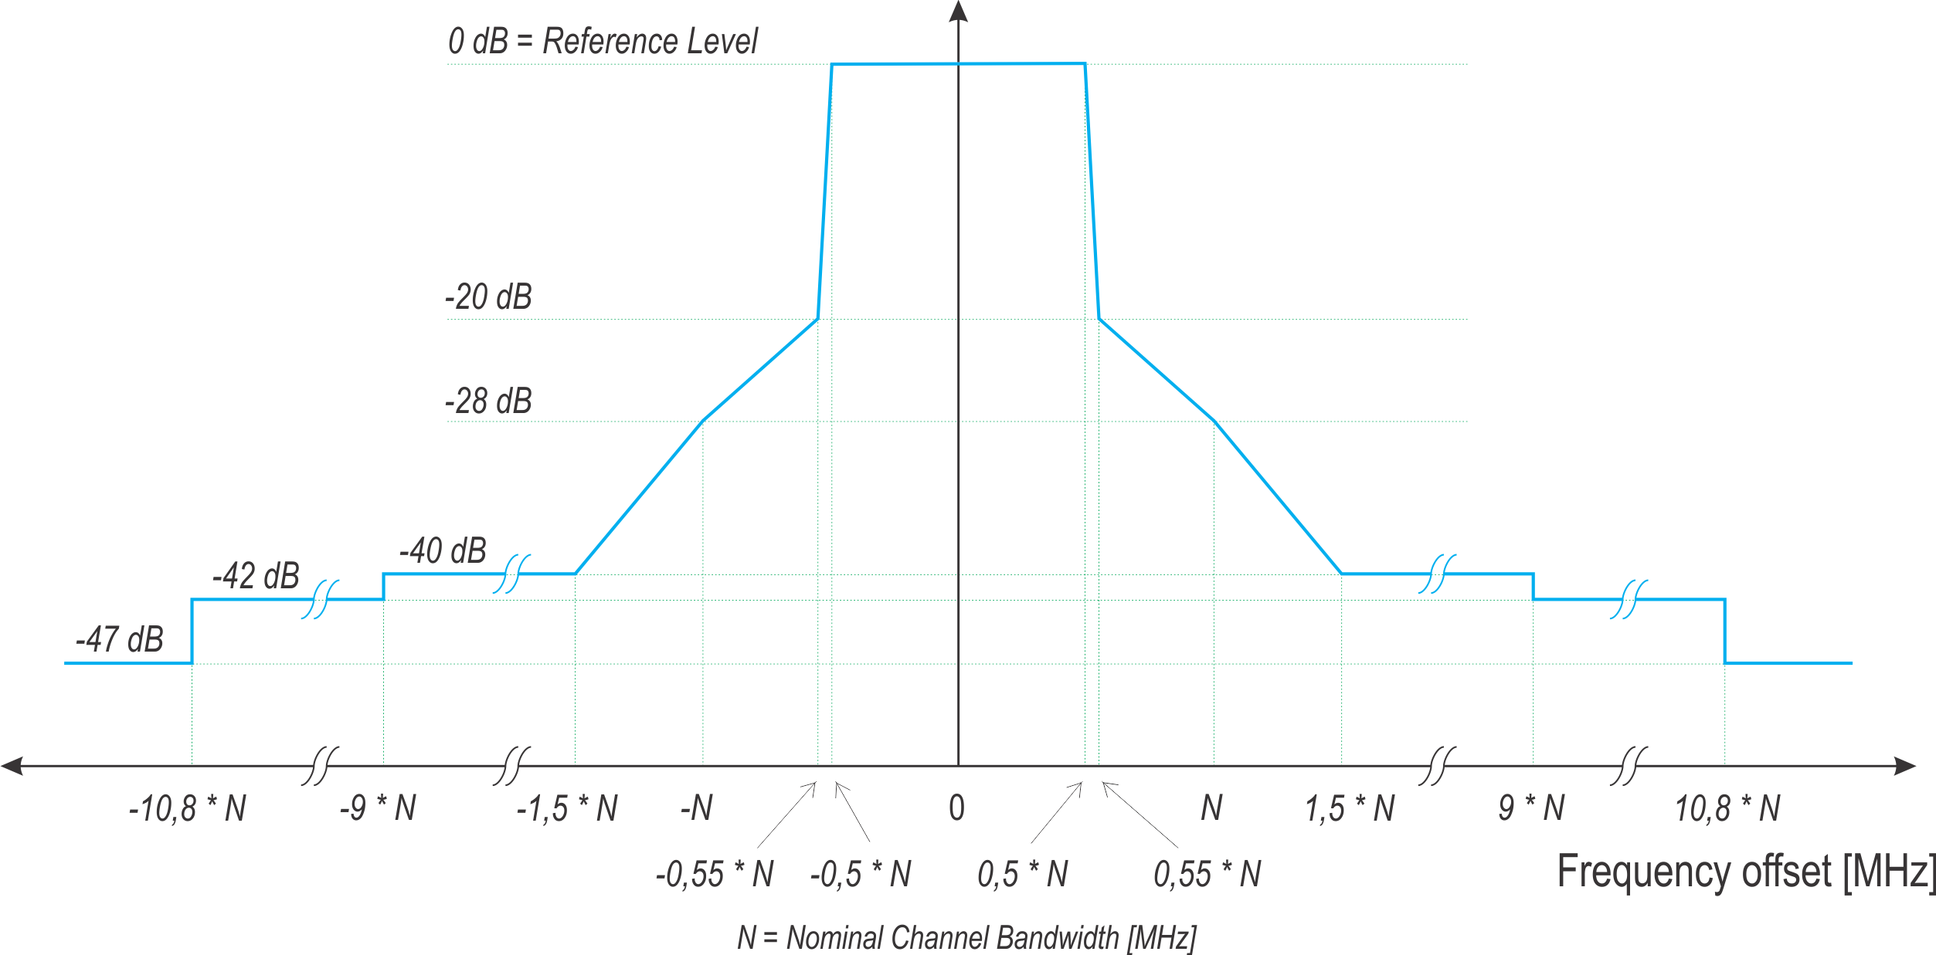
Figure 1: ETSI EN 301 893 in-band spurious emissions limit

802.11ac-2013 on the transmit spectrum mask
The spurious emissions of signals occupying less than the entire bandwidth is explicitly left undefined in the IEEE 802.11n and 802.11ac clauses, other than having to comply with the spurious emissions mask of ther greater bandwidth (clause 3.2, entry “40 MHz mask physical layer (PHY) convergence procedure (PLCP) protocol data unit (PPDU)” and friends). The transitional regions from 0.55 * N (11 MHz – 20 MHz for Figure 22-29, up to 81 MHz – 160 MHz for Figure 22-32) again have a bandwidth which depends on the nominal channel bandwidth.
The other spurious emission which is limited in the IEEE spec is the carrier leakage, clause 22.3.18.4.2 summarises everything.

The two ways to view multi bandwidth transmit when testing
EN 301 803 allows two ways to specify the signal bandwidth which are relevant to signalling at more than one bandwidth: as a single signal with a single nominal channel bandwidth and occasional partial use of the bandwidth (i.e. a single 40 MHz, 80 MHz or 160 MHz nominal bandwidth) or as parts of a wider signal (i.e. two, four or eight 20 MHz signals each of which have 20 MHz nominal channel bandwidth).
All in-band spurious emissions are measured with spectrum analyser settings including: VBW: 1 MHz, RBW: 30 kHz, detector: Peak. (Clause 5.3.6 of EN 301 893, both 1.7.1 and 1.8.0.)

Single 80 MHz (or 160 MHz) channel
The mask from Figure 1 is applied as a limit and if the carrier is inside the signal bandwidth the mask is very similar to that of the IEEE 802.11 spec and regulatory and IEEE masks are pretty much the same thing.

Multiple 20 MHz channels
The mask from Figure 1 is repeated four (or eight) times. The transition regions go from -20 dB to -40 dB in roughly 30 MHz.
Many signals which are valid according to IEEE 802.11ac would be illegal, notably with respect to the carrier leakage, if we were to measure a transmission in less than the full bandwidth (say a 20 MHz which is not adjacent to the carrier of the 80).

The proposed change

Why we want to test as single 80 MHz (or 160 MHz)
There are some spurious emissions which do not scale with channel bandwidth, while the noise-like spurious linked to transmit chain non-linearities do. The most notable spurious not linked to non-linearities is obviously the carrier leakage. In Figure 2 we have drawn an IEEE 802.11ac 80 MHz mask with a sketch of the separate measurement of and limit for the carrier leakage. We have also drawn a hypothetical 20 MHz burst transmitted while an equipment is set up to transmit on the 80 MHz channel, i.e. the carrier is outside the 20 MHz and some of the spurious emissions are not at offset frequencies purely scaled with channel bandwidth.
Without going into details about measurement bandwidths, analyser settings and possible relative levels we maintain that in light of the new flexibility in the IEEE spec when going from 802.11n to 802.11ac we need a corresponding update to the ETSI test limits. Extending the flexibility which rev 1.7.1 shows towards IEEE 802.11n with flexibility towards IEEE 802.11ac in rev 1.8.1 would allow the ETSI spec to be consistent and to not surprise vendors and test houses as products are introduced in the market.
Figure 2: IEEE 80 MHz mask, ETSI 20 MHz mask and hypothetical 20-in-80 MHz signal

Changing the percentage limit in EN 301 893

The proposed change is simply the number 40% in the note to clause 4.3.2 which we propose to change to 10%. In this way, we permit operation with 20 MHz in a nominal bandwidth of 160 MHz, which corresponds to the capabilities of the published IEEE standard at the time of writing the next revision of the ETSI EN.
We would like to point out that this change does not somehow permit a more wasteful use of spectrum. The ETSI minimum bandwidth limit of 4 MHz remains and the inclusion of 20 MHz signals in an 80 MHz (or a 160 MHz) access point is a way to allow coexistence with legacy equipment (the intent of the IEEE backwards compatibility) where the alternative would be to establish a separate access point for the legacy devices if operation at 20 MHz were not to be allowed. Including the legacy device in the up to date AP network allows the network to benefit from the enhancements which have been added to IEEE 802.11 which must by definition be a better way both to service the needs of the legacy device and to protect the up to date devices in the network.
References:
[1] “Broadband Radio Access Networks (BRAN); 5 GHz high performance RLAN; Harmonized EN covering the essential requirements of article 3.2 of the R&TTE Directive” V 1.7.1 (2012-06), available from http://pda.etsi.org/pda/queryform.asp
[2] “Broadband Radio Access Networks (BRAN); 5 GHz high performance RLAN; Harmonized EN covering the essential requirements of article 3.2 of the R&TTE Directive” V 1.8.0 draft 008, http://www.ieee802.org/11/private/ETSI_documents/BRAN/70-Draft/0060011/BRAN-0060011v008.docx

In the opposite direction, using multiple 20 MHz as a single wider signal, ETSI BRAN allows the nominal channel bandwidth, and thereby the masks, to scale with the complete nominal bandwidth – clause 4.5.2.2 of EN 301 893
ETSI has no specific rule and so the carrier is supposed to fit within the mask which is linked to nominal signal bandwidth

