IEEE P802.11
Wireless LANs
Proposed Resolution to REVmc CID 2455
Date: 2014-03-18
Author(s):
Name | Affiliation | Address | Phone | email
Mark Hamilton | Spectralink, Corp | 2560 55th St  Boulder, CO 80301 USA | +1-303-441-7553 | mark.hamilton@spectralink.com
Abstract
This document proposed a resolution to REVmc CID 2455

2455 | 9.2.2 | 1093 | 2 | Figure 9-1 line to DCF is confusing | Draw the figure so that label connectors don't have to pass "behind" boxes (making it look like they are connecting to that box). Push the label off to one side so that it's connector can be drawn without disappearing behind boxes. (If it has to disappear behind other labels, that's not ideal, but better.) Do this for the DCF label and the SP Access label. | MAC

Current figure:
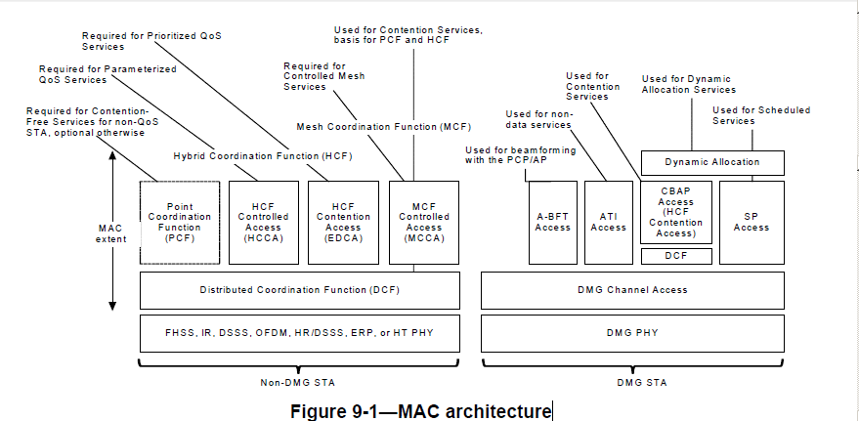

Proposed resolution: Revised. Replace with this figure. Note that other changes have already been made to this figure. The pink fill indicates the changes proposed here, editor to remove the fill in the actual draft

