IEEE P802.11
Wireless LANs
(LB200) TGah D1.0 PHY Comment Resolutions on Annex E
Date: 2014-03-17
Author(s):
Name | Affiliation | Address | Phone | Email
Eugene Baik | Qualcomm Technologies, Inc | 5775 Morehouse Dr. San Diego, CA 92121 |  | eugeneb@qti.qualcomm.com
Minho Cheong | ETRI

This document provides PHY resolutions for CIDs on Annex E, including:
- 2634
- 2635
- 2795
- 1785.

CID | Commenter | Page | Clause | Assignee | Comment | Proposed Change | Resolution
2634 | Peter Ecclesine | 371.50 | E.1 | Minho | In sub-1 GHz bands, global classes are only needed for bandwidths and bands. Table E-4 uses several classes for 1 MHz bandwidth when only one per country/band combination is necessary. Reduce the redundant classes to just unique combinations of channel spacing and band (ANA+7 and ANA+8; ANA+9 and ANA+10 are same channel spacing in different bands, so they require two operating classes). | Replace Table E-4 values with the minimum set globally for bandwidth and band. Commenter will propose a comment resolution. | REVISE.  See revised text in doc 11-14-0351.
2635 | Peter Ecclesine | 371.53 | E.1 | Minho | In sub-1 GHz bands, global classes are only needed for unique bandwidths and bands. Table E-4 says Behavior limits are country specific, but the global table should refer to global Behavior limits. Commenter will propose a comment resolution. Remove the (for China, for Korea, for Singapore) notations in Behavior limits in Table E-4 | Remove the (for China, for Korea, for Singapore) notations in Behavior limits in Table E-4. Replace Table E-4 Behavior limits set text with correct text for each class. . Commenter will propose a comment resolution. | REVISE.  See revised text in doc 11-14-0351.
2795 | Stefan Aust | 369.16 | E.1 | Minho | The Geographic area for China lits 614-787 as frequency, but without indicating operating classes in China in the following | Add operating class for 614-787 MHz | REVISE.  See revised text in doc 11-14-0351.
<Discussion>
Added additional operating class for 614-687MHz & 687-755MHz as well as the currently-existing 755-787MHz, as the commenter pointed out.

Refer to new S1G Operating Element definition in the resolution of CID 1784 (in 11-14-0359r1) for Clause-8.4.2.170w, which defines “S1G Operating Class”. From the resolution to CID 2634, 2635 in this doc., we can know it seems desirable for primary channel index to have an actual bit size within 1 octet (8 bits). The reason why I tried to separate into multiple rows is that it seems impossible to have ‘primary channel index’ bits within 1 octet if we forcibly merge China band into single “S1G operating class”.
In addition, it seems that 615-755MHz band may be only Type 1 channel focusing on 1MHz transmission, similiarily for 755-779MHz.

1785 | Eugene Baik | 370.01 | E.1 | Minho | Add country channelization for Australia and New Zealand, pending future regulatory rulings | Add rows in table for Australia and New Zealand | ACCEPT.  See revised text in doc 11-14-0351.
<Discussion>

11ah is a feasible technology for deployment in Sub-1GHz bands in Australia and New Zealand, based on current regulatory rules for those countries.

For Australia,
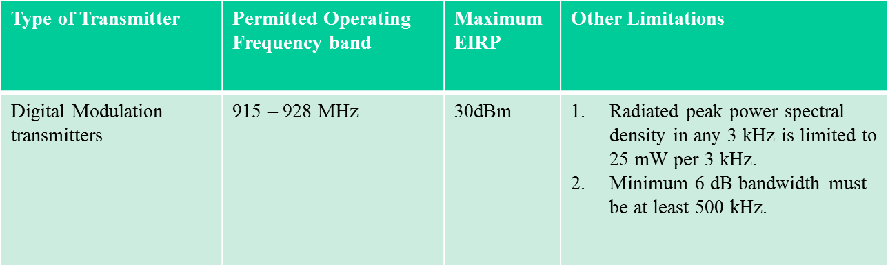

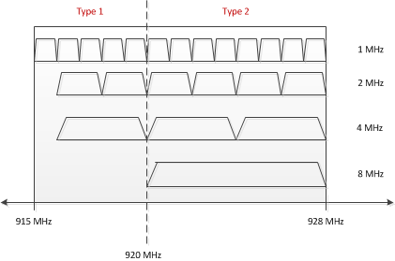

For New Zealand,
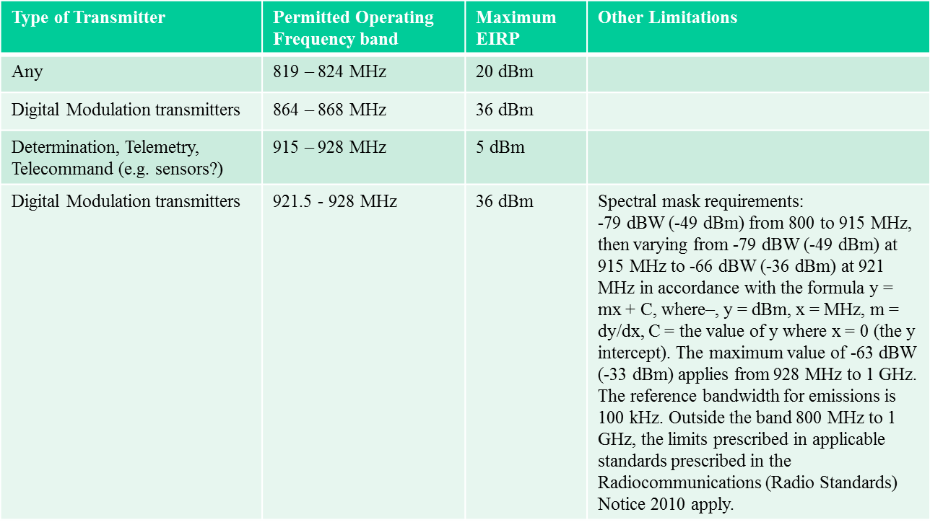

Focus on 915-928 MHz:

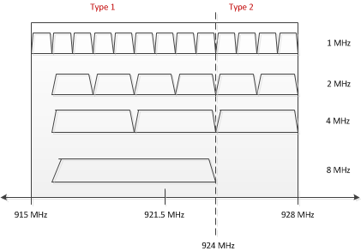

TGah editor: modify the D1.2 text from P416L04, as follows

Country elements and operating classes
- Country information and operating classes
Note - Definition of Type 1 and Type 2 channels for CCA Level Classification and required behavior is described in 24.3.18.5.4 (CCA sensitivity for signals occupying the Primary 2MHz and/or Primary 1MHz channel) and 24.3.18.5.5 (CCA sensitivity for signals not occupying the primary 2MHz channel).

Insert the rows below for Operating classes <ANA> through <ANA+???>:
Table E-4 – Global operating classes
Operating  class | Nonglobal operating class(es) | Channel starting frequency (GHz) | Channel  spacing  (MHz) | Channel set | Behavior  limits set
<ANA> - <ANA+???> | E-5 – 1??? | Reserved | Reserved | Reserved | Reserved

Table E-5 – S1G Operating classes
Operating  class | S1G Operating Class | Channel starting frequency (GHz) | Channel  spacing  (MHz) | CCA Level Classification | Behavior  limits set
<ANA> | 1 (U.S.) | 0.902 | 1 | Type 1  (902-904MHz,  920-928MHz) | TBD
Type 2
(904-920MHz)
<ANA+1> | 2 (U.S.) | 0.902 | 2 | Type 1  (902-904MHz,  920-928MHz) | TBD
Type 2
(904-920MHz)
<ANA+2> | 3 (U.S.) | 0.902 | 4 | Type 1  (920-928MHz) | TBD
Type 2
(904-920MHz)
<ANA+3> | 4 (U.S.) | 0.902 | 8 | Type 1  (920-928MHz) | TBD
Type 2
(904-920MHz)
<ANA+4> | 5 (U.S.) | 0.902 | 16 | Type 2  (904-920MHz) | TBD
<ANA+5> | 6 (Europe) | 0.863 | 1 | Type 1  (863-868MHz) | TBD
<ANA+6> | 7 (Europe) | 0.863 | 2 | Type 1  (863-868MHz) | TBD
<ANA+7> | 8 (Japan) | 0.9165 | 1 | Type 1  (916.5-927.5MHz) | TBD
<ANA+8> | 9 (China) | 0.614 | 1 | Type 1  (614-687MHz) | TBD
<ANA+9> | 10 (China) | 0.687 | 1 | Type 1  (687-755MHz) | TBD
<ANA+10> | 11 (China) | 0.755 | 1 | Type 1  (755-779MHz) | TBD
Type 2
(779-787MHz)
<ANA+11> | 12 China) | 0.755 | 2 | Type 2  (779-787MHz) | TBD
<ANA+12> | 13 (China) | 0.755 | 4 | Type 2  (779-787MHz) | TBD
<ANA+13> | 14 (China) | 0.755 | 8 | Type 2  (779-787MHz) | TBD
<ANA+14> | 15 (Korea) | 0.9175 | 1 | Type 1  (917,5-923.5MHz) | TBD
<ANA+15> | 16 (Korea) | 0.9175 | 2 | Type 1  (917,5-923.5MHz) | TBD
<ANA+16> | 17 (Korea) | 0.9175 | 4 | Type 1  (917,5-923.5MHz) | TBD
<ANA+17> | 18 (Singapore) | 0.866 | 1 | Type 1  (866-869MHz) | TBD
<ANA+18> | 19 (Singapore) | 0.920 | 1 | Type 1  (920-925MHz) | TBD
<ANA+19> | 20 (Singapore) | 0.866 | 2 | Type 1  (866-869MHz) | TBD
<ANA+20> | 21 (Singapore) | 0.920 | 2 | Type 1  (920-925MHz) | TBD
<ANA+21> | 22 (Singapore) | 0.920 | 4 | Type 1  (920-925MHz) | TBD
<ANA+22> | 23 (Australia) | 0.915 | 1 | Type 1  (915-920MHz) | TBD
 |  |  |  | Type 2  (920-928MHz) | TBD
<ANA+23> | 24 (Australia) | 0.915 | 2 | Type 1  (915-920MHz) | TBD
 |  |  |  | Type 2  (920-928MHz) | TBD
<ANA+24> | 25 (Australia) | 0.915 | 4 | Type 1  (915-920MHz) | TBD
 |  |  |  | Type 2  (920-928MHz) | TBD
<ANA+25> | 26 (Australia) | 0.915 | 8 | Type 2  (920-928MHz) | TBD
<ANA+26> | 27 (New Zealand) | 0.915 | 1 | Type 1  (915-924MHz) | TBD
 |  |  |  | Type 2  (924-928MHz) | TBD
<ANA+27> | 28 (New Zealand) | 0.915 | 2 | Type 1  (915-924MHz) | TBD
 |  |  |  | Type 2  (924-928MHz) | TBD
<ANA+28> | 29 (New Zealand) | 0.915 | 4 | Type 1  (915-924MHz) | TBD
 |  |  |  | Type 2  (924-928MHz) | TBD
<ANA+29> | 30 (New Zealand) | 0.915 | 8 | Type 1  (924-928MHz) | TBD

