IEEE P802.11
Wireless LANs
LB200 Proposed Comment Resolutions for 8.4.2.20, 8.4.2.21, 8.4.2.38 and 8.4.2.43
Date: 2014-03-18
.
Name | Affiliation | Address | Phone | email
Mitsuru Iwaoka | Yokogawa Electric Corporation | 2-9-32 Nakacho, Musashino-shi  Tokyo, 180-8750  Japan | +81-422-52-5519 | Mitsuru.Iwaoka@  jp.yokogawa.com
Abstract
This submission proposes resolutions for following Wireless LAN Radio Measurements related MAC comments of P802.11ah D1.0 WG Letter Ballot (LB200):
- 2572, 2573
- 2595, 2596

R0: Initial

CID | Page | Clause | Comment | Proposed Change | Resolution
2572 |  | 8.4.2.20.8 | The subclause 8.4.2.20.8 (Frame request) of IEEE P802.11mc D1.1 specifies that only frames matching the MAC address filed as the Transmitter Address are counted in response to the frame request.  This MAC address filtering is not possible for a non-AP STA transmitting short frames. It is necessary to specify the S1G STA's behavior. | Insert the subclauses 8.4.2.20 (Measurement Request element) and 8.4.2.20.8 (Frame request), and modify the 7th paragraph of 8.4.2.20.8 by adding a following new text at the end of last sentence:  --  and short frames (8.7 (MAC frame format for short frames)) from non-AP S1G STA are not counted. | Reject.  If TA is not obtained from a frame, that frame does not match the MAC address other than broadcast address.
2573 |  | 8.4.2.21.8 | The subclause 8.4.2.21.8 (Frame Report) of IEEE P802.11mc D1.1 specifies the Frame Report Entry field (Figure 8-177) to contain the Transmitter MAC Address and others.  In an S1G BSS using short frames, a Transmitter address of a non-AP STA is AID. It is necessary to modify the Frame Report Entry field format to allow AID as Transmitter Address. | Insert the subclauses 8.4.2.21(Measurement Report element) and 8.4.2.21.8 (Frame Report), and modify the definition of the Transmit Address field contains the Transmitter Address (TA) subfield of the Frame Report Entry field (Figure 8-177) to allow use of AID for an S1G STA. | Revise.  Agree in principle.  TGah editor to make changes shown in 11-14/0289r0 under the heading for CID 2572 and 2573.

Discussion
These comments relate to Wireless LAN Radio Measurements function (specified in 4.3.9 and 10.11 of IEEE P802.11mc D2.0). Wireless LAN Radio Measurements enable STAs to understand the radio environment in which they exist and to observe and gather data on radio link performance and on the radio environment. Wireless LAN Radio Measurements is also usefull for sub 1GHz band, and an S1G STA should optionally support it.

The subclause 10.11.9.2 (Frame report) of the IEEE P802.11mc D2.0 specifies as follows;
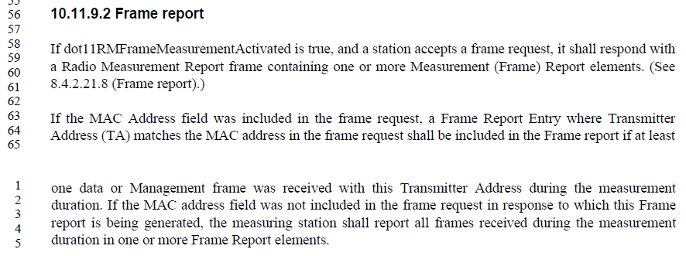

For an S1G STA, if a non-AP S1G STA transmits a short frame with frame type of 0 (Data) or 1 (Management), or an S1G AP transmits an STACK frame, the A2 field contains an SID that contains AID to identify the transmitter, and no transmitter MAC address is contained.

For CID #2572, the subclause 8.4.2.20.8 (Frame request) of the IEEE P802.11mc D2.0 specifies as follows;

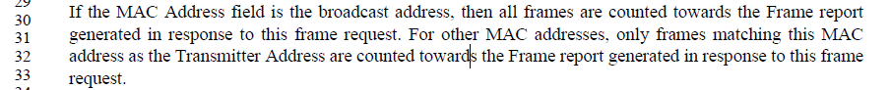

If the reporting S1G STA does not know the transmitter address of the received frame, that frame does not matche the MAC address other than the broadcast address and is not counted. So, no change to the subclause 8.4.2.20.8 is necessary.

For CID #2573, the reporting STA shall report all received frames in one or more Frame report elements if the MAC Address field of the Frame request is the broadcast address. The Frame Report Entry (Figure 8-177) contains the transmitter address (TA) and the BSSID of the frame being reported.
However, the reporting STA may not know the transmitter address of the received short frame. It is necessary to specify the value of the Transmitter Address subfield of the Frame Report Entry field for frames for which the reporting STA does not know the transmitter address. The proposed solution is using the AID for short frames with the Individual/Group address field set to 1 to distinguish from MAC address.

NOTE – It is also necessary to specify values of Transmitter Adderss filed for some control frames and NDP MAC frames that do not contain the transmitter address or the AID. However, this is not specific for the S1G STA, and should be commented to P802.11mc.

Resolution for 2573:
Revise. TGah editor to make changes as follows;

8.4.2.21.8 Frame Report
Instructions to TGah Editor: Modify the 12th paragraph as follows (Based on IEEE P802.11REVmc D2.0):

The Transmit Address field contains the Transmitter Address (TA) from the frames being reported. if the reporting STA knows the transmitter address of the frames. If the reporting STA does not know the transmitter address of the frames and the frames contain an AID of the transmitter, the Transmitter Address field contains the AID in the next 14 bits of the universal/local bit, the individual/global bit is set to 1, and the other bits are set to 0.

CID | Page | Clause | Comment | Proposed Change | Resolution
2595 |  | 8.4.2.38 | In the subclause 8.4.2.38 (BSS Average Access Delay element) of the IEEE P802.11mc D1.1, the AP Average Access Delay values are mapped to up to 24576 us, which is not sufficient for an S1G STA. | Insert the subclause 8.4.2.38 (BSS Average Access Delay element) and modify the last sentence of the 3rd paragraph as follows:  ---  The AP Average Access Delay values for a non-S1G STA are scaled as follows:  ---  Also, insert the following text as the 4th paragraph of 8.4.2.38:  ---  The AP Average Access Delay values for an S1G STA are scaled as follows:  0: Access Delay < 80 us  1: 8 us Access Delay < 160 us  2 <= n <= 14: n x 80 us <= Access Delay < (n + 1) x 80 us  15: 1200 us <= Access Delay < 1280 us  16: 1280 us <= Access Delay < 1440 us  17 <= n <= 106: (n x 160) - 1280 us <= Access Delay < ((n + 1) x 160) - 1280 us  107: 15840 us <= Access Delay < 16000 us  108: 16000 us <= Access Delay < 16320 us  109 <= n <= 246: (n x 320) - 18560 us <= Access Delay < ((n + 1) x 320) - 18560 us  247: 60480 us <= Access Delay < 60800 us  248: 60800 us <= Access Delay < 81920 us  249: 81920 us <= Access Delay < 122880 us  250: 122880 us <= Access Delay < 163840 us  251: 163840 us <= Access Delay < 204800 us  252: 204800 us <= Access Delay < 245760 us  253: 245760 us <= Access Delay  254: Service unable to access channel  255: Measurement not available | Reject.  BSS Average Access Delay measurement is less usefull for a Sensor type S1G STA.
2596 |  | 8.4.2.43 | In the subclause 8.4.2.43 (BSS AC Access Delay element) of the IEEE P802.11mc D1.1, the AP Average Access Delay values are mapped to up to 24576 us, which is not sufficient for an S1G STA. | Insert the subclause 8.4.2.43 (BSS AC Access Delay element) and modify the last sentence of the 3rd paragraph as follows:  ---  The AP Average Access Delay values for a non-S1G STA are scaled as follows:  ---  Also, insert the following text as the 4th paragraph of 8.4.2.43:  ---  The AP Average Access Delay values for an S1G STA are scaled as follows:  0: Access Delay < 80 us  1: 8 us Access Delay < 160 us  2 <= n <= 14: n x 80 us <= Access Delay < (n + 1) x 80 us  15: 1200 us <= Access Delay < 1280 us  16: 1280 us <= Access Delay < 1440 us  17 <= n <= 106: (n x 160) - 1280 us <= Access Delay < ((n + 1) x 160) - 1280 us  107: 15840 us <= Access Delay < 16000 us  108: 16000 us <= Access Delay < 16320 us  109 <= n <= 246: (n x 320) - 18560 us <= Access Delay < ((n + 1) x 320) - 18560 us  247: 60480 us <= Access Delay < 60800 us  248: 60800 us <= Access Delay < 81920 us  249: 81920 us <= Access Delay < 122880 us  250: 122880 us <= Access Delay < 163840 us  251: 163840 us <= Access Delay < 204800 us  252: 204800 us <= Access Delay < 245760 us  253: 245760 us <= Access Delay  254: Service unable to access channel  255: Measurement not available | Reject.  BSS AC Access Delay measurement is less usefull for a Sensor type S1G STA.

Discussion
These comments also relate to Wireless LAN Radio Measurements function (specified in 4.3.9 and 10.11). BSS Average Access Delay element and/or BSS AC Access Delay element are optionally present in a Beacon frame, a Probe response frame, and a Radio Measurement Report frame including one STA Statistics Report element. The BSS Average Access Delay element and the BSS AC Access Delay element represent the average medium access delay for DCF or EDCAF transmitted frames measured from the time the DCF or EDCAF MPDU is ready for transmission (i.e., begins CSMA/CA access) until the actual frame transmission start time. These elements are supposed to be indicatations of the relative level of loading at an AP.
For Sensor type use cases, non-AP STAs will use RAW or TWT to access WM, and will not contend with the associated AP. Therefore, the BSS Average Access Delay measurement and the BSS AC Access Delay measurement may not indicate the relative level of loading at an AP. These measurements are less usefull for Sensor type use cases.
For off-loading use case with wider bandwidth and higher datarate, the average access delay will be small enough to be represended with current specification.

Thus, it is not necessary to change the BSS Average Access Delay element and the BSS AC Access Delay element for the S1G STA.

Resolution for CID 2595 and 2596:
Reject.

