IEEE P802.11
Wireless LANs
LB200 Proposed Comment Resolution for 6.3.29
Date: 2014-03-16
.
Name | Affiliation | Address | Phone | email
Mitsuru Iwaoka | Yokogawa Electric Corporation | 2-9-32 Nakacho, Musashino-shi  Tokyo, 180-8750  Japan | +81-422-52-5519 | Mitsuru.Iwaoka@  jp.yokogawa.com
Abstract
This submission proposes a resolution for following MAC comment of P802.11ah D1.0 WG Letter Ballot (LB200):
- 2553

R0: Initial
R1: Revised to use a short beacon interval for units of BlockAckTimeout based on the discussion in Feb. 19th 2014 teleconference (minutes; 11-14/0266r0).
R2: Revised to use Beacon Interval for units of BlockAckTimeout as a short beacon is optional to use.

CID | Page | Clause | Comment | Proposed Change
2553 |  | 6.3.29.2.2 | The subclause 10.5.4 of IEEE P802.11mc D1.1 specifies an inactivity timer and teardown procedure on timeout. In the subclause 6.3.29.2.2, BlockAckTimeout is defined as an integer of range 0-65535 to specify the number of TUs. So, the maximum Block Ack timeout duration is about 67 seconds.  It is not enough for Sensor type STAs. The maximum duration of BlockAckTimeout shall be extended. | 1) Insert the new subclause 6.3.29 (Block Ack), and modify the valid range of BlockAckTimeout in the subclauses 6.3.29.2.2, 6.3.29.3.2, 6.3.29.4.2, and 6.3.29.5.2 as follows:  ---  As defined in 8.4.1.15 (Block Ack Timeout Value field).  2) Insert the new subclause 8.4.1.15 (Block Ack Timeout Value field) and modify the last paragraph of 8.4.1.15 as follows:  ---  The Block Ack Timeout Value field contains the duration after which the Block Ack setup is terminated, if there are no frame exchanges (see 10.5.4 (Error recovery upon a peer failure)) within this duration using this Block Ack agreement. A value of 0 disables the timeout.  When dot11S1GOptionImplemented is true the first two MSBs of the Block Ack Timeout Value field indicates the Scaling Factor and the remaining 14 bits indicate as the actual value. The duration is calculated as the value multiplied by Scaling Factor. This Bit Encoding is illustrated in Figure 8-43a (Bit encoding). The definition of the scaling factors is shown in Table 8-36a. Otherwise, The Block Ack Timeout Value field contains the duration in TUs.

Discussion
The subclause 10.5.4 of the IEEE P802.11mc D2.0 specifies timeout procedure as follows:
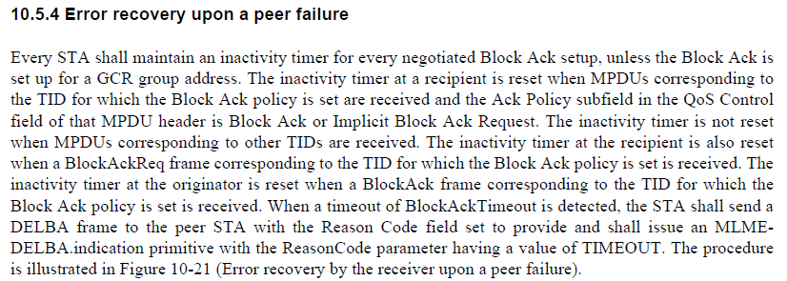

The subclause 6.3.29.2.2 (Semantics of the service primitive) of the IEEE P802.11mc D2.0 specifies timeout procedure as follows:
The maximum Block Ack timeout duration is 65535 x 1024μs ≈ 67.1 seconds in the current standard. As an S1G STA may sleep much longer duration, it is not long enough.
The commenter proposes to use the bit encoding specified in Figure 8-43a. The maximum value of scaling factor is 10000 as shown in Table 8-36a, the maximum timeout duration is follows;
16383 x 10000 x 1024μs ≈ 167762 seconds ≈ 46.6 hours.

Another solution is to change the unit of BlockAckTimeout from TU to Beacon Interval. With this solution, the maximum duration is 65535 x 65535 x 1024μs ≈ 50.9 days. It is sufficient for S1G STA.

Proposed Resolution:
Revised

6.3.29 Block Ack
6.3.29.2.2 Semantics of the service primitive
Instructions to TGah Editor: Change the associated table as follows (Only a row with change is shown, based on IEEE P802.11REVmc D2.0):

BlockAckTimeout | Integer | 0 – 65 535 | Specifies the number of TUsa time limit, in unit of Beacon Interval if dot11S1GOptionImplemented is true and TU otherwise, without a frame exchange between peers after which the Block Ack is considered to be torn down.

6.3.29.3.2 Semantics of the service primitive
Instructions to TGah Editor: Change the associated table as follows (Only a row with change is shown, based on IEEE P802.11REVmc D2.0):

BlockAckTimeout | Integer | 0 – 65 535 | Specifies the number of TUsa time limit, in unit of Beacon Interval if dot11S1GOptionImplemented is true and TU otherwise, without a frame exchange between peers after which the Block Ack is considered to be torn down.

6.3.29.4.2 Semantics of the service primitive
Instructions to TGah Editor: Change the associated table as follows (Only a row with change is shown, based on IEEE P802.11REVmc D2.0):

BlockAckTimeout | Integer | 0 – 65 535 | Specifies the number of TUsa time limit, in unit of Beacon Interval if dot11S1GOptionImplemented is true and TU otherwise, without a frame exchange between peers after which the Block Ack is considered to be torn down.

6.3.29.5.2 Semantics of the service primitive
Instructions to TGah Editor: Change the associated table as follows (Only a row with change is shown, based on IEEE P802.11REVmc D2.0):

BlockAckTimeout | Integer | 0 – 65 535 | Specifies the number of TUsa time limit, in unit of Beacon Interval if dot11S1GOptionImplemented is true and TU otherwise, without a frame exchange between peers after which the Block Ack is considered to be torn down.

8.4.1 Fields that are not elements
8.4.1.15 Block Ack Timeout Value field
Instructions to TGah Editor: Modify the second paragraph of the 8.4.1.15 as follows;

The Block Ack Timeout Value field contains the duration, in TUs unit of Beacon Interval if dot11S1GOptionImplemented is true and TU otherwise, after which the Block Ack setup is terminated, if there are no frame exchanges (see 10.5.4 (Error recovery upon a peer failure)) within this duration using this Block Ack agreement. A value of 0 disables the timeout.

