IEEE P802.11
Wireless LANs
LB 200 cluase 9.47.4 comment resolution
Date: 2014-01-20
Author(s):
Name | Affiliation | Address | Phone | email
Yongho Seok | LG Electronics |  |  | yongho.seok@lge.com
Kaiying Lv | ZTE corp. |  |  | lv.kaiying@zte.com.cn
Abstract
This submission proposes comment resolutions of the clause 9.47.4 from TGah Draft 1.0.
- CIDs: 1541, 2847, 2848, 2129

Interpretation of a Motion to Adopt

A motion to approve this submission means that the editing instructions and any changed or added material are actioned in the TGah Draft. This introduction is not part of the adopted material.

Editing instructions formatted like this are intended to be copied into the TGah Draft (i.e. they are instructions to the 802.11 editor on how to merge the text with the baseline documents).

TGah Editor: Editing instructions preceded by “TGah Editor” are instructions to the TGah editor to modify existing material in the TGah draft. As a result of adopting the changes, the TGah editor will execute the instructions rather than copy them to the TGah Draft.

CID | Page | Clause | Comment | Proposed Change | Resolution
1541 | 198.23 | 9.47.4 | how will the RID protection be done on TXOP sectorization? Also is the Speed Frame exchange allowed? If yes, explain how. | as in the comment | Revised-  TGah editor to make changes shown in 11-14-0076r1 under the heading for CID 1541
2847 | 199.04 | 9.47.4 | "When the protection is set up by the AP's omni-directional beam transmission for a duration within a TXOP and if the spatially orthogonal (SO) condition is confirmed by an OBSS station or OBSS AP, the OBSS station or OBSS AP can reset its NAV to initiate a new spatially orthogonal exchange starting with a nonbeamformed RTS/CTS."  When the protection is set up by the AP's omni-directional beam transmission inside the same BSS, the resetting of the NAV triggered by the OBSS-SO condition shall not be allowed.  Otherwise, the resetting of the NAV can make a collision inside the same BSS when the SO condition is confirmed in the same BSS. | The resetting the NAV from the SO condition shall apply only to the NAV updated from the OBSS transmission.  On this purpose, maintaining the two NAV timer (BSS NAV and OBSS NAV) is appropriate.  Commenter will submit a resolution. | Revised-  TGah editor to make changes shown in 11-14-0076r1 under the heading for CID 2847
2848 | 202.31 | 9.47.4 | The RXVECTOR parameter COLOR can be utilized to detect the SO condition because it can classify the frame type between the same BSS transmission and OBSS transmission. | Add how to satisfy the SO condition through the RX VECTOR parameter COLOR.  Commenter will submit a resolution. | Revised-  TGah editor to make changes shown in 11-14-0076r1 under the heading for CID 2848
2129 | 199.07 | 9.47.4 | The detail rules for spatial re-use for OBSS AP/STA is missing. If an OBSS STA/AP's frame exchange lasts beyond the protected BF duration, it will cause unfairness to STAs that support TXOP spatial re-use. The backoff procedure of OBSS STA/AP in protected BF duration should be defined.? | Detailed rules will be offered within a comment resolution. | Revised-  TGah editor to make changes shown in 11-14-0076r1 under the heading for CID 2129

CID 1541

Discussion:

Regarding CID 1541, when the SO condition is met, the RID should be also reset in order to allow simultaneous transmissions. And, it does not have any restriction about a Speed Frame (SF) exchange. Because a responding STA of a SF exchange does not make any interference according to the the following highlighted rule.

“Note that an OBSS station or OBSS AP infers its spatial orthogonality with the AP by observing the first omni-beam packet and the omni-preamble of the long preamble but not observing the subsequent sectorized beam transmission and with the station by observing a gap of no transmission between the first omni-beam packet and the omni-preamble of the long preamble.”

CID 2847

Discussion:

Regarding the NAV resetting of the TXOP-based sectorization operation, the problem is the TXOP-based sectorization operation shall not be allowed when the NAV of the OBSS STA is already set to a non-zero value.
The following figure shows an example. In the figure, STA2 sets the NAV after overhearing CTS frame transmitted from AP1. Then, STA2 receives a CTS frame with the early sector indicator set to 1. When the SO condition of STA2 is met, current procedure defined Draft 1.0 is saying that it can reset its NAV. However, as shown in the following, if the NAV of STA2 is reset and STA2 immediately accesses the medium, it can make a collision with transmission of STA1.

When the NAV has been updated from the same BSS transmission, the resetting the NAV from the SO condition should not be allowed.

CID 2848
When a PSDU is transmitted in Sectorized Beam, the STA can not listen to the MAC header of the sectorized beam transmission. So, it is hard to confirm that the PPDU corresponds to the OBSS transmission. In that case, the RXVECTOR parameter COLOR is useful to classify the OBSS transmission.

CID 2129

Discussion:
Commenter suggests tolimit the spacial reuse within the current TXOP in order to avoid asynchronous overlapping TXOPs.
As shown in the figure below, STA2 has its NAV set by RTS till time t1, and then has its NAV updated till time t2 by OBSS STA/AP who met the SO condition and started an SO frame exchange. Therefore STA2 can not contend the medium until t2. However AP1 and STA1 and OBSS STA/AP who are enjoying spacial reuse can start to contend again after t1 whereas STA2 can not.

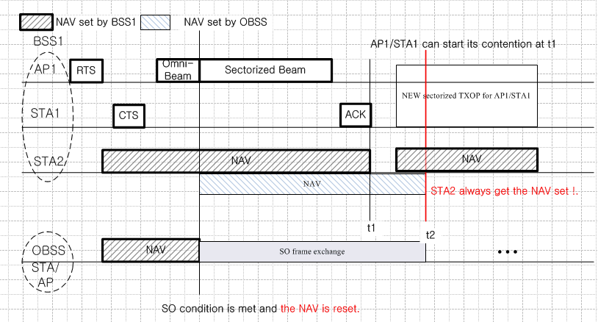

Even without using a Spatially Orthogonal (SO) condition, asynchronous overlapping TXOPs can occur.
But, the SO initiator has all of the information necessary to avoid creating this problem in this case and it should use this information to avoid creating an asynchronous overlap for the unfortunate victim that lies between the two links. An SO backoff procedure should be introduced

Propose:
Revised for CID 1541, 2847, 2848, 2129 per discussion and editing instructions in 11-14/0076r1.

TGah editor: Modify the sub-clause 9.47.4 as the following:

9.47.4 TXOP-based sectorization operation

Change the following paragraph (Page 199, Lines 6-10) in the sub-clause 9.47.4 as follows:

When the a protection NAV and RID for a TXOP is set up by anthe AP's omni-directional beam transmission for a duration within a TXOPand a if the spatially orthogonal (SO) condition is confirmed by an OBSS non-AP STAstation or OBSS AP, the OBSS non-AP STAstation or OBSS AP can reset its NAV to may initiate an new spatially orthogonal SO exchange after an SO-Backoff . For a non-AP STA the SO-Backoff is initialized with the AC_VO parameters from the most recently received EDCA parameter set element sent by the AP with which the STA is associated. For an AP the SO-Backoff is initialized with the AC_VO parameters of the AP. The SO-Backoff function begins or resumes when the SO condition is confirmed. The SO-Backoff function is independent of all other backoff functions but follows the EDCAF backoff procedure as defined in 9.2.5. An OBSS non-AP STA or OBSS AP that invokes or resumes an SO-Backoff at the confirmation of an SO condition shall set an SO timer to MAX(NAV, RID) and reset its NAV and RID and suspend EDCAF backoff procedures. At the expiry of the SO timer, the SO-Backoff is suspended and the suspended EDCAF backoff procedures resume. An OBSS non-AP STA or OBSS AP that initiates a new spatially orthogonal frame exchange after an SO-Backoff procedure shall start the exchange startingwith a nonbeamformed RTS/CTS and shall limit the duration of the exchange such that it ends before the expiry of the SO timer. The new spatially orthogonal frame exchange initiator may transmit frames from any AC. The STA shall obey the TXOP limit of the AC of the frames transmitted within the SO frame exchange. A STA that transmits an SO frame exchange may transmit additional SO frame exchanges by continuing to use the SO-Backoff function until the expiry of the SO timer. If the ongoing frame exchange transmission is between a pair of STAs within its BSS, the STA does not reset its NAV and its RID even though the Spatially Orthogonal conditions are met.

Change the following paragraph (Page 202, Lines 30-38) in the sub-clause 9.47.4 as follows:

To facilitate the detection of the spatially orthogonal conditions by OBSS stations or OBSS APs, the short CTS NDP may be transmitted preceding the SO frame exchange. If the Early Sector Indicator in the NDP CTS frame is set to 1, it indicates that the NDP CTS frame is followed by the sectorized beam frame exchange. Setting the early sector indicator to 1 also indicates to the OBSS STAs that it can cancel its NAV and its RID setting if the Spatially Orthogonal conditions are subsequently met. If the ongoing frame exchange transmission preceding the CTS NDP is between a pair of STAs within its BSS, the STA does not reset its NAV and its RID even though the Spatially Orthogonal conditions are met. The RXVECTOR parameter COLOR is utilized to detect the SO condition by classifying the received PPDU between a same BSS transmission and an OBSS transmission. Hence, if the early sector indicator is set to 0, OBSS STA need not check for spatially orthogonal conditions. Figure 9-96 (CTS-to-self preceding SO frame exchange sequence) illustrates the frame exchange preceded by CTS-to-self using CTS NDP.

TGah editor: change all the occurances of “OBSS station” to “OBSS non-AP STA” throughout the sub-clause 9.47.4.

TGah editor: change all the occurances of “CTS NDP” and “Short CTS NDP” to “NDP CTS” throughout all sub-clauses of current TGah Draft 1.1.

