IEEE P802.11
Wireless LANs
P802.11ah CC9 Comment Resolutions for CID 571,582,583
Date: 2013-08-21
Author(s):
Name | Affiliation | Address | Phone | email
Mitsuru Iwaoka | Yokogawa Electric Co. | 2-9-32 Nakacho,  Musashino-shi, Tokyo  180-8750 Japan | +81 422 52 5519 | Mitsuru.Iwaoka@jp.  yokogawa.com
Abstract
These domument proposes resolutions for following comments of P802.11ah D0.1 Comment Correction (CC9) [1].

PHY CID: 571, 582, 583

CID | Page | Clause | Comment | Proposed Change
571 | 295 | 22.4.2 | In P802.11ac D5.1, MIB attributes dot11SUBeamformeeOptionImplemented,  dot11SUBeamformerOptionImplemented,  dot11MUBeamformeeOptionImplemented,  dot11MUBeamformerOptionImplemented, and dot11BeamformeeNTxSupport  are renamed to  dot11VHTSUBeamformeeOptionImplemented,  dot11VHTSUBeamformerOptionImplemented,  dot11VHTMUBeamformeeOptionImplemented,  dot11VHTMUBeamformerOptionImplemented, and dot11VHTBeamformeeNTxSupport, respectively, and moved to dot11VHTTransmitBeamformingConfigTable.  S1G PHY MIB attributes shall follow these changes. | 1) Rename  dot11SUBeamformeeOptionImplemented,  dot11SUBeamformerOptionImplemented,  dot11MUBeamformeeOptionImplemented,  dot11MUBeamformerOptionImplemented, and dot11BeamformeeNTxSupport  to  dot11S1GSUBeamformeeOptionImplemented,  dot11S1GSUBeamformerOptionImplemented,  dot11S1GMUBeamformeeOptionImplemented,  dot11S1GMUBeamformerOptionImplemented, and dot11S1GBeamformeeNTxSupport, respectively.  2) Create a new table dot11S1GTransmitBeamformingConfigTable with following attributes.  dot11S1GSUBeamformeeOptionImplemented,  dot11S1GSUBeamformeeOptionAcitated,  dot11S1GSUBeamformerOptionImplemented,  dot11S1GSUBeamformerOptionActivated,  dot11S1GMUBeamformeeOptionImplemented,  dot11S1GMUBeamformeeOptionActivated,  dot11S1GMUBeamformerOptionImplemented,  dot11S1GMUBeamformerOptionActivated,  dot11S1GNumberSoundingDimensions, and dot11S1GBeamformeeNTxSupport,

The following shows a snapshot of table 22-28 in the IEEE P802.11ac D6.0.
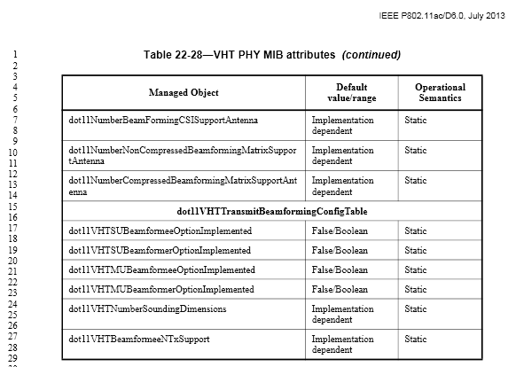

As there are no comments related to Table 22-28 during the last sponsor ballot [2], the VHT PHY MIBs can be considered as stable.
The S1G PHY is based on the VHT PHY. The S1G PHY MIB attributes shall be based on the VHT PHY MIB attributes.

Proposed Resolution:
Revised:

(Instruction to TGah Editor) Please modify the last 6 rows of Table 24-33 as follows (Blue text);

dot11TransmitBeamformingConfigTable
dot11S1GSUBeamformerOptionImplemented | False/Boolean | Static
dot11S1GSUBeamformeeOptionImplemented |  | Static
dot11S1GMUBeamformerOptionImplemented |  | Static
dot11S1GMUBeamformeeOptionImplemented |  | Static
dot11S1GNumberSoundingDimensions | Implementation  dependent | Static
dot11S1GBeamformeeNTxSupport | Implementation  dependent | Static

CID | Page | Clause | Comment | Proposed Change
582 |  | 10.24.16.2 | The subclause 10.24.16.2 (DMS procedures) of P802.11mc D1.4 specifies that dot11HighThroughputOptionImplemented shall be true for a non-DMG STA when dot11DMSImplemented is true.  This is not true for S1G STA. | Add the modification of the 4th sentence of the 3rd paragraph of the subclause 10.24.16.2 as follows:  ---  dot11S1GOptionImplemented shall be true for an S1G STA, dot11DMGOptionImplemented shall be true for a DMG STA, and dot11HighThroughputOptionImplemented shall be true otherwise.
583 |  | 10.24.16.3.1 | The subclause 10.24.16.3.1 (Overview) of P802.11mc D1.4 specifies that dot11HighThroughputOptionImplemented shall be true for a non-DMG STA when dot11RobustAVStreamingImplemented or dot11MeshGCRImplemented is true.  This is not true for S1G STA. | Replace "non-DMG STA" by "STA other than DMG or S1G" in the 2nd paragraph of the subclause 10.24.16.3.1.

These descriptions were introduced in IEEE Std 802.11aa-2012, and slightly modified in IEEE 802.11ad-2012. The following shows a snapshot of the paragraph in subclause 10.23.15.2 and 10.23.15.3.1 of IEEE Std 802.11ad-2012.
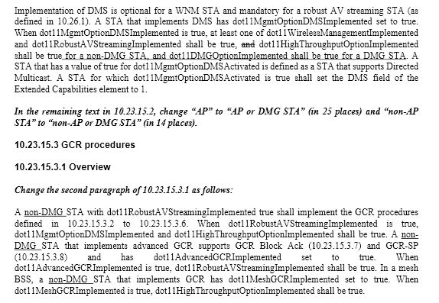

An S1G STA may implement DMS and/or robust AV streaming for off-loading use case, and shall set dot11HighThroughputOptionImplemented to false. A specification in this subclause is not satisfied by the S1G STA.
The same situation arises for a TVHT STA. The TVHT STA may implement DMS and/or robust AV streaming, but set dot11HighThroughputOptionImplemented to false.
It is better to amend these subclauses in P802.11af first. If modifications in P802.11af also cover the S1G STAs, it is not necessary to amend these subclauses in P802.11ah.

Proposed Resolution:
Rejected:

(Note) The commenter will provide comments for these subclauses in the sponsor ballot of P802.11af.
After TGaf resolves these comments, the necessity of modicitaion in P802.11ah will be reconsidered.

References:
[1] IEEE 802.11-13/0701r6 “TGah CC9 comments on D0.1”
[2] IEEE802.11-13/0942r1 “SB02 comments D6.0”

