IEEE P802.11
Wireless LANs
Comment Resolution for CID 11030
Date: 2013-08-15
Authors:
Name | Affiliation | Address | Phone | Email
Brian Hart | Cisco Systems | 170 W Tasman Dr, San Jose, CA 95134, USA |  | brianh@cisco.com
Robert Stacey | Intel |  |  | robert.stacey@intel.com
Edward Au | Huawei Technologies | 303 Terry Fox Drive, Suite 400, K2K 3J1 Kanata Ontario |  | edward.au@huawei.com

This submission presents proposed resolution to CID 11030. Changes indicated by a mixture of Word track-changes and instructions.

CID 11030

CID | Clause | Page | Line | Comment | Proposed Change
11030 | 22.1.4 | 225 | 65 | "Support for VHT format is mandatory if dot11VHTOptionImplemented is true."  This last part of the sentence is redundant, since we are talking about VHT STAs. | Remove " if dot11VHTOptionImplemented is true"

Discussion:
The following is a snapshot of the clause the commenter mentioned:

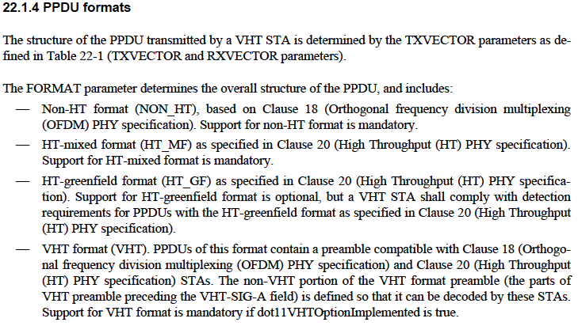
The proposal here is to move those mandatory and optional statements in each bullet to 22.1.1 (Introduction to the VHT PHY) (c.f., see snapshot in the next page), and state in 10.39.1 (Basic VHT BSS Functionality) that a VHT STA has dot11VHTOptionImplemented equal to true.

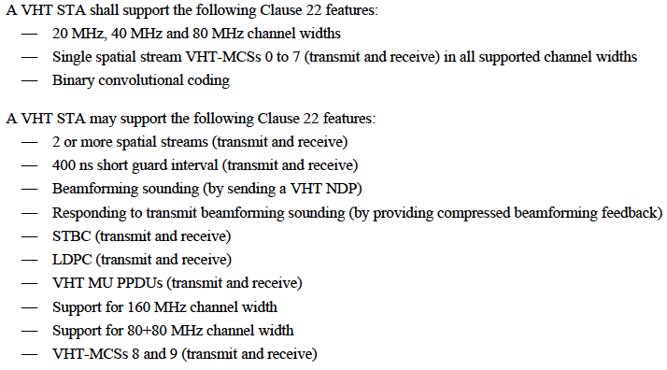

Proposed Resolution:
Revised.

TGac Editor: Please modify the second paragraph of clause 22.1.4 (lines 48-65, page 225) as follows.
For a VHT STA, the FORMAT parameter determines the overall structure of the PPDU, and includes:
- Non-HT format (NON_HT), based on Clause 18 (Orthogonal frequency decision multiplexing (OFDM)) PHY Specification).
- HT-mixed format (HT_MF) as specified in Clause 20 (High Throughput (HT) PHY specification).
- HT-greenfield format (HT_GF) as specified in Clause 20 (High Throughout (HT) PHY specification).
- VHT format (VHT). PPDUs of this format contain a preamble compatible with Clause 18 (Orthogonal frequency division multiplexing (OFDM) PHY specification) and Clause 20 (High Throughout (HT) PHY specification) STAs. The non-VHT portion of the VHT format preamble (the parts of VHT preamble preceding the VHT-SIG-A field) is defined so that it can be decoded by these STAs.

TGac Editor: Please add the following NOTE right after the second paragraph of clause 22.1.4 (lines 48-65, page 225).
NOTE: Required support for these formats is defined in 20.1.1 (Introduction to the HT PHY) and 22.1.1 (Introduction to the VHT PHY) through 10.39 (Basic VHT BSS functionality).

TGac Editor: Please add the following sentences in the bulleted list of the second last paragraph of clause 22.1.1 (lines 37-42, page 224).
A VHT STA shall support the following features:
- Non-HT and non-HT duplicate formats (transmit and receive) for all bandwidths supported by VHT STA
- HT-mixed format (transmit and receive)
- VHT format (transmit and receive)
- 20 MHz, 40 MHz and 80 MHz channel widths
- Single spatial stream VHT-MCSs 0 to 7 (transmit and receive) in all supported channel widths
- Binary convolutional coding

TGac Editor: Please add the following sentences in the bulleted list of the last paragraph of clause 22.1.1 (lines 44-60, page 224).
A VHT STA may support the following features:
- HT-greenfield format (transmit and receive)
- 2 or more spatial streams (transmit and receive)

TGac Editor: Please add the following sentence at the beginning of clause 10.39.1 (line 54, page 189).
A VHT STA has dot11VHTOptionImplemented equal to true.

