IEEE P802.11
Wireless LANs
Assorted Sponsor Ballot 2 Comment Resolution
Date: 2013-08-08
Author:
Name | Affiliation | Address | Phone | Email
Edward Au | Huawei Technologies | 303 Terry Fox Drive, Suite 400, K2K 3J1 Kanata Ontario |  | edward.au@huawei.com

This submission presents proposed resolution to CIDs 11005, 11006, 11028, 11029, 11030, 11032, 11033, and 11034. Changes indicated by a mixture of Word track-changes and instructions.

CID 11005

CID | Clause | Page | Line | Comment | Proposed Change
11005 | 9.31.5.2 | 174 | 29 | A dot11VHTSUBeamformeeActivated is used here, but it is not defined in 22.4.2 nor C.3. | Replace dot11VHTSUBeamformeeActivated by dot11VHTSUBeamformeeOptionImplemented.

Discussion:
The following shows a snapshot of the paragraph the commenter mentioned.
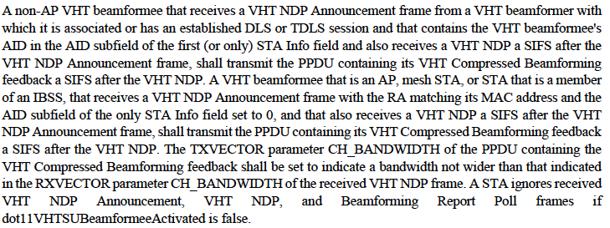
The commenter is correct that there is no term “dot11VHTSUBeamformeeActivated” in clause 22.4.2 and C.3. Indeed, this term does not exist throughout the draft specification version 6.0 and the published IEEE 802.11-2012 specification. Further, it is correct that “dot11VHTSUBeamformeeActivated” should be replaced by “dot11VHTSUBeamformeeOptionImplemented”. Examples of support can be found in clause 9.31.5.1:
Proposed Resolution:
Accepted.

TGac Editor: Please modify the last sentence (lines 27-29) of the second paragraph in page 174 as follows:
A STA ignores received VHT NDP Annoucement, VHT NDP, and Beamforimg Report Poll frames if dot11VHTSUBeamformeeOptionImplemented is false.

CID 11006

CID | Clause | Page | Line | Comment | Proposed Change
11006 | 9.21.10.3 |  |  | A method to detect a beginning of reception of an expected response to a BlockAckRequest frame in subclause 9.21.10.3 (GCR Block Ack BlockAckReq and BlockAck frame exchanges) of IEEE Std 802.11aa-2011 shall be modifed in a same way of subclause 9.19.3.2.4 (Recovery from the absence of an expected reception). | Insert a new subclause 9.21.10.3 (GCR Block Ack BlockAckReq and BlockAck frame exchanges) with modification of the 9th paragraph as follows:  The beginning of reception of an expected response to a BlockAckRequest frame is detected by the occurrence of a PHY-CCA.indication(BUSY,channel-list) primitive at the STA that is expecting the response where the channel-list parameter is absent, or, if present, includes "primary".

Discussion:
The following shows a snapshot of the paragraph the commenter mentioned. In short, the recovery procedure in HCCA is modified according to the channel-list paramters of VHT.
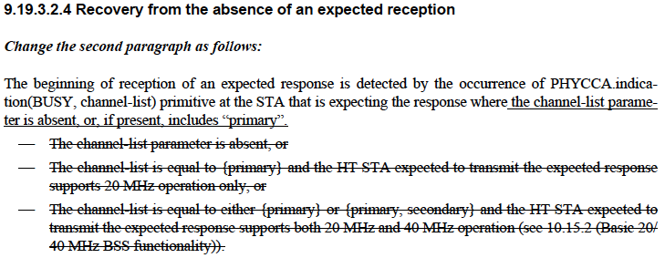

For clause 9.21.10.3 (GCR Block Ack BlockAckReq and BlockAck frame exchanges) of the IEEE 802.11aa-2011 specification, or clause 9.22.10.3 of the draft specification version 1.5 of IEEE 802.11mc, however, similar change is yet to be implemented. See the following snapshot:

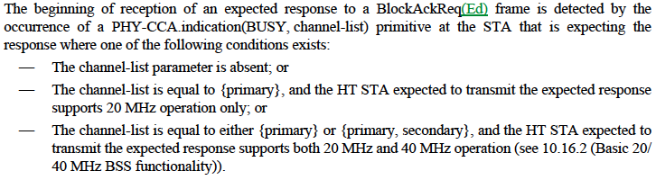

Proposed Resolution:
Accepted.

TGac Editor: Please insert a new subclause 9.21.10.3 (GCR Block Ack BlockAckReq and BlockAck frame exchanges) with modification of the 9th paragraph as follows.

9.21 Block Acknowledgment (Block Ack)

9.21.10 GCR Block Ack

9.21.10.3 GCR Block Ack BlockAckReq and BlockAck frame exchanges

The beginning of reception of an expected response to a BlockAckReq frame is detected by the occurrence of a PHY-CCA.indication(BUSY, channel-list) primitive at the STA that is expecting the response where the channel-list parameter is absent, or, if present, includes “primary”.

CID 11028

CID | Clause | Page | Line | Comment | Proposed Change
11028 | 18.2.27 | 214 | 33 | Replace "duplicated bandwidth of the PPDU" with "bandwidth of the duplicate PPDU" | As in comment.  See also, page 215, L 27

Discussion:
The commenter points out correctly that there is no duplicated bandwitdth of the PPDU.

Proposed Resolution:
Accepted.

TGac Editor: Please modify the first paragraph of clause 18.2.2.27 (lines 31-34, page 214) as follows.
If present, the allowed values for CH_BANDWIDTH_IN_NON_HT are CBW20, CBW40, CBW80, CBW160 and CBW80+80. If present, this parameter is used to modify the first 7 bits of the scrambling sequence to indicate the bandwidth of the duplicated PPDU.

TGac Editor: Please modify the first paragraph of clause 18.2.3.27 (lines 26-30, page 215) as follows.
If present, the allowed values for CH_BANDWIDTH_IN_NON_HT are CBW20, CBW40, CBW80, CBW160, and CBW80+80. If present and valid, this parameter indicates the bandwidth of the duplicated PPDU. This parameter is used by the MAC only when valid (see 9.3.2.6 (CTS and DMG CTS procedure) and 9.7.6.6 (Channel Width selection for control frames)).

CID 11029

CID | Clause | Page | Line | Comment | Proposed Change
11029 | 22.1.4 | 225 | 49 | The list of PPDU formats transmitted by a VHT STA does not include non-HT duplicate | Add non-HT duplicate format

Discussion:
The following is a snapshot of the clause the commenter mentioned:

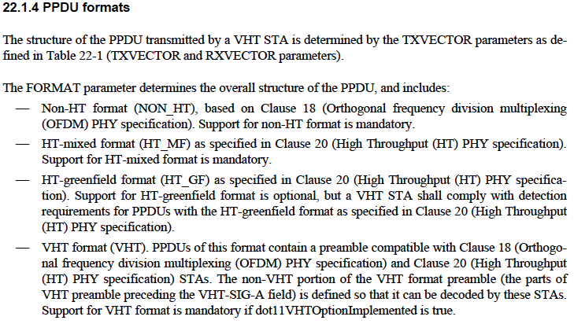
As referred to the comment, the commenter would like to add “non-HT duplicate” to the first item (Non-NT format) of FORMAT parameter.

Referring to Table 22-1 (c.f., see the snapshot below), however, NON_HT format actually indicates Clause 18 or non-HT duplicated PPDU format.

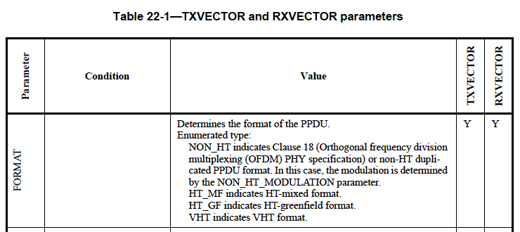

Proposed Resolution:
Rejected.
Referring to Table 22-1 (c.f., line 29, page 226), NON_HT format includes non-HT duplicated PPDU format.

CID 11030

CID | Clause | Page | Line | Comment | Proposed Change
11030 | 22.1.4 | 225 | 65 | "Support for VHT format is mandatory if dot11VHTOptionImplemented is true."  This last part of the sentence is redundant, since we are talking about VHT STAs. | Remove " if dot11VHTOptionImplemented is true"

Discussion:
The following is a snapshot of the clause the commenter mentioned:

As far as I understand, the intention here is to indicate clearly Non_HT format (NON_HT), HT-mixed format (HT_MF), and VHT format (VHT) shall be mandatorily supported. To support the VHT format, however, there is a condition that dot11VHTOptionImplemented is true. The question here is whether it makes sense if a VHT STA does not support VHT format.

Proposed Resolution:
Accepted.

TGac Editor: Please delete the last sentence of the second paragraph of clause 22.1.4 (line 65, page 214).

CID 11032

CID | Clause | Page | Line | Comment | Proposed Change
11032 | 22.3.6 | 256 | 6 | There is only one VHT long training field (see e.g. Figure 22-4, Table 22-4) | Replace "Number of VHT long training fields" with "Number of symbols in the VHT long training field"

Discussion:
The following is a snapshot of the clause the commenter mentioned:

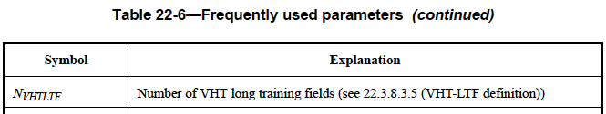

The commenter is correct that there is only one VHT long training field and therefore, the definition of N_{VHTLTF} should be modified.

There is actually a definition of N_{VHTLTF} in caluse 22.3.8.3.5:

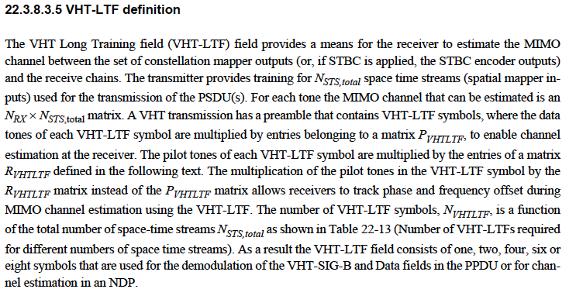

Proposed Resolution:
Counter

TGac Editor: Please modify the definition of N_{VHTLTF} in Table 22-6 (line 6, page 256) as follows.
N_{VHTLTF} | Number of VHT-LTF symbols (see 22.3.8.3.5 (VHT-LTF definition))

CID 11033

CID | Clause | Page | Line | Comment | Proposed Change
11033 | 22.3.7.1 | 256 | 42 | There is no concept of left and right in matrices, at least not as they are used here. | Remove "The index for the top left element of Q is (1, 1)"

Discussion:
The following is a snapshot of the clause the commenter mentioned:

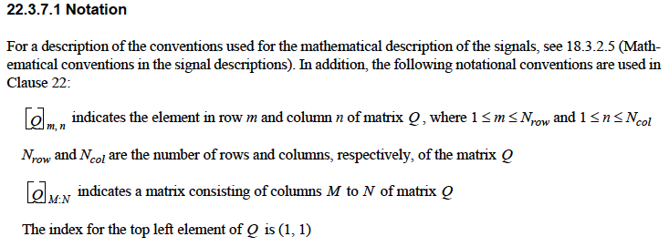

Actually, the notation (1,1) is not needed because it is not used from 22.3.7.1 to the end of the clause (c.f. 22.5).

Proposed Resolution:
Accepted.

TGac Editor: Please delete the sentence (The index for the top left element of Q is (1,1)) in line 42, page 214.

CID 11034

CID | Clause | Page | Line | Comment | Proposed Change
11034 | 22.3.7.4 | 261 | 17 | Add introductory sentence before the list of notations. | Insert sentence: "In (22-13), the following notations are used: "

Discussion:
The following is a snapshot of the clause the commenter mentioned:

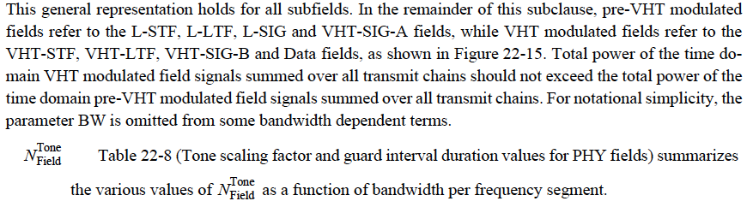

The commenter is correct that it is quite odd to show list the notations without any introductory sentence.

Proposed Resolution:
Accepted.

TGac Editor: Please add the following paragraph right after the first paragraph in page 261.
In (22-13), the following notations are used:

