IEEE P802.11
Wireless LANs
802.11ac Operating Classes in China
Date: 2013-07-11
Author(s):
Name | Affiliation | Address | Phone | email
Zhendong Luo | CATR |  |  | luozhendong@catr.cn
Sun, Bo | ZTE Corporation |  |  | sun.bo1@zte.com.cn
Eldad Perahia | Intel |  |  | eldad.perahia@intel.com
Osama Aboul-Magd | Huawei |  |  | Osama.aboulmagd@huawei.com
Edward Au | Huawei |  |  | edward.au@huawei.com
Meng Yang | CATR |  |  | yangmeng1@catr.cn
Abstract
This document provides the resolution for CID 10206, in which 802.11ac operating classes in China are defined.

Comments:

CID | Page | Clause | Comment | Proposed Change | Resolution
10206 | 393 | E.1 | China's spectrum regulator recently released a new spectrum in 5GHz frequency band for wireless access systems. See 13/0329r1. | In order to align the channels available in China with those in other regions, please add a subclause in Annex E for Operating Classess in China. | Revised. See the following lines for details.

Discussion:
As introduced in 13/0329r1, China's spectrum regulator recently released a new 5 GHz spectrum (5150-5350MHz), plus the original 5.8 GHz spectrum (5,725-5,850MHz), the total bandwidth available for 802.11ac in China is up to 325 MHz. In order to support the updated 5 GHz spectrum regulation of China, it is very necessary to modify the related content of the current 11ac draft specfication. First of all, the operating classes in China need to be defined to support 802.11ac devices working in China. To keep compatibility and coexistence, 802.11ac channels for China should be aligned with those in other regions, as shown in the following figure. In addition, the updated China’s 5GHz spectrum regulation document need to be included in Regulatory requirement list (Table D-1).

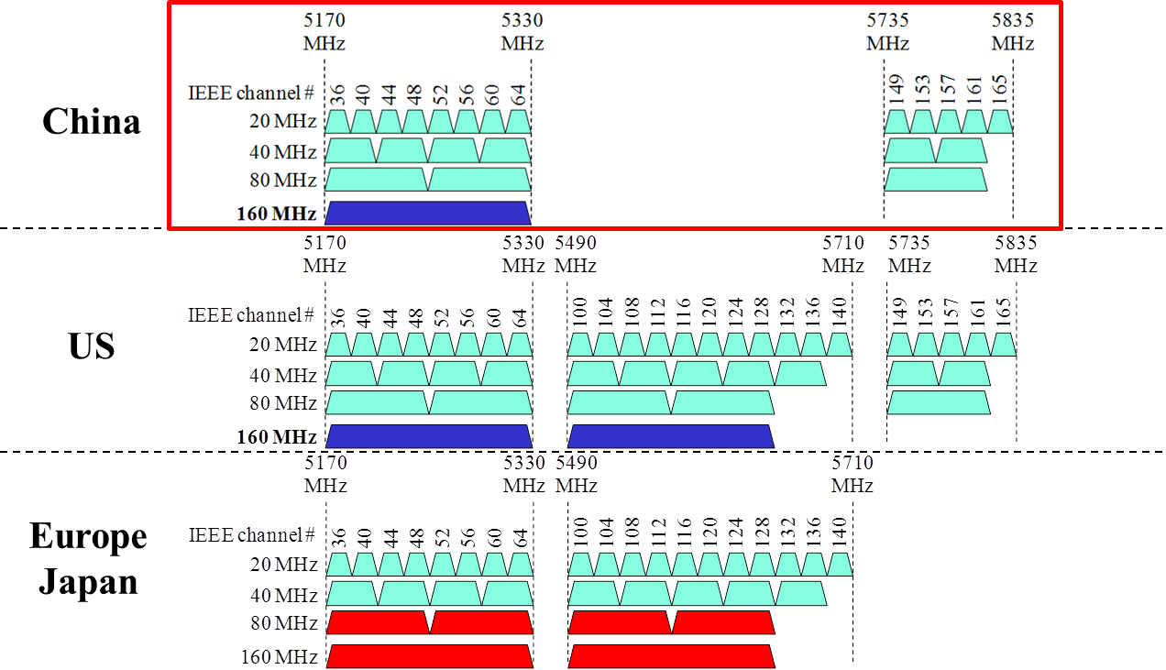

Context:

Annex D

Regulatory references

D.1 External regulatory references

Table D-1—Regulatory requirement list

Geographic  area | Approval standards | Documents | Approval  authority
China | Ministry of Industry and Information  Technology (MIIT) | Xin Bu Wu [2002] #353,  Xin Bu Wu [2002] #277,  Gong Xin Bu Wu Han [2012] #620 | MIIT
…

Annex E

Country elements and operating classes

E.1 Country information and operating classes

Table E-5 Operating classes in China
Operating class | Global operating class (see Table E-4) | Channel starting frequency (GHz) | Channel spacing (MHz) | Channel set | Channel center frequency index | Behavior limits set
1 | 115 | 5 | 20 | 36, 40, 44, 48 |  | UseEirpForVHTTxPowEnv
2 | 118 | 5 | 20 | 52, 56, 60, 64 |  | DFS_50_100_Behavior  UseEirpForVHTTxPowEnv
3 | 125 | 5 | 20 | 149, 153, 157, 161,  165 |  | UseEirpForVHTTxPowEnv
4 | 116 | 5 | 40 | 36, 44 |  | PrimaryChannelLowerBehavior  UseEirpForVHTTxPowEnv
5 | 119 | 5 | 40 | 52, 60 |  | PrimaryChannelLowerBehavior  DFS_50_100_Behavior  UseEirpForVHTTxPowEnv
6 | 126 | 5 | 40 | 149, 157 |  | PrimaryChannelLowerBehavior  UseEirpForVHTTxPowEnv
7-127 | Reserved | Reserved | Reserved | Reserved | Reserved | Reserved
128 | 128 | 5 | 80 | - | 42, 58, 138,155 | UseEirpForVHTTxPowEnv
129 | 129 | 5 | 160 | - | 50 | UseEirpForVHTTxPowEnv
130 | 130 | 5 | 80 | - | 42, 58, 138,155 | 80+,  UseEirpForVHTTxPowEnv
131-255 | Reserved | Reserved | Reserved | Reserved | Reserved | Reserved
NOTE 1—The channel spacing for operating classes 4 through 6 is for the supported channel width rather than the operating channel width. In these operating classes, the AP operates in a 20/40 MHz BSS, and the operating channel width for a non-AP STA is either 20 MHz or 40 MHz.
NOTE 2—The channel spacing for operating classes 128, 129 and 130 is for the supported channel width rather than the operating channel width.

