IEEE P802.11  
Wireless LANs

|  |  |  |  |  |
| --- | --- | --- | --- | --- |
| Clause 22 PHY comment resolutions for SB 0 | | | | |
| Date: July-08-2013 | | | | |
| Author(s): | | | | |
| Name | Affiliation | Address | Phone | email |
| Yusuke Asai | NTT | 921A, 1-1, Hikarinooka, Yokosuka, Kanagawa 2390847 | +81 46 859 3494 | asai.yusuke@lab.ntt.co.jp |
|  |  |  |  |  |

Abstract

This submission contains miscellaneous PHY comment resolutions in Clause 22 for TGac D5.0 Sponsor Ballot.

There are fifteen such comments: 10089, 10090, 10091, 10120, 10136, 10121, 10092, 10122, 10124, 10093, 10125, 10095, 10094, 10097 and 10098.

All comments belong to PHY ad-hoc group.

R0: Initial Version

| **CID** | **Commentor** | **Page** | **Clause** | **Comment** | **Proposed Change** |
| --- | --- | --- | --- | --- | --- |
| 10089 | Schelstraete, Sigurd | 238.54 | 22.3.4.2 | Use consistent reference when mentioning windowing | When applying windowing, sometimes the referenced section is 22.3.7.4 (see e.g. p238.54 , p239.62, p 241.50), sometimes 18.3.2.5 (see e.g. p242.60, p243.52, p244.60, p246.16, ...)  18.3.2.5 looks like the better reference. Propose to consistently use this in the places listed above |

**Context:**

At 238.53: (**22.3.4.2 Construction of L-STF**)

f) Insert GI and apply windowing: Prepend a GI (LONG_GI) and apply windowing as described in　22.3.7.4 (Transmitted signal).

At 242.60: (**22.3.4.5 Construction of VHT-SIG-A**)

i) Insert GI and apply windowing: Prepend a GI (LONG_GI) and apply windowing as described in 18.3.2.5 (Mathematical conventions in the signal descriptions).

At 258.01: (**22.3.7.4 Transmitted signal**)

 is a windowing function. An example function,  is given in 18.3.2.5 (Mathematical conventions in the signal descriptions). *T*Subfield is *TL-STF* for L-STF, *TL-LTF* for L-LTF, *TL-SIG* for L-SIG, *TSYML* for VHT-SIG-A, *TVHT-STF* for VHT-STF, *TVHT-LTF* for VHT-LTF and *TVHT-SIG-B* for VHT-SIG-B. *T*Subfieldis *TSYM* for VHT-Data, that is *TSYML* when not using the short guard interval (Short GI field of VHT-SIG-A is 0) and *TSYMS* when using the short guard interval (Short GI field of VHT-SIG-A is 1).

**Discussion:**

In D5.0, windowing function for L-STF, L-LTF and L-SIG is referred from 22.3.7.4. On the other hands, 18.3.2.5 is referred for VHT-SIG-A, VHT-STF, VHT-LTF, VHT-SIG-B, and data symbols. The subsection 22.3.7.4 (Transmitted signal) defines the window function to all fields of a VHT PPDU; therefore, the subclause is better reference than 18.3.2.5.

**Proposed resolution to CID 10089:**

Revised. Change the reference for windowing function from “18.3.2.5 (Mathematical conventions in the signal descriptions)” to “22.3.7.4 (Transmitted signal)” in P242L60, P243L52, P244L60, P246L16, P247L05, P247L60 and P248L40.

|  |  |  |  |  |  |
| --- | --- | --- | --- | --- | --- |
| 10090 | Schelstraete, Sigurd | 240.52 | 22.3.4.4 | Last sentence of bullet a) is redundant | The last sentence reads "Add calculated one bit parity and Ntail tails bits into the L-SIG symbol". The previous sentence already covers both parity and tail bits.  Proposal: remove last sentence of bullet a) |

**Context:**

At 240.51: (**22.3.4.4 Construction of L-SIG**)

1. For a VHT PPDU, set the RATE subfield in the SIGNAL field to 6 Mb/s. Set the Length, Parity and Tail bits in the SIGNAL field as described in 22.3.8.2.4 (L-SIG definition). Add calculated one bit parity and tail bits into the L-SIG symbol.

**Discussion:**

The second last sentence already says the parity and tail bits are added to the SIGNAL field and the last sentence is redundant.

**Proposed resolution to CID 10090:**

Accepted.

|  |  |  |  |  |  |
| --- | --- | --- | --- | --- | --- |
| 10091 | Schelstraete, Sigurd | 240.55 | 22.3.4.4 | Improve wording | Replace "L-SIG symbol of the PHY header" with "bits of the SIGNAL field" to use wording consistent with bullet a). |

**Context:**

At 240.55: (**22.3.4.4 Construction of L-SIG**)

1. BCC encoder: Encode the L-SIG symbol of the PHY header by a convolutional encoder at the rate of R=1/2 as described in 22.3.10.5.3 (Binary convolutional coding and puncturing).

**Discussion:**

A BCC encoder does not encoded the L-SIG symbol but the bit sequence of L-SIG field.

**Proposed resolution to CID 10091:**

Accepted.

|  |  |  |  |  |  |
| --- | --- | --- | --- | --- | --- |
| 10120 | Inoue, Yasuhiko | 241.01 | 22.3.3 | Figure 22-10 does not have STBC block after LDPC tone mapper and Constellation mapper blocks in each user. | Replace the Figure 22-10 with that embedded in 11-12/1438r3. |

**Context:**

At 241.01: (**22.3.3 Transmitter block diagram**)

(This figure is referred from P236L60)

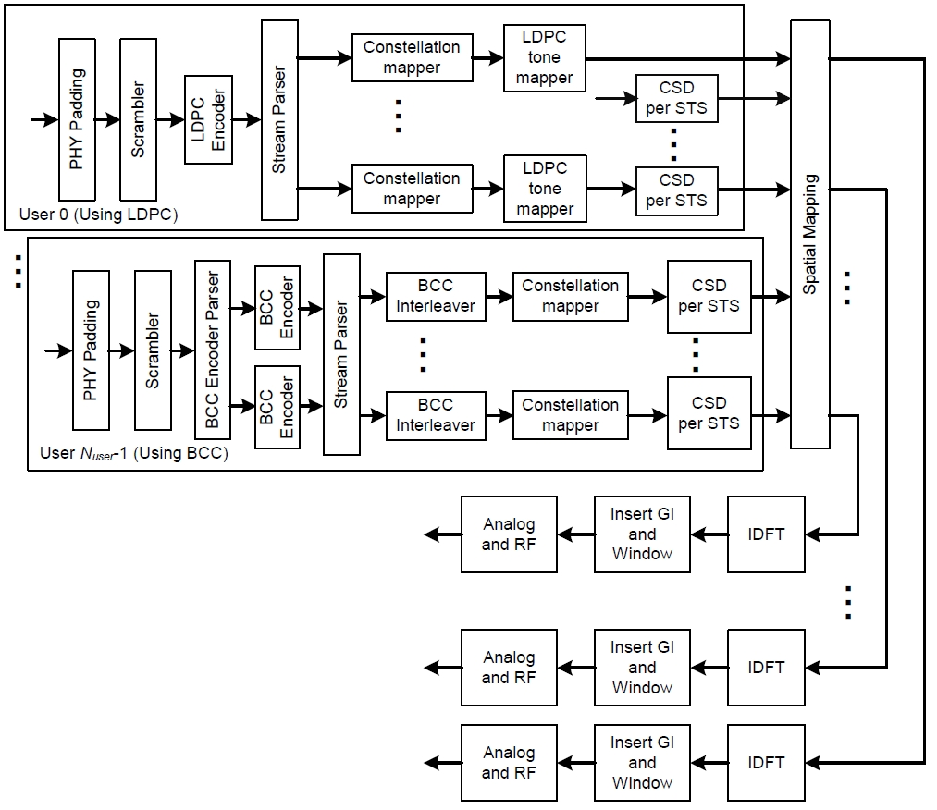

**Figure 22-10—Transmitter block diagram for the Data field of a 20 MHz, 40 MHz or 80 MHz VHT MU PPDU**

**Discussion:**

The comment is incorrect. Because STBC shall not be applied to a VHT MU PPDU as described in 22.3.10.9.4 (Space-time block coding) (P297L47). The Figure 22-10 still has an editorial error that the first CSD per STS block for the User 0 does not have an input.

**Proposed resolution to CID 10120:**

Revised. <This document> provides proposed change of the figure.

**Proposed figure change:**

At 241.01: 

**Figure 22-10—Transmitter block diagram for the Data field of a 20 MHz, 40 MHz or 80 MHz VHT MU PPDU**

(*The revised figure without redline is embedded below.*)



|  |  |  |  |  |  |
| --- | --- | --- | --- | --- | --- |
| 10136 | Kim, Youhan | 242.01 | 22.3.3 | According to 22.3.4.9.1, 22.3.4.9.2 and 22.3.10.9.~~3~~4, segment deparser is performed before STBC encoding. However, Figure 22-11 and 22-12 shows the segment deparser after the spatial mapping block. | Move the segment deparser block to before STBC in Figure 22-11 and 22-12. |

**Context:**

At 246.52 (**22.3.4.9.1 Using BCC**) and at 247.41(**22.3.4.9.2 Using LDPC**):

1. Segment deparser (if needed): For a contiguous 160 MHz transmission, merge the two frequency subblocks into one frequency segment as described in 22.3.10.9.3 (Segment deparser). This block is bypassed for 20 MHz, 40 MHz, 80 MHz and 80+80 MHz VHT PPDU transmissions.
2. STBC: Apply STBC as described in 22.3.10.9.4 (Space-time block coding).

At 297.51: (**22.3.10.9.4 Space-time block coding**)

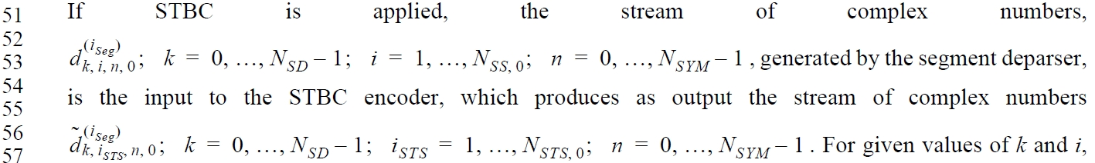

At 242.01: (**22.3.3 Transmitter block diagram**)

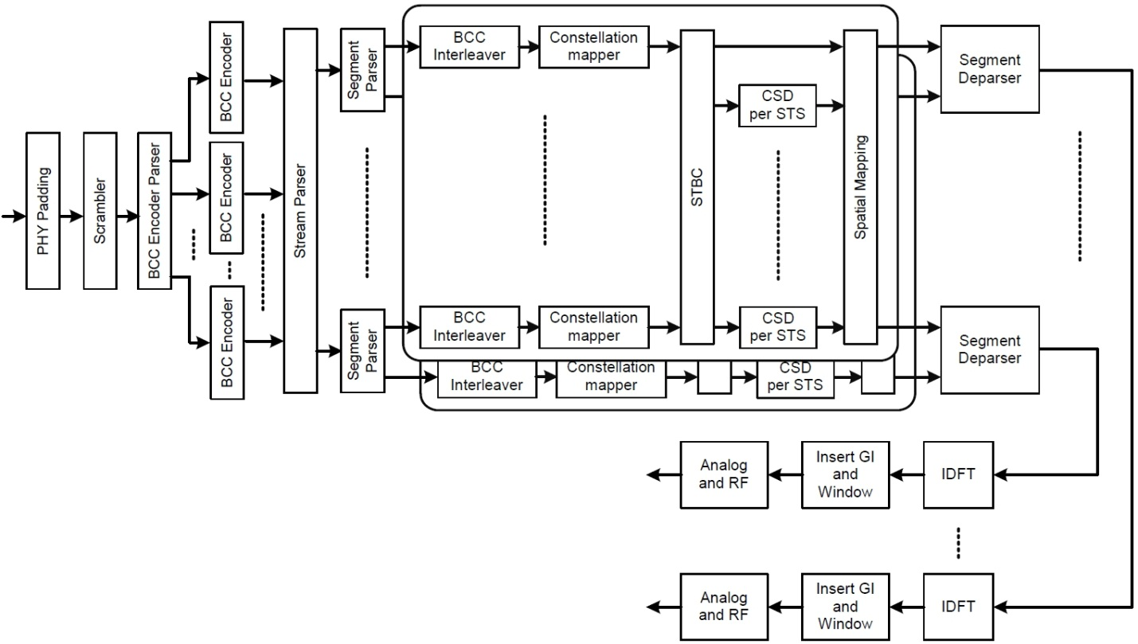

**Figure 22-11—Transmitter block diagram for the Data field of a 160 MHz VHT SU PPDU with BCC encoding**

At 243.01: (**22.3.3 Transmitter block diagram**)

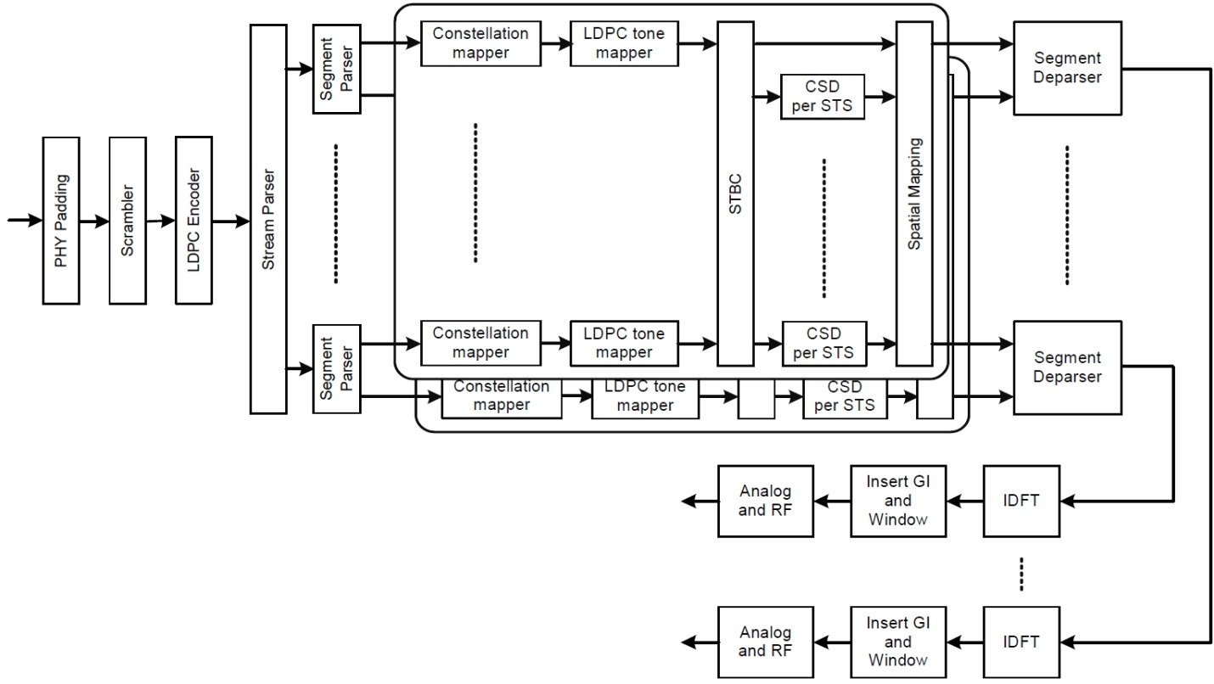

**Figure 22-12—Transmitter block diagram for the Data field of a 160 MHz VHT SU PPDU with LDPC encoding**

**Discussion:**

The orders of the STBC and the segment deparser blocks in Figures 22-11 and 22-12 do not correspond to the subclauses 22.3.4.9.1 and 22.3.4.9.2.

**Proposed resolution to CID 10136:**

Revised. The segment deparsers locate at just after the STBC block. <This document> provides proposed changes of the figures.

**Proposed figure change:**

At 242.01:



**Figure 22-11—Transmitter block diagram for the Data field of a 160 MHz VHT SU PPDU with BCC encoding**

At 243.01:



**Figure 22-12—Transmitter block diagram for the Data field of a 160 MHz VHT SU PPDU with LDPC encoding**

(*The revised figures without redline is embedded below.*)

 

|  |  |  |  |  |  |
| --- | --- | --- | --- | --- | --- |
| 10121 | Inoue, Yasuhiko | 254.64 | 22.3.7.4 | f_{CH,start} and the corresponding equation number should also be referred. As stated on the top of Table 22-27, f^(i_{Seg})_c is the function of f_{CH,start} and f_{(i_{seg})}. | Apply the resolution to CID 7052 in 12/1438r3. |

**Context:**

At 254.60: (**22.3.7.4 Transmitted signal**)

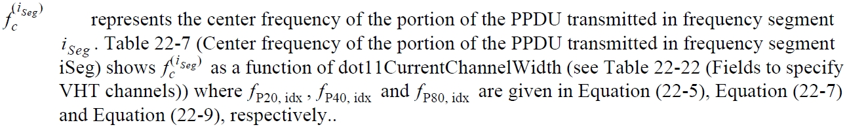

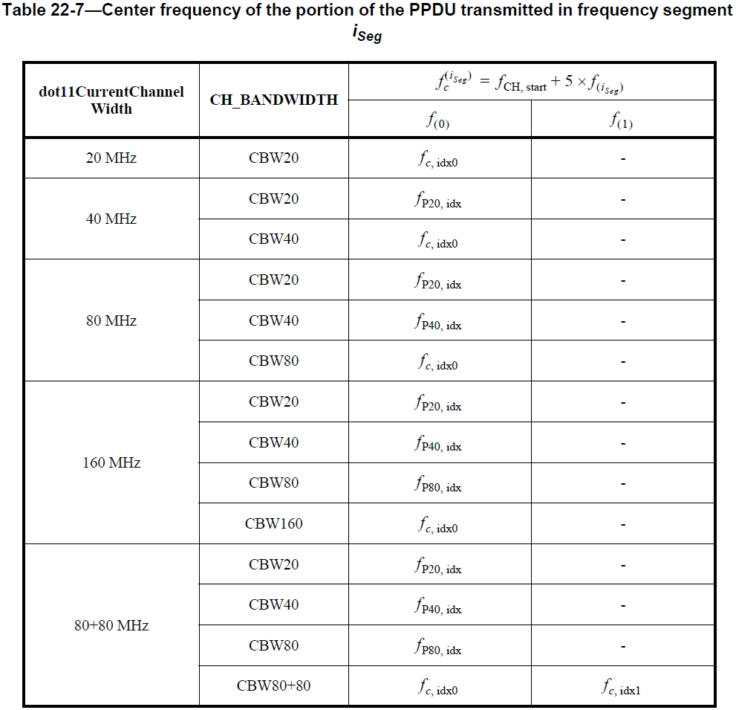

**Discussion:**

As in Table 22-7,  is one of the parameters for  and should be referred.

**Proposed resolution to CID 10121:**

Revised. <This document> provides proposed text changes.

**Proposed text change:**

At254.60:

 represents the center frequency of the portion of the PPDU transmitted in frequency segment . Table 22-7 (Center frequency of the portion of the PPDU transmitted in frequency segment ) shows as a function of the channel starting frequency and dot11CurrentChannelWidth (see Table 22-22 (Fields to specify VHT channels)) where , ,  and  are given in Equation (22-4), Equation (22-5), Equation (22-7) and Equation (22-9), respectively.

|  |  |  |  |  |  |
| --- | --- | --- | --- | --- | --- |
| 10092 | Schelstraete, Sigurd | 258.17 | 22.3.7.4 | Redundant definition | The notation [X]a.b for matrix elements has already been introduced in section 22.3.7.1 and doesn't need to be repeated here.  Propose to delete. |

**Context:**

At 258.17: (**22.3.7.4 Transmitted signal**)

 indicates the element in row *a* and column *b* of matrix *X*, where  and . .  and  are the number of rows and columns, respectively, of the matrix *X*.

At 252.29: (**22.3.7.1 Notation**)

For a description of the conventions used for the mathematical description of the signals, see 18.3.2.5 (Mathematical conventions in the signal descriptions). In addition, the following notational conventions are used inClause 22:

 indicates the element in row *m* and column *n* of matrix *Q*

…

**Proposed resolution to CID 10092:**

Revised. <This document> provides proposed text changes.

At 252.29: (**22.3.7.1 Notation**)

For a description of the conventions used for the mathematical description of the signals, see 18.3.2.5 (Mathematical conventions in the signal descriptions). In addition, the following notational conventions are used inClause 22:

 indicates the element in row *m* and column *n* of matrix *Q,* where  and . 

.  and  are the number of rows and columns, respectively, of the matrix *Q*.

…

At 258.17: (**22.3.7.4 Transmitted signal**)

|  |  |  |  |  |  |
| --- | --- | --- | --- | --- | --- |
| 10122 | Inoue, Yasuhiko | 258.61 | 22.3.7.5 | "Gamma" does not have context. It is better to change the title of this subclause to "Definition of phase rotation of tones". | As in comment. |

**Context:**

At 258.61

**22.3.7.5 Definition of gamma**

The function of  is used to represent a rotation of the tones.

**Discussion:**

“Definition of gamma” should be revised to include some context. In addition, although Equation (22-13) includes , the phase rotation fuction per 20 MHz bandwidth, there is no explanation about it in 22.3.7.4.

**Proposed Resolution to CID 10122:**

Revised. <This document> provides proposed text change.

**Proposed text change:**

At 258.30: Add the following sentence.

 is defined in 22.3.7.5 (Definition of rotation of the tones)

At 258.61:

**22.3.7.5 Definition of rotation of the tones**

|  |  |  |  |  |  |
| --- | --- | --- | --- | --- | --- |
| 10124 | Inoue, Yasuhiko | 264.53 | 22.3.8.3.2 | M_u is already defined in Table 22-6 (P252L12). | Delete the equation and refer to Table 22-6. |
| 10093 | Schelstraete, Sigurd | 264.54 | 22.3.8.3.2 | Repeated definition | M_u is already defined in Table 22-6. Moreover, it is slightly different here from Table 22-6. Propose to replace line with "Mu is defined in Table 22-6". |

**Context:**

At 252.13: (**Table 22-6—Frequently used parameters**)

|  |  |
| --- | --- |
| *Mu* | For pre-VHT modulated fields, *Mu* = 0, For VHT modulated fields,  *M*0 = 0 for *u* = 0 and  for *u* = 1, …, *Nuser* -1. |

At 264.53:

*Mu* is given by  with *M*0 = 0.

**Proposed Resolution to CID 10124:**

Revised. See the resolution to CID 10093 in <this document>.

**Proposed Resolution to CID 10093:**

Accepted.

|  |  |  |  |  |  |
| --- | --- | --- | --- | --- | --- |
| 10125 | Inoue, Yasuhiko | 265.39 | 22.3.8.3.3 | "SU and MU PPDUs" should be revised to "VHT SU and MU PPDUs" because a VHT-SIG-A field only exists on a VHT PPDU. | As in comment. |

**Context:**

At 265.37:

Note that the mapping of the NSTS/Partial AID field, the SU/MU[0] Coding field, the SU VHT-MCS/MU[1-3] Coding field, and the Beamformed field is different for SU and MU PPDUs.

At 2.38: (**3.1 Definitions**)

**single user (SU) physical layer protocol data unit (PPDU)**: A PPDU that carries a single PLCP service

data unit (PSDU), or no PSDU.

At 7.64: (**3.2 Definitions specific to IEEE 802.11**)

**very high throughput (VHT) single user (SU) physical layer protocol data unit (PPDU):** A VHT PPDU transmitted with the TXVECTOR parameters FORMAT equal to VHT and GROUP_ID equal to 0 or 63.

**Discussion:**

As defined in 3.1, an SU PPDU includes non-HT/HT/VHT PPDUs. Subsection 22.3.8.3.3 defines VHT-SIG-A, which exists on VHT PPDUs only.

**Proposed resolution to CID 10125:**

Accepted.

|  |  |  |  |  |  |
| --- | --- | --- | --- | --- | --- |
| 10095 | Schelstraete, Sigurd | 270.40 | 22.3.8.3.4 | Unclear references | It's not clear why references to Eqs (22-12) and (22-33) are needed here. Neither one has anything to say about the length of VHT-STF. Replace last sentence of this subclause with "The duration of the VHT-STF field is T_VHT-STF." |

**Context:**

At 270.40:

As indicated by Equation (22-12) and Equation (22-33), the duration of the VHT-STF field is *T*VHT-STF regardless of the Short GI field setting in VHT-SIG-A.

At 256.25:

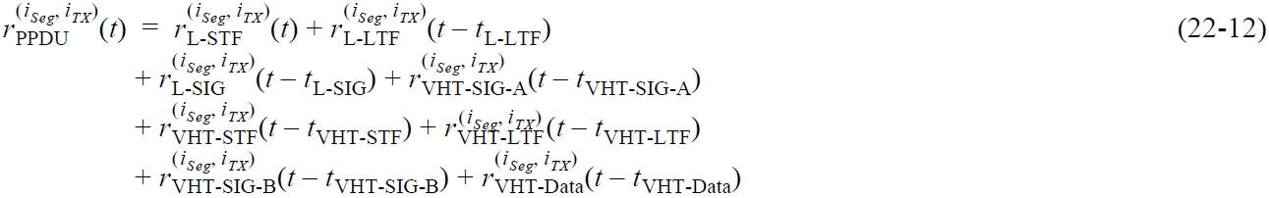

At 270.01:

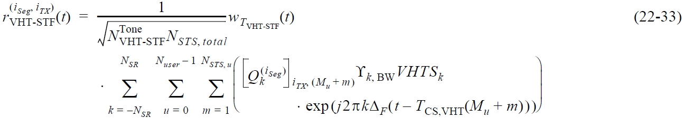

**Discussion:**

Neither Equations (22-12) nor (22-33) explicitly indicates that the duration of VHT-STF field is fixed to *T*VHT-STF regardless of the Short GI field setting in VHT-SIG-A. At 269.5, there is a sentence:

“The duration of the VHT-STF field is 4 μs.“, which explicitly defines the VHT-STF duration.

**Proposed resolution to CID 10095:**

Revised. <This document> provides proposed text change.

**Proposed text changes:**

At 269.5:

The duration of the VHT-STF field is*T*VHT-LTF regardless of the Short GI field setting in VHT-SIG-A.

At 270.40:

|  |  |  |  |  |  |
| --- | --- | --- | --- | --- | --- |
| 10094 | Schelstraete, Sigurd | 268.64 | 22.3.8.3.3 | Confusing caption title | Caption reads "Data constellation in the VHT PPDU". What is shown is not data. Change to "Data tone constellation in VHT PPDU pre-VHT modulated fields" (See Clause 20 for similar wording in HT-SIG) |

**Context:**

At 268.54

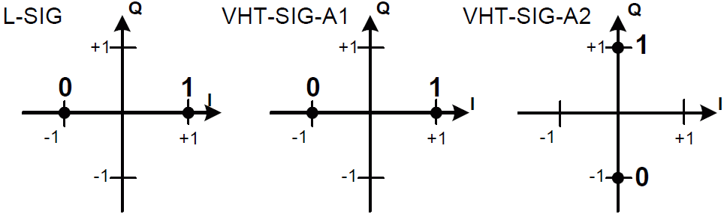

**Figure 22-18—Data constellation in the VHT PPDU**

At 1701.42 (in Std.802.11-2012)

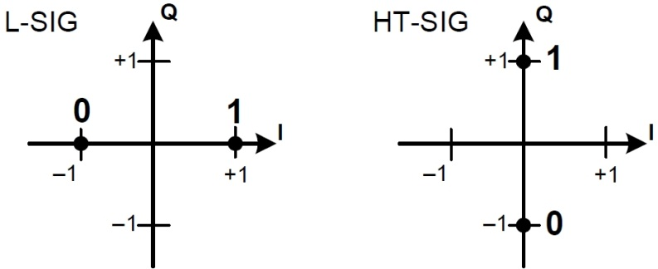

**Figure 20-7—Data tone constellations in an HT-mixed format PPDU**

**Proposed resolution to CID 10094:**

Accepted.

|  |  |  |  |  |  |
| --- | --- | --- | --- | --- | --- |
| 10097 | Schelstraete, Sigurd | 274.43 | 22.3.8.3.5 | Unclear references | It's not clear why references to Eqs (22-12) and (22-42) are needed here. Neither one has anything to say about the length of each VHT-LTF symbol. Replace last sentence of this subclause with "The duration of the VHT-LTF field is T_VHT-LTF." |

**Context:**

At 274.43:

As indicated by Equation (22-12) and Equation (22-42), the duration of each VHT-LTF symbol is *T*VHT-LTF regardless of the Short GI field setting in VHT-SIG-A.

At 256.25:



At 273.30:

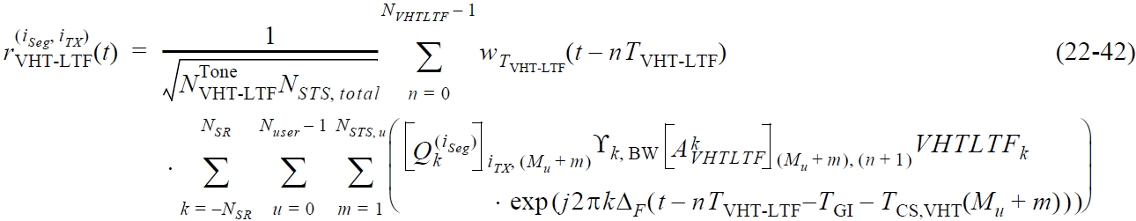

At 249.61: (**Table 22-5—Timing-related constants**)

|  |  |  |
| --- | --- | --- |
| *T*VHT-STF | 4ms = *TSYML* | Duration of each VHT-LTF symbol |

**Discussion:**

Neither Equations (22-12) nor (22-42) explicitly indicates that the duration of each VHT-LTF symbol is fixed to *T*VHT-STF regardless of the Short GI field setting in VHT-SIG-A.Instead, Table 22-5 is better reference for the duration of each VHT-LTF symbol.

**Proposed resolution to CID 10097:**

Revised. <This document> provides proposed text change.

**Proposed text changes:**

At 274.43:

As defined in Table 22-5, the duration of each VHT-LTF symbol is *T*VHT-LTF regardless of the Short GI field setting in VHT-SIG-A.

|  |  |  |  |  |  |
| --- | --- | --- | --- | --- | --- |
| 10098 | Schelstraete, Sigurd | 277.08 | 22.3.8.3.6 | Replace definition by reference | N_STS,u is already defined in Table 22-6. Don't repeat definition here. Replace this line with "N_STS,u is defined in Table 22-6" (similar to most other parameters in this list) |

**Context:**

At 277.08:

*NSTS*,*u* is the number of space-time streams for user *u*

At 251.17:

|  |  |
| --- | --- |
| *NSTS*, *NSTS,u* | For pre-VHT modulated fields, *NSTS*,u = 1 (see NOTE 2). For VHT modulated fields, *NSTS*,*u* is the number of space-time streams for user *u*, *u* = 0,…, *Nuser*–1.  For a VHT SU PPDU, *NSTS* = NSTS,0.  For a VHT MU PPDU, *NSTS* is undefined. |

**Proposed resolution to CID 10094:**

Revised. <This document> provides proposed text change.

At 277.08:

*NSTS*,*u* is defined in Table 22-6 (Frequently used parameters).